Centre for Local and Regional Enterprise (CLaRE) | 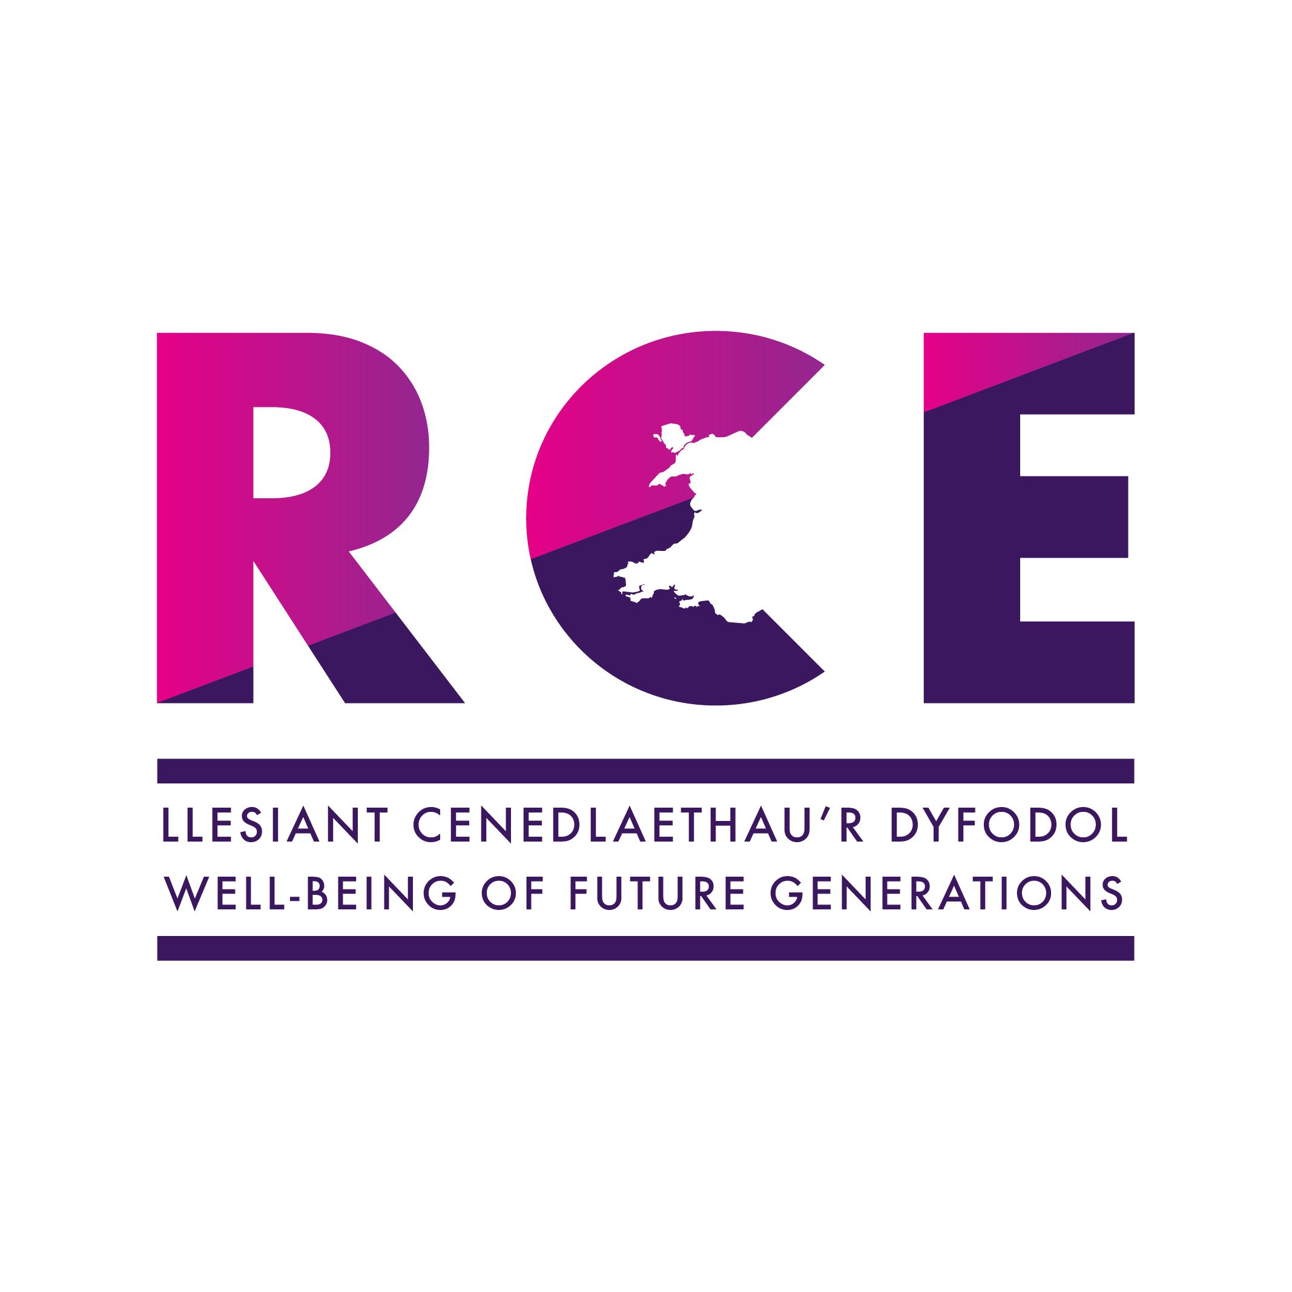
INTERNAL CALL FOR PRESENTATIONS/PAPERS
CLaRE and the Regional Centre of Expertise (Resilient communities)
Regenerating rural communities after COVID-19: challenges and opportunities.
First Annual Symposium

Wednesday 23rd June 2021 (1.00pm, via TEAMS)
Aberystwyth University

The Regenerating Rural Communities symposium seeks to promote research relating to the impact the COVID-19 has had on rural communities (defined in this instance as living outside of cities). It aims to showcase the research of academics, practitioners, and research students across Aberystwyth University and its stakeholder networks.

You are invited to present a 15 minute presentation at the symposium in areas such as (but not restricted to):

The impact of COVID-19 on enterprise operating outside of cities.
COVID-19 and the Creative Industries
Entrepreneurship and COVID-19
COVID -19 and supply chain systems
The impact of COVID-19 on tourism, hospitality and events

We welcome presentations in working papers, conceptual papers, empirical research papers and impact case studies from experienced and new researchers (including research students).

Structured abstracts should be submitted by email in word format to Dr Lyndon Murphy lym18@aber.ac.uk by 14th May 2021. The document should be labelled with the author’s name and indicate which track the author wishes the paper to be included within as identified in the list of themes above. Abstracts will be subjected to peer-review and accepted abstracts will be published in the symposium proceedings. Please see the guidelines for structured abstracts below.

Authors who have had an abstract accepted for symposium presentation may also submit a full paper for publication in the Centre for Local and Regional Enterprise (CLaRE) Working Papers Journal – all full papers submitted to the CLaRE Working Papers Journal will be subject to a further review process.

GUIDELINES FOR STRUCTURED ABSTRACTS

Structured Abstracts should include the following:
- Title
- Name of authors/including affiliation
- Contact details of leading author
- Key words - minimum 4, maximum 8
- Introduction – purpose of paper / objectives
- Relevant background information/context
- Research approach e.g. primary research methods utilised, desk based research
- Discussion (including results where appropriate)
- Conclusions/implications
- References

Abstract format:
- 500 words maximum (not including titles, references or key words)
- Times New Roman 11 Font
- Single line spacing
- Headings in bold
- Copyright: It is the author’s responsibility to ensure that, where copyright materials are included the permission of the copyright holder has been obtained

