ED13720- Seminar
Overleaf are links to several Virtual Reality (VR) apps and YouTube clips. Each is linked via a QR code which can be read from any QR reader app. Begin by downloading the ‘Sites in VR’ app to get used to how the VR controls work. Try to make your way to the entrance to Disneyland.
Once you are familiar with how to control the VR sets try downloading the ‘Within’ VR app and watch the following videos:
- Clouds over Sidra
- The Source
Also watch the suggested YouTube videos (these can be watched in VR or standard format). For each video and consider the following 2 issues.

What kinds of play are observed or mentioned?

What, if any, are the barriers to play in each video?

VR Apps
Sites in VR
Android Apple
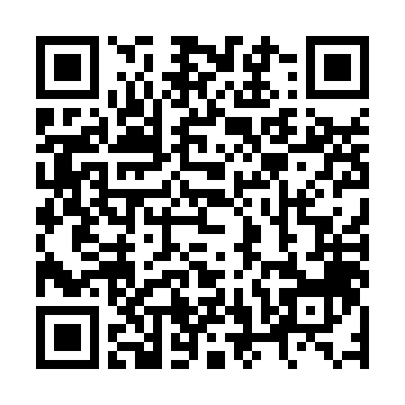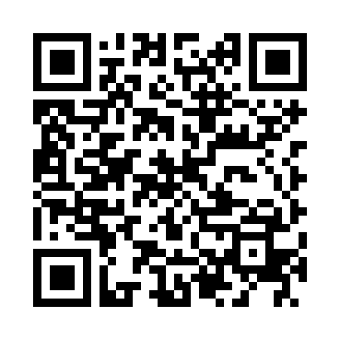
Within
Android Apple
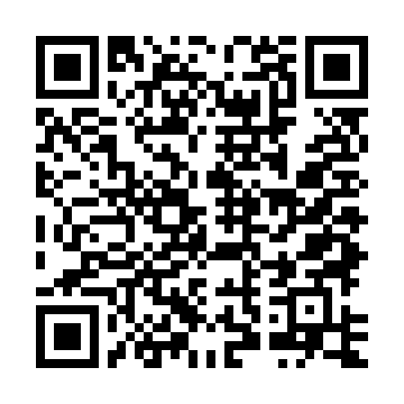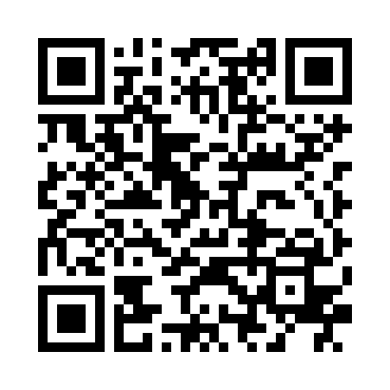

YouTube Videos

Montessori School Monroes Nursery Kid Spot Nursery
