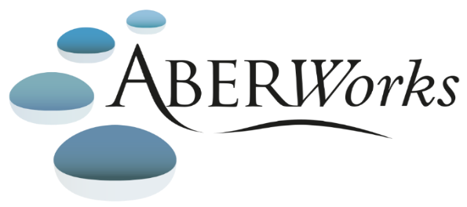TRAINING PROGRAMME
Diversity in the Workplace |  |  |  | On-Line
Aberystwyth University provides mandatory training for all staff to:  familiarise them with equality legislation  give them an understanding of the broader issues around equality/diversity  raise their awareness of their responsibilities and rights as members of staff  The training is provided by means of an online tutorial. This tutorial can be done in one sitting or in 'bite-sized' chunks at your convenience. The quiz contained within the programme must be completed for you to finish the training. These quiz marks will be retained and will be used to identify further training needs for staff.  The tutorial is available in both Welsh and English.  Logging On  To log in, please use the following details:  Email: your full Aberystwyth University email address, e.g. abc@aber.ac.uk  Password: Please type in the word ‘password1’ as the default password. Once you are in please change your password.  In case of problems accessing this tutorial, please contact works@aber.ac.uk. |  |  |  | https://aber.learnupon.com/users/sign_in

