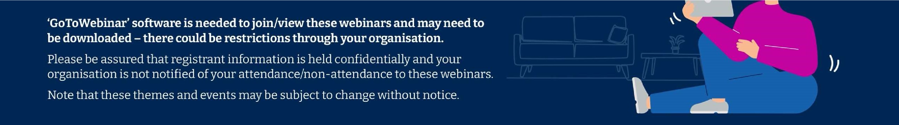

Monday

April 15

th

, 2024

12

pm-12.30pm

Service Awareness

Care first Lifestyle – Your

Digital Wellbeing Solution

LINK:

https://attendee.gotowebinar.com/register/549546245190885214

This webinar walks you through the

Lifestyle website, with details and

demonstrations of the tools on offer and

how to access it.

Wednesday

April 17

th

, 2024

12

pm-12.30pm

Care first

Awareness

How Care first can support

you

LINK:

https://attendee.gotowebinar.com/register/378660147938119520

A webinar to raise awareness of the service

and information on how to access the EAP

support provided by Care first.

Friday

April 19

th

, 2024

pm - 12:30pm

12

Menopause

Supporting others through

the menopause

LINK:

https://attendee.gotowebinar.com/register/8238963218690250329

This session will be run by Care first

Menopause Mentor, Suzanne. In this

webinar, we will explore ways to support

individuals going through menopause and

touch upon the concept of male menopause,

often referred to as andropause.

