Turnitin paper requests

Turnitin allows staff who find a match between their student assignments and assignments submitted to other modules to request a full copy of the matching paper. This may be internally between AU modules, or externally from other educational institutions. You may receive requests from Turnitin from colleagues at AU or from other UK or international institutions.
Paper request emails look like this
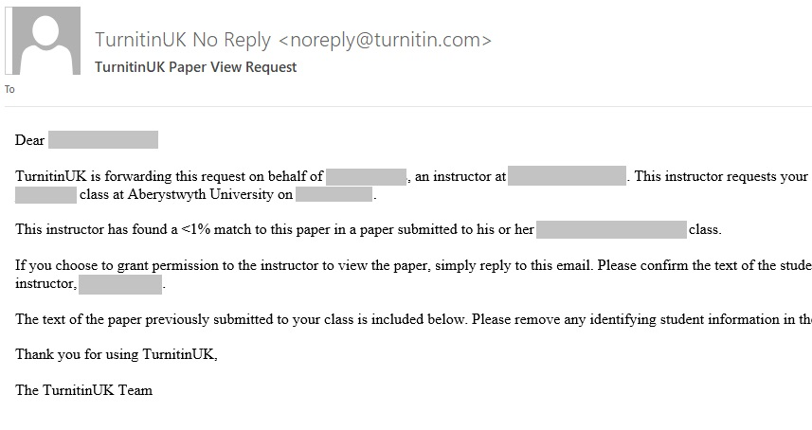
It is the decision of the module co-ordinator as to whether they release the assignment or not. If this is not you, please refer the request to the module co-ordinator. You are under no obligation to share the assignment, but do consider that you may wish to use the service yourself at some point.
Considerations about whether to share the assignment should include:
- The size of the percentage match. Small percentage matches are probably best to avoid, as you give the whole paper to another university. You may want to consider the overall size of the assignment in this consideration.
- The matching text. A matching bibliography or sourced material in appendices will probably provide little useful information.
- The nature of the assignment. Assignments that could contain personal information about the student (for example a sample CV), sensitive information (for example the results of a focus group, material relating to children / medical information etc), or personal reflection are best not shared.
If you are unsure about whether to share the whole paper, you can query the request and request more information before making a final decision.
To do this, reply to the email, but remove the text of the full paper before sending the reply.
If you decide to:
- not share the assignment- ignore the request and delete the email.
- share the assignment:
  - Press Reply in your email programme
  - Remove anything from the text that could identify the student, including student name and number
  - Copy and paste the following statement at the top of your message:
Copyright in this assignment remains with the student author. You may only use this assignment for the purposes of checking students’ work for improper citation and potential plagiarism and for no other purpose. Copies of assignments should not be stored beyond being needed for these purposes.
If you have any concerns about Turnitin paper requests email elearning@aber.ac.uk
This document is based on pages written by staff in the Centre for Quality Support and Development (CQSD) at the University of Reading. We are grateful to CQSD for permission to use and adapt this information.

