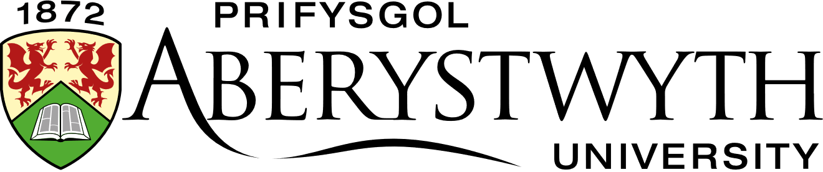

TITLE | Thriller and Detective Fiction
TUTOR | Lara Clough

Dear Student,
Thank you for enrolling on this Lifelong Learning course. This letter gives you some further information. If you have any questions, please contact either:
The LLL Office: learning@aber.ac.uk
The Tutor: Lara Clough lac15@aber.ac.uk
The Co-ordinator: Elin Mabbutt emm32@aber.ac.uk
We hope you enjoy the course.
Best Wishes,
The Lifelong Learning Team
----------------------------------------------------------------------------------------------------------------
GETTING STARTED
Aberystwyth University Student Account
Before you can begin your course, you need to activate your Aberystwyth University Student Account. After you pay and enrol, you will be sent your unique student number by the Lifelong Learning Administrator. This will enable you to obtain your student username and set a password for your student account.
Having an account gives you many additional benefits such as access to the university library and online journals, an email address, and discounts for university services.
Click here to find all the instructions you will need to set up your student account.
Once you have completed this process login to your Aberystwyth University email account here

Online Learning Environment: Blackboard
Once you have an active username and password you can login to our online learning environment called Blackboard by going to https://blackboard.aber.ac.uk. This is where you can access the learning materials for your course, interact online with your tutor and other students and submit your assignments. Guide to Blackboard Ultra - Students : Information Services , Aberystwyth University

Microsoft Teams
Your course may include one or more live online learning webinars or seminars. If so, these will be held using the online platform Microsoft Teams. Like Blackboard, you can access Teams online by going to https://teams.microsoft.com/ and logging in with your Aberystwyth University student username and password. Although not essential, we would recommend you download the Microsoft Teams software onto your desktop. Once you have logged in, you can do this from the Microsoft Teams homepage. Click on the circle in the top right-hand corner of the screen and select Download the Desktop App.
If an online meeting has been scheduled by your tutor you will receive an email to your University Email Account that will contain a link, which you can click on to join the meeting. Alternatively, if you go to your Calendar in Microsoft Teams, which is on the left-hand side of the screen, you will see a Join button appear by the meeting just before it begins, which you can click on.
If you haven’t used Microsoft Teams before I would recommend watching this one minute video (link) so you know what to expect.

COURSE OUTLINE
Detective and thriller fiction are enormously popular. For the writer, these genres demand intricate plots, detailed research, and the ability to create ‘deep’ and complex characters. This module will identify the historical contexts of both genres from their beginnings in (for example) the works of Edgar Allan Poe and Sir Arthur Conan Doyle. We will also explore the wide range of sub genres-from cozy-crime to the literary, to contemporary visceral, Nordic crime. Students will analyse and compare the work of a wide range of published fiction. Each student will also be guided in the key skills of writing effective detective and thriller fiction as they identify their own particulargenre ‘position’ and style.
This distance learning course enables you to study from home and participate in an online community of other students. The module is delivered through Blackboard, our online learning environment.
This module can be studied as a stand-alone course, but it is also an optional module for the Certificate of Higher Education in Creative Writing at Aberystwyth University.

LEARNING OUTCOMES
On completion of this module, students should be able to:
1. Evaluate the history and genre ‘evolution’ of detective and thriller fiction.
2. Analyse and apply the craft of writing detective or thriller fiction, including the place of psychology and motive and the importance of plotting.
3. Demonstrate the ability to critically appraise own work and that of other writers.
COURSE PROGRAMME
Activities and tasks will be embedded into each unit so students can practise the techniques they have learned and develop their skills. Students will be encouraged to share their own work and participate in discussions on Blackboard. Alongside the learning materials on Blackboard the tutor will be on hand via email to answer any queries and provide guidance throughout the course. They will also participate in the online discussions.
ASSESSMENTS
- A critical synopsis which records and reflects on the process of working up the synopsis, and how this work is positioned within genres of either thriller or detective fiction 600 words (40%)
- Extract from a proposed novel or short story 1500 words (60%)

Find our full programme listings here: https://www.aber.ac.uk/en/lifelong-learning/courses/
Are you interested in completing a Certificate in Higher Education? If you are, speak to your tutor or contact the co-ordinator: emm32@aber.ac.uk

Don’t forget to follow us on social media to keep updated about Lifelong Learning at Aberystwyth University:
Facebook: Dysgu Gydol Oes Aberystwyth Lifelong Learning

Twitter: @Aber_LLL

Instagram: @aberystwyth.lifelong.learning

