Aberystwyth University - Risk Appetite Matrix – To be approved at a Meeting of the Aberystwyth University Council November 2020
This matrix should be used as guidance for assessing risk appetite in conjunction with the Risk Appetite Statement (available at http://www.aber.ac.uk/en/pgbi/general-info/risk-management/ ). Any high level strategic risks should be referred to Council
Risk Appetite | Example Risk Areas  (May be subject to change) | Potential Impact  (Not all will apply in each case) | Potential Reward
High Risk Appetite:  The University is prepared accept risks in order to further its strategic objectives or because the potential rewards are considered to be significant. | - Innovation / Enterprise  - Achievement of Strategic Objectives  - International Delivery and Recruitment  - Change of delivery methods including hi-tech DL  - Recruitment of FTUG Home/EU students | Reputational: Possibility of some damage if undertakings do not deliver.  Legal: Risk of legal issue arising from undertakings  Students: Limited negative impact on student experience (e.g. building work); some disruption as systems are changed.  Staff: Some disruption to day-to-day activities. No more than 5 days of senior staff time | Financial: Additional income of more than 5% of turnover  Reputational: Boost to University’s reputation on a national or international scale. Potential rise up the League Tables.  Legal: N/A  Students: Significant improvement to student experience, and/or 10-20% increase in student numbers / 40% increase in applications.  Staff: Significant improvement to staff satisfaction and potential for staff development; recruitment and retention.
Medium Risk Appetite:  The University is prepared to accept some risks in order to improve upon student experience or deliver strategic targets. | - Estate Development  - Investment in Facilities  - Partnerships  - Research | Financial: Investment / potential loss of £500k  Reputational: As above  Legal: As above  Students: Possibility of short-term, negative impact on student experience (e.g. building work etc.)  Staff: Over 5 days of senior staff time | Financial: Additional income of 2% of turnover  Reputational: Improvement to reputation on a national or local level.  Legal: Improvement to compliance.  Students: Improvements to student experience in the medium / long term. 5-10% increase in student numbers / 25 % increase in applications.  Staff: Improvement to staff satisfaction in the medium / long term.
Medium / Low Risk Appetite:  The University is generally risk adverse but will accept some small risks as a necessary part of day-to-day operations. | - Service delivery  - IT Innovation  - Teaching Quality | Financial: Investment of up to 2% of turnover, including staff time  Reputational: As above.  Legal: As above  Students: As above.  Staff: Significant (more than 45 days of senior staff) time required for dedicated projects | Financial: Limited possibility of financial gain / gaining new business  Reputational: Limited positive impact on reputation.  Legal: None  Students: Limited immediate improvement to student satisfaction, possibly only in one area of the NSS.. Increase student numbers in some areas.  Staff: Limited positive outcomes for small numbers of staff.
Low Risk Appetite:  The University will seek to avoid taking any risks in these areas and, where risks are unavoidable, will seek to mitigate as much as possible. | - Regulatory Compliance  - Health & Safety  - Environmental Compliance | Financial: Investment of more than 2% of turnover, either in terms of cash or staff time/effort  Reputational: Damage to reputation on a national level  Legal: Severe breach of compliance resulting in legal action and possible heavy sanctions.  Staff: Physical danger to staff and severe negative impact on staff satisfaction. | No possible reward would compensate for taking these levels of risk.
The University will proactively mitigate to the fullest extent possible any risks with these potential impacts |  | - Physical danger / loss of life.  - Severe negative impact on student experience  - Financial loss of more than 10% of turnover  - Severe damage to reputation on a national and international level.

Appendix 3 – Risk Appetite

The Risk Appetite Cycle
The risk appetite cycle should be a dynamic process, as depicted by the diagram below, with appetite and limits responding to the business environment and/or changes to risk capacity as required. Achieving this dynamism is greatly assisted by the use of a common organisational language with respect to the components of the organisation’s risk appetite framework.

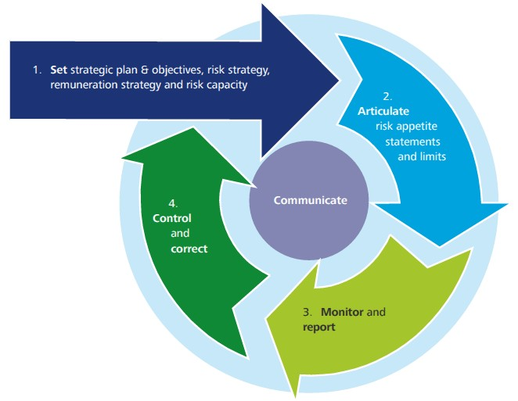
Defining Risk Appetite
The following radar graph is an effective way for organisations to begin a discussion on risk appetite. Each stakeholder is requested to assess their perceived current risk appetite of the organisation, and also their perceived ideal risk appetite, for a range of risk themes. This can then be consolidated to show whether stakeholders believe too much or too little risk is taken.
1 = Risk averse 5 = Risk hungry
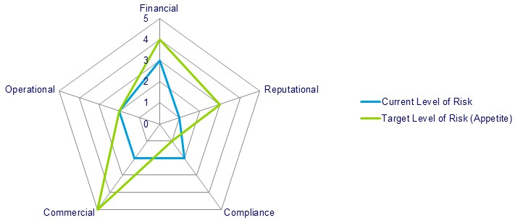
The following framework from the public sector describes the attitudes and behaviours the risk appetite should give rise to f or each risk category. This framework may be useful when assessing the adequacy of the responses to risk and in communicating the Councils risk appetite to the whole organisation.

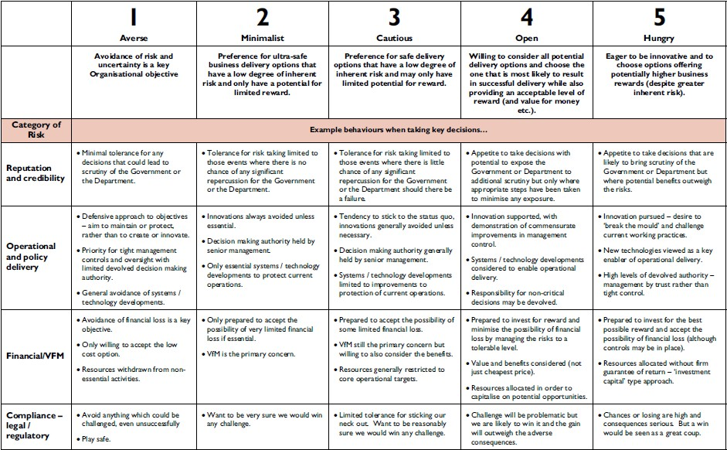

The following diagram illustrates how defining risk appetite can add sophistication to the consideration of risk levels:

