Microsoft Teams Training
  - Suzy Shipman, 24 January 2020
Contents
Microsoft Teams Training 1
Accessing Microsoft Teams 3
Creating a Team 5
Creating a Channel 7
Notifications 9
Having a Conversation 11
Channel conversation 11
Conversation with a specific person 13
Document Management 15
Adding Documents 15
Collaborating on Documents 17
Connecting with SharePoint 19
Adding a Planner Plan 21
Using Planner 23
Rename a Bucket 23
Add a New Bucket 23
Add a task 24
Edit a Task 25
Move a Task 26
Mark a Task as Complete 26
Viewing your Planner Tasks 27
Having an Online Meeting 29

Accessing Microsoft Teams
To get started we need to know how to find Teams.
- Open your web browser (Chrome).
- Go to teams.microsoft.com.
- Log in (using your full email address like with SharePoint).
- Click on the download button at the bottom of the left menu.
- When the download is complete, click on the downloaded file.
- Teams will be installed on your computer.

Notes:
You could continue to use the online version of Teams if you don’t want to download the desktop application.
If you use the online version, you should click ‘Turn on’ on the ‘Stay in the know. Turn on desktop notifications’ message in the bottom right corner of the screen. If you are not going to use the online version, you can click ‘Dismiss’ instead to make the message go away.

Creating a Team
The starting point for anything within MS Teams is your team. If there isn’t already a team available that suits your needs, you can create a new one. Teams do not have to reflect ‘real’ teams and can include staff that you work with from any area of the university.
- Click on the ‘Create team’ button in the ‘Create a team’ box:
- Click on ‘Staff’:
- Give your team a name, e.g. Suzy’s Training Team.
- Give your team a description, e.g. A test team for training.

Note:
If you’re already a member of a team, you’ll see your teams displayed on the screen at the start. You can create a new one by clicking on ‘Join or create team’ at the top right of your screen.
- Leave Privacy set to ‘Private – Only team owners can add members’:
- Click the ‘Next’ button
- Type the name of one or two members of staff who are in the room today and click the Add button to add them to the team.
- When you’ve added all the people you want to add, click Close
- You will now see your new team:

Note:
You can add people to your Team later, by clicking on the … to the right of the name of your team and choosing ‘Manage team’.

Creating a Channel
Separate channels are useful so that you can keep discussions about different topics in different places. Some teams have many channels, and some may just have the default ‘General’ channel.
- Click on the … to the right of the name of your team:
- Choose ‘Add channel’.
- Give your channel a name, e.g. Training Session.
- Give your channel a description: e.g. A channel for conversation in the training session.
- Leave Privacy set to ‘Standard – Accessible to everyone on the team’
- Tick the ‘Automatically show this channel in everyone’s channel list’ tick box.
- Click Add.
- Your channel will be created, and you’ll see it displayed in the panel on the left:
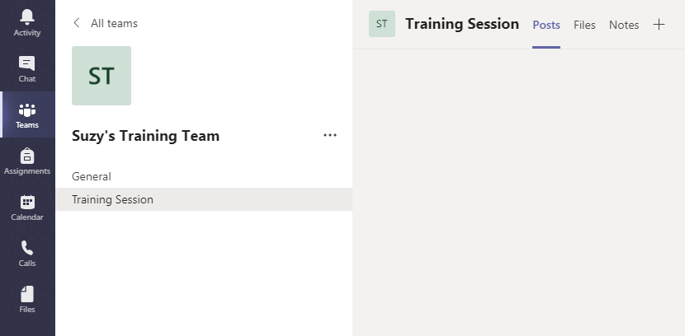

Note:
You can create a channel that is only visible for certain people within the team by setting the Privacy to ‘Private – Only accessible to a specific group of people within the team’.

Notifications
It is useful to make sure you are notified when other people post something in your new channel. By default, notifications are off, but you can turn them on.
- Click on the … by the channel name.
- Click on ‘Channel notifications’.
- For ‘All new posts’ select ‘Banner and feed’.
- Tick the ‘Include all replies’ tick box.
- Leave ‘Channel mentions’ set as ‘Banner and feed’.
- Click Save.

Having a Conversation
You can have conversations in a variety of areas within Teams. Conversations in a channel can be seen by any member of your team who has access to that channel. Conversations in Chat can only be seen by the people you have added to the chat.

Channel conversation
- Type in the box at the bottom of the channel screen to start the conversation.
- To make sure people are aware of your new message, you can use @ to notify different people or groups of people. After typing the @, suggestions will appear as you continue typing so you can pick the right option from the list:
- Type a message for your whole team, e.g. @Suzy’s Training Team Hello everyone in the team.
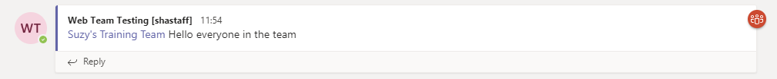
- Type a message for the whole channel, e.g. @Training Session Hello people in the channel.
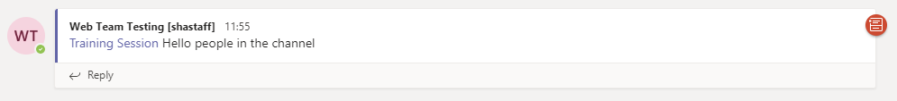

- Type a message for a member of your team, e.g. @Suzy Shipman this is a message for Suzy.
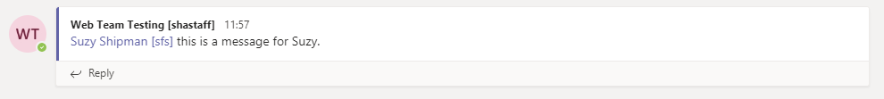
- Reply to one of the messages you have posted by clicking on Reply and typing your reply text:
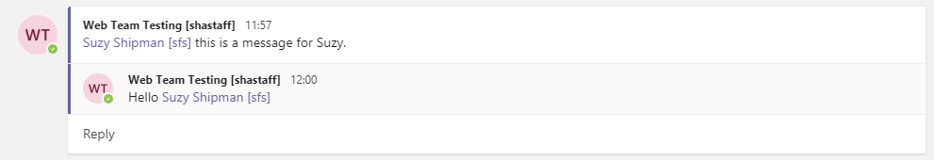
- You can also use a quick response to someone’s message. Like one of your messages by putting your mouse over it and choosing the thumbs up icon on the top right of the message:

Conversation with a specific person
- Click on Chat in the left menu.
- Click on the ‘new chat’ icon at the top of the Chat pane (pencil & paper icon):
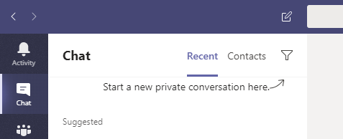
- Type the name or userid of one of the people in the room and choose the right person from the suggestions that appear.
- Type your message in the box at the bottom.
- If you want to type a message with formatting such as new lines, click on the ‘Format’ icon to change into a mode where you can format your message before sending it.
- Type your message and format as required:
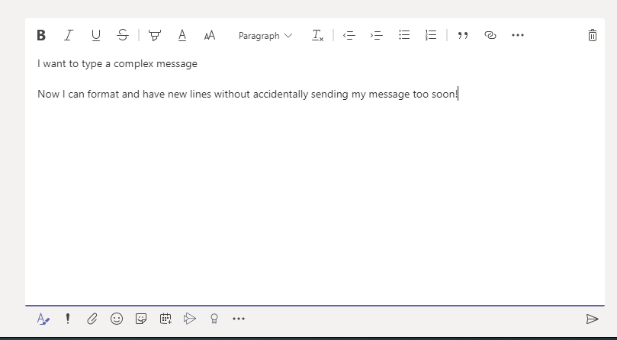
- Click on the ‘Send’ icon at the bottom right to send the message.
- If you want to send a short, simple message, just type it and hit Enter.
- The person you are chatting with should get a notification in Teams.
- Check if you have a reply to the message that you sent.
- Reply to the chat message.

Notes:
You can chat with anyone across the university. Today we will stick to people in the room, so we don’t annoy or confuse anyone else!
If you start a chat with someone you’ve chatted with before, you’ll see the previous conversations showing in the chat window.
If you add a new person to an existing chat that was previously with a single person, the new person will see all the chat history.
If you add a new person to an existing chat that is already a group chat, you will be asked if you want the new person to see the chat history or not.

Document Management
You can use the Files section within Teams to share and collaborate on documents. If you have a SharePoint site already which has a suitable document library within it, you can connect this up to your team.

Adding Documents
- Return to your Team by clicking on Teams in the left menu.
- If your team is not already open, click on the square for your team to open it:
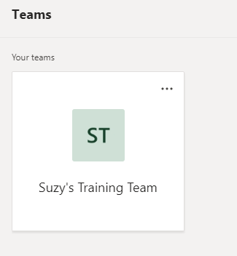
- In the left panel, click on the name of the channel you created today (e.g. Training Session).
- Click on ‘Files’ at the top of the conversation window:
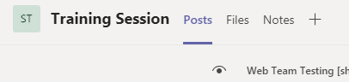
- Click ‘New’ at the top left:
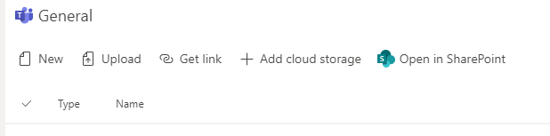
- Choose Word document from the menu.

- Give your Word document a name, e.g. Suzy’s Document:
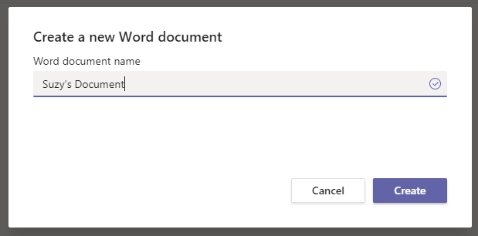
- Click Create.
- Word will open within the Teams app.
- Add some content to your document, e.g. This is a very interesting document.
- Click Close on the top right to finish.
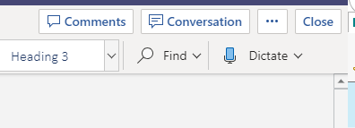
- You’ll now see your Files area, with your new document listed:
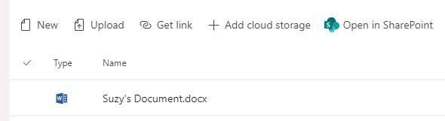

Note:
The Files area is actually storing documents in a special Team Site in SharePoint. You can view it through the SharePoint interface by clicking ‘Open in SharePoint’.
In this view you can access version history for documents. You can also access the team’s recycle bin where you can retrieve deleted documents if required.

Collaborating on Documents
- Click on the name of your document.
- On the top right of the screen, click on Conversation.
- The conversation panel opens on the right of the screen:
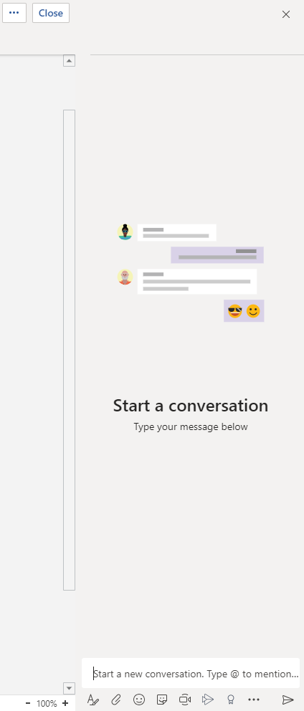
- Type in the box at the bottom to start a conversation, e.g. What do you think of this document so far?
- The text will show at the top of the panel with a link to the document.
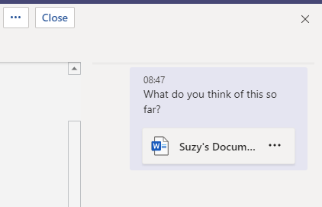
- Click Close at the top right.
- Return to the main page of your channel by clicking on Posts at the top of the screen.
- You will see your text showing so anyone in the channel can see it.
- Click Reply and type a reply, e.g. It’s a bit boring if I’m honest.
- Hit enter and the reply will appear.
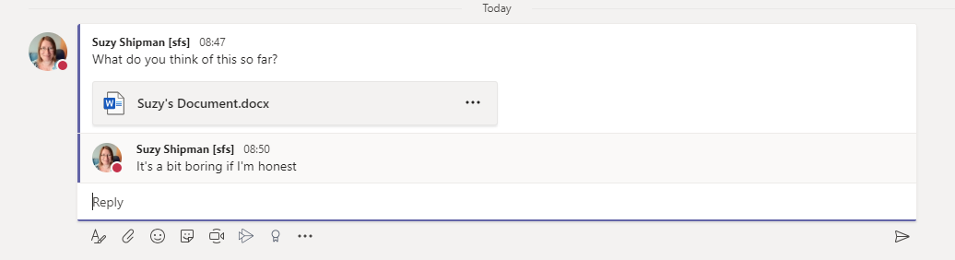
- Your reply will also be shown in the Conversation panel when anyone is viewing the document.
Notes:
You can use @ in the Conversation panel just like in the channel screen.
You can also leave comments on specific parts of the document by right clicking on part of the document and choosing New Comment. These stay inside the document and aren’t shown on the channel screen.

Connecting with SharePoint
- Open SharePoint in your web browser.
- Go to your department’s SharePoint site and find a document library.
- Copy the web address of the document library from the address bar.
- Return to Teams.
- Click on the Files tab at the top of your screen.
- Click on +Add cloud storage at the top of the page.
- Click on SharePoint.
- Click on ‘Use a SharePoint link’ on the left of the pop-up window.
- Paste the web address of the document library into the ‘Library Url’ box and press the Go button.
- You should see the SharePoint site shown beneath the Library Url box:
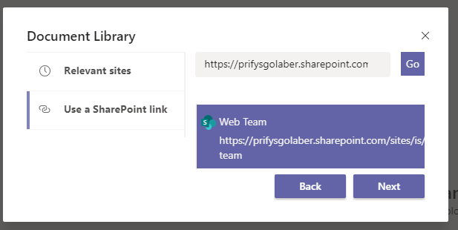
- Click Next to continue.

- Click on the document library that you want to use:
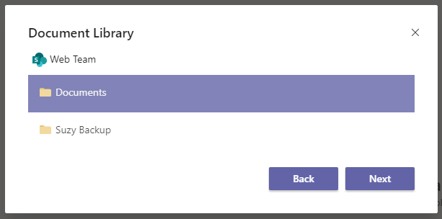
- Click Next.
- More information about the folder is shown:
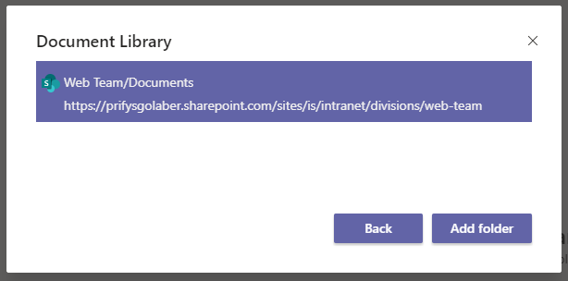
- Click Add folder to confirm that this is the folder you want to add.
- You’ll now see the document library listed on the Files page, as if it was a folder:
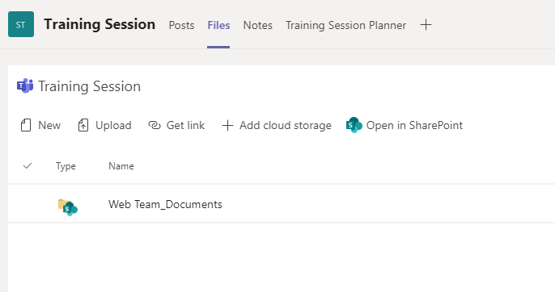

Adding a Planner Plan
Planner is a very useful addition to Teams. You can create tasks and plan projects using a simple visual interface. It needs to be added to the channel manually.
- Return to your Team by clicking on Teams in the left menu.
- If your team is not already open, click on the square for your team to open it:
- In the left panel, click on the name of the channel you created today (e.g. Training Session).
- Click on the + icon at the top of the conversation window:
- In the ‘Add a tab’ screen click on Planner (a green icon with 3 different length bars on the right of the top row):
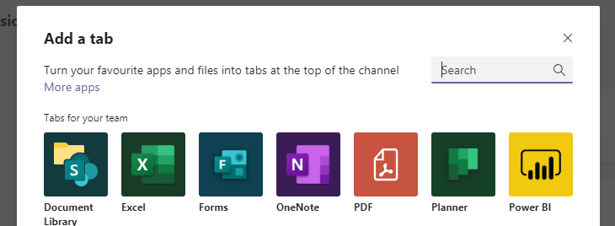

- Type the name of the new plan in the ‘Create a new plan’ box, e.g. Training Session Planner:
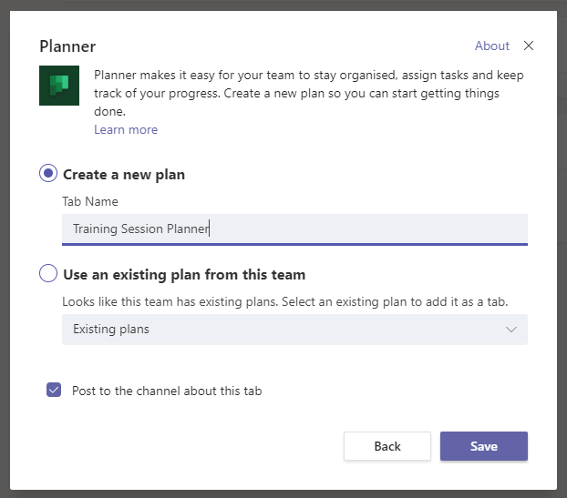
- Click Save.
- Your new plan will open, and you will see its name as an additional tab across the top of the screen:
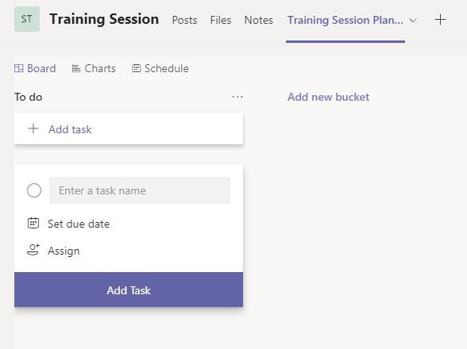

Using Planner
Planner is flexible and easy to use. You can customise your plan according to the needs of your project or team.

Rename a Bucket
- Click on the name of the default ‘bucket’ that is currently called ‘To do’.
- Replace the text with your chosen bucket title, e.g. Things to fix, and hit enter to save.

Add a New Bucket
- Click on ‘Add new bucket’.
- Type the name of your new bucket, e.g. Wishlist, and hit enter to save.

Note:
You can add as many buckets as you like, but you’ll probably only be able to see 4 at once on screen without scrolling.

Add a task
- Click on + Add task at the top of your first bucket, e.g. the ‘Things to fix’ bucket.
- Type the task name in the ‘Enter a task name’ box, e.g. Fix broken link.
- Click on ‘Set due date’ and choose the due date from the calendar that appears, e.g. January 30^{th.}
- Click on ‘Assign’ and choose your name, or another person, from the list of people in the team.
- Click out of the box so you can see all the details you have entered so far:
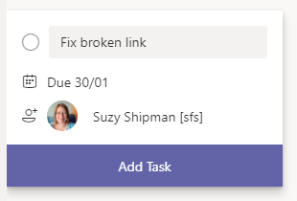
- Click Add Task to save the task
- The task is now displayed:
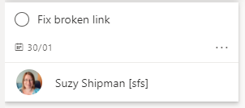

Edit a Task
- Click on the task to edit it.
- Change the priority to Important.
- Add further details of the task to the Notes section, e.g. It’s the link to the open day page.
- Tick the ‘Show on card’ box that appears once you have typed something in the Notes box.
- Click out of the window to close it.
- Your task is now marked with an exclamation mark (!) to show it is important, and displays the description text.

Move a Task
- Drag your task to the 2nd bucket, e.g. the Wishlist bucket.
- Your task is now displayed under this bucket instead:
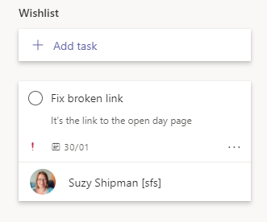

Mark a Task as Complete
- Imagine you have completed the task. Click the circle to the left of the task name to mark it as complete.
- The task will now be hidden but can be shown by clicking on ‘Show completed’:
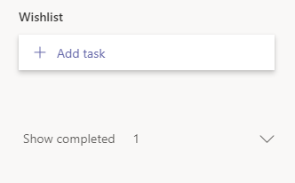
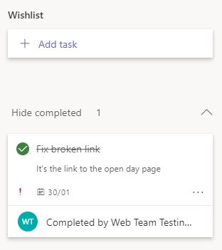

Viewing your Planner Tasks
Planner is useful, but once you are a member of a few teams, it can be hard to keep track of your Planner tasks. Instead of looking in each team, you can view all your tasks together.
- Click … in left menu, under the main icons.
- Choose Planner from the menu that appears:

- You’ll see all the tasks which have been allocated to you:
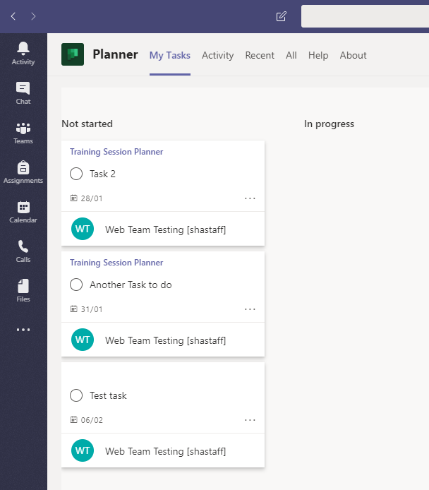
- Change the view so that you see the tasks in order of due date by clicking on ‘Group by Progress’ in the top right corner and choosing ‘Due Date’ instead.
- You’ll now see your tasks in order so you can prioritise the more urgent tasks:
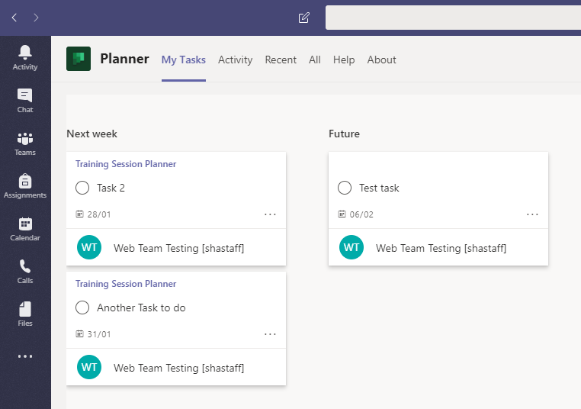

Having an Online Meeting
You can have online meeting through Teams. This is very useful if you are working with people across the university or if team members are not currently on campus. Meetings are similar to Skype calls.
- Click on Calendar in the left menu.
- You’ll see your Outlook calendar so you can choose a date/time for your meeting that fits round your existing commitments.
- Click ‘+ New meeting’ at the top right of the screen:
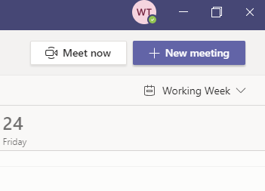
- Give the meeting a title, e.g. Suzy’s Test Meeting
- Choose a start and end date/time
- Type more information about the meeting in the Details box, e.g. This is a test meeting from a Teams training session.
- In the ‘Select a channel to meet in’ choose the channel you created earlier, e.g. Training Session.
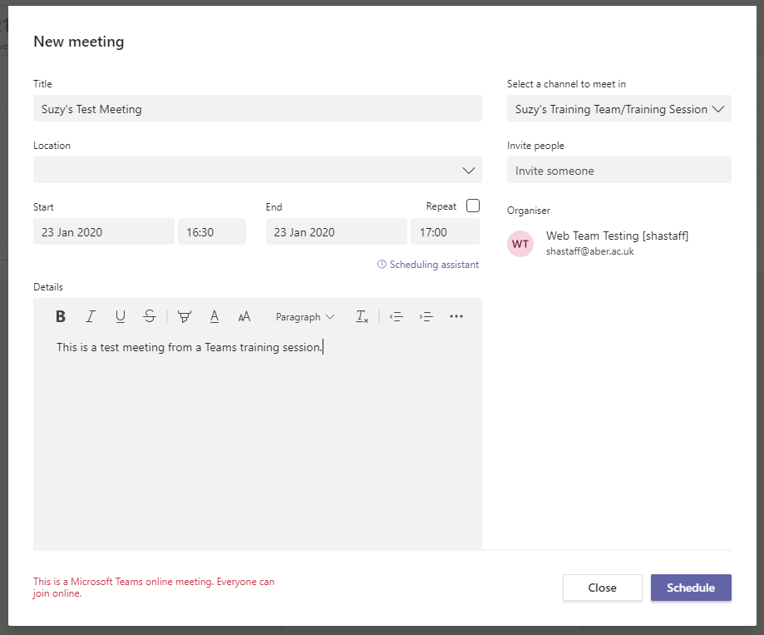
- Click Schedule to finish.
- You’ll be sent to the channel that you selected for the meeting and will see a post letting the rest of the staff in the channel know about the meeting.
- Click on Calendar in the left panel.
- You should now be able to see your meeting in the calendar.
Note:
You can also start a meeting from the Channel window, by clicking on the ‘Meet now’ icon (video camera) beneath the text box.
Or you can start a meeting from the chat window, by clicking on the ‘schedule a meeting icon’ (calendar with a +) beneath the chat box.

