1. Introduction to TerminalFour

What is TerminalFour?
TerminalFour is the Content Management System (CMS) which we use at Aberystwyth University (AU). TerminalFour is used to create, review and publish content to the AU website. We use a CMS in order to separate the structure and look of the pages from the content within the pages. It also means that you don’t need to know html to create or work on web pages here.

Access to TerminalFour
TerminalFour is accessed through a web interface at https://cms.aber.ac.uk/. Log in using your usual AU username and password. The system works on any browser.

Users
Users of TerminalFour are assigned to edit different areas of the site. For each department there may be several site editors called “Moderators” and there may be other site editors called “Contributors”. Moderators and Contributors have different levels of permissions within their departments. Moderators can create and work with sections and content, whereas Contributors can only create and work with content.
Before any users can access the CMS, they must complete CMS and Digital Accessibility Training.

Layout
When logging into TerminalFour, you are presented with the Site Structure which shows the areas of the site you have permission to access. There is a menu on the left for working with content, and a menu across the top right which allows you to move around to different areas of the system and change language.
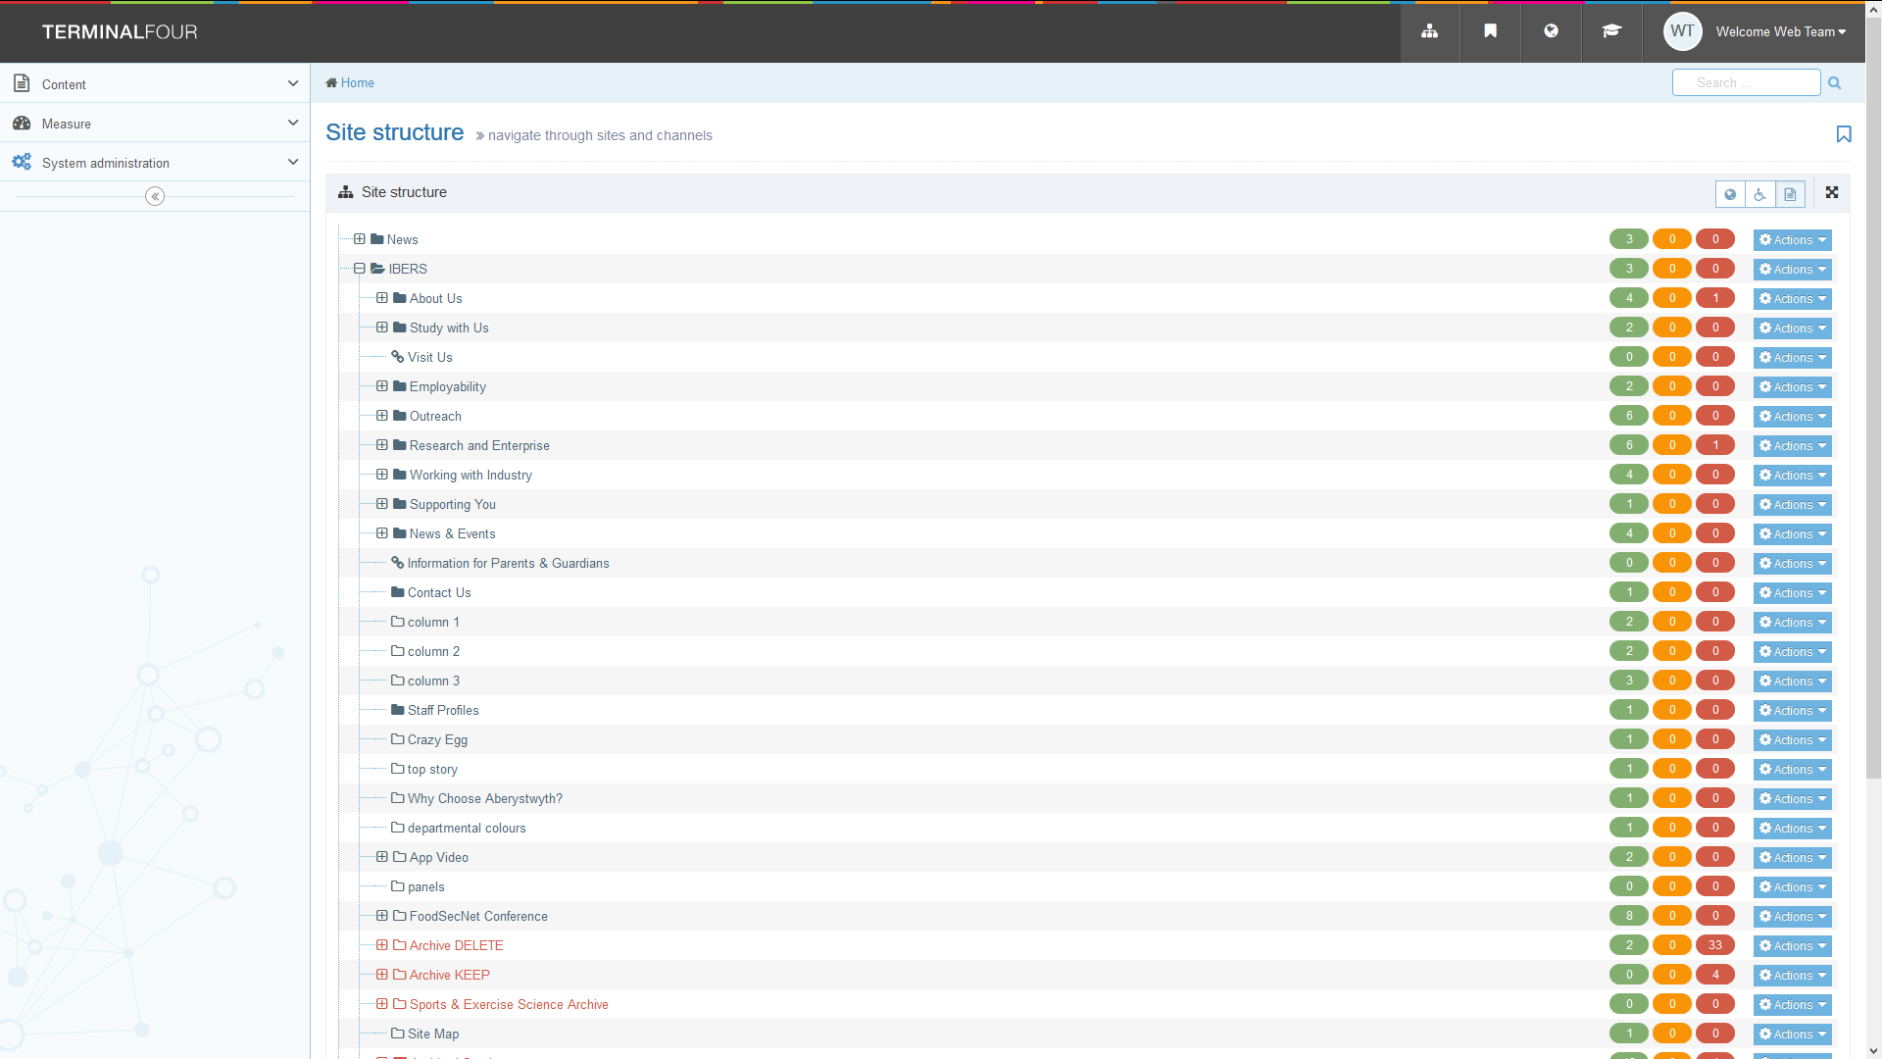

Site Structure
The site is organised into a tree-like structure made up of sections and sub-sections. Within sections is content as well as any sub-sections. Terminology may be used which refers to parent sections and child sections depending on their location within the structure. In the example below, the section ‘IBERS’ is the parent of the section ‘About Us’, and the section ‘The Institute Executive’ is the child of the section ‘About Us’.
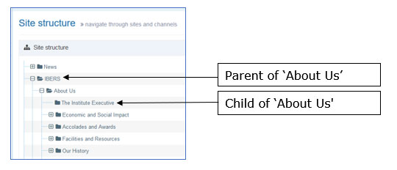
You can get back to the Site Structure at any time by clicking on the TerminalFour logo in the top left of the screen or the Site Structure icon at the top left of the screen.

Creating Web Pages
A web page is made of a section and content within it. To create a web page on your site, you create a section (Moderators only) and content that you wish to be displayed on the page. Each page should have at least one block of content to hold the main text of the page, as well as contact information, and metadata – See Information Sheet 3.

Editing Content
All editing is done through web-based forms, using a WYSIWYG (What You See Is What You Get) editor. See Information Sheet 4. The Editor is not fully WYSIWYG as styling may be applied to content when previewed or viewed on the main website.

Previewing your work
When you create or edit a section in TerminalFour, you should preview it to see how it looks. There is a limited preview available from the content editing pages, but it may not look exactly like the final page. There is also a better preview available from the site structure – see Information Sheet 2.3. After content has been approved and published you can check how it looks on the staging server at http://cmspreview.aber.ac.uk/en/ (English version) or http://cmspreview.aber.ac.uk/cy/ (Welsh version).

Version Control
All versions of content created and edited within TerminalFour are stored. This enables administrators to roll back content to a previous version if required. It is also possible to see which user made which change and when.

Languages
TerminalFour is set up to use English and Welsh. Each piece of content should have an English version and a Welsh version.

Documentation
These documents are available on the Information Services website and that is the place you should go for up to date versions.
http://www.aber.ac.uk/en/is/it-services/web/cms/info-sheets/

Help
If you need help, you should email is@aber.ac.uk or ring 2400. The IT Service Desk will help you with your query or pass your query on to the relevant Team if required.

