10. Working with Departmental News
  - Departmental News pages that are using the News system need to be treated a little differently from normal pages, and there are extra steps you will need to take to ensure they appear correctly
The News system allows you to have one news store which is used in several ways. The 3 latest news articles are listed on the Department homepage and the 4 latest articles and additional Other Top Stories are listed within the dedicated News section. Clicking on a news headline takes the user to the full news article.
News appears at the bottom of the department homepage:

The news page includes images and abstract for the main stories:
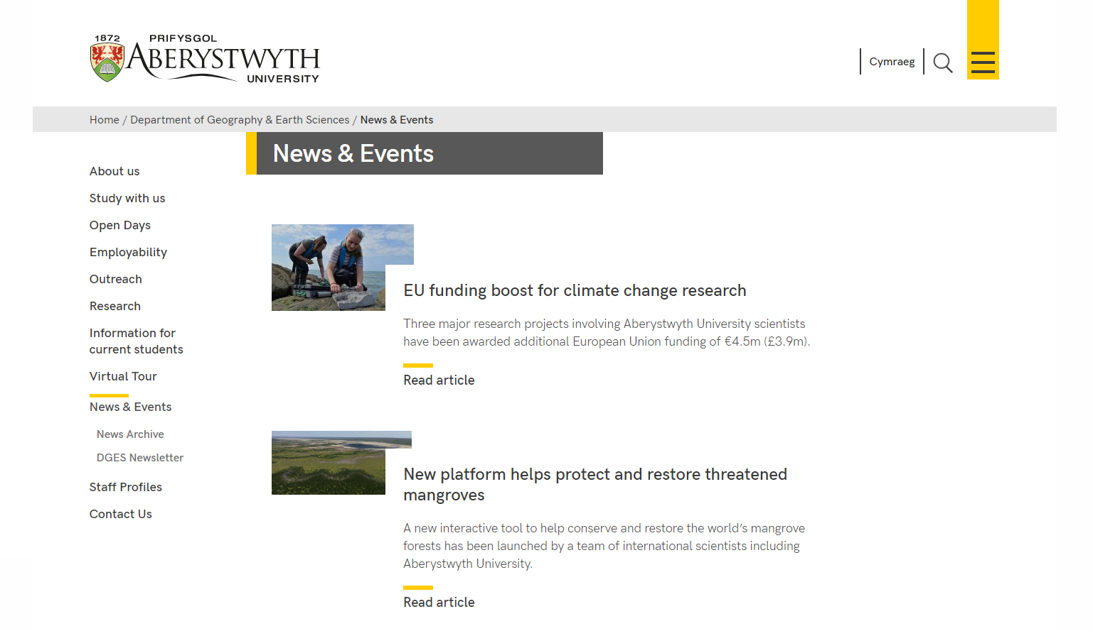
Other stories are displayed under the main stories:
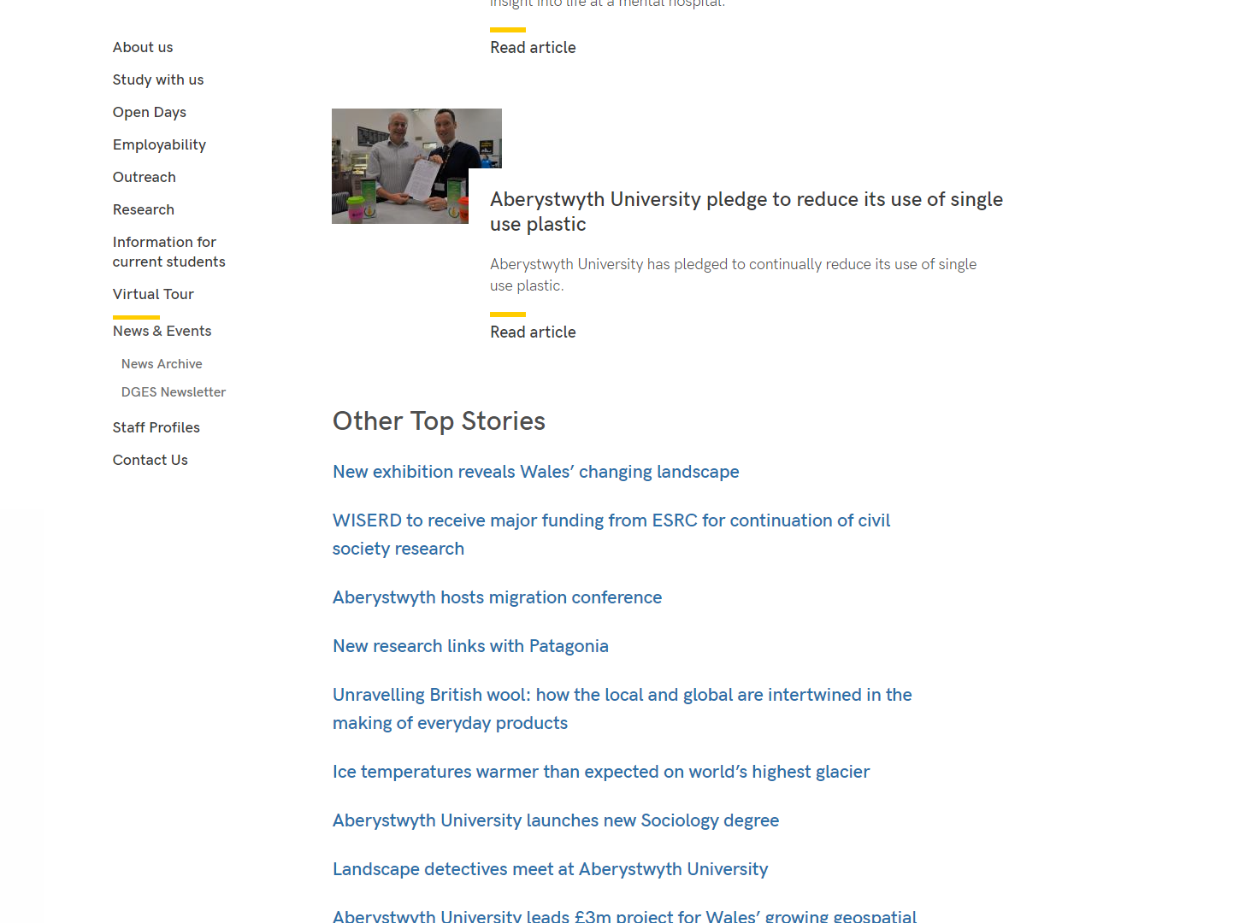
Standard display for news articles.
Top:
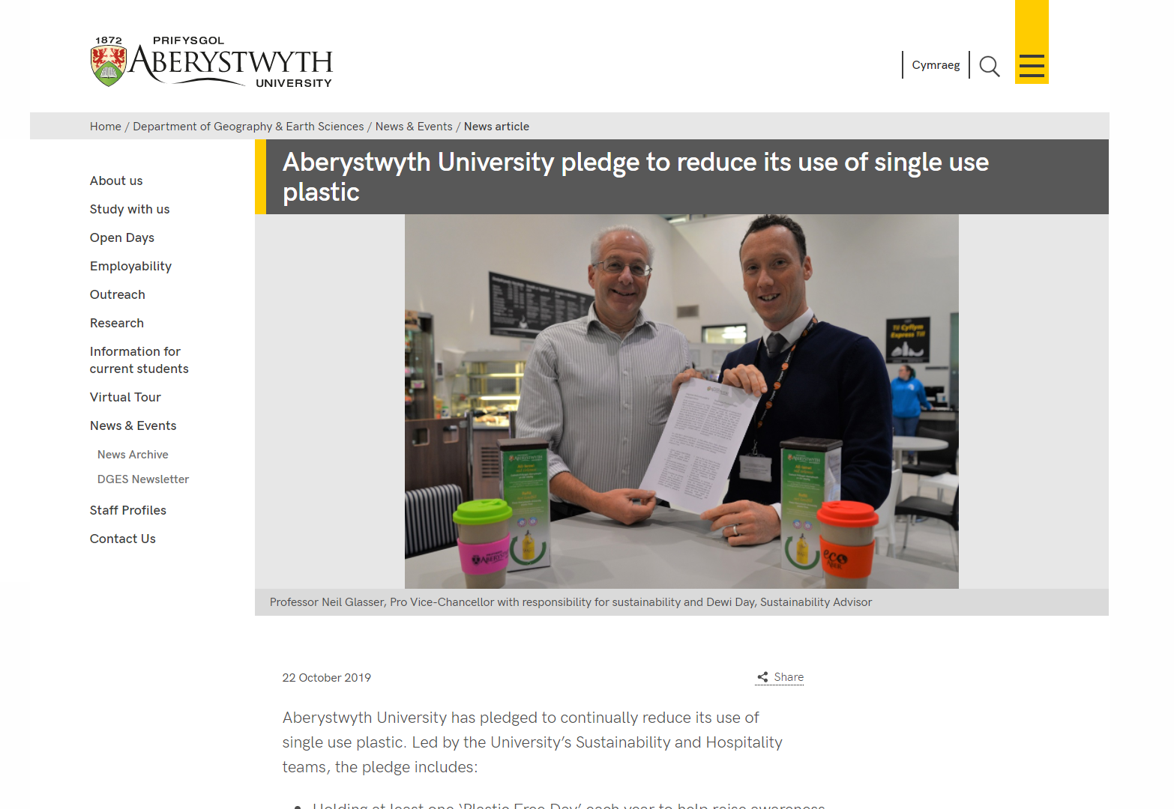
Bottom:

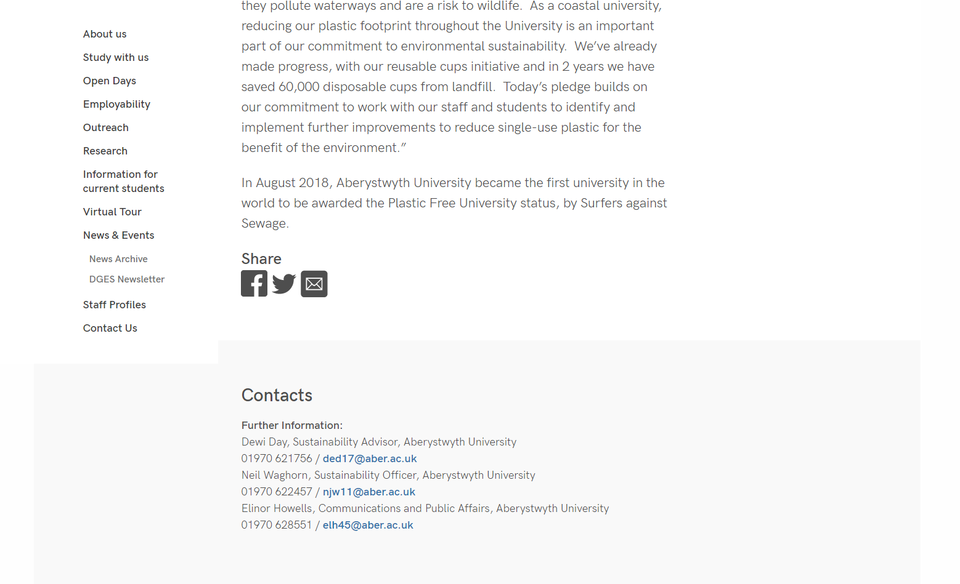
Creating a News Article
News articles are usually stored in a section called 'News article' within a section called 'Latest News', 'News & Events', 'News' or something similar. For most departments this will be one of the top-level sections in your site and appears in the left-hand menu throughout your site.
- To create a new News Article, find your News section in the CMS and expand it to see the sections inside. Open the News article section by clicking on it.
- Click on the Content tab and you will see any existing news items listed
- Click on the Add Content button
- In departments which use the standard news style, you will only be able to choose the 'News' template. In departments which use the more recent news style, you will only be able to choose the 'News version 2' template. Choose the appropriate type of content. These templates are broadly similar with some minor differences which will be noted below.

- The template will appear
  - The standard 'News' template:
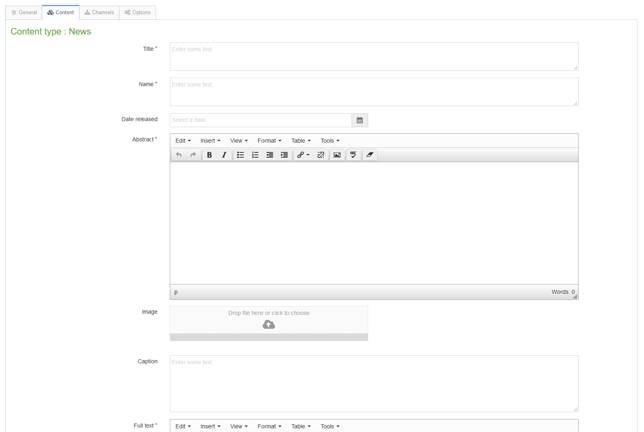

  - The more recent 'News version 2' template:
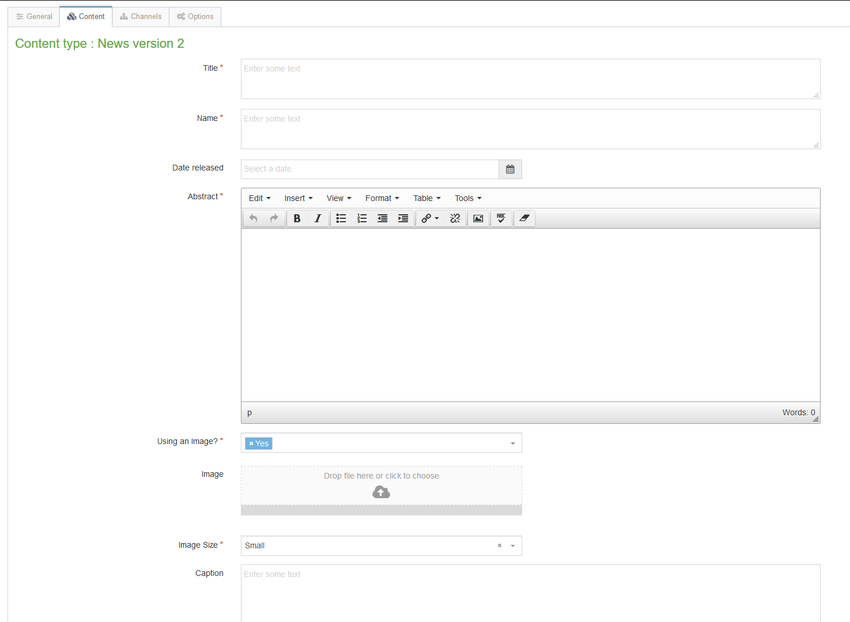

- Fill in as many fields as you have information for – some are essential, and others are optional:
  - Title (essential) – this is the main headline of the news item.
  - Name (essential) – this is the name of the piece of content and doesn’t show up for people viewing the web page – it’s just for you and your colleagues to know what this piece of content is.
  - Date released – this is filled in for you automatically with the current date and time – if the news article is to be released on a future date rather than immediately, change this date. It will appear under the headline when the news article is viewed. Changing this date will not affect when the news article shows up on the web site – this is done by another mechanism – see point 7 for more information.
  - Abstract (essential) – this is a brief summary of what the news article contains – it will appear on the main News section.
  - Use an image? (essential, only on the new style template) - this needs to be set as Yes if you wish to use an image in your news article, otherwise your image will not be displayed. If you are not using an image, set it to No.
  - Image (recommended) – this is where you can upload an image to go with the news article. Click on the box to choose an image from your computer or drag an image onto the box to select it. For the standard news style, the image should be no larger than 200px wide. For the more recent news style, you can use an image up to 1140 x 500 px.
  - Image Size (essential, only on the new style template) - this is where you specify what size image you have chosen to use above. 200px = smaller, 400px = small, 800px=big.
  - Caption – this is the caption to go with the image – it will become the alternative text for the image and will also show beneath the image when the full article is viewed.
  - Full text (essential) – this is the main text of the news article.
  - YouTube Video Code – this is where you can embed a YouTube video within the news article if you want to. You will just need to enter the last part of the YouTube video address Just the last part e.g. just "kktMqrMioY0" from https://www.youtube.com/watch?v=kktMqrMioY0
  - Full text part 2 – this is where you can continue the main text of the news article if you would like the YouTube video to be positioned in the middle of the story rather than at the end of the story.
  - Links – this is where you can place any links related to the article – these will be placed in the bottom part of the right-hand column. You should use a bulleted list for the links, and they should be text links – i.e. don’t just type in the URL of web site.
  - Contacts – this is a list of any specific contacts for this news article – you will already have your general contact block appearing on the left under the menu, so you will only need to use the contacts if they are different or more specific. The contacts appear in the right-hand column when the article is viewed.
  - News code – this is used if you have a coding system for your news articles and want to record that.
  - Add to AU Homepage? (only on the new style template) - this is only used on the university's central news pages. It marks the news article to be displayed on the university homepage.
  - Flickr Username (only on the standard template) - this is where you can add a Flickr gallery to the end of the news article, by adding both the Flickr Username in this field and the specific set ID in the next box.
  - Flickr Set ID (only on the standard template) - see above.
- The news item will not yet show up anywhere on your site even on preview in the CMS as the release date needs to be set. As mentioned previously the Date released field in the news template is only used to display a date on the page – to set the date at which the news shows up on the page, we need to use the options tab:
  - Click on the Options tab – you’ll now see the 'Content embargo and expiry information' page.
  - Enter the date and time when the news article should be released in the Publish Date boxes.
  - If required, enter the expiry and review dates and select an archive section – see section 3, part B, for more information.
- Click on the 'Save changes' button to finish. You will be returned to the list of content in the News article section.
- If you now preview the News section of your site, you should see your new News Article appearing at the top of the list (unless you set the publish date in the past, before other article’s publish dates)

Reorganising Your News
When adding new items, you will find that older items will get dropped off the list shown on the News page as it only shows 4 items. If you want items to still show up on the news page, you can add them to a different section so they will show up on the right under Other Top Stories.
- Open the News article section for editing and click on the Content tab
- Find the news item which has dropped off the list and choose Move from the Actions menu (accessed from the Actions button to the right of the news item)
- The 'Move content' screen will be displayed – click on the Top Stories section which should be inside the News section (along with the News article section)
- You will be returned to the list of content in the News article section with a success message at the bottom. You will see that the news item you moved is no longer in this list
- If you now preview the News section of your site, you should see the headline of your moved news article appearing in the right-hand side under Other Top Stories.

Archiving News

A. To archive news manually
- Open the News article or Top Stories section where the news item you wish to archive is located
- Choose Move from the Actions menu (accessed from the Actions button to the right of the news item)
- The 'Move content' screen will be displayed – click on the archive section where you wish to place the news item
- You will be returned to the list of content in the News article section with a success message at the bottom. You will see that the news item you moved is no longer in this list

B. To archive news automatically
- When adding news items, you can set an expiry date and a location for them to be archived to. When the expiry date is reached, the CMS will move them to the archive location.
- Reopen the news article for editing & click on the Options tab – you’ll now see the 'Content embargo and expiry information' page.
- Enter the expiry date when you want the news item to be archived. Click on Select in the Archive section row and choose the section where the item is to be archived to. When the date is reached the item will be moved to the new location automatically.

