14. Using Expanding Content
Expanding content can be used to have some content on a page hidden and then revealed when users click on a link. This can be useful for helping users to navigate through information and for pages such as FAQs.
An alternative would be to use the Accordion style for Tabbed content which has a similar appearance and is simpler to set up. See Information Sheet 13 for more information.
Unexpanded content:
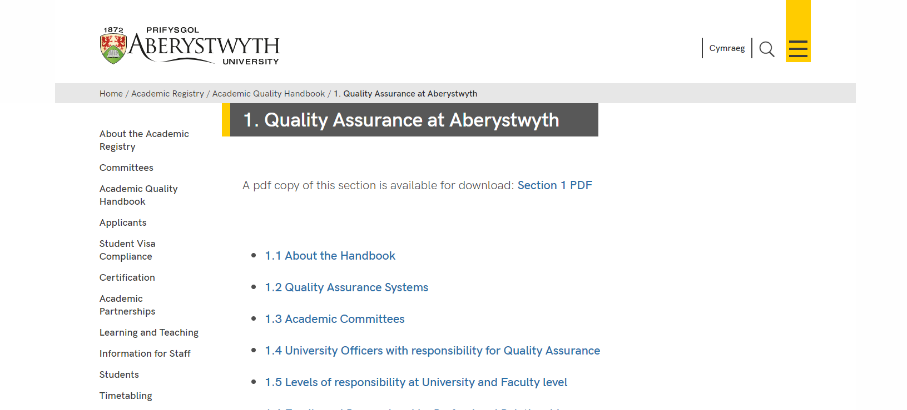
Expanded content (user has clicked on ‘1.1 About the Handbook’):
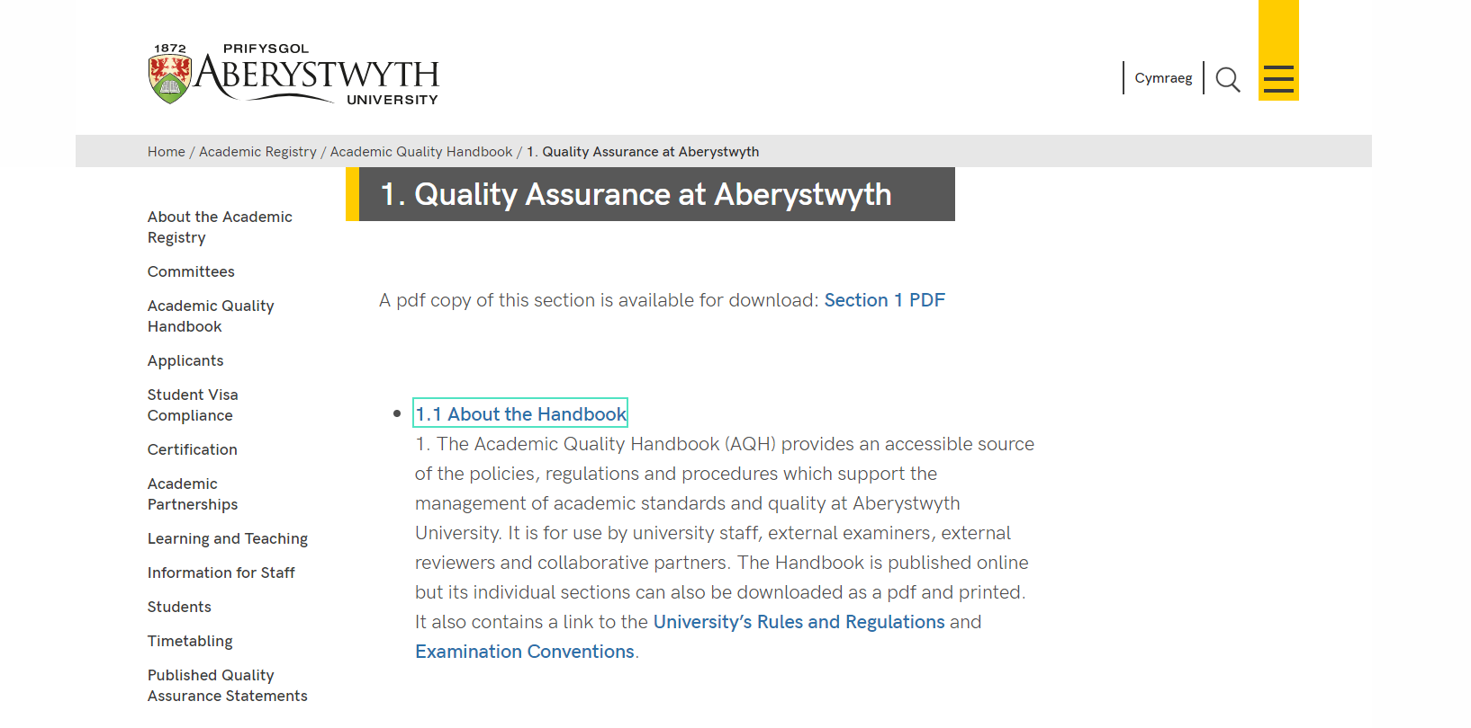
The page is made up of multiple pieces of content within a section.
You will need to make sure everything is using the right content template, and that the right tick boxes are ticked to make it work successfully. Expanding content can be used in bulleted lists of many items, or for a single item.

Creating an Expanding Content Page
- Create a new section to hold your expanding content. Name it and give it an appropriate Output URI as usual.
- Open your newly created main section and click on the Content tab.
- Click the Add content button and choose the content template named “General Content”.
- Create a piece of General Content to include the main heading of your page (in the Title box) and any introductory text you will need at the top of the page before the expanding items.
- When you have finished adding content, click on the Save changes button.
- Now you will need to add the expanding items.
- Click the Create content button and choose the content template named “Expanding Content”.
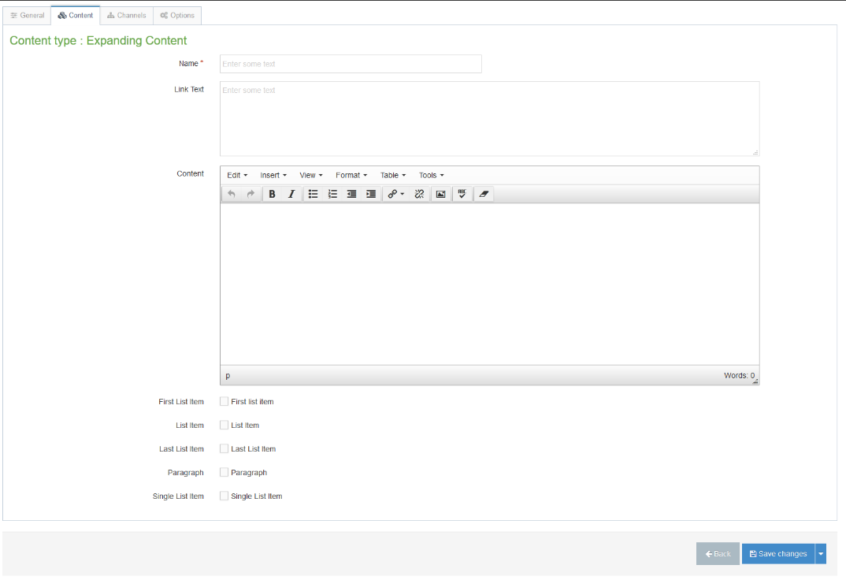
Note: If you don’t see this content template in the list, you’ll need to contact Information Services to ask them to enable the necessary template for Expanding Content.
- Insert a name for your new content in the Name box.
- In the Link Text box, type the text that you want to appear on the page – this will be the text that the user clicks on to reveal the text that is going to be in the Content box
- In the Content box, add the content that you want to be revealed when the user clicks on the Link Text – this may be more bullet points or straight text depending on your needs.
- You will now need to tick the appropriate tick boxes before you add this piece of content:
  - If this is the first item you are adding, and you will be adding more, you should tick the box named “First List Item”.
  - If this is one of many items you are adding, but is not the first or last, you should tick the box named “List Item”.
  - If this is the last item you are adding, you should tick the box named “Last List Item”.
  - If you are only adding one item, you should tick the box named “Single List Item”.
  - If your expanding content is going to be made up of paragraphs rather than bulleted list items, or you want your bullet points to have larger gaps between them, you should tick the box named “Paragraph”.
- Click the Save changes button to save.
- Repeat the process from point 7 to point 12 above until you have finished adding all your items, being careful to tick the appropriate tick box for each item.
- If you later want to change the order that the items appear, you will need to change the order of the pieces of content within the section. Please see Information Sheet 8.0 for more information on reordering content. Remember when you do this that you may need to change the tick boxes if you change which items come first or last in the list.
- When you have finished creating your expanding content page and have checked it on the preview, remember to approve the content so that it will be published.
- Repeat the process for the Welsh version of your page.

