2. Creating a Section (Moderators Only)
- A new section can be added at the top level of your Department (or area of the AU web site) or it can be added as a sub-section of an existing section.
- From the Site Structure view, find the section where you wish to work.
- Click on the Actions button to the right of the section you have chosen, and the Actions menu will appear. Choose 'Create Section'.
- The General Section Details page will appear:
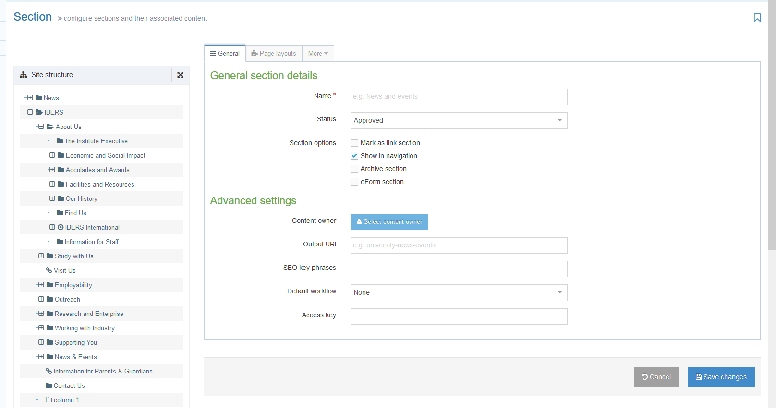
- Insert a name for the section. This name will be used as the page title and will appear in the left menu of your site.
- Insert an Output URI for the section. This will be used in the web address of the section – the CMS will build most of the web address but needs you to specify the last part of the web address for your new section.
Note: How to choose an appropriate URI
The URI should be lowercase, with spaces replaced by hyphens (-). The following symbols are not permitted in a URI: !”£$%^*()_{}[]:;@’~<>.,/\| URIs should be “friendly” – i.e. they should make sense to the user and should be easy to type into a computer/device if the user has the web address on a leaflet. Much of the time, your output URI can use the same wording as the section name – e.g. if your section name is Web Services, then your output URI could be web-services.
- You may choose to add an SEO key phrase. This can be used as part of an SEO report to see if the page is performing well for this key phrase.
- If you wish to work on this section without it becoming visible through the site navigation until you are ready, un-tick the “Show in navigation?” check box.
- Leave ‘Mark as link section’ unticked. See Information Sheet 2.1 for more information about link sections.
- Leave 'Archive section' and ‘eForm section’ unticked.
- When you have finished, select the 'Save Changes' button at the bottom of the page.
- You will now be able to view your new section within the site structure.

Creating the Welsh Version of your section
Note: You should only create the Welsh version of your section when you have the Welsh text ready. If you have sent your English text to Translation, wait for it to return before creating the Welsh section. Do not publish changes/new webpages in English if the Welsh versions are not ready.
- Click on the 'Site language' icon (globe) at the top of the screen and select Cymraeg
- The Welsh version of the Site Structure page appears:
- Find the section you just added. It will be called ‘Not translated’ as the Welsh title has not been set. Click on the words ‘Not translated’ to open the section for editing.
Note: If there are lots of new sections which haven’t had their Welsh title set, it can be hard to find the right one that you need to work on – move or hover your mouse over the words ‘Not translated’ and a small box containing the English title of the page will appear.
- The General section details page will appear:
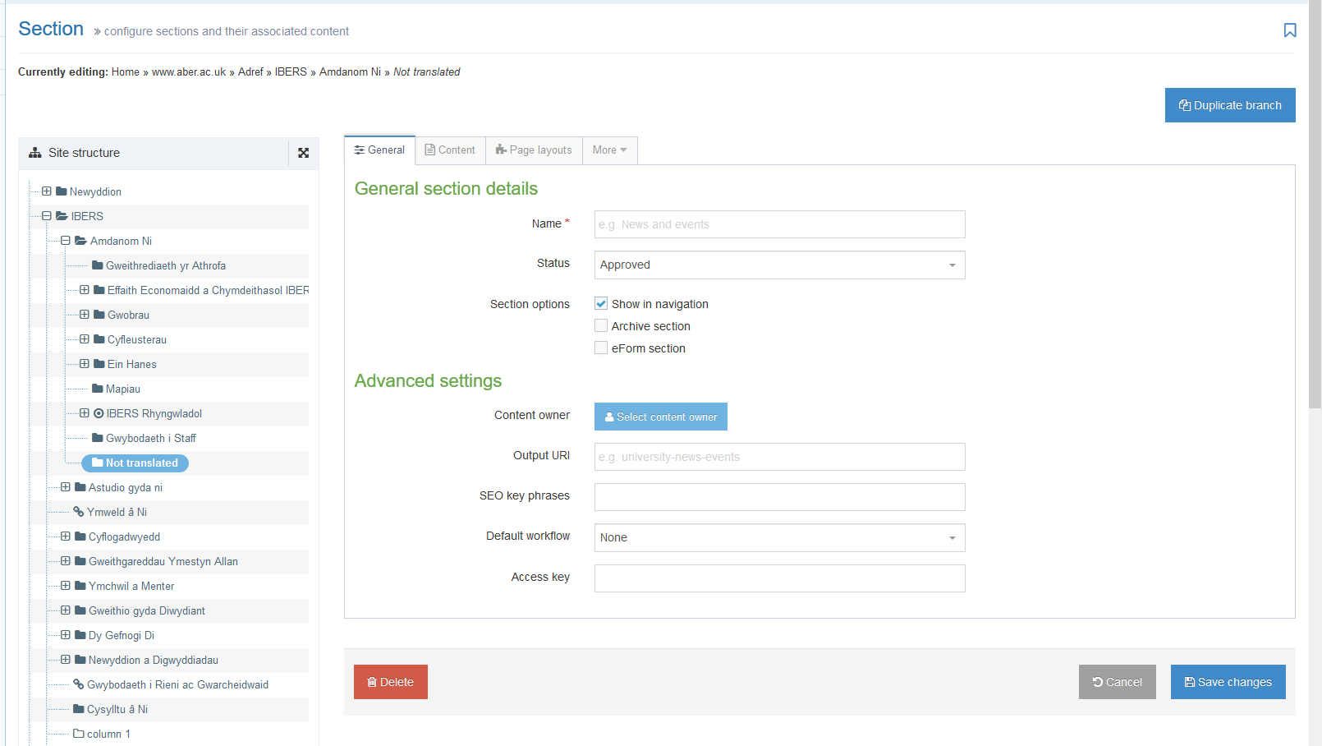
- Add the name of the section – this should be the Welsh equivalent of the English Name.
- Type the same URI as you had in your English version into the Output URI box, e.g. ‘web-services’.
- Click the 'Save changes' button to save this change.
- You will now be able to view your Welsh section within the site structure.
- At this point you can prepare to add content to your section. See Information Sheets 3 to 3.3 for more information on content.
Note: All new sections inherit styles from their parents. Depending on the section settings, if your new section’s parent is the top-level page for your department, it may inherit the special style used on this page. This can only be changed by a CMS Administrator – please contact is@aber.ac.uk.

