22. Communications Quick Updates - News
Note: Please refer to Information Sheet 10.1 to familiarise yourself with the basic principles of adding news articles and organizing the University News page before attempting to use the Communications Quick Update system.
A new system has been set up so that members of the Communications team (and other relevant staff) can quickly get news articles live on the University website.
Steps to getting your news article live:
- Create the News Article in the appropriate area of the News Archive
- Mirror the News Article into the appropriate area of the News homepage
- Reorganise the News homepage to keep the correct arrangement (1 item in main story, and multiple items in top story)
- Publish the News site
- Transfer the News section to the live site
Steps 1-3 are covered in Information Sheet 10.1. Please make sure that you have completed these steps before proceeding to steps 4 & 5.

Step 4 – Publish the appropriate areas of the News site
Now that you have completed steps 1-3, you will have your news article showing up correctly when previewing the News section in the CMS. The next step is to get these changes published onto the “staging server”, before then making them live.
You will first need publish the News section.
- In the CMS Site Structure, click on the Actions button to the right of the main News section and choose 'Publish branch':
- The publish will be added to the publish queue and a message will appear at the bottom of the screen to confirm
- To check on the progress of this publish, click on 'Publish channels' in the 'Sites & Channels' menu on the left:
- The 'Publish channels' screen will be displayed, and you will be able to see your publish listed under 'Upcoming publishes':
- The screen will refresh every few seconds, and when the publish is finished it will disappear. Always make sure that your publish is no longer showing here before proceeding to step 5.

You have now completed Step 4 and should move on to Step 5.

Step 5 – Transfer the News section to the live site
Before proceeding with Step 5 you should check that everything you did in Step 4 was successful. To do this you should visit the News page on the staging server to check that it looks as expected.
Visit this link to check: http://cmspreview.aber.ac.uk/en/news/
If you are happy with how the News home page and News article are looking, you can proceed.
- To transfer the News section to the live site, you should open this web address in your browser: https://cms.aber.ac.uk/jenkins/view/Comms/job/CommsTransfer/
- You will be asked to log in – use your usual University login and password.
- You will now see the Comms transfer screen:
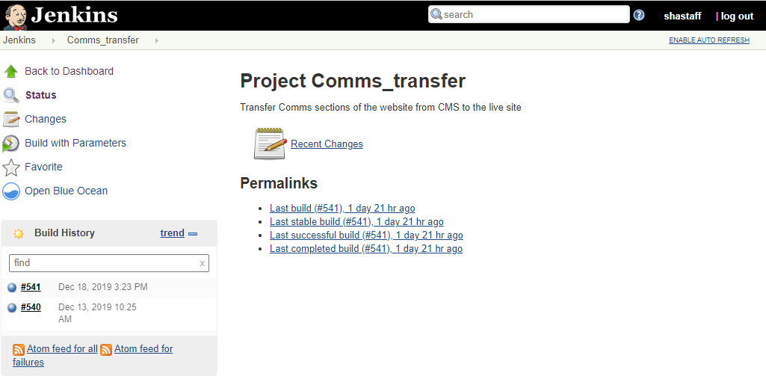
- Click on ‘Build with Parameters’ in the left menu.
- Click on the drop-down menu to choose what you need to transfer:
  - News
  - Notices
  - Graduation News
  - Old College
- To make a news article live, you will need to choose News
- Click the Build button to start the transfer
- You will see the progress of the transfer in the Build History panel on the left
- Once the transfer has finished, your news article should be live – check the News home page to see that it is there. Visit this link to check: http://www.aber.ac.uk/en/news/. If you can’t see any changes, click Ctrl+F5 to refresh the page and check again.

You have now completed Step 5 and the process should be complete.

