32. Creating a Notification of Works

Introduction
The Notifications of Works page automatically displays notifications that are added to a sub-section. The notifications can be set to automatically expire after the end date of the works.
Notifications of Works page (https://www.aber.ac.uk/en/estates/notifications-of-works/):
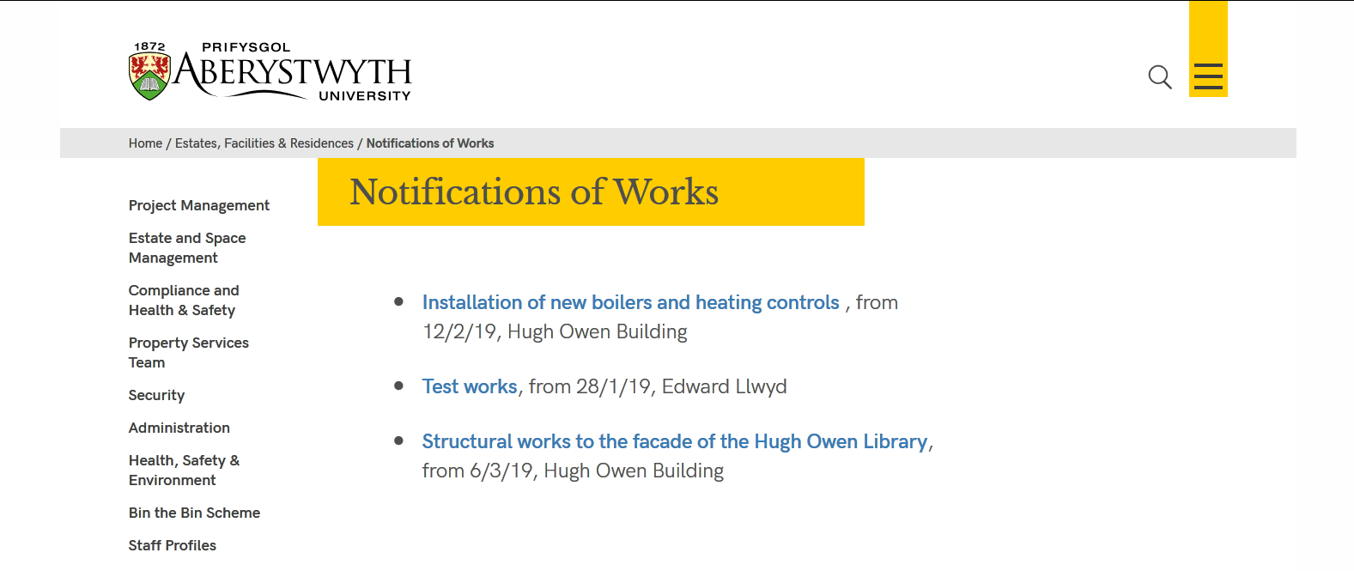
When a user clicks on a particular notification, they will be able to view the details of the works including the contact:
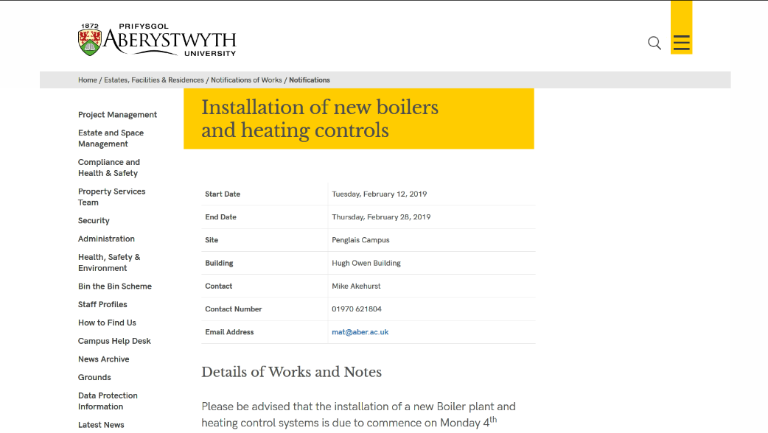

Creating a New Notification of Works
- In the CMS find the 'Notifications of Works' section and expand it to find the 'Notifications' sub-section that is inside it
- Click on 'Notifications' to open the section
- Click on the Content tab to view the content in the section
- Click the green 'Create content' button
- From the list of content types that is displayed, choose 'Notification of Works' by clicking on its name
- The Notification of Works template will be displayed:
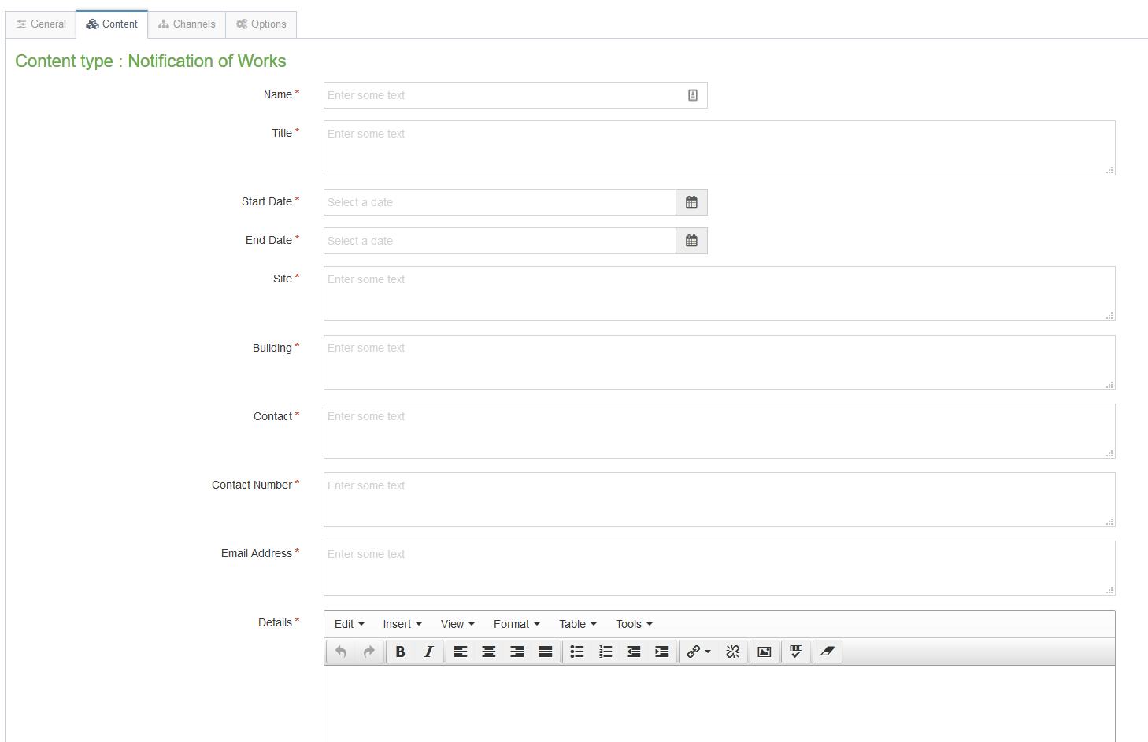
- Fill in the details of the Notification of Works:
  - Name - give the content a name, e.g. new boilers
  - Title - enter the title of the works, e.g. Installation of new boilers and heating controls
  - Start Date - click into the box to make the date picker appear and choose the start date for the works
  - End Date - click into the box to make the date picker appear and choose the end date for the works
  - Site - enter the location of the works, e.g. Penglais Campus
  - Building - enter the name of the building (or buildings) where the work is located
  - Contact - enter the name of the person who should be contacted by anyone with queries about the works
  - Contact Number - enter the phone number of the contact
  - Email Address - enter the email address of the contact
  - Detail - enter the full information about the works that are going to be carried out
- Before saving the notification, you can add an expiry date - this will mean that the notification will stop showing on the website once the expiry date has passed:
  - Click on the Options tab at the top of the template
  - Click into the Expiry date box to make the date picker appear - choose the date when the notification should be removed from the site
- When you have finished, click the blue Save changes button at the bottom of the template
- You will be able to see your new Notification of Works listed on the preview of the main Notifications of Work page
- Remember that you will need to approve your new notification before it will go live

Reordering your Notifications of Works
- Open the Notifications section in the CMS and click on the content tab to view the content
- Click on the move arrows to the left of the item you want to move () and drag it to the correct position in the list
- Let go of the mouse to complete the move
- Click on the Save changes button to save your reordering

