34. Creating a Video Wall

Introduction
Video Walls can be used to display several videos on a page in a neat grid. The videos themselves are not loaded up until a user clicks on one – this avoids the page being slowed down by multiple videos loading. Users can click on the video of their choice and the video will open in a pop-up for them to watch.
The Video Wall rearranges itself for mobile screen resolutions or if a user has their browser in a smaller window.
Video Walls can only be created by Moderators because a new section has to be created, but if you already have one in your site, it can be edited by both Contributors and Moderators.

Example Video Wall
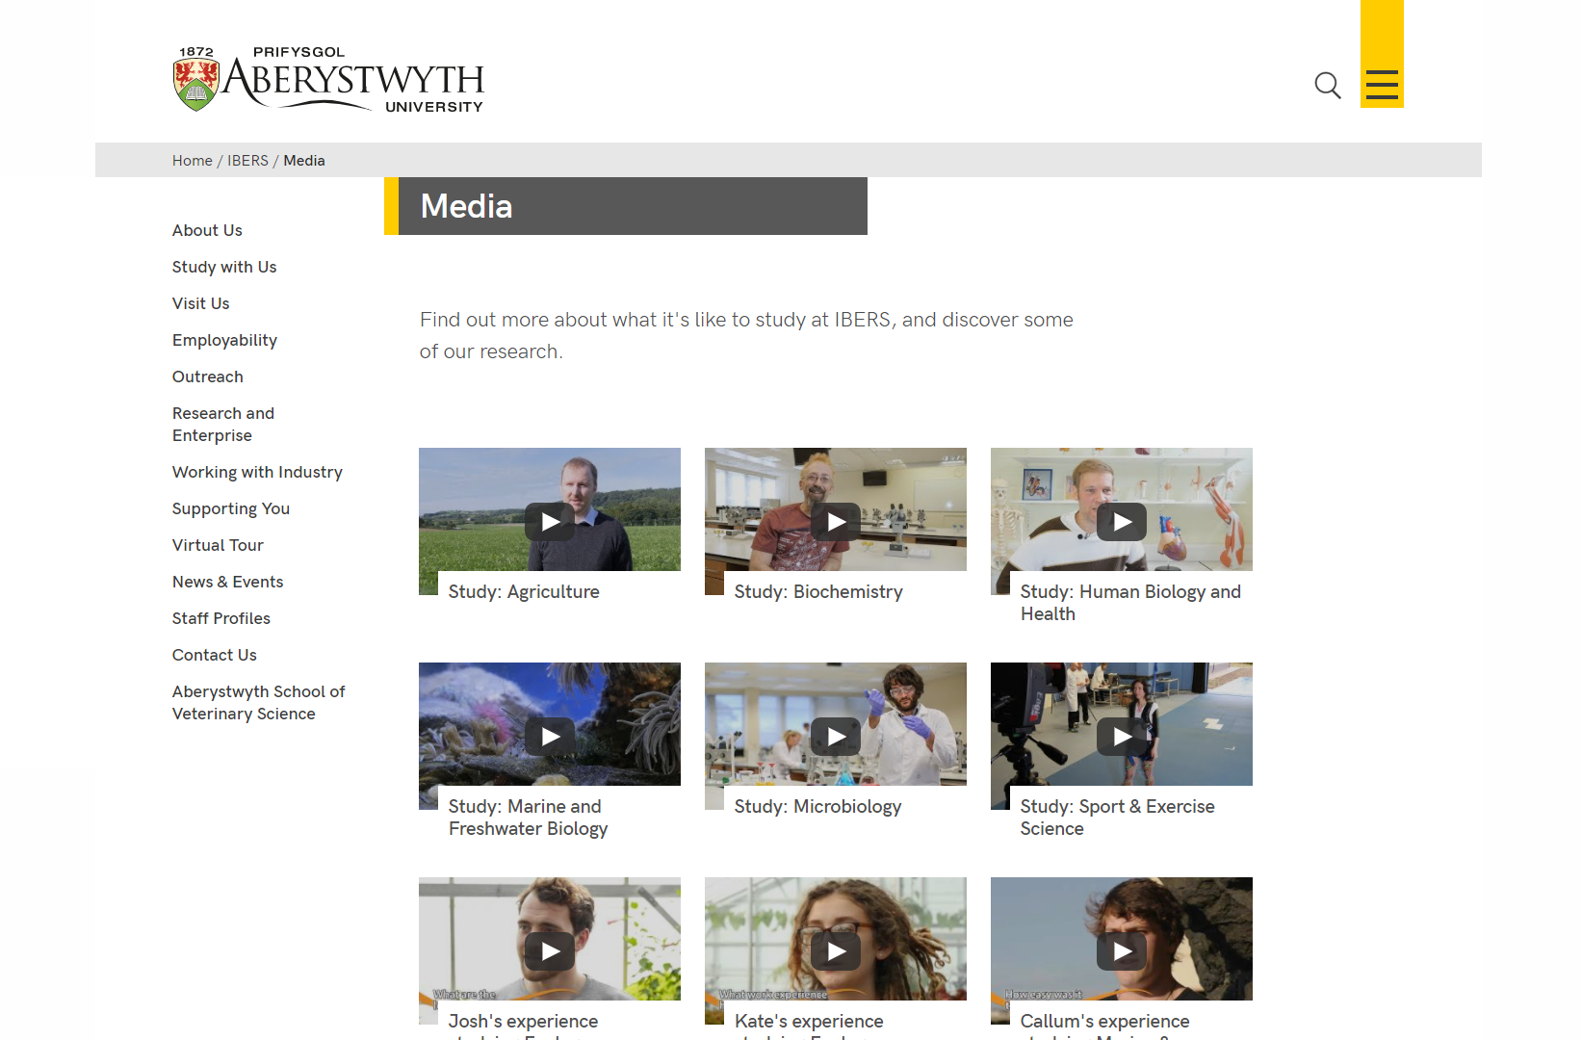

Creating a Video Wall

Add content where you want the video wall to appear
- Open the section in the CMS where you want the video wall to appear.
- Click on the Content tab.
- Click Add content and choose 'Display Video Wall’
Note: If you don’t see this content template in the list, you’ll need to contact the Web Team to ask them to enable the necessary templates for Video Walls.
- The 'Display Video Wall' template is displayed:
- Give the piece of content a name.
- Click Save changes to save the content.
- If required, you may need to order the content in your section so that your video wall appears in the correct point in the page. See Information Sheet 8 for further information on reordering content.

Add the Video Wall items
- Return to the Site Structure and find the section where you want the video wall to appear.
- Click on the Actions button to the right of the section you have chosen, and the Actions menu will appear. Choose 'Create Section'.
- The General Section Details page will appear:
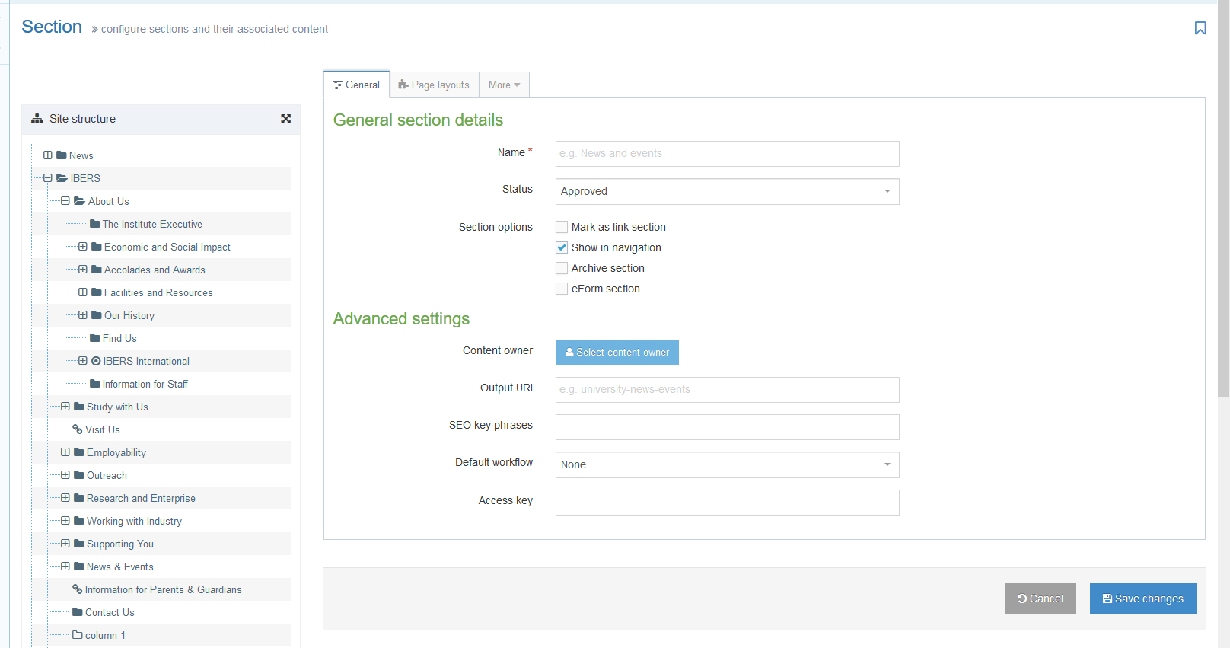
- Type video-wall as the name of the section. It is important to use the correct wording, or the video wall will not work.
- Un-tick the “Show in navigation” tick box so that this section will not show up in the left menu.
- Click Save changes at the bottom of the screen
- You will be returned to the Site Structure
- Click on the plus sign to expand your section so you can see your new video-wall section
- Click on the video-wall section
- Click on the Content tab
- Click Add content and choose ‘Video Wall Item’.
Note: If you don’t see this content template in the list, you’ll need to contact Information Services to ask them to enable the necessary templates for Video Walls.
- The template will be displayed:
- Give the item a name. You may wish to use the same text as will appear to the user, so you can see which item is which in the content list.
- Type or paste the YouTube Code in the ‘YouTube Code’ box. This is just the last part of the YouTube address for the video after the v=. For example for the YouTube address https://www.youtube.com/watch?v=Ff_JHihNbyU, you just need Ff_JHihNbyU.
- Add the text you would like shown with the video in the ‘Title’ box
- Click Save changes to finish.
- Repeat for all the videos you wish to show in the video wall.

Check how the video wall looks
- When you have finished adding your video wall items, return to the Site Structure.
- Click on the Actions button for the section where the video wall will appear. Choose 'Preview section'.
- Check that the video wall appears as you would like it to:
- Remember that you will need to approve the content that you have created so that the new image menu can be displayed on the live webpage.

