4. Editing Content
When editing content, you will use a web form which contains various boxes for different parts of the content. For some types of content e.g. General Content, there is an HTML Editor box used to enter text. Using the HTML Editor, you can format your text and add links, pictures and tables. Other boxes do not allow formatting and you are only able to edit the text or choose an image.

Opening existing content for editing
- Open the Site Structure and browse to the section containing the content you wish to edit. Click on the name of the section to open it for editing.
- The ‘General section details' page appears. Click on the ‘Content’ tab.
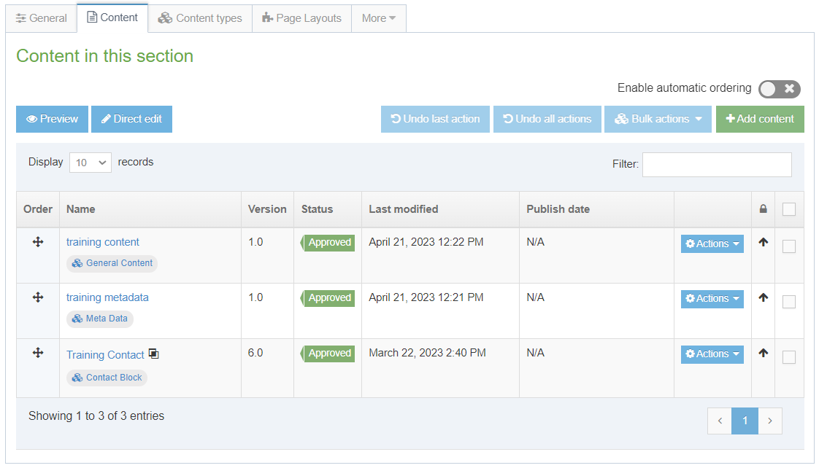
- Find the piece of content that you wish to edit and click on its name to edit it
- The content editing page will appear. This will appear differently depending on the type of content you are editing. For more information about different types of content, see Information Sheet 3.0.
- Make the necessary edits to the content. See Information Sheets 4.1, 4.2, 4.3, 4.4 and 4.5 for more information on editing content using the HTML Editor.
- When you have finished adding content click on the 'Save changes' button or click on small triangle at the end of the button and select 'Save as draft' if you are going to come back to this piece of content later and don't want it to enter the approval process.
- A message will appear at the bottom of the page to tell you that the content has been successfully updated:

Notes

Timeout
When editing content, you should be aware of the system timeout. If you leave your edit window unused for a certain amount of time, a timeout will occur, and your work could be lost. If you need to leave your work when you haven’t finished with it, remember to click on 'Save changes' or 'Save as draft' to save what you have done so far.

Lines and Paragraphs
To create a new line within the current paragraph, use Shift + Return. To create a new paragraph, just press Return.

Information Sheets
4.1 Formatting Text
Basic text formatting can be achieved using the HTML Editor. This Information Sheet introduces the formatting options available.
4.2 Inserting Links
Links can be created between sections within the CMS or to external web pages. This Information Sheet describes how to add these links.
4.3 Inserting Images
Images from the Media Library can be inserted into content. This Information Sheet describes how to insert an image. Please see Information Sheet 7 for information on adding images to the Media Library.
4.4 Inserting Tables
Tables can be used to display data (not for page layout). This Information Sheet describes how to insert and format a table.
4.5 Inserting Links to Documents
Links to documents stored in the Media Library can be inserted into content. This information sheet describes how to insert a link to a document. Please see Information Sheet 7 for information on adding documents to the Media Library.

