4.2. Editing Content – Inserting Links
There are 6 different types of links which are inserted in different ways.
- Link to a section (page) within the CMS
- Link to a specific piece of content within the CMS – this allows you to link to a specific piece of content within a page. For example, it could be used to link to a question half way down a page containing a long list of frequently asked questions (assuming each question was in a separate piece of content). This also allows you to link to a specific news article in the news system.
- Link to an external page – this means a link to a web page which is not in the CMS – this could be an Aberystwyth University page or an external website.
- Link to an email address
- Link to an anchor within the current page – this involves marking a point in the page with an anchor, then creating a link to this anchor allowing the user to jump to that point in the page – this is particularly useful in long pages.
- Link to a document in the Media Library – see Information Sheet 4.5

Link Text
For all links it is important to make sure that your link text is ‘friendly’. This means that if the user could only read the link text, they would still understand where the link was taking them.
For example, this is a friendly link:
If you would like to know more about using the CMS, please view the CMS Information Sheets page.
This is not a friendly link:
If you would like to know more about using the CMS, please click here.

Link to a page within the CMS
- Select the text that you want to become the link and click on the Insert Link button
- Select 'Insert section link'
- The “Select section” window pops up:
- Browse through the site structure to find the page you want to link to – start by clicking on the + to expand www.aber.ac.uk, then expand Home. Note: the search function does not currently work.
- Use the + and – buttons to expand and close sections – only clicking on the name of a section to select it. You will be able to choose any section from the entire site, not just your department/area. When you find the section you wish to link to, click on it.
Note: Sections with folder icons with white backgrounds have been set to not show in navigation (left hand menus). Avoid linking to one of these sections unless you are confident that they are ok to be seen by users and aren't unfinished or out of date.

Note: If you need to link to a section in a different language, you can switch language using the “Change language” button. This is useful if you are trying to direct a user to information that is available in only one language.
- After clicking on your chosen section, the Select section window closes, returning you to the content editor where you will see your link in place.

Link to a specific piece of content within the CMS
- Select the text that you want to become the link and click on the Insert Link button
- Select 'Insert content link'
- The “Select content” window pops up:
- Browse through the site structure to find the page you want to link to – start by clicking on the + to expand www.aber.ac.uk, then expand Home. Note: the search function does not currently work.
- Use the + and – buttons to expand and close sections – only clicking on the name of a section to select it. You will be able to choose any section from the entire site, not just your department/area. When you find the section containing the content you wish to link to, click on it.
- The window will now show the content contained in the section. For example:
- Click on the piece of content you wish to link to.
- The window closes, returning you to the content editor where you will see your link.

Link to an external page
- Select the text that you want to become the link and click on the Insert Link button
- Select ‘Link to external site’.
- The Insert/Edit link window pops up:
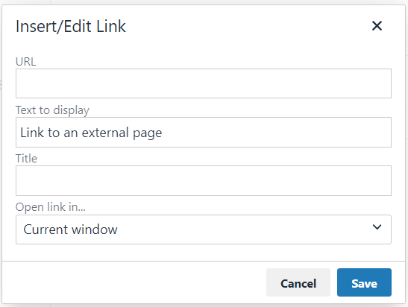
- Type (or paste in) the web address in the Link URL box.
- Don’t make any changes to the Title.
- Click Save to finish.
- The window closes, returning you to the content editor where you will see your link.

Note: If you forgot to put the http:// or https:// at the beginning of your web address a pop up window will appear asking you if you want to add it “The URL you entered seems to be an external link, do you want to add the required http:// prefix?”.
However, this only works for web addresses beginning with www.
It's better to make sure you include http:// or https:// at the beginning of the address as you can't rely on the CMS to fix your link. You may wish to visit the page you want to link to in your web browser and copy the full web address from the address bar.

Link to an email address
- Select the text that you want to become the link and click on the Insert Link button
- Select ‘Link to external site’.
- The Insert/Edit link window pops up:
- In the Url box, Type mailto: followed by the email address, e.g. mailto:sfs@aber.ac.uk
- Don’t make any changes to the Title.
- Click Save to finish.
- The window closes, returning you to the content editor where you will see your link.

Link to an anchor within the current page
- Create the anchor:
  - Place your mouse at the point in the page where you want the anchor to be.
  - Click on the Insert Link button
  - Select 'Insert anchor'
  - The Anchor window appears:
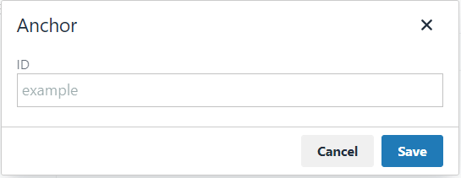
  - Type the name of your new anchor in the Anchor ID box and click Save to add it.
  - You will see a small anchor symbol has appeared in the content editor to mark this anchor.
- Select the text that you want to become the link and click on the Insert Link button
- Select ‘Link to external site’.

- The Insert link window pops up:
- Leave the Url box blank.
- Click on the Anchors drop down menu and choose the anchor you created. The name of your anchor with a # will appear in the Link URL box
- Don’t make any changes to the Target, Title or Class.
- Click Ok to finish.

