4.3. Editing Content – Inserting Images
Note: Before inserting an image, it must be in the Media Library. If you want to use a new image that is not already in there, see Information Sheet 7 for details of how to upload an image to the Media Library. There are some exceptions to this, where images are uploaded within the content template.
- Place your mouse in the position on the page where you want the image to be.
- Click on the Add an image or link to a file from the Media Library button:
- The Select media window pops up: 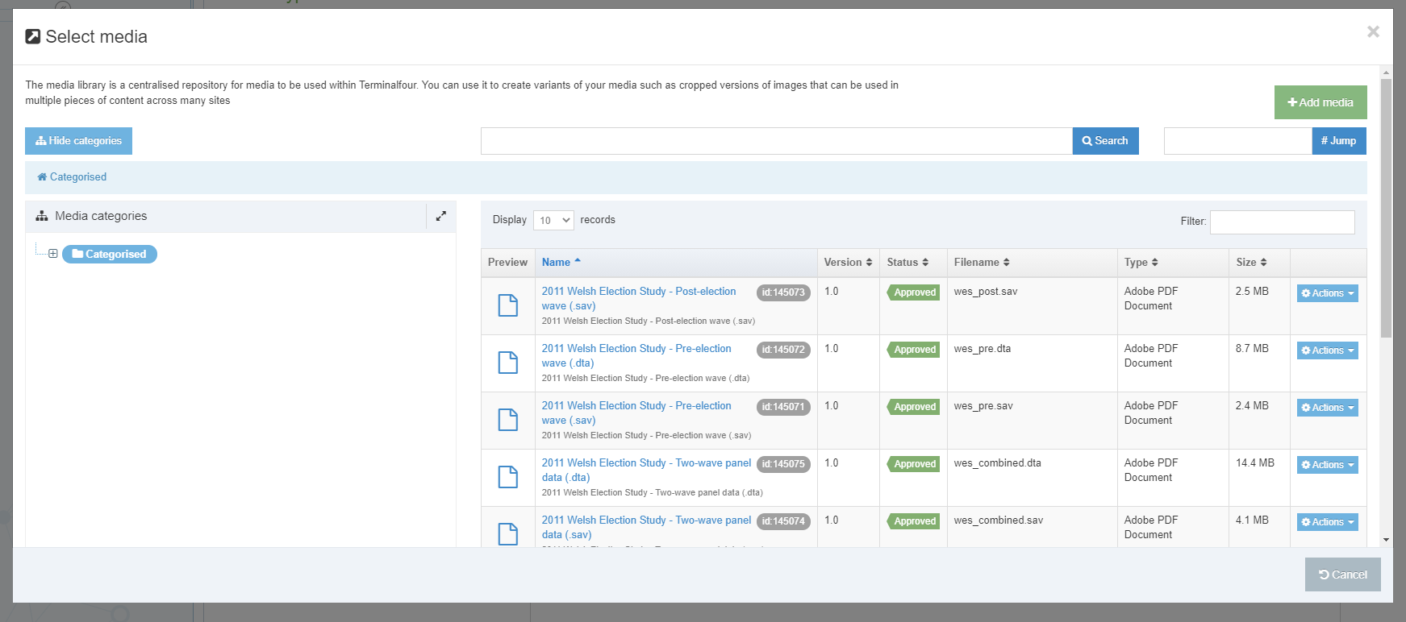
- Browse through the categories on the left to find the appropriate area of the Media Library. Most departmental images are stored within the appropriate section under the 'Departmental' category.
- When you find the image you want to use, click on its name to select it.
- If there are any variants of the image, they will be displayed, so that you can pick the correct variant (otherwise the image will immediately be inserted into the page).
- Click on the name of your chosen variant to select it.
- The image will now be displayed in the Content Editor page.
- Double click on the image - the Set Media Attributes window pops up.
- Enter a brief description of the image as the alt text in the box.

- The default position of the image will be on the right of the page, with the text flowing round it on the left. If you would prefer the image to be in a different position, you can put different classes in the class box to control this:
- If you want the image to be displayed on the left of the page with the text wrapping round it, type “float-left” in the class box.
- If you want your image to be on the left on a new line, with the text continuing beneath it, type “float-none” in the class box.
- If you want your image to be centred, type “centre” in the class box.
Note: any changes to the class of the image will not appear to have any effect in the Editor window (apart from centre), but you will be able to see the results of the changes when you preview the page.

