7. The Media Library
The Media Library is where all documents and most images are stored in the CMS. Files must be uploaded into the Media Library before they can be used in the pages. There are some exceptions to this, where images are uploaded within the content template.
Contents
7. The Media Library 1
Find and Navigate through the Media Library 2
Searching and Filtering 4
Creating Sub-Categories (Moderators Only) 6
Uploading Files to the Media Library 8
Modifying Media Library Files 10
Creating an Image Variant 11

Find and Navigate through the Media Library
- From the Content menu on the top left of the page, select ‘Media library'
- The Media Library page appears:
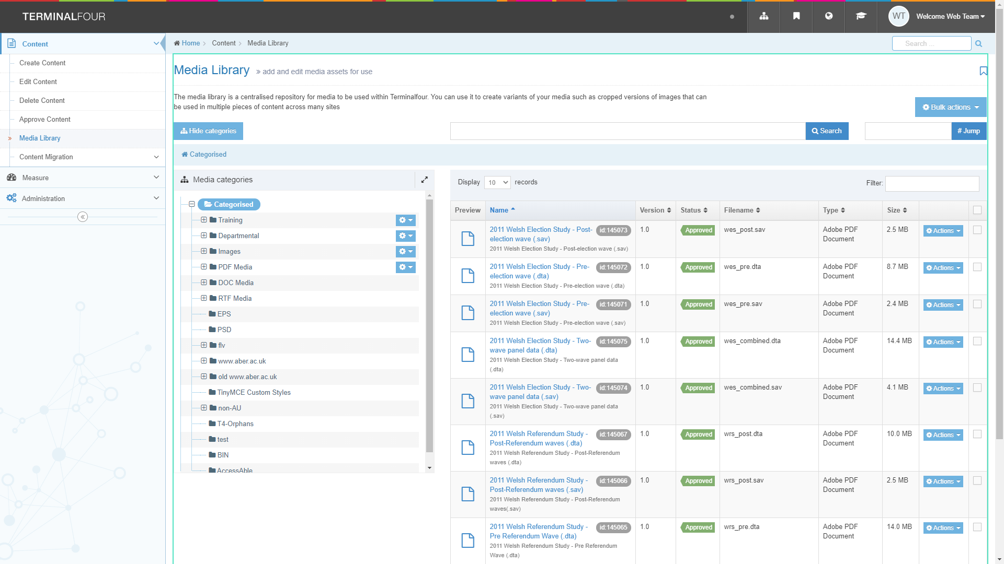
- Browse through the categories on the left to find the appropriate area of the Media Library. Most departmental files are stored within the appropriate section under the 'Departmental' category.
- Some categories within your department will be for documents, some for images – select the right category for what you are uploading. Click on the category name to open it.
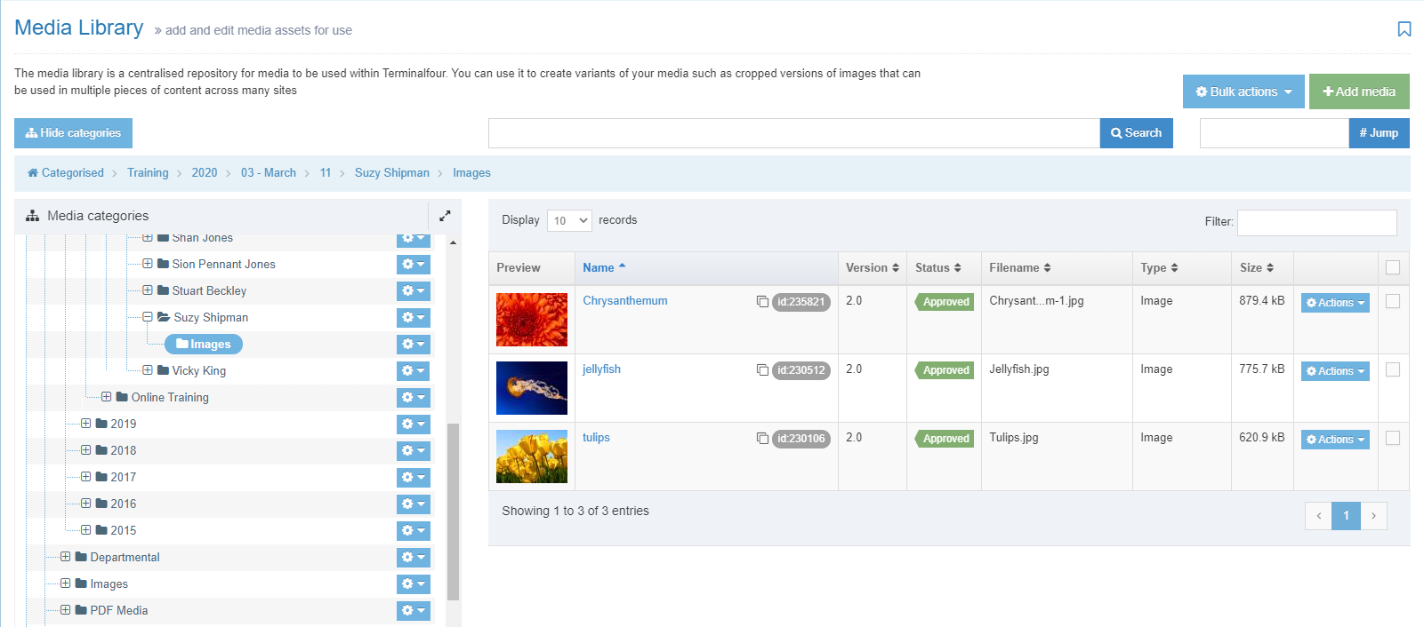

Searching and Filtering
If you don't know where a file is located, you can search for it.
Type your search term in the search box and click the ‘Search’ button
Search results will be displayed:
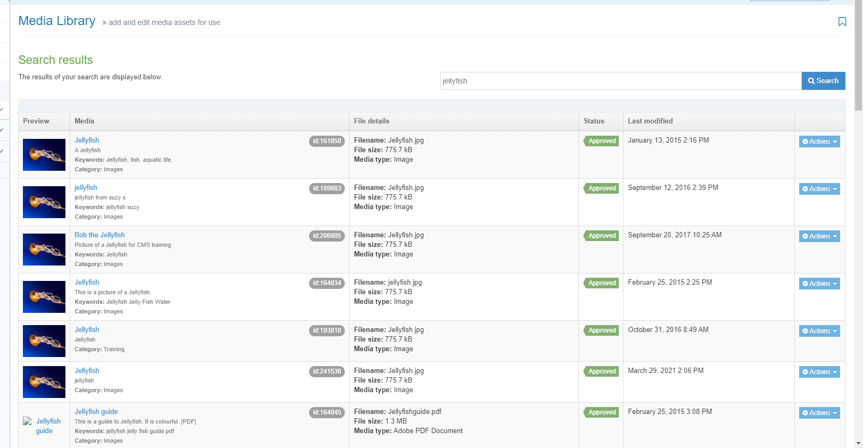

You can also use the Filter box to find a file within the current category. For example:
All files within the Training > PDF category:
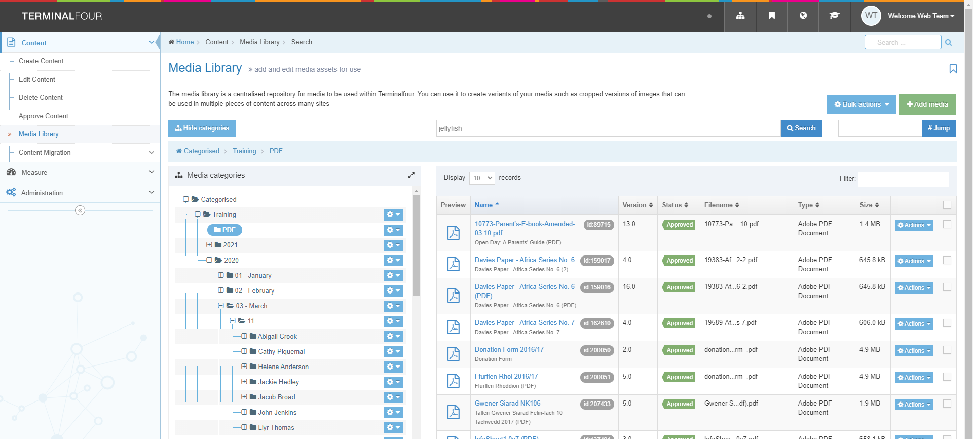
Using the word ‘africa’ in the filter box allows us to see the files that include this word in their name or filename:
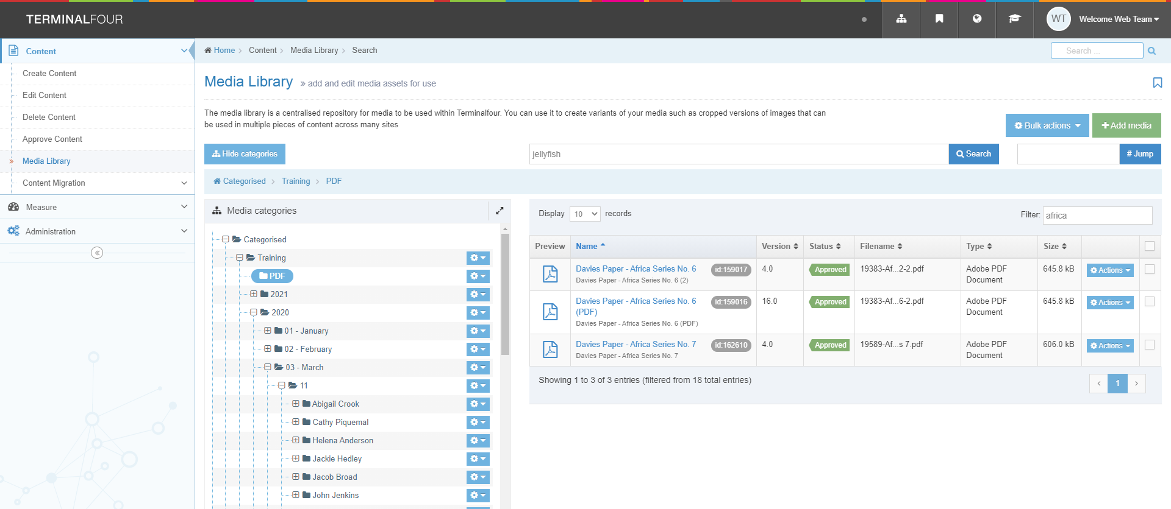

Creating Sub-Categories (Moderators Only)
- It is possible to create sub-categories in your departmental/area category to organise your files. We recommend that you do this to keep your section of the media library tidy and easy to use.
- For Media Library categories that you have permission to work in, you will see a small Actions button (cog symbol) displayed to the right of the category name.
- Click on the Actions button and choose 'Create child category'
- The Media Library General information screen will be displayed:
- Type your chosen name for the new category in the Name box
- Click the Save changes button to finish.

- You will be returned to the Media Library where you will be able to see your new sub-category showing.

Uploading Files to the Media Library
- To upload files to the Media Library, choose the category you wish to place the files in. Click on its name to open it.
- Click on the Add media button at the top right of the screen
- The Media Library upload page appears:
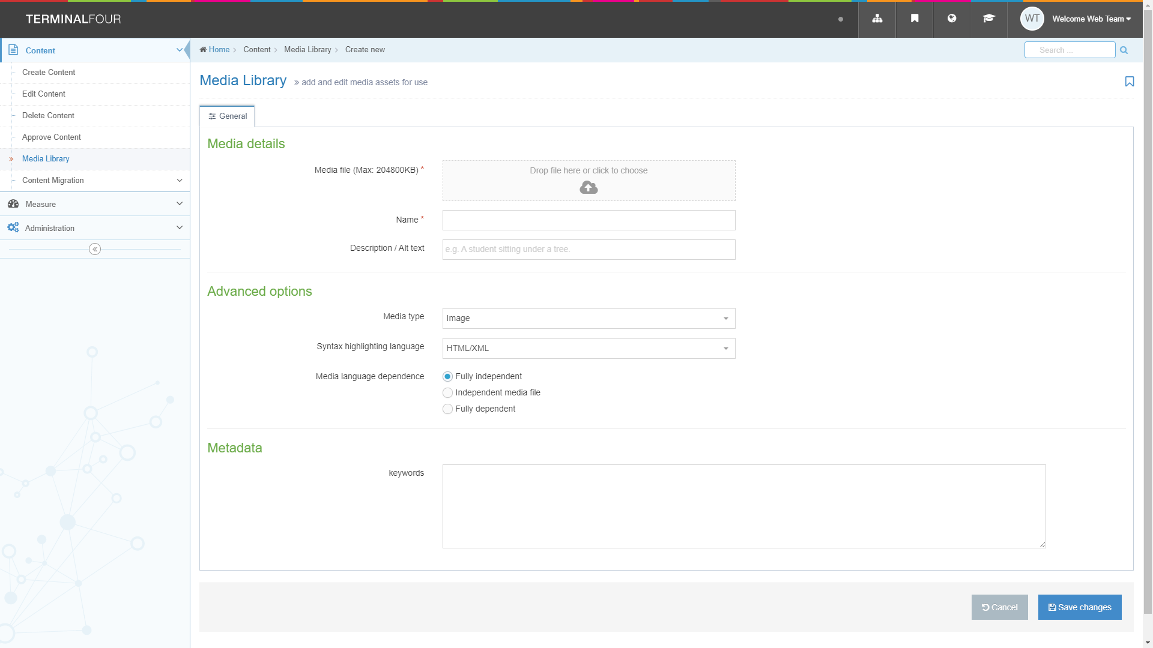
- Choose your file by clicking in the box next to 'Media file' (or drag your file onto the box)
- If you choose an image you will see a thumbnail of the image appear along with its filename. If you chose a PDF or other type of document, you will only see the filename.
- If you chose the wrong file, click on the Remove button to choose your file again.
- Give your file a name in the Name box.
- If you are uploading a PDF or another type of document, you must type the text you would like to be used as the link text in the Description box. If you are uploading an image, you may type a Description if you wish, but it is optional.
- Don’t make any changes to options within the Advanced options area.
- Click on the Save changes button to continue.
- The file will be uploaded, and you will be returned to the Media Library view, where you will see your newly added file.

Modifying Media Library Files
- Click on the name of the media item to get to the editing screen.
- From here you can modify the file: You can edit the name, add or edit the description, or re-upload the file if you have made changes to it on your machine. Click the Save changes button to finish.
- You can also use the modification screen to re-categorise your files if necessary. Click on the ‘Categorisation' tab:
- The full list of all categories in the Media Library is displayed with your file’s category ticked. You can untick this category if necessary and tick another category instead, or your file can be in multiple categories. If tick boxes are not visible to the right of a category, this means that you don't have permission to put items into it.
- Click the Save changes button to finish.
Note: You can also access the categorisation tab by clicking on ‘Move’ in the Actions menu for the media item when viewing the list of items.

Creating an Image Variant
- You can create a new variant of an image that is a different size, or is cropped. You can have multiple versions of an image to be used in different situations.
- Click on the name of the image to get to the editing screen.
- Click on the Variants tab to open the Media variants screen:
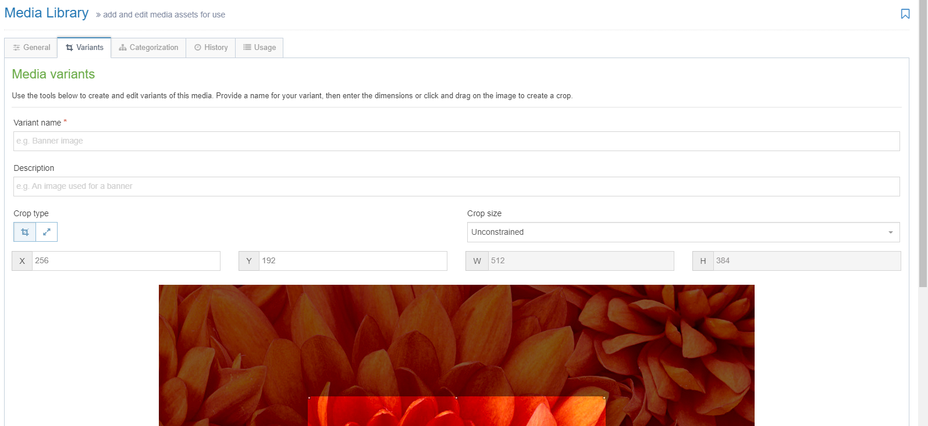
- The original image is shown with the editing options above it.
- You can either crop or resize your image. It is not possible to do both together. The Media variants tab opens in crop mode by default.

- Crop:
  - If you want to create a new variant made of just part of the original image, you can use the Crop tool.
  - If you are not already in the crop tool, click on the crop symbol at the top left of the screen (the symbol on the left):
  - Click and drag on the image to select the part that you wish to crop. You can adjust the shape you have made by dragging the squares at the corners or sides.
  - You can see the size of your crop shown in the width and height boxes.
  - When you are happy with your crop, give the variant a name in the Name box at the top left above the image. Scroll down and click the Save variant button in the centre underneath the image.
  - A success message will appear at the bottom of the screen:
  - You should now see your new variant listed at the bottom of the screen.
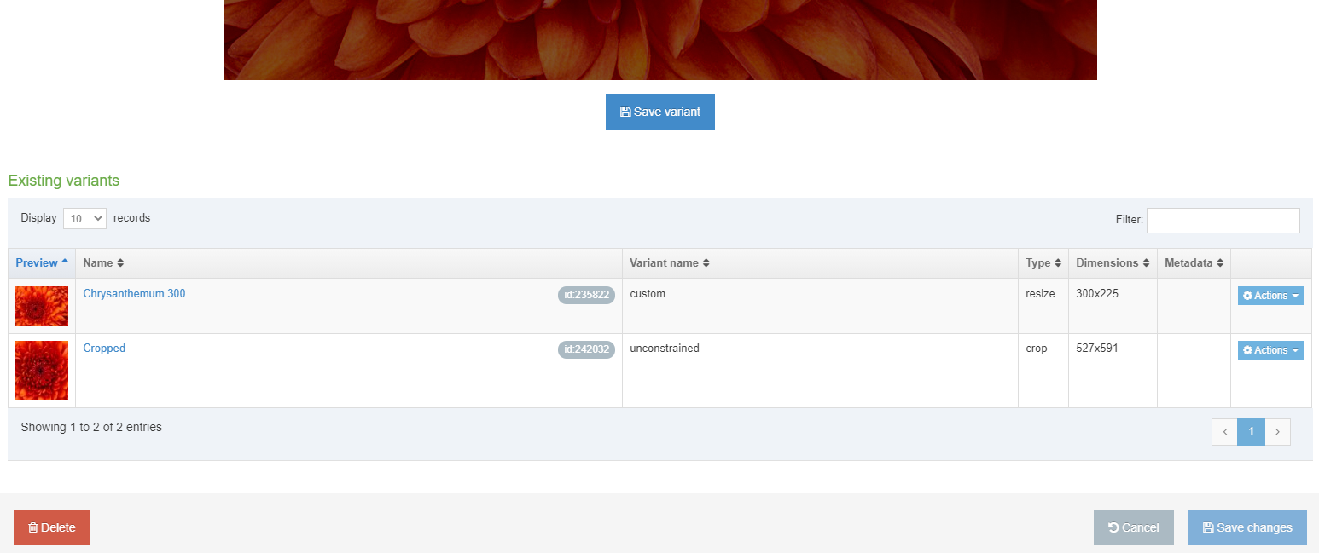
- Resize:
  - If you want to create a new variant of your image which is smaller than the original, you can use the Resize tool.
  - If you are not already in the resize tool, click on the resize symbol at the top left of the screen (the symbol on the right):
  - Making sure that the 'Maintain aspect ratio' tick box is ticked, type the width that you want the new variant to be in the box marked W.
  - The height (H) box will automatically filled to keep the image in the correct proportions.
  - Give the variant a name in the Name box at the top left above the image. Scroll down and click the Save variant button in the centre underneath the image.
  - A success message will appear at the bottom of the screen:
  - You should now see your new variant listed at the bottom of the screen.
- When you have finished creating variants for your image, return to the Media Library by clicking on it in the left menu.
- You will be returned to the Media library screen when you will see your image listed. You should see the variants symbol next to the image id:
- When you insert this image into content, you will now be able to choose from either the original image or one of the variants that you have created.

