8. Reordering a section
It is possible to reorder pieces of content or sub-sections within a section.
Reordering content doesn’t affect the position of the Contact Block or Related Links within the resulting page, but if you have more than one piece of content displaying as the main text of the page, reordering them can affect their positioning.
Reordering sub-sections affects their position in the site navigation (left hand menu).
Note: Contributors can only reorder pieces of content within a section.

Reordering Content
- To reorder content, click on the section you want to reorder the content in then click on the Content tab.
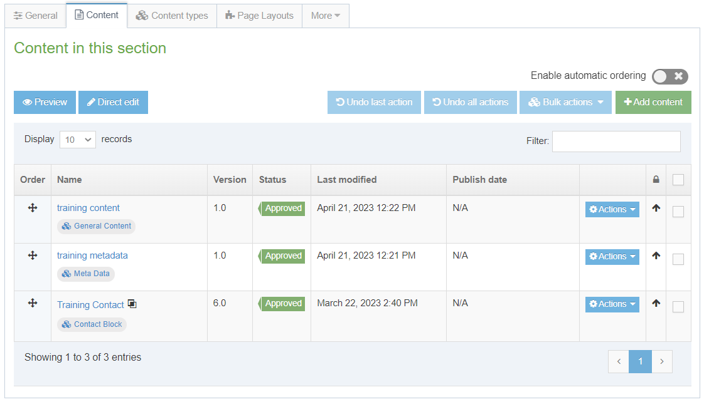
- To reorder the pieces of content, click in the Order column for the appropriate piece of content and drag it to the new position you want it to be in.
- Moving some content such as Contact Blocks or Related Links up or down will have no effect on how they appear on the page as they have set positions. Other types of content such as General Content or Student Profiles can have their positions changed on the resulting page by reordering them.

- It is also possible to have the pieces of content ordered automatically. To enable this, switch the 'Enable automatic ordering' switch to on:
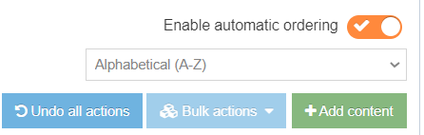
- Choose the ordering method from the drop-down menu that appears.
- After selecting the method, tick the boxes to the right of the items that you want to automatically order. If you want to automatically order all of the items, tick the box at the top which will tick all of the boxes for you.
- Click the 'Bulk actions' button and choose 'Bulk unlock'.
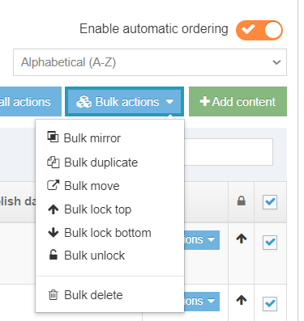
- All the items you selected will now be listed in the order specified.
- Click ‘Save changes’ to save your reordering.

Reordering Sub-Sections (Moderators Only)
- This section contains multiple sub-sections, as well as content

- The sub-sections appear in the departmental navigation in the left menu:
- To view the subsections in the CMS, click on the main section, then click on the More tab and select 'Child sections':

- The list of subsections will be displayed:
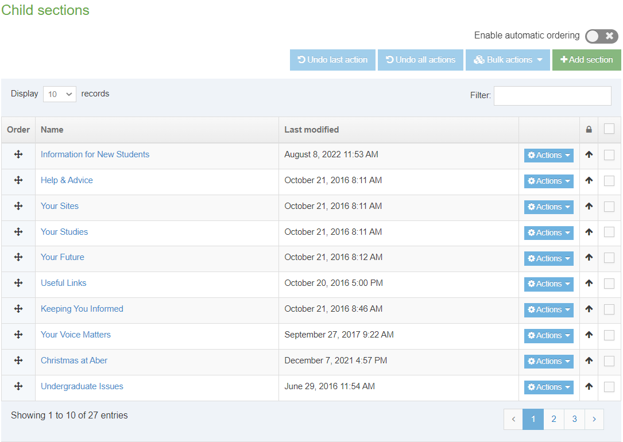
- To reorder the subsections, click in the Order column for the appropriate subsection and drag it to the new position you want it to be in.
- It is also possible to have the sections ordered automatically. To enable this, switch the 'Enable automatic ordering' switch to on:
- Choose the ordering method from the drop-down menu that appears.
- After selecting the method, tick the boxes to the right of the subsections that you want to automatically order. If you want to automatically order all of the subsections, tick the box at the top which will tick all of the boxes for you.
- Click the 'Bulk actions' button and choose 'Bulk unlock'.
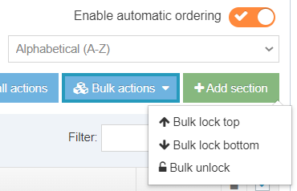
- All the items you selected will now be listed in the order specified.
- When you preview the main section page, you will see that the navigation in the left menu has changed to reflect your reordering.
- Click ‘Save changes’ to save your reordering.

