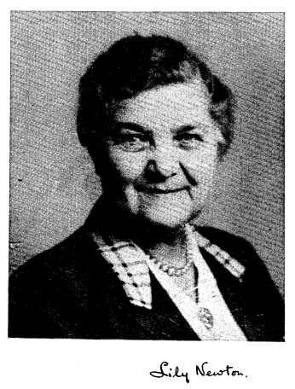
Dr Lily Newton was born on the 26th January 1893, educated in Bristol, and attended the University of Bristol, becoming an assistant lecturer in Botany there in 1919.
In 1920 she took up a lectureship in Botany at Birbeck College, University of London, remaining there for another 3 years, before a period as a research working at the Imperial College of Science and the British Museum. In 1925, Lily married William Charles Frank Newton, but was widowed two years later.

She came to Aberystwyth in 1928 taking up a post as a lecturer in Botany, becoming the university’s first female head of department as professor and chair of Botany in 1930, after the previous holder, Wilfred Robinson died suddenly. Under her leadership the department ‘established a considerable reputation in Wales and beyond’. She is known worldwide for her A Handbook of the British Seaweeds published in 1931, which was still used 50 years later.
Another major contribution of hers was during the Second World War; The Ministry of Health realized the danger of a shortage of agar – a product of seaweed which is used as a growth medium in Petri dishes and invited Newton to coordinate botanical work involving large scale production of agar. The importance of which was recognised by the chairman of the Vegetable and Drugs Committee stating ‘A shortage of agar during the war would have meant the breakdown of our public health services’

Newton wrote and published on plant distribution and seaweeds, and undertook research work on the pollution problems of lead and zinc in the River Rheidol, caused by mining operations in the 19th century. Thanks to her contributions the river, once devoid of most plants and animals recovered to become a major salmon river in the late 1950s.

Dr Newton became the first female Vice-Principal in 1951, and when the Principal Ifor L. Evans died suddenly in 1952, she became the first female Acting Principal, where she was described as being ‘direct in manner, unfailingly courteous, completely devoted to the college’.
In 1958 Lily Newton retired after almost thirty years as a professor of botany, and a year later the University of Wales, Aberystwyth made Newton an Emeritus Professor. She also received an honorary LLD from the University of Wales in 1973.
Outside of her work at the university, Lily Newton held the presidency of multiple societies including Section K of the British Association 1949, the British Phycological Society from 1955-57, and the UK Federation for the Education in Home Economics from 1957-63.
She died in her Swansea home on the 26th March 1981.
She was featured in a 2012 exhibition on Inspiration Female Botanists at the National Botanic Garden of Wales.

Ellis, E. L, The University College of Wales, Aberystwyth 1872-1972 (Cardiff: University of Wales Press, 1972) p233
Gareth Jones (1982) ‘Lily Newton (Née Batten) (1893–1981)’, British Phycological Journal, 17:1, pp3
Ellis, p292

