Section 14 – Project Authorisation

Approving Body: |  | Resources and Performance Committee
Date of Approval: |  | November 2021
Policy Owner: |  | Finance and Compliance
Last Review Date: |  | November 2021
Next Review Date: |  | December 2022

Section 14: Project Authorisations

14. Section 14: Project Authorisations

14.1. Project authorisations

Type of projects |  | Description | Finance Support
 |  |  | provided by
14.1.1. The University may commit to a number of new projects during a year.
Research Grants | Grants to support research activities at the | Research Finance
 | University. Provided by Research Funding
 | Organisations or charities, these do not generally
 | cover the Full Economic Cost of delivery.
Commercial Research | Commercial research contracts that cover at least | Research Finance
Contracts | 100% of the Full Economic Cost of delivery.
Earmarked Revenue | Grants from Government bodies that generally cover | Central Finance
Grants | only the direct costs associated with a particular
 | initiative.
New Collaborative | These may include franchises, joint degree courses, | Central Finance
Arrangements | exchange partnerships, or partnerships designed to
 | increase recruitment.
 | These new projects are proposed through the
 | International and Collaborative Provision Committee.
Other projects | e.g. Major initiatives to develop a new tuition Central Finance
 | product or to enter a new market, or a significant
 | new student marketing or recruitment initiative.
Capital Projects | Major building, renovation or equipment purchase Central Finance
 | projects. These may be funded by grants from
 | Government bodies or Research Funding
 | Organisations that cover only the initial building or
 | acquisition costs of equipment or land and buildings.

14.1.2. Responsibility for obtaining appropriate authorisation lies with the project manager. The project manager is encouraged to engage with the relevant financial support team early in the process in order to ensure that relevant due diligence can be undertaken in a timely manner.

14.2. Research projects, commercial research contracts and research related projects

14.2.1. The process for preparing and submitting research projects is managed by the Research, Business and Innovation department.

14.2.2. The Research Finance team support the financial analysis of research projects and the Principle Investigator or Project Manager should contact Research Finance to provide support for the financial analysis.

14.2.3. The grant application process is summarised within the following flowchart.

Section 14: Project Authorisations

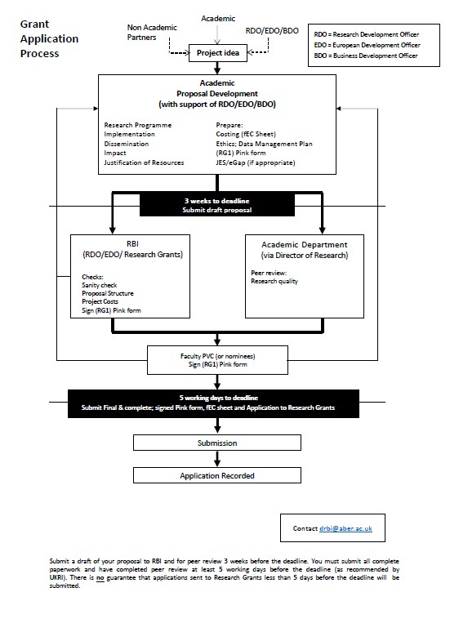

Section 14: Project Authorisations

Authority Matrix for Research Projects

14.2.4. The following table sets out the authorisation levels for each project. The authorisation is based on the loss made on the project compared to the Full Economic Cost (“FEC”) value of the project.

Total project loss Authorised Signatory Supporting Documents compared to FEC

> £2.5m | Chair of Aberystwyth University Council | Project Financial Approval
 | (or VC with minuted Council approval) | Form RG1
 |  | Proposal
 |  | Full Economic Costing Form
£1m - £2.5m | Chair of Aberystwyth University RPC | Project Financial Approval
 | (or VC with minuted RPC approval) | Form RG1
 |  | Proposal
 |  | Full Economic Costing Form
£250k - £1m | Aberystwyth University Pro Vice-Chancellor Research, Knowledge Exchange & Innovation | Form RG1 Proposal Full Economic Costing Form
£50k - £250k | Aberystwyth University Pro Vice-Chancellor of | Form RG1
 | relevant Faculty | Proposal
 |  | Full Economic Costing Form
£10k - £50k | Head of Department | Form RG1
 |  | Proposal
 |  | Full Economic Costing Form

14.2.5. The Project Financial Approval form is available in available below, Appendix 2. Form RG1 and the
Full Economic Costing excel sheet are available on the following link
https://www.aber.ac.uk/en/rbi/staff- students/support/toolkit/

14.3. Earmarked Revenue Grants

14.3.1. Earmarked Revenue Grants generally only cover the direct costs associated with the project and do not cover overhead costs such as building costs, professional service support costs, staff sickness etc.

14.3.2. In certain circumstances the University may choose to undertake Earmarked grants because they assist the University to meet a strategic aim.

Section 14: Project Authorisations

Authority Matrix for Earmarked Grants

14.3.3. The following table sets out the required financial approval levels for Revenue Earmarked Grant projects.

Project income Approval authority Supporting Documents

> £2.5m | Chair of Aberystwyth University Council |  | Project Financial Approval
 | (or VC with minuted Council approval)
£1m - £2.5m | Chair of Aberystwyth University RPC |  | Project Financial Approval
 | (or VC with minuted RPC approval)
£250k - £1m | Aberystwyth University VC |  | Project Financial Approval
£50k - £250k | Accountable Budget Controllers |  | Project Financial Approval
 | Director of Estates
£10k - £50k | Senior Budget Managers |  | -

14.3.4. The Project Financial Approval form is available, see Appendix 2.

14.3.5. RPC and Council approve a number of revenue earmarked grant projects as part of the Annual Budget setting process. Further RPC and Council approval would not be required if RPC and Council have already approved the project as part of the annual budget setting process.

14.4. New Collaborative and Partnership Arrangements

14.4.1. New partnership arrangements are managed by the International and Collaborative Provision Committee (“ICPC”). The full process is shown on the Collaboration site. https://www.aber.ac.uk/en/collaborative-provision/staff-info/the-approval-process/

14.4.2. As part of the approval process, a Financial Analysis must be completed for the following types of collaborative activity:
- Articulation

- Credit bearing CPD

- Collaborative Degrees

- Franchise

- Validation

14.4.3. Financial analyses may also be completed for other types of arrangements (e.g. Services Agreements) at the request of the Committee.

14.4.4. The financial arrangements of all collaborative and partnership arrangements must be fully costed and accounted for accurately and fully, including provision for monitoring and external examining arrangements, if relevant, before the Memorandum of Agreement can be signed and approved by ICPC. An Excel template for the financial analysis is available on the following website (“Business Case Template”). https://www.aber.ac.uk/en/collaborative-provision/staff-info/the-approvalprocess/business-case/

Section 14: Project Authorisations
14.4.5. The financial analysis can happen in parallel with the development of the academic case for collaborative provision. However, the QAA requires that the business and academic case for a proposed collaborative arrangement are considered separately.
14.4.6. The Financial Analysis templates and the Project Financial Approval (see appendices below) should be submitted to Finance after a Memorandum of Understanding has been signed but before any contractual agreement is committed. The decision taken by the Director of Finance & Corporate Services and/or the University’s Executive must be conveyed to the Collaboration Office in AQRO (collaboration@aber.ac.uk) in order for it to be reported to ICPC.

Authorisation Matrix for New Collaborative arrangements

Annual income Approval authority Supporting Documents projection

> £2.5m | Chair of Aberystwyth University Council | Project Financial Approval
 | (or VC with minuted Council approval) | Business Case Template / Other Financial Analyses
£1m - £2.5m | Chair of Aberystwyth University RPC | Project Financial Approval
 | (or VC with minuted RPC approval) | Business Case Template / Other Financial Analyses
£250k - £1m | Aberystwyth University VC | Project Financial Approval  Business Case Template / Other Financial Analyses
£50k - £250k | Accountable Budget Controllers | Project Financial Approval
 | Director of Estates, Facilities and Residences | Business Case Template / Other Financial Analyses
£10k - £50k | Senior Budget Managers | Business Case Template / Other Financial Analyses
The Project Financial Approval form is available, see Appendix 2.

14.5. Other Projects
14.5.1. The University will also undertake a number of significant projects every year. Business cases must be created and reviewed for these projects if the annual cost to the University before any income received exceeds £250k. Projects over £250k must be approved by the VC, or the Chair of Council if project is outside of budget. Business cases are also encouraged for smaller projects.
14.5.2. Template specifying the information required in the business case.

Appendix 2 - Project Financial Approval
Subject: Brief description
Situational Analysis
Summary description of the proposed project and the reason the project is being proposed.
Activities required
Actions that the Executive are now asked to approve
Financial Analysis of project
Key considerations arising from the Due Diligence
Key assumptions / unresolved uncertainties / risks
Key Uncertainty Potential Impact
Due Diligence |  | Approvals
Taxation impact …………………………………… | Date …………………. | Originator ………………………………………………………… | Date ………………….
Procurement ………………………………………. | Date …………………. | Project Accountant……………………………………………. | Date ………………….
Legal ……………………………………………………. | Date …………………. | Departmental Head …………………………………………. | Date ………………….
Market Research…………………………………… Business Case ………………………………………. | Date …………………. | Institute Director /PVC …………………………………… | Date ………………….

Appendix 3 - Business Case Template

Business Case Template
Executive Summary
- Description of initiative
including;
  - Benefits
  - Strategic fit
  - Deliverables
  - Alternatives º Financial summary º Outline timescale
Sign-off page
- Author and Sponsor o Academic provision contributors o Impact analysis contributors
  - Academic
  - Support
  - Other (e.g. Trading)
- Finance
Compliance & Risk
- Quality analysis o Legal analysis o Regulatory analysis o Risk of project (including risk register)
Planning
- Project governance and project team Overall timeline and milestones
Description of venture
- What is it, what will it bring to
the University? o Strategic fit o Research
- Measures of success – including KPI’s
Environment
- Market
- Segmentation & market shares
- Competitor positions o Political and topical factors
Finance
- Income
  - Demand Forecasts (students)
  - Pricing (including competitor analysis) º Costs
  - Impact analysis (what is the effect on each department and the University as a whole?)
  - Cost evaluation
  - Tax (including VAT, Corporation Tax, establishing permanent establishment, Employee tax, foreign tax regimes stamp duty)
- 5 year post launch I&E, Cash flow and payback
- Source of funds for investment o Financial Administration
(including Invoice raising process, debt collection process and timings, risk of bad debt, Payment timing and processing arrangements)
- Cash extraction and Banking
arrangement

