FINANCIAL PROCEDURES

Section 15 – Capital Projects and Fixed Assets

Approving Body: Resources and Performance Committee
Date of Approval: February 2021
Policy Owner: Finance and Compliance
Last Review Date: February 2021
Next Review Date: June 2022

Section 15: Capital Projects and Fixed Assets

Definitions

- Fixed asset - An asset that is not consumed or sold during the normal course of business, such as land, buildings, equipment, machinery, vehicles. Any asset expected to last, or be in use for, more than one year is considered a fixed asset and has a cost over £10,000.
- Tangible fixed asset - A tangible fixed asset has physical substance (with the exception of capitalised software) and:
  - is held by the University for use in the production or supply of goods and services, for rental to others, or for administrative purposes;
  - is controlled by the University through custody or legal rights; has been acquired or constructed with the intention of being used on a continuing basis; and
  - is not intended for sale in the ordinary course of business.
- Investment assets - An asset that has been acquired or is being held by the University so that it generates economic benefits in the form of surpluses or appreciation in the market value.
- Capital expenditure - The cost of acquiring, producing or enhancing fixed assets.
- Capital expenditure budget - Section of the University’s annual budget that relates to expected capital expenditure.

General Rules for Capital Expenditure Projects

15.2.1. Capital expenditure must be budgeted
All items of capital expenditure must be included in the annual budget and five year plan. Only in exceptional circumstances, through approvals defined in the Authority Matrix, will capital expenditure be approved when not previously included in the annual budget.

15.2.2. Capital expenditure must be approved
The policy on capital expenditure approvals includes a sliding scale which details the person/body who should approve individual capital expenditure projects. Even if approved through the capital budget final ratification will be required based on the Authority Matrix before proceeding.

15.2.3. A business case must be completed for all capital expenditure
The type of business case required for each type of capital expenditure e.g. outline proposal, simple business case or full business case varies depending on the value of the spend. A Capital Approval Form should be completed for all capital expenditure along with a full business case for expenditure over £1m.

15.2.4. Supporting Documents
All Capital Approval Forms and / or Business Cases must be reviewed by the relevant Management or Project Accountant before being sent for approval.

15.2.5. The University Estates Department must be involved in all Faculty building projects
The University Estates Department must be involved from the planning stage of all building projects (including additions, enhancements and alterations). They will provide input with regards cost, timings, etc.

15.2.6. The Health and Safety Department
The University Estates Department must be involved from the planning stage of all building projects (including additions, enhancements and alterations). They will provide input with regards cost, timings, etc.

Capital Spend Authority Matrix

The following table sets out the stages of expenditure approval.
 | Approves
1) Approving the capital budget. | AU Council
2) Pre-procurement approvals | Authority Matrix below
3) Approving contract / purchase orders and contract signing | Authority Matrix below
4) Authorising invoices for payment | Senior Budget Manager

Contract Value | Authorised Signatory  (Within Budget) | Authorised Signatory  (Outside Budget) | Supporting Documents
> £2.5m | Chair of Aberystwyth University Council  (or VC with minuted Council approval) | Chair of Aberystwyth University Council | Capital Approval Form  Business Case
£1m - £2.5m | Chair of Aberystwyth University FSC  (or VC with minuted FSC approval) | Chair of Aberystwyth University Council | Capital Approval Form  Business Case
£250k - £1m | Aberystwyth University VC | Chair of Aberystwyth University Council | Capital Approval Form
£50k - £250k | Accountable Budget Controllers  Director of Estates, Facilities and Residences | Aberystwyth University VC | Capital Approval Form
£10k - £50k | Executive | Aberystwyth University VC | Capital Approval Form

All Faculties and Departments will make requests for capital expenditure during the annual planning process and within the budget returns. This will include all equipment purchases and / or teaching room investments.

15.4.1. The Director of Estate, Facilities and Residences is responsible for the costing of all building work and Estates will review all refurbishment or reconfiguration requests made through the budget setting processes.
15.4.2. Cost estimates for equipment or furniture should be provided by the department making the request to purchase capital assets.

Capital Expenditure Authorisation Process

15.5.1. Once the Capital Budget has been approved by Council capital expenditure is only permitted once the relevant Authorised Signatory in the matrix above has approved the CAF and / or Business Case submitted.

15.5.2. For all capital expenditure, a Capital Approval Form (“CAF) will need to be completed by the project manager and signed by the individuals noted in the Authority Matrix and returned to Finance before starting the procurement process.
15.5.3. The project manager must also:
- Consult with the Health and Safety department where applicable.
- Consult with the IS department if the project involves spend on IT equipment or infrastructure.
- Consult with Estates if the project requires changes or additions to the estate.

15.5.4. The contract of purchase order will need to be signed by the individual noted in the Authority Matrix.

15.5.5. If the actual contract value is more than 5% higher than the values noted in the original Capital Approval Form, then the Capital Approval Form must be updated and approved again.

15.5.6. For the capital expenditure, a Capital Expenditure Record form should be completed at the time of signing the contract or purchase order.

Variations and Overspend

15.6.1. If expenditure on any Capital Proposal is expected to exceed the approved amount on the Capital Approval Form by more than 5%, a supplementary Capital Approval needs to be authorised. Authorisation is required according to the levels set out within the Authorisation Matrix. Such a proposal should be raised as soon as the likelihood of overspend is identified.

15.6.2. Contract variations are only permitted where they care catered for in the original contract. Such variations should also be considered when originally valuing the contract (even if the variation may not subsequently be adopted) to determine which financial procedures must be followed to award the original contract. An existing contract should not be extended by more than 40% of its original value in total.
15.6.3. Changes to programmes of work, made up of discrete individual projects, which materially impact on the timing or nature of the constituent projects must be reported to the University Executive for noting.
15.6.4. Items of equipment which are fully funded by external grants are not subject to the Authority Matrix though the Finance Office will need to confirm funds are available as part of the procurement process.

Capital Expenditure Workflow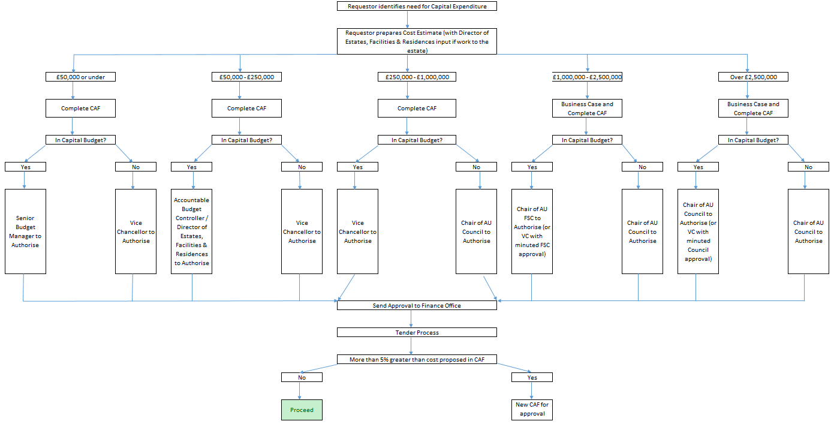

Capitalisation criteria

Capital Expenditure Projects are broadly:

- Any individual piece of equipment, fixtures and fittings, or software costing more than £10,000
- Land and building projects costing more than £10,000.
15.8.2. The definition is, however, subjective and it is possible that projects above these thresholds (primarily land and buildings) are not considered to be capital in nature but instead are classified as revenue. A key factor in deciding the nature of a project is usually whether the project provides increased value to the University rather than maintenance of value. If there is any doubt regarding the classification of a project, the Finance Office should be contacted to assess.
15.8.3. Specific guidance on Capitalisation of Costs.
15.8.4. The basis for the capitalisation cost of property, plant, and equipment is the cost on the date of the acquisition or at fair market or appraised value on the date of the donation in the case of gifts.

15.9. Monitoring and Reporting

15.9.1. For each capital project, quarterly reporting will be undertaken by the Financial Planning and Analysis team.
15.9.2. Project spend will be reported indicating any variances to forecast and the authorised project budget. If an adverse spend greater than 5% of the total project cost is forecast, a supplementary CAF must be prepared and authorised.

15.9.3. Total capital expenditure compared to annual budget and any changes to total forecast capital expenditure will also be reported on a quarterly basis.

15.10. Depreciation

15.10.1. The depreciation charge is designed to reflect that through usage the value of an asset is reduced. The University’s general accounting policies on depreciation are as follows:

Asset | Depreciation
Freehold Land | Not depreciated
Leasehold Land | Depreciated on straight line basis over the life of the lease
Freehold buildings | Depreciated on a straight line basis over their expected useful lives according to their constituent parts as follows:  - Long term e.g. foundations & structure 40 to 60 years  - Medium Term e.g. services 10 to 30 years  - Short Term e.g. internal fittings 5 to 10 years
Equipment (Non Research) | Depreciated on a straight line basis over its expected useful life (generally five years)
 | Depreciated on a straight line basis over the life of the project (generally three years).

15.10.2 Depreciation is calculated monthly, commencing the month after the construction is completed and brought into use.

15.10.3 How is the depreciation funded
Equipment – depreciation posted to the work order attached to the invoice when originally entered on to code 6130 unless otherwise specified by the financial planning and analysis accountant for the department.
Land and Buildings – work to the main academic campus is charged to Estates. Works for specific use i.e. dance rooms to Arts Centre, astro turf pitch to Sports Centre may be charged directly to that department benefiting from that work, particularly if that department receives regular consideration in exchange for its use.
15.10.4 The Director of Estates, Facilities and Residences will review the University land use and buildings for indicators of impairment on an annual basis at the year end.
15.10.5 If the University capitalises any expenditure on existing buildings, it undertakes a review of the carrying value and the useful life of the building to ensure this is still appropriate.
15.10.6 Depreciation is calculated monthly, commencing the month after the construction is completed and brought into use.

15.11. Revaluation and Impairment

15.11.1. The University has adopted a transitional arrangement policy on transition to FRS102. The University’s freehold property excluding Residences and other trading related buildings, were revalued as at 31 July 2014 on a one-off basis. These assets are carried at the 2014 valuation.

Ongoing Maintenance

15.12.1. Departments are responsible for meeting the ongoing repairs and maintenance costs of equipment that are under their control from their annual budgets.
15.12.2. The Estates Department is responsible for arranging and delivering the ongoing planned maintenance and reactive maintenance of the University estate.

Responsibilities

15.13.1. Responsibilities of Departments

The Principle Investigator or project manager (or Head of Department if neither has been appointed) must:-
- ensure that appropriate approvals are in place, before committing the University to any spend on fixed assets.
- Tag all assets with the Fixed Asset Register number provided by the Financial Accounting team
- Assist in keeping the Fixed Asset Register system up to date by informing the Financial Accounting team of any movement of assets – room location, owner, obsolete etc.
- Carry out an annual physical inspection of assets.
- Assist Finance in random physical inspection of assets.
- Ensure asset disposal procedures are followed.
- Record asset transfer forms.
- Ensure any removal of equipment by staff follow procedures.
For capital projects spanning two or more financial years, the Project Manager will be responsible for identifying the profiling of all costs across each of the financial years in question.
15.13.2. Responsibilities of Finance
- Assess all Business Cases and / or Capital Approval Forms in terms of cash availability (even if previously approved in a Capital Budget). Procurement and VAT implications of any proposal must also be assessed prior to final approval.
- Process equipment additions on a monthly basis and allocating each new asset an ID on the fixed asset register (asset ID to be transferred onto an asset ID label and sent to relevant department to attach to relevant asset)
- Send asset lists to departments annually for departments to identify any obsolete, sold, damaged items or any additions which have not been previously identified.
- Maintaining the Fixed Asset Register based on information provided by departments.
- Identify new assets by liaising with Estates Department on a quarterly basis. New buildings are capitalised on completion.
- Monitor capital expenditure compared to the approved Capital Budget on a quarterly basis.
- Ensure that ongoing work at the year-end is recorded as Work in Progress.
- Depreciation processed on a monthly basis before the ledger closes
- Asset register is reconciled to the general ledger twice a year
- New assets such as property, boats, vehicles are notified to UMAL (AU insurers) on acquisition to ensure that these are added to the policy and full cover is in place.
15.13.3. Responsibilities of Estates
- Notify Finance upon completion of building project for Insurance purposes.
- Notify Finance of any changes to the Estate land and building estate management records and ensure that a consistent coding is used for maintaining the estate management records.
- Ensure appropriate financial approvals are in place for Estates managed capital projects before committing the University to capital spend. The VAT implications of such projects must be assessed by Finance before they commence.
- Liaise quarterly with Finance to confirm which projects have completed and the nature of projects which are due to commence.

Maintaining the Fixed Asset Register

15.14.1. The Finance Department maintains a central register of building and equipment over £10k. The purpose of this register is:
- To ensure all capital assets are accurately recorded and maintained
- To allow the Finance Department to accurately calculate the monthly depreciation for inclusion within the monthly management accounts, the annual budget and the five year plan
- To provide a reference point to check all assets held within the University
- To provide contact details for all assets for both asset sharing and for asset verification
15.14.2. The register is updated monthly by the Financial Accounting team. The information is obtained from the Capital Expenditure Record forms and the asset disposal forms provided by departments.

Coding structure for Fixed Assets

15.15.1. The Estates department maintain a schedule of land and buildings on the Planet Systems. All University land and buildings have been assigned a unique specific code that is used by both Finance and Estates.
15.15.2. The Financial Accounting team is responsible for reconciling the Finance Department codes with the Estates Department codes at the year end and to ensure that all additions and disposals have been captured.
15.15.3. Finance Department and the Estates Department should maintain their record systems using the agreed coding structure.

