Carbon Emissions Summary: 2024/25 vs. 2019/20 Baseline
- Progress Toward Net Zero by 2030
In 2019, the University committed to achieving carbon neutrality by 2030. Emissions have been calculated in line with the latest Welsh Government reporting guidance. The 2024/25 data shows a 40% reduction in net emissions compared to the 2019/20 baseline, despite a slight year-on-year increase due to higher gas demand during a colder winter.

Table 1. Summary of emissions (tCO2e) by category
Emissions Source | 2019/20  Base Year | 2023/24 Previous year | 2024/25 Current year | % Change from 2023/24 | % Change from base year
Buildings – Electricity | 5,327 | 4,069 | 3,854 | -5% | -28%
Buildings – Gas | 5,113 | 3,840 | 4,193 | +9% | -18%
Buildings – Other | 635 | 643 | 614 | -5% | -3%
Business Travel | 3,531 | 832 | 1,092 | +31% | -69%
Staff Commuting & Homeworking | 2,505 | 971 | 1,367 | +41% | -45%
Agricultural Emissions | 2,076 | 1,556 | 1,517 | -3% | -27%
Waste | 9 | 15 | 6 | -60% | -34%
Total Gross Emissions | 19,196 | 11,871 | 12,643 | +7% | -34%
Sequestration by AU land | -2,797 | -2,528 | -2,772 | +10% | +1%
Total Net Emissions | 16,399 | 9,347 | 9,871 | +6% | -40%
Key Emission Sources: Gas/heating (33%), electricity (30%), agriculture (12%), commuting (10%), and travel (9%). Carbon sequestration offsets 22% of total emissions.

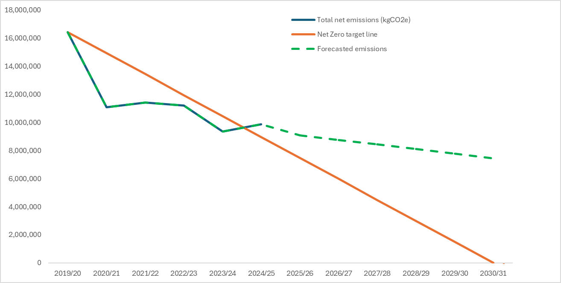
Fig 1. Table of our actual and estimated emissions against forecasted emissions and our net zero target line.

To remain on track, a 45% reduction in net emissions was required this year. With a 40% reduction achieved, we are slightly behind target. Current projections estimate a 55% reduction by 2030/31 without further interventions. Additional decarbonisation efforts are ongoing.

Table 2. Supply chain emissions
Emissions source | 2019/20  Base year | 2022/23  Current year | % Change from base year
Supply chain | 29,082 | 6,613 | -77%

Emissions from purchased goods and services (based purely on spend data) have decreased by 77%. Although not included in our net zero target, we have set a 30% reduction goal by 2030, which has already been met. We now use the Welsh Government’s SIC code-based method, acknowledging its limitations but recognising its value in identifying priority areas.

- Performance Against Net Zero KPIs
We have monitored our progress against each of our targets specified within the Net Zero strategy and summarised the results below, as well the likelihood of achieving these goals by 2030, with red meaning we are off target, yellow possible to achieve and green very likely/already achieved.

Target | 2030 Target | Progress | Likelihood
Renewables | 25% of our electricity to come from on-site renewables | 10% achieved
Decarbonise Heat | 85% gas from renewable heat sources | Limited progress
Energy Efficiency | 15% reduction in energy demand | 24% reduction
Construction/Refurbishment | Stringent standards for all new builds and refurbishments | In development
Travel | 54% reduction in emissions | 69% reduction
Waste | 25% reduction in emissions | 36% reduction
Water | 25% reduction in water consumption | 46% increase
Procurement | 30% reduction in emissions | 77% reduction
Agriculture | Detailed targets by 2025 | In development
Community Involvement | Hold at least 3 events per year | over 10 events held

Overall: Strong progress in energy and travel emissions. Heat decarbonisation and water consumption remain key challenges.

- Recently Completed Carbon Reduction Projects and Improvements

- Renewable Energy: Solar PV Array (Fferm Penglais Fields): 2.5MW system generating since Feb 2023, saving 610 tCO₂e annually (20% of campus electricity).
- Heating Optimisation: Reduced set-points, heating hours, and improved monitoring.
- Transport: We now have 20 electric vehicles and 2 hybrids; EV salary sacrifice scheme ongoing.
- Woodland Creation (Phase 2): 16,000 native trees planted at Frongog, expected to sequester 16 tCO₂e/year.
- REFIT Phase 3: LED upgrades, 118kWp rooftop solar, heating insulation improvements, and plant growth lighting upgrades.
- Trawscoed Office Block: LPG boiler replaced with air source heat pump; insulation and 34kWp rooftop solar PV installed.
- Ethical Investments Policy: Fossil fuel divestment; annual portfolio publication; socially responsible investment.
- Ethical Careers Policy: No promotion of careers in fossil fuel/mining sectors; encourages climate-conscious career choices.

- Planned Carbon Reduction Projects and Improvements
- Renewable Energy: exploring feasibility of a wind turbine at Gogerddan Campus
- Woodland creation: hoping to plant an additional 21,000 trees at Rhydyronnen over the next winter, increasing carbon sequestration by approx. 21 tCO2e per annum along with being a key component of our biodiversity enhancement activity.
- Energy and water monitoring: investing in sub-metering improvements across Penglais and Gogerddan Campuses
- Smart Local Energy System: Ynni Cymru funded project to include Transformer upgrade, EV infrastructure upgrade and Battery Storage System for the Solar Array.

