Aberystwyth University
Towards Net Zero Carbon 2030 Strategy

Document Version Control

Version Number | Date of Issue/Update
1.0 DRAFT | 22/07/2022
1.0 FINAL | 17/07/2023
1.1 2024 Updated Version | 03/04/2024
1.2 Updated Version | 08/02/2026

Signature:

Iain Barber, Faculty Pro Vice-Chancellor (Sciences)
Date: 15/06/2026

Contents
1 Key Terms and Definitions 4
2 Foreword 5
3 Introduction 6
4 Scope of our Net Zero Target 9
5 Our Pathway to Net Zero 12
6 Key Carbon Reduction Targets 13
7 Key Theme 1 - Buildings & Estate 14
8 Key Theme 2 - Transport & Travel 22
9 Key Theme 3 – Agriculture 28
10 Key Theme 4 - Land Use & Sequestration 30
11 Key Theme 5 - Waste Reduction & Minimisation 32
12 Procurement 32
13 Responsibilities and Governance 34
14 Financing 34
15 Risks & Constraints 35
Appendix 1 – References & Supporting Documentation 36

Key Terms and Definitions
The following key terms are used in our Net Zero Carbon by 2030 Strategy. For reference a definition of each term has been provided in the following table.
Key Term/Acronym | Definition
Carbon Dioxide Equivalent  (CO₂e) | Standard unit of measurement of Greenhouse Gas (GHG) emissions used to compare relative impacts of different GHG’s based upon their global warming potential.
Decarbonisation | The process of first reducing then removing, GHG emissions released into the atmosphere from our operations.
Greenhouse Gas Emissions  (GHG emissions) | Greenhouse Gas gases defined as gases which are capable of absorbing infra-red radiation (heat) from the sun, contributing to the Earth’s greenhouse gas effect.
Net Zero Carbon | A balance between GHG emissions emitted into the atmosphere and the GHG emissions removed through removals
Total GHG Emissions (per annum)  (tonnes CO₂e) | An organisation/entity’s annual GHG emissions total before adjustments are applied for sequestration or GHG removals, measured in tonnes CO₂e.
Well-to-Tank GHG Emissions  (tonnes CO₂e) | Emissions from the processing and refinement of fuels and energy consumed by reporting organisations.
Transmission & Distribution  (tonnes CO₂ e) | Indirect GHG emissions resulting from the losses of generated electricity as a result of transmission and distribution through the National Grid.

Acronym | Definition
AU | Aberystwyth University
CCC | Committee on Climate Change
GHG | Greenhouse Gas
HEF | Higher Education Facility
T&D | Transmission & Distribution (electricity)
UNFCCC | UN Framework Convention on Climate Change
WTT | Well-to-Tank GHG Emissions

Foreword
In this, our 150th year, we have been celebrating Aberystwyth University’s long and distinguished contribution to university education in Wales and across the world. The environment has been a central theme for research and teaching here from the earliest days.
Climate change is the biggest challenge facing our planet and we are committed to carrying out research that pushes the boundaries of our understanding of our changing environment and develops real-world solutions that will contribute to a more sustainable future.
Equally, we recognise our responsibility to protect the environment from the impact of our own operations and activities and to influence our staff, students and the wider community to minimise their impacts through our actions, teaching and research.
Much has already been achieved. In 2019 we joined organisations around the world in declaring a climate emergency and over the past 10 years we have reduced our CO2 emissions by over 40 per cent.
In 2020 we were part of landmark £50m deal to buy clean electricity and March of this year saw the commissioning of a new 2.5MW solar array that will deliver 25% of the annual electricity needs of our Penglais campus and reduce annual carbon emissions by over 500 tonnes.
As an institution rooted in our community, we work closely with partners to improve local infrastructure. Land provided by the University facilitated the development of the new railway station in Bow Street and improved links with Gogerddan and Penrhyncoch. These are being extended to the Penglais campus and on to Aberystwyth, providing safer alternatives for walkers and cyclists.
We are committed to do more. Set against the backdrop of the United Nations Sustainable Development Goals and the UN Framework Convention on Climate Change Paris Agreement of 2015, and reflecting Welsh Government’s commitment to achieving a carbon neutral public sector by 2030, this report sets out the priority actions for Aberystwyth University as we work towards net zero, recognising that we will need to continue to identify additional measures by 2030.
This is an ambitious undertaking and echoes our responsibility to contribute to lasting change through our research, teaching and day-to-day operations. It is also an undertaking that will only be achieved in partnership with our students and staff, along with external partners and stakeholders. Their cooperation will be key as we play our part in building a more environmentally sustainable world.


Professor Neil Glasser
Pro Vice-Chancellor

Introduction
This document details Aberystwyth University's Net Zero Carbon (NZC) by 2030 Strategy. It sets out our key actions that support decarbonising our operations and becoming a Net Zero organisation. Achieving Net Zero means reaching a balance between Greenhouse Gas (GHG) emissions emitted into the atmosphere and the emissions taken out through removals, and land sequestration.
Aberystwyth University, alongside the broader higher education and research sector, has an essential role in helping Wales and the UK achieve our national Net Zero targets. As an academic institution, we can support the active decarbonisation of our operations by being at the forefront of climate change research and developing strategies to mitigate against anthropogenic climate change.
Our NZC Strategy has been co-produced with engagement received from representatives in our academic and operational activities.

The Need to Act
Climate Change - The Global Context
Action on an international scale is required for any level of meaningful change to the Earth’s climate. The 2030 climate and energy framework developed by The United Nations (UN) aims to reduce greenhouse gas emissions and increase momentum towards sustainable development and Climate Change resilience through the UN Sustainable Development Goals and the UN Framework Convention on Climate Change (UNFCCC) Paris Agreement 2015.
Since the Paris Agreement was ratified in 2015, global average temperatures have risen by over 1°c since the pre-industrial period, and by 0.2°c compared to 2011-2015, with further inevitable rises projected to occur as a result of carbon already emitted. Increased climatic consequences are already prevalent due to this rise, highlighting the urgency of acting to drastically reduce global carbon emissions. If we don’t act now, the threat we face becomes critical as we risk global temperatures rising above a tipping point resulting in irreversible changes to our planet.
Climate Change – The National Context
Wales and the UK is already experiencing significant climatological impacts as a result of Climate Change. The Committee on Climate Change’s (CCC) Third Independent Assessment of Climate Change Risk report highlights that the UK as a whole has been impacted by higher average annual temperatures (0.3°C increase per decade since 1980), sea level rise (currently estimated to be rising at 2.5cm per decade), and significant increases in temperature and precipitation extremes. Most noticeably this has been demonstrated with the milder/wetter winters, warmer/drier summers, and increased extreme weather events (e.g. flooding, heatwaves, storms) occurring in the UK.
The biodiversity of the UK is also under threat from the impacts of Climate Change. Across the UK, different habitats and ecosystems are at risk from a range of factors including rising sea levels, extreme weather, and temperature extremes. This has led to a 40% decline in UK native species with 25% of mammals being at risk of extinction.
Most worrying of late, a recent report from the Committee for Climate Change outlined to the UK Parliament that the rates of improvement in energy efficiency within buildings continue to be well below the necessary level, as they have been over the last decade.
Initial indicators reported by the Committee for Change also show a lack of progress in the advancement of low carbon farming and productivity measures needed to decarbonise the agriculture sector. Land-use change which is necessary to reduce greenhouse gas emissions from degraded peatlands and promote carbon sequestration have yet to meet delivery targets.
Welsh Government Climate Emergency
In 2019, Welsh Government became one of the first nations in the UK to declare a Climate Emergency, committing to achieve a carbon neutral public sector by 2030.
In line with the advice from the Climate Change Committee (CCC), this must be a decade of action in Wales. We need to make more progress in the next ten years than we have in the last thirty. In areas such as the public sector we can expect to see emissions reduce quickly, helping us meet our immediate Carbon Budget (2021–2025). In other areas, we are laying the foundations for longer term and systemic change. In revolutionising the way, we support and incentivise farmers to manage their land, and in planning for a national energy grid that is fit for a renewable future we will use this period to complete the groundwork that will enable significant emissions reductions in later years.
The Welsh Government supported its commitments to decarbonisation through its publication of ‘Prosperity for All: A Low Carbon Wales‘ in 2019, which set out 100 policies and proposals to ensure the 2030 carbon emission ambitions are met. Net Zero Wales, the Welsh Government’s second emissions reduction plan for Carbon Budget 2 (2021 to 2025) sets the foundations to make Wales Net Zero by 2050 and the public sector Net Zero by 2030.
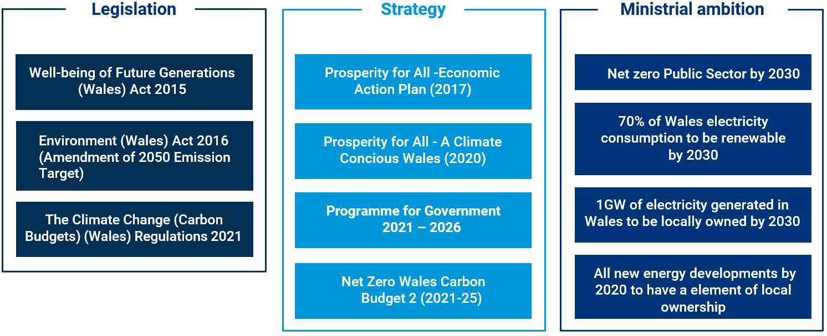
The Partnership Council for Wales will head up the ‘Team Wales’ approach to allow public bodies, including Aberystwyth University and other HEF’s to work together to reduce their carbon emissions. This will build on the good work already underway across Wales and encourage a partnership approach to maximise resources, avoid duplication and ensure communication is consistent.
The Environment (Wales) Act requires all public authorities to seek to “maintain and enhance biodiversity” within their operations. As one of the leading Universities conducting research across a range of biosciences, we recognise that ecosystems are vital for public health and well-being, providing our food and medicines, regulating our water and controlling disease, and supporting our leisure activities. Our health and well-being depend upon a healthy environment, which includes using our natural resources in a sustainable way and supporting our biodiversity.
Welsh Government Public Sector Carbon Reporting
In May 2022 the Welsh Government published the Welsh Public Sector Net Zero Reporting Guide 2, which aims to be a universal guide as a set of instructions for use by Welsh public bodies to estimate baseline emissions. This new reporting is being undertaken in parallel with other activities within many public sector organisations related to carbon emissions estimates and developing and implementing action plans to reduce emissions. The Welsh Government has acknowledged that the reporting process is a learning process for all parties involved and that the response rate and completeness of data is bound to improve over time.
Aberystwyth University participated in the first round of reporting for 2021 and is (at time of writing) in the process of calculating our GHG emissions for the 2022 reporting year. Moving forwards, we will continue to report our emissions on an annual basis.
The Well-Being of Future Generations Act
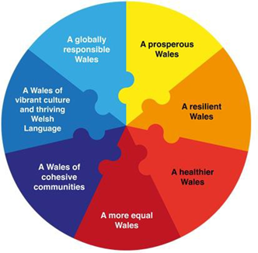
The Well-being of Future Generations (Wales) Act 2015 is about improving the recognised four dimensions of well-being in Wales - social, economic, environmental and cultural, captured in the seven well-being goals. The Act ensures our decarbonisation actions support the Welsh Government’s well-being objectives and the 7 national well-being goals.
Public Sector organisations are required to embed the ‘sustainable development principle’ in everything they do and adopt the 5 Ways of Working to think more about the long term, collaborate better with people and communities and each other, have a joined-up approach and look to prevent problems.
Climate Change is considered one of the greatest global challenges and requires innovation and collaboration to ensure the well-being of the future generations in Wales. Identifying opportunities and actions to reduce carbon emissions within our day-to-day activities will limit our contribution to Climate Change and thereby its consequences.

Figure 1 - The Well-Being of Future Generations Act's seven wellbeing principles
Aberystwyth University has embedded the five ways of working through the development of our NZC Strategy:
Long Term: Each activity stream sets out appropriate long-term actions to address the challenges we face to achieve Net Zero, both now and in the future.
Integration: The five activity streams relate to each other and form an integrated approach to reduce our carbon emissions.
Prevention: We have identified specific actions to prevent emission levels from increasing and to reduce our impact on climate change to help prevent future health problems.
Involvement: We have co-developed our decarbonisation plan working closely with decarbonisation leads from all directorates with Aberystwyth University and engaged with members of staff from across service areas within the eight directorates.
Collaboration: We aim to maximise delivery of the actions identified within our decarbonisation plan by collaborating closely with partners, stakeholders and others across Wales. We will build on current partnerships and aim to develop new ones to maximise our efforts to reduce our emission.

Scope of our Net Zero Target
Aberystwyth University aims to become operationally Net Zero by 2030. The scope of our target is closely aligned with the reporting requirements outlined by Welsh Government in the Welsh Public Sector Net Zero Reporting Guide. Carbon emissions are classified into various Scopes of emissions. Scopes are defined by the Greenhouse Gas Protocol for GHG accounting and reporting purposes. All carbon accounts include scope 1 and 2 emissions, whereas scope 3 sources might be excluded or only partially included, depending on both the availability of data and the usefulness of its collection. It should be noted that one organisation’s scope 3 emissions are another organisation’s scope 1 or 2. Therefore, when multiple organisations are accounting under the same umbrella target, care must be taken to avoid double or triple counting the same emission source.
Direct emissions: (Scope 1)
Direct emissions are produced by sources which are owned or controlled by the University, and include oil or gas for heating, and fuel consumption as a result of business travel or distribution.
Indirect emissions: (Scope 2)
Emissions from the generation of purchased or acquired electricity, steam, heating, or cooling generated by a third party and consumed by the Universities direct operations.
Other Indirect emissions: (Scope 3)
All other indirect GHG emissions that occur as a consequence of business activities but occur from sources not directly owned or controlled by the University.
The scope that makes up our Net Zero Target will take a theme-based approach, as detailed below.
Key Theme | Reporting Scope | Emission Sources
Buildings &  Estate | Scope 1 | Natural Gas  Gas Oil  Liquefied Petroleum Gas  Kerosene  Biomass
Buildings &  Estate | Scope 2 | Grid Electricity  Renewable Electricity
Buildings &  Estate | Scope 3 | Well-to-Tank Emissions (electricity, site fuels)  Grid Electricity Transmission & Distribution (T&D)  Water (Treatment & Supply)
--continued following page--
Transport &  Travel | Scope 1 | University Vehicles (cars, vans, plant equipment, specialist vehicles)
Transport &  Travel | Scope 2 | EV Pool Car Electricity (University-owned)
Transport &  Travel | Scope 3 | Employee Commuting  Business Travel (Grey Fleet, Public Transport, Flights)  Well-to-Tank Emissions (vehicle travel, business travel, commuting)
Agriculture | Scope 1 | Livestock  Animal Husbandry  Fertilisers
Sequestration | - | Land based emissions and/or Carbon Sequestration potential of land assets.
Waste Reduction & Minimisation | Scope 3 | Wastes generated and disposed of resulting from the University operations.
Homeworking | Scope 3 | Emissions arising from the consumption of electricity and use of heating by employees working from home.

Scope Exclusions
Procurement and supply chain GHG emissions are not included in the scope of our 2030 operational Net Zero Target. However, this strategy includes a dedicated SMART target and an action plan to reduce supply chain emissions. Reporting of supply chain emissions reductions will be included in our annual net zero progress reports.
In the first instance the challenge will be to understand and map our supply chain emissions in more detail. We will also aim to implement a range of measures (as detailed in our action) to help decarbonise supply chain emissions, even though the benefits of many of these may be more difficult to quantify.

Aberystwyth University’s GHG Emissions Footprint
Aberystwyth University’s GHG emissions footprint was calculated for our 2019-20, 2020-21 and 2021-22 fiscal years aligned with reporting requirements as set out by the Welsh Government for the Public Sector. Our 2019-20 GHG emissions footprint will act as the University’s baseline and will be used to inform target setting and act as a benchmark to monitor the progress of our Net Zero Carbon by 2030 Strategy.
GHG emissions are presented for all three reporting years in the summary table below. Results for each emissions source are presented in tonnes CO₂e. Results also include calculated carbon sequestration potential of our land assets (shown as negative values), which have been factored in to develop our net GHG emissions footprint.
Reporting  Scope | GHG Emissions  Source | 2019-20  GHG Emissions  (tonnes CO₂e) |  | 2020-21  GHG Emissions  (tonnes CO₂e) | 2021-22  GHG Emissions  (tonnes CO₂e)
Scope 1 | Natural Gas | 4,539 |  | 4,259 | 4,430
Scope 1 | Agriculture | 4,301 |  | 4,301 | 4,301
Scope 1 | Gas Oil | 273 |  | 273 | 289
Scope 1 | University Vehicles | 132 |  | 38 | 143
Scope 1 | Liquefied Petroleum Gas | - |  | - | 24
Scope 1 | Kerosene | 20 |  | 20 | 10
Scope 1 | Biomass | 1 |  | 1 | 1
Scope 2 | Grid Electricity | 5,189 |  | 3,804 | 4,146
Scope 2 | University Pool Car (EV) | - |  | - | 1
Scope 2 | Renewable Electricity | 0.00 |  | 0.00 | 0.00
Scope 3 | Employee Commuting | 2,505 |  | 752 | 1,268
Scope 3 | Homeworking | - |  | - | 270
Scope 3 | Business Travel | 1,680 |  | 493 | 124
Scope 3 | Well-to-Tank Emissions | 1,639 |  | 1,206 | 2,156
Scope 3 | Grid Electricity T&D | 417 |  | 296 | 317
Scope 3 | Water (Treatment & Supply) | 195 |  | 206 | 90
Scope 3 | Waste | 12 |  | 10 | 12
(Gross) Total GHG Emissions (tonnes CO₂e) |  |  | 20,903 | 15,659 |  | 17,581
Land Use Sequestration (tonnes CO₂e) |  |  | -2,718 | -2,718 | -2,718
(Net) Total GHG Emissions (tonnes CO₂e) |  |  | 18,185 | 12,941 | 14,863

Scope 3 Emissions – Procurement and Supply chain emissions
Although we are not including GHG emissions resulting from the University’s procurement spend in our Net Zero 2030 target, we have a specific target to reduce supply chain emissions by 30% by 2030 and are collating the information using the Welsh Government reporting methodology each year. Our results for our base year 2019-20 along with 2020-21 and 2021-22 published data are presented in the table below.
Reporting  Scope | GHG Emissions  Source | 2019-20  GHG Emissions  (tonnes CO₂e) | 2020-21  GHG Emissions  (tonnes CO₂e) | 2021-22  GHG Emissions  (tonnes CO₂e)
Scope 3 | University Procurement | 29,083 | 30,616 | 27,932

Our Pathway to Net Zero
Outlined below is our model for the University is to work towards becoming operationally Net Zero by 2030. This model has been developed based upon the identifed key actions and decarbonisation measures presented under each key theme. The measures identified in the action plan are expected to reduce our emissions by approx. 70% by 2030. We will continue to review the strategy (at least every 2 years) and hope to be able to identify further measures that will help the University achieve its Net Zero ambition by 2030.

Figure 2 – Decarbonisation Model based on implementation of measures in the Action plan

Key Carbon Reduction Targets
To help meet the Universities Net Zero 2030 aspiration, the following 10 key initial decarbonisation targets have been identified:
- Renewable Energy - At least 25% of the Universities total Electricity to come from renewable sources by 2030.
- Decarbonise Heat - Seek to convert at least 75% of annual gas demand to renewable heat sources by 2030.
- Energy Efficiency – seek to reduce total energy usage (natural gas and electricity consumption) by at least 15% by 2030.
- Construction and refurbishment – ensure stringent sustainability standards for all new and refurb projects to improve energy efficiency and minimise embedded carbon by 2024
- Travel – reduce total business travel and commuting emissions by at least 50% by 2030.
- Waste – reduce general and DMR waste emissions by at least 25% by 2030
- Water - reduce total water and wastewater emissions by at least 25% by 2030
- Procurement – Reduce supply chain emissions by 30% by 2030
- Agriculture – develop detailed decarbonisation targets and action plan by end of 2025
- Community involvement – seek to hold at least 3 events per year to raise awareness on decarbonisation and wider sustainability issues within the community
Sections 7-13 identify the key actions required to achieve these initial targets to work towards net zero by 2030. Further measures will be required to achieve net zero by 2030 as the measures identified so far are anticipated to achieve a 70% reduction in total emissions. Progress against the targets and action plans will be reviewed annually.
Further information on the Reference Scenario Model used to model reductions is provided in Appendix 1 of this Strategy.

Key Theme 1 - Buildings & Estate
Aberystwyth University has two main campuses and several locations for research and agricultural activities. Our estate is made up of a variety of different building archetypes, which range from city centre Grade II listed historic buildings, modern residential housing blocks, through to research laboratory facilities and commercial farms.
Emissions arising from Aberystwyth University’s buildings and estate equated to 12,273 tonnes CO₂e (58% of our total operational emissions) within our 2019/20 baseline reporting year, which includes emissions arising from utilities use (electricity, natural gas, onsite fuels, water consumption and fugitive emissions).
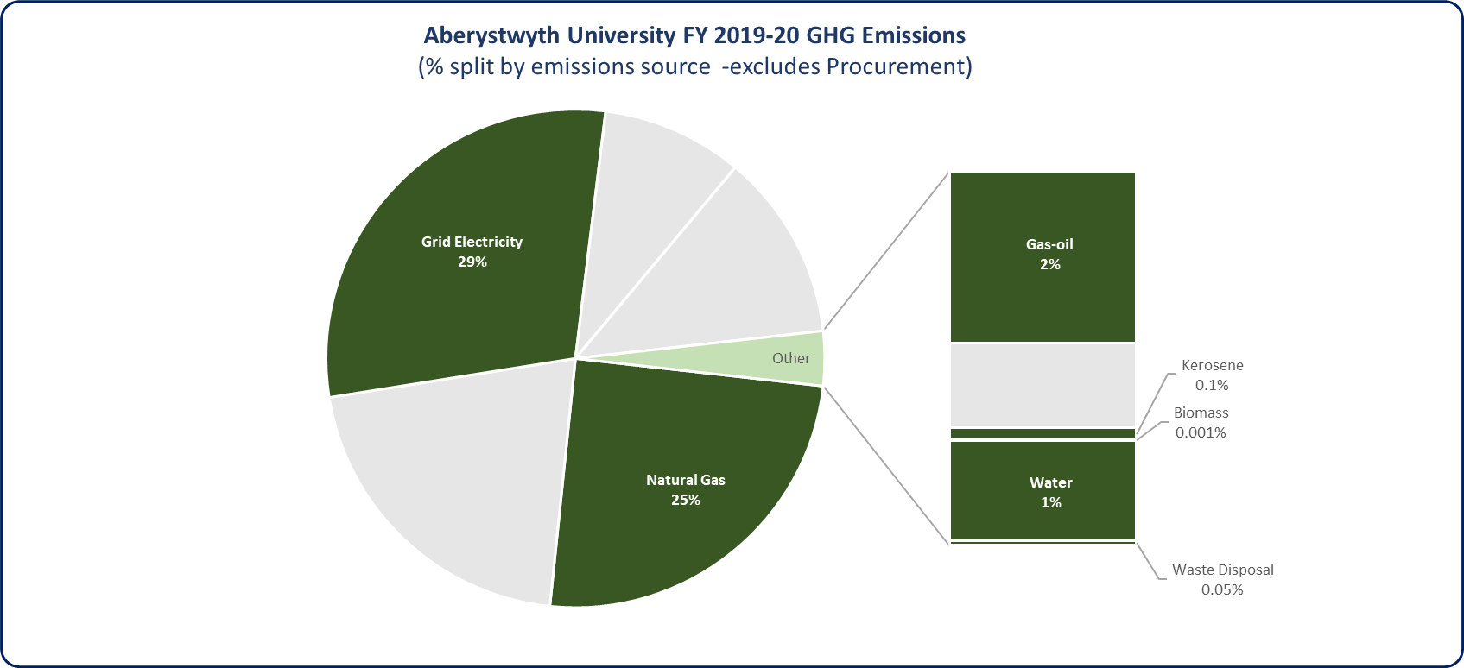
Figure 3 – Percentage split of Buildings & Estate GHG emissions as part of AU’s overall GHG emissions footprint for FY 2019-20.
The most significant source of GHG emissions from our buildings and estate is associated with the use of electricity and gas use. The majority of our electricity and gas consumption derives from Penglais Campus. Penglais Campus is made up of +50 buildings of varying size and construction type. Some buildings are used by the University for the provision of teaching and research, while other buildings are utilised as student accommodation. Penglais campus also contains the main Students Union as well as a number of staff offices.
Our other larger campuses and operational sites include:
- Gogerddan Campus – located outside of Aberystwyth the campus is home to our Institute of Biological, Environmental and Rural Science (IBERS). The campus is also home to AberInnovation.
- Fferm Penglais – located close to our main Penglais Campus this site is where the majority of our student accommodation is located. Due to current ownership arrangements, the University has limited scope for implementing active decarbonisation measures at this site; but will look to work with current owners to encourage decarbonisation.
- Llanbadarn Campus – home to a number of academic and office buildings as well as tenants.
- Agricultural and research Estate – the University has numerous working farms as part of our agricultural estate as well as research facilities and sites.
- Old College – Grade II listed building located in Aberystwyth town centre which is currently being refurbished.
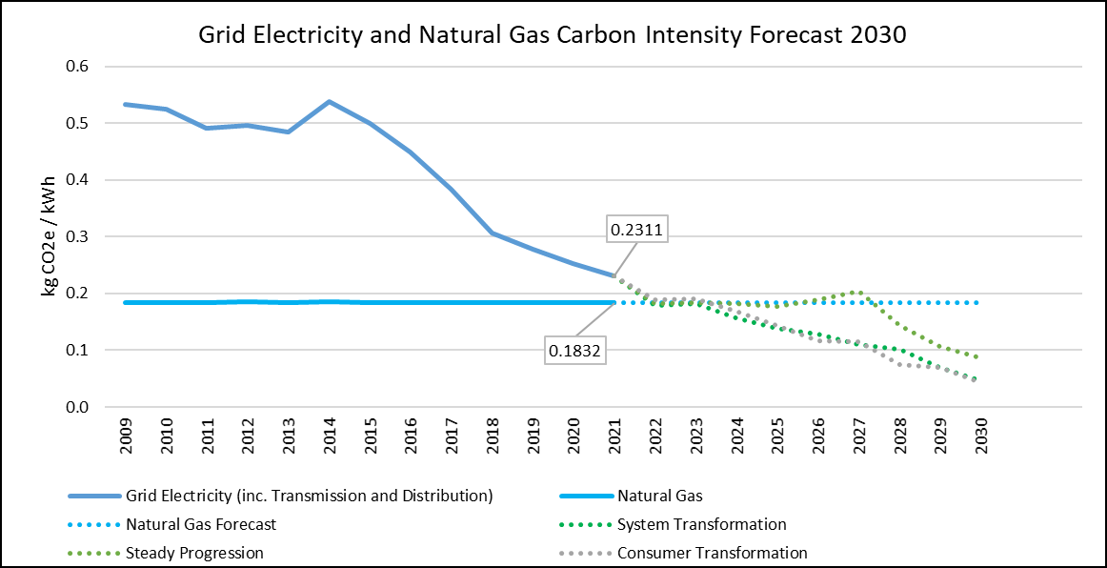
Aberystwyth University recognises that reducing operational GHG emissions from our buildings and wider estate involves not only technical innovation but also effective estates planning to ensure we are operating as efficiently as possible.
An implementation Masterplan for the estate has been developed by the University to complement “The Estate Strategy 2021 – 2031”. This strategy links to the University’s key strategies including; Teaching & Learning, Research & Innovation, Digital and Sustainability, to support these core activities and ensure that all space provided is functional (correct type of space), of a high quality and in the appropriate location. It will demonstrate that by consolidating the space occupied by the University, by improving space utilisation and conceivably zoning activities, the University will experience efficiency gains including reduction in energy from buildings through the effective utilisation of space.
Although some considerable gains will be made through rationalising the estate and carrying out deep refurbishments, this by itself will not decarbonise our estate enough to reach Net Zero Carbon by 2030. To progress our Net Zero Carbon vision, we will need to focus upon how we can transition to using low carbon technologies, without compromising the delivery of our teaching and academic research activities.
Figure 4 - Grid Electricity and Natural Gas Carbon Intensity 2050 Forecast; shows National Grid ‘Future Energy Scenarios’ projected reduction towards 100gCO₂e.
The carbon intensity of the National Grid is due to change dramatically over the next decade (see Figure 2), leading to passive decarbonisation benefits for the University. The electricity network is progressively decarbonising as both more large-scale renewable generation sources are coming online, and while fossil fuel power stations are being progressively decommissioned. Moving forwards we expect that GHG emissions from natural gas and other site/vehicle fuels will gradually account for a incresing proportion of our future emissions profile and thus needs to be tackled head on.

Current Decarbonisation of the Built Estate
Over the last 5 years the University has invested heavily in carrying out significant projects to reduce carbon, understanding that there is a need to act sooner rather than later to achieve Net Zero Carbon by 2030. We undertook an estate rationalisation assessment in 2021-22 to determine if our buildings are being fully utilised. For buildings that were severely underutilised or not being appropriately used, we investigated opportunities to consolidate/rationalise services into other buildings
Aberystwyth University has committed to reducing energy within our buildings through partnering with an industry specialist via the REFIT framework for Energy Performance Contracts. Since partnering with Vital Energi through the framework we have invested almost £3.4 Million in energy efficiency projects that are guaranteed to reduce our energy related emissions by >9% and save us over £350,000 per annum in electricity and gas costs. These works included heating optimisation, campus wide LED lighting, energy efficient ventilation fans, pipework insulation, refurbishment of the animal House heating ventilation and air conditioning system, Hugh Owen Library refurbishment, and replacement of a number of energy intensive research equipment with modern efficient units.
Following the successful first phase of energy works carried out by the contractor in 2021, we completed a 2.5MW Solar PV Array in the fields surrounding Fferm Penglais in 2022, designed to provide 25% of Penglais Campus annual electricity requirements.
We have identified several actions to reduce GHG emissions associated with energy used related to buildings and the wider estate. To inform our priorities and the potential emissions reductions which can be achieved, we have undertaken detailed modelling of the key technological and energy conservation actions listed in the following table.
Emissions Reduction Impact descriptions are based upon the following ranges: Low (< 250 tCO₂e), Medium (250 – 500 tCO₂e), High (> 500 tCO₂e).
Activity Area | Key Action(s) | Action Reference | Action Details | Emissions Reduction Potential by Target Year  (tCO₂e) | Emissions Reduction Impact (Low/Medium/High) | Target Implementation Dates | Estimated Cost of implementation  (£) | Responsible Person
Buildings  Natural Gas | Decarbonisation of heat at Penglais Campus | BE01 | large scale heat decarbonisation (subject to feasibility, funding support, approvals and planning permissions etc.) to meet heating demand at Penglais Campus and adjacent sites | 2,550 | High | 2025-2027 | £20,000,000 | Pro Vice-Chancellor Faculty of Earth & Life Sciences
Buildings  Natural Gas | Decarbonisation of heat at Gogerddan Campus | BE02 | large scale heat decarbonisation (subject to feasibility, funding support, approvals and planning permissions etc.) to meet heating demand at Gogerddan Campus | 512 | High | 2027 - 2030 | £7,000,000 | Pro Vice-Chancellor Faculty of Earth & Life Sciences
Buildings Electricity & Natural Gas | Estate rationalisation | BE03 | Disposal of Llanbadarn campus will help to reduce overall electricity and gas consumption for the University and associated GHG emissions. | 510 | High | 2023 | - | Director  EF&R
Buildings Electricity & Natural Gas | Implement estate-wide energy conservation measures | BE04 | Implement energy conservation measures (where feasible) across other areas of the estate at up to £10,000 per tCO2e saved: | 279 | Medium | 2023-2030 | £18,000,000 | Director EF&R
Buildings Electricity & Natural Gas | Penglais Campus Solar Farm and energy conservation measures | BE05 | Complete commissioning of Penglais Solar Farm to reduce reliance on grid electricity across the campus | 235 | Low | 2022 - 2023 | £3,000,000 | Director EF&R
Buildings Electricity | Gogerddan Campus renewable energy project | BE06 | Seek to install renewable energy for 25% of Campuses requirements. Assuming £1.75M per MW (Subject to feasibility, planning etc). | 178 | Low | 2024-2026 | £2,625,000 | Director EF&R
Buildings Electricity | Battery Storage installed in Renewable Energy installations | BE07 | Maximise renewable generation self-consumption through battery storage schemes | 62 | Low | 2025-2027 | £1,000,000 | Director EF&R
Buildings Electricity | Solar PV at Fferm Penglais | BE08 | expand the provision of roof-mounted Solar PV and other renewable technologies | 25 | Low | 2025 | £500,000 | Director EF&R
Combined GHG Emissions Reduction Potential (tonnes CO₂e) |  |  | 4,525 | Total budget cost
Percentage Reduction versus 2019-20 Baseline GHG Emissions |  |  | 85% | £52,000,000
All modelled GHG emissions savings factor in the forecast decarbonisation of the National Grid (electricity only) to 2030.
The projected carbon emissions reduction potential should all the above measures be implemented is 4,525 tonnes CO₂e: reducing the GHG emissions footprint of our Buildings & Estates to 1,509 tonnes CO₂e (an 85% reduction on our 2019-20 baseline). The actions in the table above are designed to show the magnitude of decarbonisation activities which will be required to achieve sufficient emissions reductions. Actual emissions savings when actions are implemented may differ from the results shown in the table above. The viability of each action will be assessed on a case-by-case basis, as there are a variety of factors that may impact the ability to deliver these schemes as they go through more detailed feasibility assessments. The action plan will be updated annually to include any additional or alternative opportunities for decarbonisation that have been identified.

Built Estate – Indicative Cost to Decarbonise
Based on the range and type of decarbonisation projects required across the University’s estates indicative costs to achieve required reductions, is estimated to be £52 million. This high-level figure has been developed using a range of assumptions and should be used for guidance purposes only. Due to the scale of investment required, it is recognised that delivery of this strategy will be heavily reliant on significant levels of external funding support.

Built Estate – Supporting Actions
We have identified several supporting actions to reduce GHG emissions associated with energy used related to buildings and the wider estate. These actions are focused on initiatives to improve the operational use of our existing buildings, support the decarbonisation of new build/refurbishment projects, and also set benchmark standards for new build construction. Additional supporting actions will also support staff behaviour changes to help reduce emissions.
Activity Area | Key Action(s) | Action Reference | Sub Actions | Action Owner(s) | Target Implementation  Date(s)
Use of Existing Buildings | Optimising the use of and reviewing the need for our current buildings | BE09 | Continue to identify and review suitable opportunities for further funding to support ongoing building refurbishment/renovations of our Estates through our established Re:fit Serviced Provider and other appropriate resources. | Sustainability Advisor | Ongoing
Use of Existing Buildings |  | BE10 | Implement planned rationalisation measures across our Estate and continue to review the requirement/need for other low occupancy or low use buildings.  Review opportunities and implement space saving measures in our existing buildings to reduce the amount wasted space (and associated energy consumption) (e.g., hot-desking) | Director  EF&R | Ongoing
Use of Existing Buildings |  | BE11 | Adopt a heating and cooling policy in line with best practice to ensure these are not being over heated in winter and over cooled during the summer. | Director  EF&R | 2023
Use of Existing Buildings |  | BE12 | Develop a targeted engagement plan to support behaviour change improvements | Sustainability Advisor | 2024
Existing Estate | Onsite Renewables | BE13 | Undertake a programme of targeted feasibility assessments to determine the viability of installing renewable energy technologies across the wider estate the reduce reliance on the National Grid and support the decarbonisation of heat in our buildings. | Sustainability Advisor | Ongoing
Existing Estate | Refurbishment & Planned Maintenance | BE14 | Implement a fabric-first approach to the refurbishment of our buildings with a targeted strategy to improve insulation across our estate. | Director  EF&R | Ongoing
Existing Estate | Refurbishment & Planned Maintenance | BE15 | Ensure that minor works and planned maintenance across our estate are completed with a focus upon sustainability. Recommend that sustainability assessments are completed for all planned and approved minor works. | Director  EF&R | 2023
Existing Estate | Refurbishment & Planned Maintenance | BE16 | Ensure that the electrification of heat as standard requirement for all new and planned plant room replacement works. | Director  EF&R | 2023
New Builds | New Build Design & Construction | BE17 | Develop a bespoke low carbon building standard which will apply for all new build projects for the University. Review opportunities to integrate or go beyond existing national (e.g. Welsh Government) and organisational (e.g. London Energy Transformation Initiative) design standards within our existing new build and refurbishment standards.  This will help to embed high sustainability standards across all over our new builds. | Director  EF&R | 2024
New Builds | New Build Operational Energy | BE18 | Develop an approach to minimising the amount of unregulated energy consumption across our estate from future new build projects, focusing upon the installation of smart metering, BMS controls, and any additional submetering. This will allow the University to better monitor and target reductions un-regulated energy use to reduce our emissions. | Director  EF&R | 2024
New Builds | New Build Operational Energy | BE19 | Ensure new build design makes provision for the installation of on-site renewables (where feasible) and/or the connection to existing renewable energy sources and networks (e.g., solar PV farms, district heat networks). | Director  EF&R | 2024
Water reduction | Water usage monitoring | BE20 | Monitor usage monthly to help identify waste events | Sustainability Advisor | 2024
Water reduction | Minimising water wastage | BE21 | Establish efficient leak detection and resolution approach | Director  EF&R | 2024
Water reduction | Improve water efficiency | BE22 | Develop a programme of water efficiency measures as part of the University Estates Strategy | Director  EF&R | 2025
Governance & Financial | Effective governance and financial planning for Estates decarbonisation | BE23 | Set up a wider Net Zero Decarbonisation Task Group (headed by an executive chair) to help monitor usage across our Estate as well as co-ordinate future actions to support our decarbonisation activities. | Pro Vice-Chancellor Faculty of Earth & Life Sciences | 2023
Governance & Financial |  | BE24 | Ensure annual decarbonisation capital budgets are included in planning rounds in line with indicative budget requirements detailed in section 7.3. | Director  EF&R | 2023
Governance & Financial |  | BE25 | Assign an annual budget for a programme of Energy Efficiency Surveys to support future decarbonisation activities as well as the provision of annual surveys to maintain operational energy efficiency across our estate. | Director  EF&R | 2023

Key Theme 2 - Transport & Travel
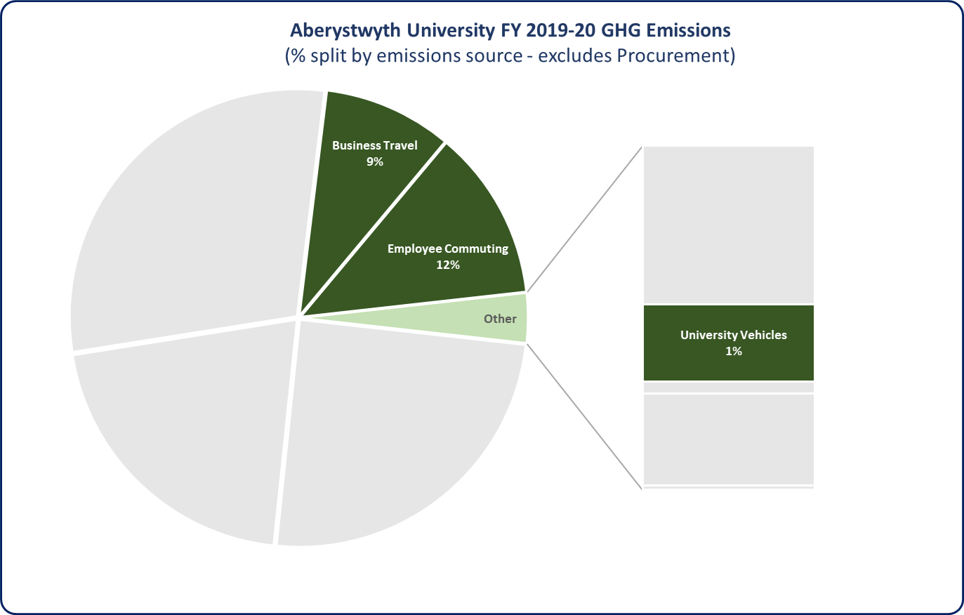
Aberystwyth University directly owns and operates a fleet of support vehicles, plant equipment, and agricultural vehicles. The majority of the fleet is currently fossil fuelled (petrol and diesel) however our fleet also includes a modest number of electric vehicles. GHG emissions resulting from the operation of our vehicle fleet totalled 132 tonnes CO₂e (1% of total operational emissions).
In addition to our direct transport impacts, business travel completed by employees using their own vehicles (Grey Fleet) and air travel represents another key GHG emissions reduction priority.
Another significant indirect GHG emissions source is emissions associated with the commute of staff into the University’s campuses and other locations. GHG emissions resulting from employee commuting totalled 2,505 tonnes CO₂e (18% of total operational emissions) for the 2019-20 reporting year.
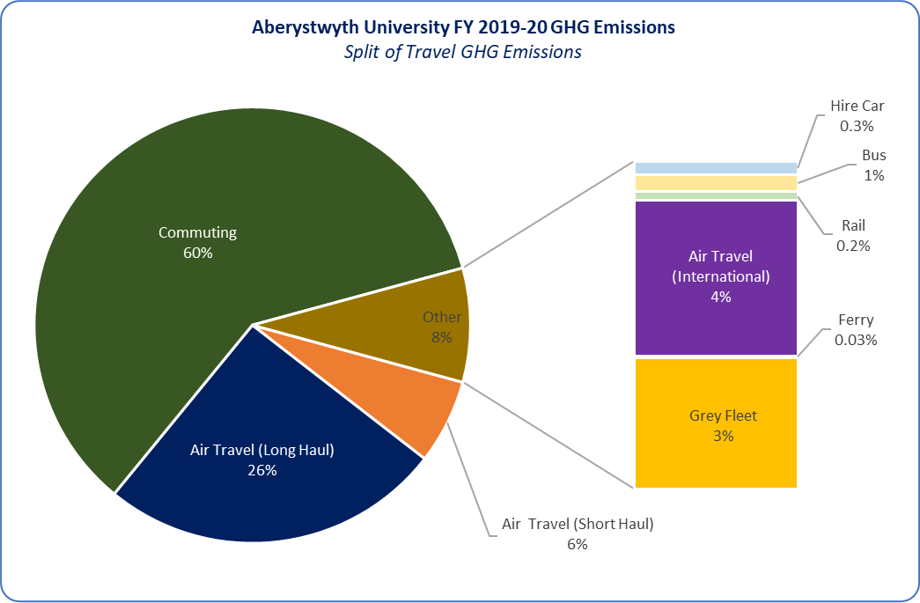
GHG emissions resulting from Aberystwyth University’s business travel activities totalled 1,680 tonnes CO₂e (10% of total operational emissions) for the 2019-20 reporting year. A detailed split of business travel emissions is provided below. This category includes emissions from wider business and academic activities.
Unlike our owned fleets where we can directly intervene to reduce emissions, reducing emissions from our Grey Fleet and from employee commuting will require the University to support our staff to adopt sustainable transport methods and provide incentives to help the transition to electric/hybrid vehicles.
A proportion of our travel emissions result from staff undertaking flights to conduct academic research and collaborate with other University’s worldwide. The challenge the University faces is ensuring that any reductions made in air travel do not come at the expense of our worldwide reputation and role as a leading research institute.
Figure 5 (top) & Figure 6 (bottom) - Percentage of travel & transport GHG emissions as part of AU's overall FY 2019-20 emissions footprint ; Percentage split of transport emissions by source.
The University also recognises that it has an important role to play in decarbonising its own vehicle fleet as well as supporting our employees to make more sustainable transport choices.

Travel & Transport – Key Decarbonisation Actions
We have identified several actions to reduce GHG emissions associated with our travel and transport activities (including academic travel). To inform our priorities and the potential emissions reductions which can be achieved, we have undertaken modelling of a series of reduction measures listed in the following table. Decarbonisation actions in this section have been developed based on potential reduction/transition targets in 2030 for our University fleet, employee grey fleet, staff commuting, and air travel.
Emissions Reduction Impact descriptions are based upon the following ranges: Low (< 250 tCO₂e), Medium (250 – 500 tCO₂e), High (> 500 tCO₂e).
Activity Area | Key Action(s) | Action Reference | Action Details | Potential GHG Emissions Reduction (tCO₂e) | Potential Emissions Reduction Impact (Low/Med/High) | Action Owner & Target Implementation  Date(s)
Employee Business Travel & Commuting  (Grey Fleet & Commuting) | Target 75% of personal vehicles used to transition to electric/hybrid alternatives | TRA01 | Develop and implement a targeted salary sacrifice scheme to support our staff transition to electric vehicles.  Action targets our aspiration to have up to 75% of private car commuting and grey fleet mileage completed by electric alternatives by 2030. | 912 | High | Pro Vice-Chancellor Faculty of Earth & Life Sciences
Air Travel | Reduce international travel by 30% | TRA02 | Air travel accounts for a significant proportion of our travel emissions. The action targets an aspiration for a 30% reduction in air travel.  A series of supporting actions to support our ambition are included within the ‘Supporting Actions’ table below. | 491 | Medium | Pro Vice-Chancellor Faculty of Earth & Life Sciences
University Vehicle Fleet | Transition vehicle fleet to EV (except agricultural vehicles) | TRA03 | Investigate and implement opportunities to transition our university vehicle fleet to electric vehicles between now and 2030. Action targets a transition to a fully electric fleet.  A series of supporting actions to support the transition are provided within the ‘Supporting Actions’ table below. | 128 | Low | Operations Manager, EF&R
Employee Commuting | Target a 30% reduction in commuting mileage | TRA04 | Develop and implement programme of ongoing engagement with student/staff members to promote sustainable and active travel options for commuting and for business travel, to target a further 50% reduction in private car emissions by 2030.  The following actions should be considered:  - Subsidised public transport grants.  - External partnership opportunities (Hywel Dda, local authority)  - Lift-share schemes  - Using local car clubs  This can be facilitated through existing focus groups and sustainability panels the University has in place. | 106 | Low | Sustainability Advisor
Business Travel & University Vehicle Fleet | Target a 33% reduction in business mileage | TRA05 | Seek to reduce business mileage by 30% through changes to travel policy. The following actions should be considered:  - Public transport prioritised for business travel where possible.  - Implement a sustainable travel policy to encourage business travel mileage reduction.  - Implementation of Targeted behaviour change programmes  This can be facilitated through existing focus groups and sustainability panels the University has in place. | 28 | Low | Pro Vice-Chancellor Faculty of Earth & Life Sciences
 |  |  | Combined GHG Emissions Reduction Potential (tonnes CO₂e) | 1,665 | High
 |  |  | Percentage Reduction versus 2019-20 Baseline GHG Emissions | 54%
The projected carbon emissions reduction potential should all the above measures be implemented is 1,665 tonnes CO₂e: reducing the GHG emissions footprint of our travel and transport activities to 1,425 tonnes (a 54% reduction on our 2019-20 baseline). The actions in the table above are designed to show the magnitude of decarbonisation activities which will be required to achieve sufficient emissions reductions. Actual emissions savings when actions are implemented may differ from the results shown in the table above. The University will continue to keep abreast of technological updates (e.g. hydrogen, battery HGVs/plant equipment) and solutions which will allow us to transition as much of our fleet to electric/hybrid alternatives as possible.
Air travel will continue to be a significant part of our academic travel requirements. The University will work with our academic and support departments to understand where suitable reductions can be made to help reduce unnecessary air travel; and reduce emissions.

Travel & Transport – Supporting Actions
We have identified several actions to reduce GHG emissions associated with the use of our vehicle fleet as well as from wider business/academic travel undertaken by our staff. These actions are focused not only on practical measures to reduce our emissions but also on improving the quality of transport data that is available to support future reporting and inform reduction activities. All actions listed in the table below have been developed in consultation with representatives from a variety of University departments.
Activity Area | Key Action(s) | Action Reference | Sub Actions | Action Owner(s) | Target Implementation Date(s)
Staff Business &,  Academic Travel, and Commuting | Support staff to decarbonise their business, academic, and commuting travel. | TRA06 | Undertake a review with academic departments to assess current business travel requirements for staff and students, ensuring that sustainability has major weighting in determining the requirement for travel (especially overseas to long-haul destinations). | Operations Manager, EF&R | 2024
Staff Business &,  Academic Travel, and Commuting |  | TRA07 | Set interim targets between now and 2030, to gradually reduce the amount of air travel completed by staff members for business and academic travel. | Pro Vice-Chancellor Faculty of Earth & Life Sciences | 2024
Staff Business &,  Academic Travel, and Commuting |  | TRA08 | In consultation with academic and support departments, develop a set of rules surrounding air travel which are designed to reduce unnecessary travel as well as reducing travel emissions. Rules can include (but are not limited to):  - No first or business class flights for those journeys which are less than 6 hours  - Internal journeys within the UK have to be completed by public transport/own vehicles rather than by air where possible.  - International travel to be signed off by department leads once the need for travel has been determined. | Pro Vice-Chancellor Faculty of Earth & Life Sciences | 2024
Staff Business &,  Academic Travel, and Commuting |  | TRA09 | Using the outputs of the first three sub actions, develop a university-wide Sustainable Transport Policy to help formalise targets and set ambitions for decarbonisation. The Policy must include provisions for the following:  - Reducing unnecessary travel across all modes  - Preference to use public transport over air travel for UK journeys.  - Specific rules surrounding longer haul air travel.  - Encouraging staff to work from home as much as possible.  Ensure this policy is reviewed and maintained on a regular basis (at least annually) to support Net Zero Carbon by 2030 ambitions. | Pro Vice-Chancellor Faculty of Earth & Life Sciences | 2024
Staff Business &,  Academic Travel, and Commuting | Support staff to decarbonise their business, academic, and commuting travel | TRA10 | Investigate opportunities to improve the active travel facilities (e.g., improving cycle provision) of our sites to enable both staff, students and visitors to choose low carbon forms of transport. | Space Manager | Ongoing
Staff Business &,  Academic Travel, and Commuting | Governance & Monitoring | TRA11 | In consultation with academic and support departments, develop a series of university-wide sustainability targets for travel and transport activities. These targets will be used to monitor progress in reducing our emissions from travel. | Pro Vice-Chancellor Faculty of Earth & Life Sciences | 2024
Staff Business & Academic Travel | Improving the quality and collation of travel data. | TRA12 | Undertake a detailed assessment of the type and quality of business travel data which is available across all academic and operational faculties of the University.  Work with these departments to continually improve the quality of reported data to allow for accurate GHG assessment as part of Welsh Government annual reporting and to support the development of reduction targets. | Operations Manager, EF&R | 2023
Staff Business & Academic Travel | Improving the quality and collation of travel data. | TRA13 | Review current data collection methodologies for business travel with the aim of incorporating travel booking system data within datasets used to calculate annual GHG emissions.  Update our existing Travel Request Form to make the following information mandatory:  - Mode of travel  - Destination airport/location  - Class of travel (flights only)  - Distance (if known)  - Single or Return trip | Operations Manager, EF&R | 2024
University Vehicle  Fleet | Transition our Vehicle Fleets to Low Carbon/EV/hybrid alternatives | TRA14 | Develop a strategy to support the transition to electric vehicles within AU operations. Transition all small/medium fleet vehicles to EV in the first instance before reviewing alternatives for plant and agricultural vehicles. | Operations Manager, EF&R | 2024
University Vehicle  Fleet |  | TRA15 | Where EV/hybrid alternatives are not available ensure the most efficient petrol/diesel vehicles are procured when vehicles are replaced. Consider vehicles which maximise fuel efficiency but can still provide the same performance levels to meet operational requirements. | Operations Manager, EF&R | Ongoing
University Vehicle  Fleet |  | TRA16 | Continue to keep abreast of advances in hybrid/EV technologies for large commercial vehicles and plant, particularly agricultural vehicles. | Operations Manager, EF&R | Ongoing

Key Theme 3 – Agriculture
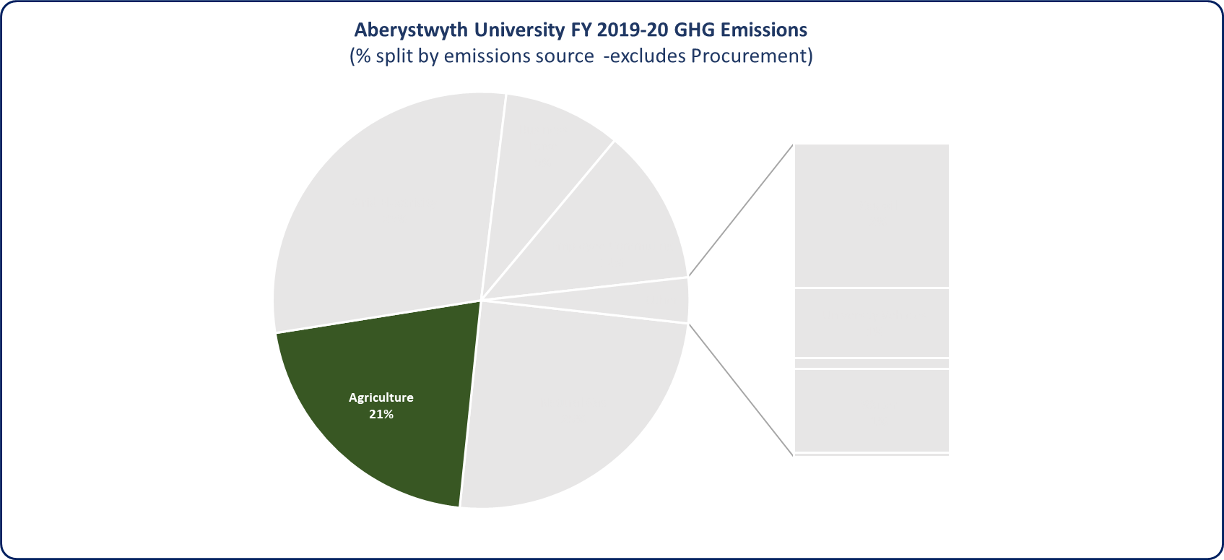
GHG emissions arising from our agricultural activities’ accounts for a significant proportion of the University’s direct GHG emissions footprint. For the 2019-20 reporting year emissions arising from our sheep flocks, cattle herds, the use of fertilisers, and animal husbandry totalled 4,301 tonnes CO₂e (21% of our operational GHG emissions). It should be noted that GHG emissions arising from the operation of farm buildings and machinery are included within Key Themes 1 (Buildings & Estates) and 2 (Travel & Transport).

Figure 7 - Percentage of agriculture GHG emissions as part of AU's overall FY 2019-20 emissions footprint.

Unlike other emissions sources within our GHG emissions footprint, agricultural greenhouse gas emissions are focused upon the emission of methane and nitrous oxide (converted to carbon equivalents) from fertiliser use, animal husbandry and other agricultural practises. These greenhouse gases are more difficult to reduce as they result from complex natural soil and animal microbial processes, changes in local climatic conditions and have severe limitations associated with their measurement.
As a leading research institute for sustainable agriculture as well as our role as the lead organisation within the Farm Business Survey (FBS), the University however has the opportunity to identify and apply innovative solutions to reduce the environmental impacts of our herds, as well as supporting the rest of the agriculture sector in Wales to decarbonise.

Agriculture – Key Decarbonisation Actions
We have identified several actions to reduce GHG emissions associated with our agricultural estate. These actions are focused upon not only active decarbonisation measures which can be implemented, but also how we can look to support our world-leading sustainable agriculture research programmes.
Activity Area | Key Action(s) | Action Reference | Sub Actions | Action Owner(s) | Potential Emissions Reduction Impact (Low/Med/High) | Target Implementation Date(s)
Agriculture | Improved GHG measurement | AG01 | University Farms and Research departments to develop an improved methodology for estimating carbon emissions from agricultural activities by end of 2023. | AU Farms / Agricultural Research | Low | 2025
Agriculture | Reduce agricultural GHG emissions | AG02 | University Farms team to develop ambitious and deliverable SMART targets for 2030, along with an action plan, detailing measures to reduce carbon emissions by end of 2023. | AU Farms / Agricultural Research | High | 2025

Key Theme 4 - Land Use & Sequestration
Land is a critical natural asset. It provides us with the fundamentals of life: clean water, food, timber, maintaining biodiversity, and the natural regulation of hazards such as flooding. Land assets can also be transformed to be substantial terrestrial carbon sinks. In addition, the best carbon stocks are ones that persist over time (multidecadal timescales).
Aberystwyth University owns and maintains over 1,600 hectares of land, which is used to support teaching, research, commercial arable and livestock farming. As a significant landowner within the local area, the University has a responsibility to ensure our land management practises look to enhance existing carbon sequestration potential. We recognise that sequestration from our land assets will also play a crucial role in helping the University to sequester our unavoidable GHG emissions to achieve Net Zero Carbon by 2030.
Based on our submission to Welsh Government the carbon sequestration potential of our land assets for our baseline 2019-20 reporting year is 2,718 tonnes CO₂e. The charts below show the proportion of various land use types (measured in hectares) and sequestration potential, as defined by Welsh Government’s Public Sector Net Zero Carbon Reporting guide. The vast majority of land owned and maintained by the University is grassland, which is largely used for research purposes and also to support commercial farmland (grazing for cattle & sheep, crops) operations.
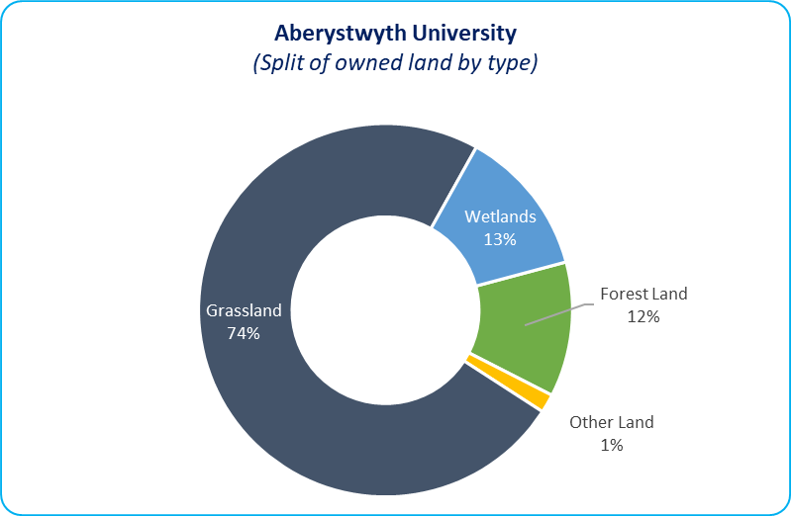
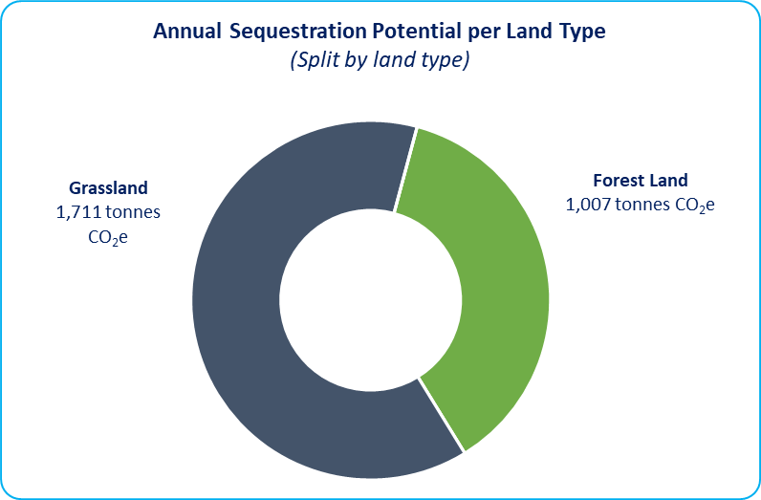
Figure 8 (left) & Figure 9 (right) – Split of AU owned land by type and associated sequestration potential.

Land Use & Sequestration - Key Actions
The University is currently in the process of completing a programme of tree planting which is expected to increase the sequestration potential of our land assets by circa 109 tonnes CO₂e per annum. In 2030 we are currently forecasting a sequestration potential of 2,948 tonnes per annum however this is likely to be subject to significant change through future acquisitions/disposals of land assets. In addition to this programme we have also identified the following actions which will help to increase the carbon sequestration potential of our land assets.
Activity Area | Key Action(s) | Action Reference | Sub Actions |  | Action Owner(s) | Target Implementation Date(s)
Land Use & Management | Enhancing our land use and supporting biodiversity | LU01 | Determine whether there is underutilised land and/or green spaces across the estate that could be enhanced and/or redeveloped to enhance carbon sequestration, support biodiversity and support biophilic design (to encourage people to connect with the natural environment) |  | Director finance and corporate services | Ongoing
Land Use & Management | Enhancing our land use and supporting biodiversity | LU02 | Identify opportunities to expand our current tree planting programme (where appropriate) and land use management to support future sequestration of GHG emissions. |  | Director finance and corporate services | Ongoing
Land Use & Management | Enhancing our land use and supporting biodiversity | LU03 | Utilise land management and sustainable agriculture research conducted by the University to inform the initial development and continued update of our land management strategy.  Identify opportunities to release under-utilised or fallow farmland from agricultural activity to support habitat restoration or afforestation (trees/hedgerows) increasing future sequestration potential and biodiversity across the University Estate. |  | AU Farms / Agricultural Research | Ongoing
Land Use & Management | Enhancing our land use and supporting biodiversity | LU04 | Work with Welsh Government to help develop improved methodology for quantifying carbon sequestration for land use, focusing upon the sequestration potential of peatland. Peatland carbon sequestration is not currently account for in Welsh Public Sector Net Zero reporting. | AU Farms / Agricultural Research |  | Ongoing

Key Theme 5 - Waste Reduction & Minimisation
Another indirect and highly visible impact of our operations is the generation of waste and its subsequent disposal. As part of our Waste Management Policy a number of initiatives and behavioural change campaigns are already underway to help achieve this ambition.
The University is currently implementing a suite of measures to reduce waste across our operations but are aware that further opportunities exist to reduce waste.

Waste Reduction & Minimisation - Key Actions
Activity Area | Key Action(s) | Action Reference | Action  Owner(s)
Waste Reduction & Minimisation | Seek to reduce business wastes (including paper and single-use plastics) generated in our operations across all departments through targeted audits and engagement. | WR01 | Sustainability Advisor & Head of Facilities Management
Waste Reduction & Minimisation | Identify opportunities to help digitise our existing systems by adopting a digital-first approach; reducing the amount of wastepaper generated. | WR02 | Sustainability Advisor & Head of Facilities Management
Waste Reduction & Minimisation | Expand the use of asset reuse schemes such as Warp-it to reduce the amount of material being disposed to landfill. | WR03 | Sustainability Advisor & Head of Facilities Management

Procurement
The procurement of goods and services represents Aberystwyth University’s largest indirect environmental impact but also a significant opportunity to support cross-sector decarbonisation across our supply chain. GHG emissions resulting from Aberystwyth University’s Procurement activities totalled 29,083 tonnes CO₂e. The majority of our procurement emissions are associated with research equipment, ICT, and construction accounting for 32% 26%, and 19% and of total procurement emissions respectivley
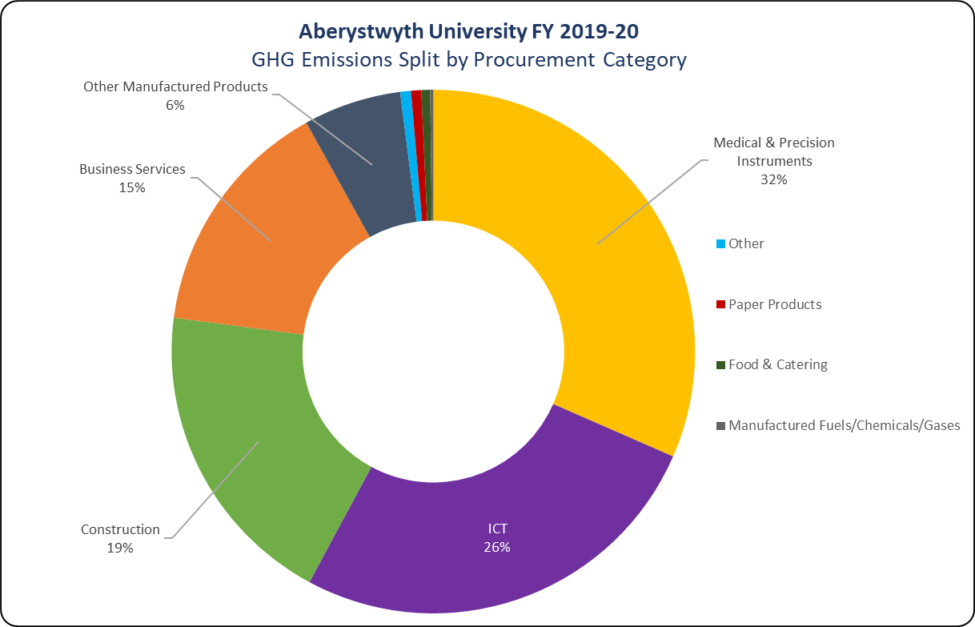

Figure 10 - FY 2019-20 Procurement GHG emissions split by procurement category.

The first two years of Welsh Government reporting has included a requirement to carry out a screening exercise for emissions resulting from procured goods and services. Welsh Government are in the process of refining the methodology that is currently being used to determine the carbon emission related to certain procurement spend and it is likely that a different mechanism is used in future years for determining the impact. The scale and the variety of the services and goods that we procure represents a significant challenge in being able to set meaningful emissions reduction targets across our supply chain.
In the first instance, Aberystwyth University (AU) will take the approach to develop an indicative benchmark of our procurement emissions with a view towards using this to inform an engagement strategy with our suppliers. This will allow AU to determine the level of carbon management that already exists within our supply chain and to develop a series of active intervention measures to reduce our GHG emissions in this area. We will also look to understand how our current behaviours surrounding procurement contribute to our GHG emissions and will identify actions to improve the sustainability of our procured goods.

Procurement - Key Actions
We have identified several actions to reduce GHG emissions associated with our procurement activities. These actions are focused in the first instance in improving the visibility of carbon emissions and management within our supply chain, to enable the University to develop robust and meaningful actions and set targets to reduce emissions.
Activity Area | Key Action(s) | Action Reference | Sub Actions | Action Owner(s) | Delivery Timescales
Procurement | Sustainable Procurement Strategy | PR01 | Develop and publish a Sustainable Procurement strategy using results of the 2019/20 footprint to aid interaction with our suppliers considering the following key elements (outlined in the following Key Actions) | Procurement Manager | 2024
Procurement | Supplier &  Supply Chain Engagement | PR02 | Develop and implement a programme of supplier engagement throughout the procurement process and contract delivery to encourage and support ongoing decarbonisation of their operations, as well as support the improved quantification of the University’s supply chain emissions.  Set an interim target to engage with at least 50% of the University’s largest suppliers by 2025, with an aspiration to increase this to at least 75% by 2030. | Procurement Manager | 2025
Procurement | Supplier &  Supply Chain Engagement | PR03 | Review current processes for reviewing suppliers and contractors within our procurement activities. Update our current process to ensure we are actively evaluating decarbonisation commitments from suppliers and considering their relative award weighting against value within tenders. | Procurement Manager | 2025
Procurement | Supplier &  Supply Chain Engagement | PR06 | Undertake internal engagement with different faculties within the University to understand how procurement activities fit in within our Net Zero by 2030 Strategy. | Procurement Manager | 2025
Procurement | Measurement & Reporting | PR07 | Continue to feedback and support Welsh Government with the ongoing development of their Public Sector Reporting – particularly for supply chain emissions. | Sustainability Advisor | Ongoing

Responsibilities and Governance
It is important that our Net Zero Carbon by 2030 Strategy has ownership to drive it forward and to adapt to take advantage of all opportunities and advances in climate change research. A strategic approach to promoting, planning and delivering the changes required to deliver our Strategy will provide the greatest opportunity for impact, resource use, capacity and carbon reduction.
The University Executive team and Sustainability Committee, with appropriate representation, will be responsible for ensuring the Actions outlined in this strategy are delivered.

Financing
It is vital that sustainability and our net zero target is considered in decision-making outside of the normal decarbonisation project space, including influencing supply chains. Additionally capital budgets and spending must align with the decarbonisation agenda. Achieving Net Zero 2030 will require Aberystwyth University to scrutinise all of its activities and take appropriate action where necessary. This will require more emphasis placed on environmental considerations.
Due to the scale of investment required, we need to explore all funding sources to help support delivery of actions. Due to the scale of investment required, significant external funding support will be a key requirement to help achieve the actions and meet the reduction targets by 2030.

Risks & Constraints
Aberystwyth University has identified the following risks and potential constraints which may limit the ability to meet our Net Zero by 2030 target. To this end we have also included examples of mitigation strategies we will look to implement to mitigate these risks.
Key Theme | Identified Risk/Constraint | Mitigation Strategies
All Themes | Insufficient capacity across AU and within individual service areas to deliver the actions identified within this NZC Strategy. | - Identify and assign responsibility to appropriate SLT leads for delivery of action plan.  - Consider opportunities to align roles and processes to coordinate activities, maximise efforts and promote achievements.  - Embed into existing governance arrangements.  - Integrate actions into Universities Strategic Plans and identify budget to support delivery
All Themes | Insufficient funding availability to deliver the NZC Strategy | - Integrate actions into individual Directorate/ Service area Planning.  - AU will need to commit resources and make financial allocation decisions for 2022/23 onwards  - Take advantage of opportunities for external funding to deliver actions, including The Wales Funding Programme, Invest to Save Schemes and WG funding.
All Themes | Support required from other partners to deliver actions within the NZC Strategy | - Identify opportunities for partnership projects with other Public/Private sector organisations to support funding opportunities  - Capture opportunities to work with WG and other available services including the Welsh Government Energy Service and Carbon Trust
All Themes | Managing the breadth and cross cutting scope of the NZC Strategy to align resources and capacity | - Establishment of a Strategic Decarbonisation Delivery Group  - Action Leads report to the Strategic Decarbonisation Delivery  - The Strategic Decarbonisation Delivery Group report to University Exec etc.

Appendix 1 – References & Supporting Documentation

Reference Scenario Model
Detailed in this section are detailed scenario modelling results which have been undertaken to support the development of the Net Zero Carbon by 2030 Strategy. Outlined below is a trajectory model which compares projected emissions in 2030 for a Business-as-Usual scenario versus a University Wide Decarbonisation scenario.
The Business-as-Usual scenario assumes that the University does not implement active decarbonisation measures; with emissions reductions only being achieved through the passive decarbonisation of the National Grid. By comparison the University Wide Decarbonisation scenario models the projected impact a series of active decarbonisation measures will have upon emissions. Emissions reduction projects are focused only upon the University’s built estate and travel & transport activities.
All GHG emissions totals in the model reflect the University’s net GHG emissions footprint, which factors in the sequestration potential of our land assets. The Reference Scenario Model will be updated on an annual basis to include further identified decarbonisation projects across other emissions sources, as well as reflect our annual GHG emissions footprint which is reported to Welsh Government.
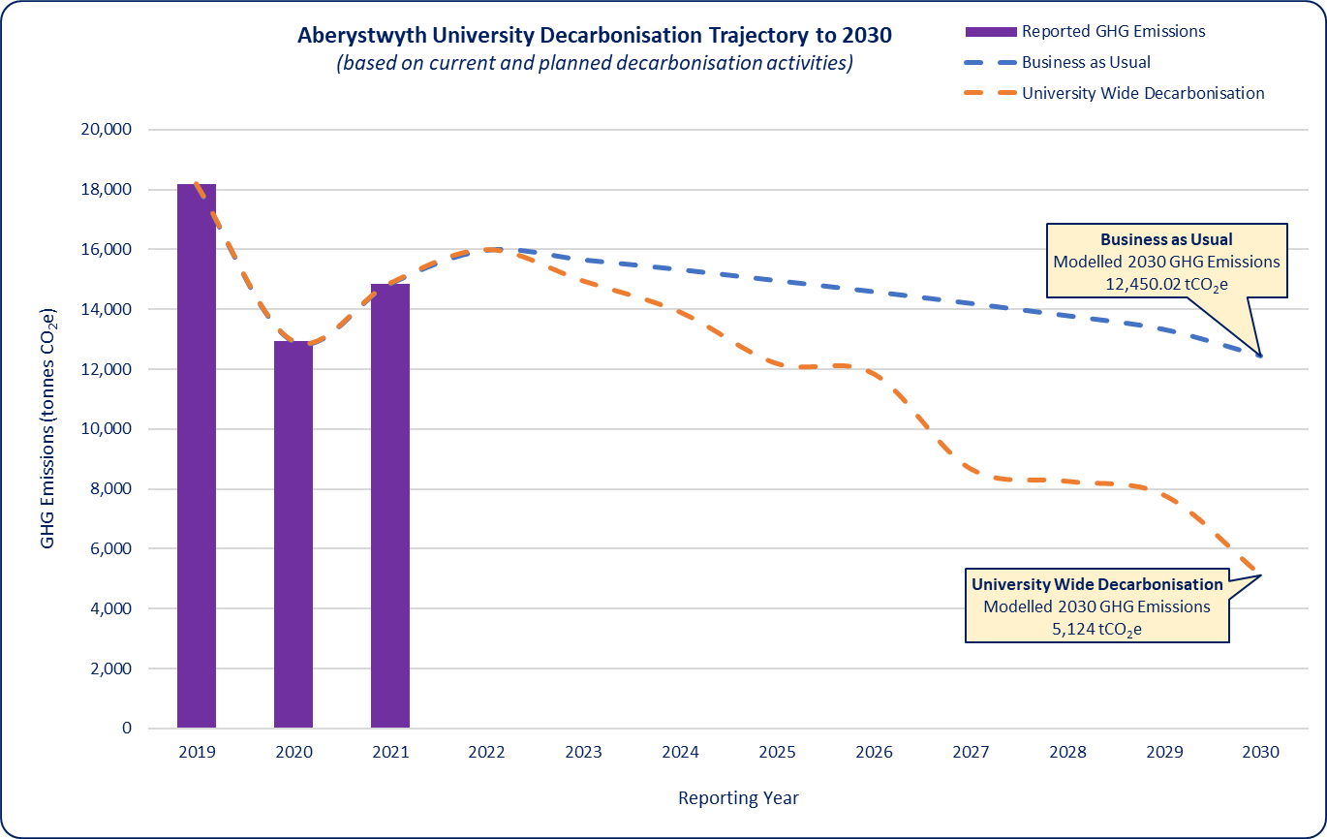Figure 11 - Reference Scenario Model used to inform our Net Zero by 2030 Strategy.

- - - END OF STRATEGY DOCUMENT - - -



Committee on Climate Change (June 2021) ‘Independent Assessment of UK Climate Risk’ (Third Climate Change Risk Assessment) (https://www.theccc.org.uk/publication/independent-assessment-of-uk-climate-risk/)
Committee on Climate Change (June 2022) ‘Progress in reducing emissions 2022 Report to Parliament’ (https://www.theccc.org.uk/publication/2022-progress-report-to-parliament/)
Welsh Government (2019) ‘Prosperity for All: A Low Carbon Wales’ (https://gov.wales/sites/default/files/publications/2019-06/low-carbon-delivery-plan_1.pdf)
Welsh Government (2016) ‘Overview of The Environment (Wales) Act 2016’ (https://gov.wales/sites/default/files/publications/2019-05/environment-wales-act-2016-overview.pdf)
https://gov.wales/sites/default/files/publications/2022-06/welsh-public-sector-net-zero-reporting-guide.pdf
Welsh Government (2015) ‘Well-being of Future Generations Act 2015’ (https://gov.wales/sites/default/files/publications/2019-08/well-being-of-future-generations-wales-act-2015-the-essentials.pdf)

