FIRE SAFETY & EVACUATION MANUAL

This manual provides an overview of fire evacuation arrangements for the IBERS Gogerddan buildings. The information given is supplemented by specific training for key personnel.

Information is given to aid in the development of Personal Emergency Evacuation Plans (PEEPS) for staff and students in the IBERS Gogerddan Buildings should they be required. Specific procedures for the production of PEEPs are given elsewhere.

The evacuation arrangements described (in terms of Wardening) apply during normal working hours (09:00 - 17:00hrs). Outside these times the arrangements will be coordinated by Site Security and the Fire and Rescue Service.

Table of Contents

1. Rationale and synopsis of alarm system

2. Responsibilities and actions

3. Assembly Points

4. Evacuation of mobility and/or sensory impaired people

5. Fire Drill procedure

6. References

7. Appendices

7.1 List of evacuation personnel, proforma

7.2 Plans of IBERS Gogerddan & Warden Coordinator evacuation checklist

7.3 Proforma to record performance of Fire Drills

7.4 Summary details of the Deaf Alerter system

7.5 Summary of Fire Actions

1.0 Rationale and synopsis of alarm system

In the event of a fire alarm the over-riding aim is to evacuate the building promptly, efficiently and completely.

Evac Cards indicating the areas to be swept are located in holders in corridors, along with yellow Hi Viz jackets.

A Warden Coordinator clipboard, orange jacket and checklist will be located near an exit of the building.

On activation of the fire alarm, Fire Wardens will look to see if the Evac Card and jacket are in the holder. If the items are in the holder, they will put on the jacket, sweep the area shown on the Evac Card areas, asking people to leave as they go, then proceed to the Assembly point and hand the card to the Warden Coordinator. The Warden Coordinator will be any member of staff who collects the clipboard and holder as they evacuate the building. If anyone refuses or is unable to evacuate, the information is given to the Warden Coordinator, who informs the Fire and Rescue Service (FRS). If the card and jacket are already deployed they will evacuate as normal.

If staff or students of AU, contractors or other visitors do not evacuate, or refuse requests to do so following activation of the fire alarms they will subsequently be subject to disciplinary or other suitable sanctions. Information on such non-compliance to be passed by the Warden Coordinator to the AU HS&E Advisor for follow-up.

1.1 Alarm Activation

‘Continuous’ alarm sound indicates that the alarm has been triggered within that section of the building and evacuation should take place immediately.

‘Intermittent’ pulsing alarm sound indicates that the alarm has been triggered in an adjacent segment / Zone of the building. Occupants should prepare themselves for evacuation in case the alarm sounder changes to ‘continuous’.

If IBERS building goes into Continuous Alarm, all adjoining buildings will go into intermittent activation.

If William Davies building goes into Continuous Alarm, IBERS building will go into intermittent activation. All other buildings will not be activated at this point.

If PT Thomas building goes into Continuous Alarm, IBERS building will go into intermittent activation. All other buildings will not be activated at this point.

If Stapledon building goes into Continuous Alarm, IBERS building will go into intermittent activation. All other buildings will not be activated at this point.

During the ‘Intermittent’ phase of the alarm, the situation in the ‘continuous’ section will be investigated and if the cause of the alarm is an actual fire, then the whole of IBERS Gogerddan buildings will be set to ‘continuous’ and the buildings totally evacuated.

2.0 Responsibilities and Actions (during normal working hours)

2.1 Building Facilities staff

On hearing the fire alarm the Facilities staff (if available) will proceed to the incident control point at the fire alarm control panel, and follow the University Alarm Activation Incident response protocol.

Facilities Staff will be deployed by Site Security to supervise relevant building entrances or other duties as appropriate.

Once the building may be reoccupied, Site Security will notify the evacuated people either via the Warden Coordinator or directly (using a megaphone where appropriate).

Following a fire alarm activation (be it real, false or a planned fire drill) the Security staff will complete the relevant sections of the Fire Log Book.

2.2 Site Security

On arrival at the fire alarm control panel one member of the Security Team will liaise directly with the Facilities staff and FRS, if present. Once it is decided that the building may be reoccupied, Site Security staff will communicate the information to the Warden Coordinator.

2.3 Warden Coordinator

On hearing the fire alarm the Warden coordinator will collect the fire alarm clipboard and orange Hi Viz vest (storage locations for these to be determined locally) and proceed to the appropriate Assembly Point and receive reports and Evac Cards from the Fire Wardens.

On receipt of their reports the Fire Wardens may then be deployed by the Warden Coordinator to a variety of tasks, such as assisting Facilities Staff by positioning themselves at building entrances to discourage re-entry if the all-clear has not been given.

Information to be relayed back to the staff at the control panel includes:

- the location of people who refuse or cannot evacuate
- any other relevant information, for example unexpected fire hazards such as gas cylinders in transit

On receipt of the ‘all-clear’ from the FRS (or other Responsible Person such as Site Security) the evacuated people can be given permission to re-enter the building. Note: sometimes the fire alarms may be silenced before permission to re-enter has been given; on such occasions requests by people to re-enter should be rejected.

2.4 Fire Wardens

All staff are acting as Fire Wardens for their building and have an important proactive role in fire prevention. They should take ‘ownership’ of the areas around their offices and monitor their evacuation routes day-to-day and immediately report to Campus Services (or remove as appropriate) objects that present a fire safety risk (such as combustible rubbish dumped in stairwells, fire doors wedged open; fire evacuation routes compromised e.g. by furniture being ‘temporarily’ stored in corridors, anything that might impede the opening of fire escape doors). To become familiar with fire-fighting equipment in their areas and to report to the Campus Services Helpdesk if equipment vanishes or if extinguisher tags are broken. Also, to check that the Evac Cards and Hi Viz jackets are present in their holders – if not then report the situation to the HS&E office immediately.

On hearing the fire alarm the Fire Wardens should look for the Evac Card and Hi Viz jacket in the holder on the corridor; if the items are in the holder they will put on the jacket, and sweep the area shown on the card asking people to leave and ensuring doors are closed on the way out. If the card has already been deployed then the individual will immediately evacuate the building.

If people state they cannot leave (for whatever reason) they should be encouraged firmly to do so, but physical inducements should not be used. A note should be taken (name, or if not known a physical description plus location) and the information immediately passed on to the Warden Coordinator on arrival at the Assembly Point.

A note should be made of any unusual / unexpected fire hazards on their way out (e.g. gas cylinders abandoned en-route to destination).

Following arrival at the Assembly Point and delivery of information, Fire Wardens can be deployed to help manage building door entrances, keeping people within the assembly area away from the building or other tasks as requested by the Warden Coordinator.

Fire Wardens should acquaint themselves with any specific local issues and procedures such as restricted area access (darkrooms etc) and make suitable arrangements with staff responsible for those areas.

All staff in the building will be trained to act as Fire Wardens.

2.5 Building Safety and Evacuation

The responsibility to ensure that departmental staff understand and follow AU safety arrangements rests with the relevant Head of Institute and Institute Manager.

n.b. physical issues to do with buildings (such as maintenance of fire detection and alarm systems) are the responsibility of the Property Services Team in Campus Services.

3.0 Assembly Points

It is important that people evacuated from a building are located in a suitable place away from danger (such as falling debris from the burning structure) or away from where they may get in the way of Emergency Services.

Zone A | Stapledon & Blas Gogerddan | Front Carpark
Zone B | IBERS Building  PT Thomas Building  William Davies Building | Rear Car park behind William Davies Building

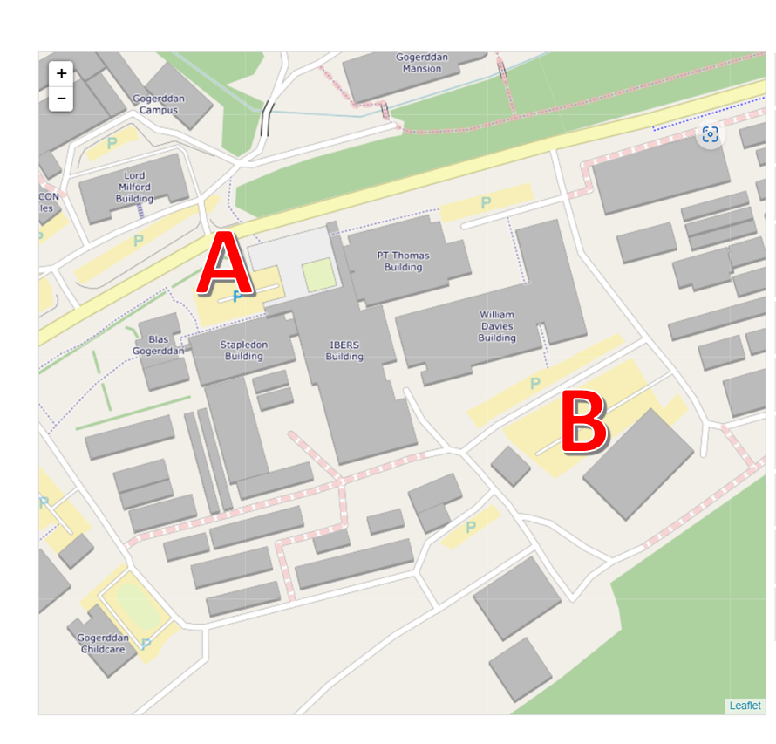
4.0 Evacuation of mobility and/or sensory impaired people

A great variety of building types and facilities exist at AU and this presents a wide range of challenges to access and egress arrangements, especially during emergency evacuation situations.

For people who cannot use stairs the principal measure to ensure safe evacuation for them (and others who may be involved) is to provide their needs (e.g. teaching space; office accommodation; computer workstations; laboratory research etc) in locations with one or more horizontal routes of egress. This should be considered the norm, with any other locations being viewed as unusual and should only be contemplated if a suitable case and management arrangements can be made by the Department concerned.

For people with auditory impairments the large majority of AU buildings have been equipped with the ‘DeafAlerter’ system to help warn individuals of an evacuation situation (see Appendix 7.6).

For people with serious visual impairments reliance is placed on a guiding companion; spatial awareness training; or the AU host (for invited visitors), to aid safe evacuation.

4.1 AU Staff and Students

On first arrival at the university an individual with a special need relevant to safe emergency evacuation will participate in the generation of a Personal Emergency Evacuation Plan (PEEP). The Health, Safety and Environment office are responsible for coordinating the PEEP process.

The methodology for generating a PEEP is documented elsewhere but will make use of IBERS building specific information given in this manual.

4.2 Visitors to AU

Visitors fall into three main classes: people attending open public events; those who are attending third party arranged meetings / conferences; or those who are invited.

Public Events at AU mainly take place in the Arts Centre and the Sports Centre where arrangements are in place to manage the evacuation of those with special needs who may arrive without prior notification. It is not expected that the IBERS Buildings will be host to such events.

Third Party Conferences at AU are arranged via the Conference Office who assist the organisers by specifying suitable locations for their meetings, including a consideration of emergency arrangements (in part by making use of information held in this manual).

Invited Visitors (including those coming to Open Days and public lectures). The AU host is responsible for ensuring that suitable emergency evacuation arrangements are in place for their visitor/s. For those with special needs (excluding mobility impaired) the arrangements would usually consist of supervision and guidance by the host or representative (following suitable dialogue with the visitor to ascertain needs).

Visitors with mobility impairments (essentially where stairs cannot be used) must currently be accommodated in areas with horizontal routes of egress (see below for details).

4.3 Evacuation routes for people who cannot use stairs

PEEP development guidance on areas in Llandinam that can / should not be occupied by people who cannot use stairs.
Floor | Stapledon | Ibers | William Davies | PT Thomas
Level 0 | Horizontal evacuation route available. | Horizontal evacuation route available. | Horizontal evacuation route available. | Horizontal evacuation route available.
Level 1 | No Level routes from this floor.
Level 2 | No Level routes from this floor.

5.0 Fire Drill Procedure

Fire drills should be carried out each year during the autumn term.

The HS&E office will liaise with the Department represented in the building concerned, so as to try and avoid sensitive dates and times (e.g. Open Days, Examinations etc).

Site Security will ensure the appropriate communications with the Alarm Receiving Centre and the FRS take place.

Site Security will initiate the drill and the guidelines given in Section 2 will be followed.

Where appropriate, it is good practice during drills for some fire Wardens to act as a ‘fire’ in commonly used routes and ask evacuating staff to seek out the alternative escape routes.

6.0 References

6.1 Fire Safety Risk Assessment - Educational Premises. HM Government (2006)
Available via:
http://www.aber.ac.uk/safety-environment/english/handbook/proc_and_pracs/fire_safety/rro_guides.shtml

6.2 Fire Risk Assessment – IBERS, Stapledon, PT Thomas, William Davies

Appendices
7.1 Building plans
Stapledon
Ground Floor

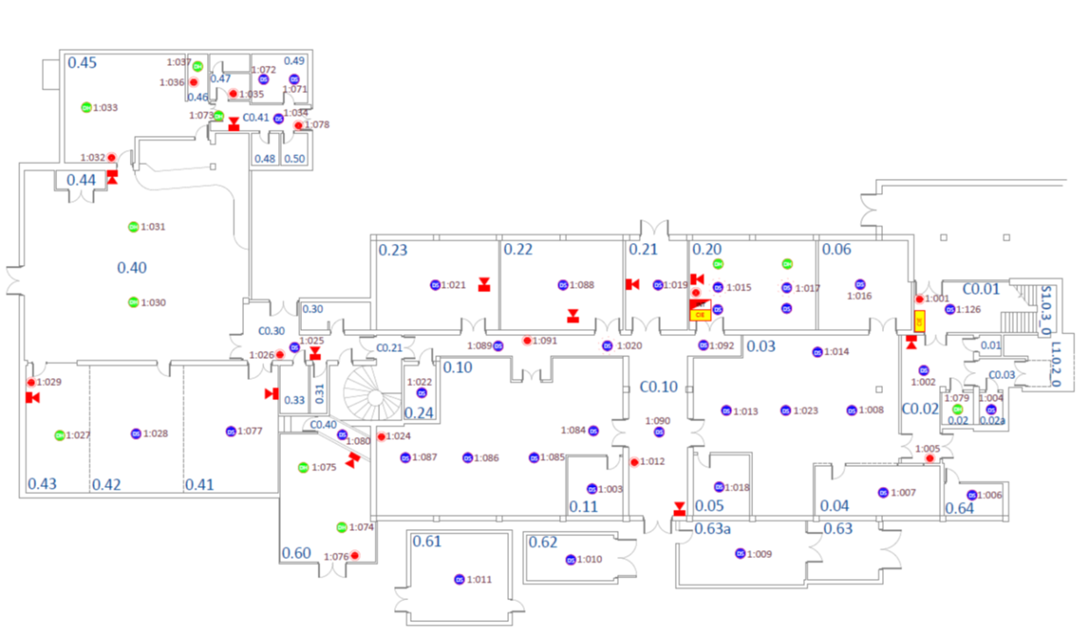
First floor

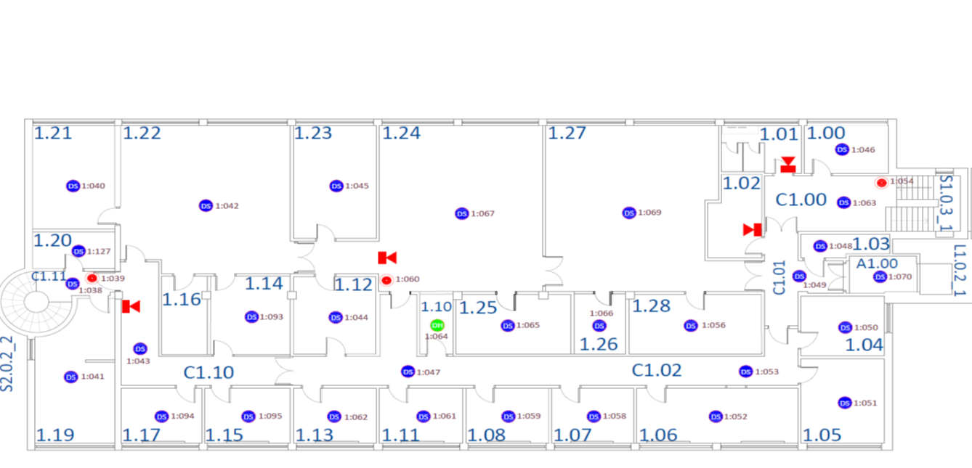
Second Floor
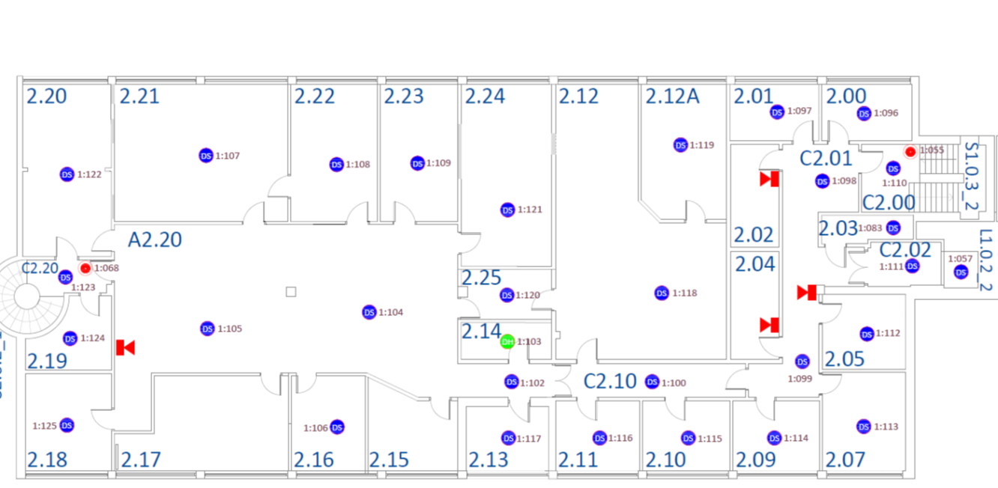
IBERS
Ground Floor
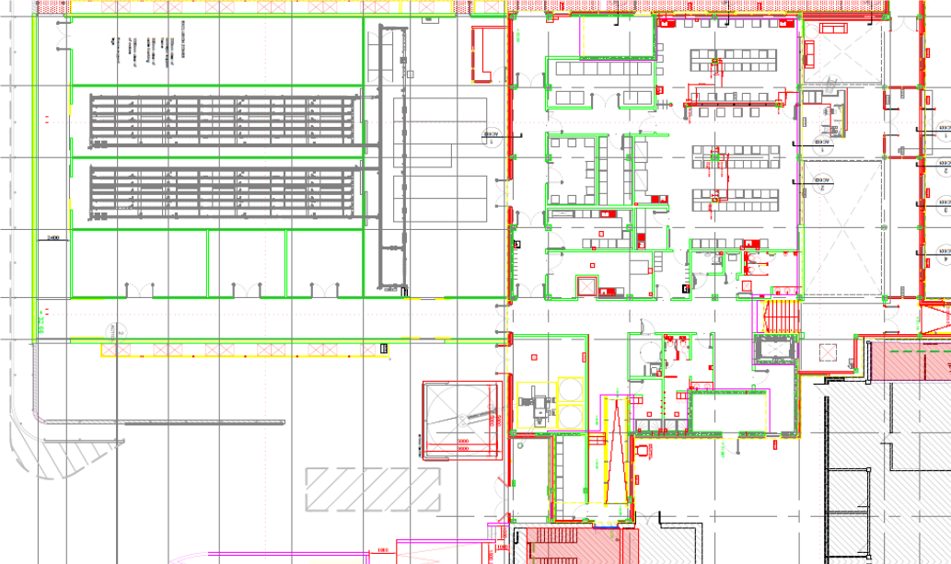

First Floor
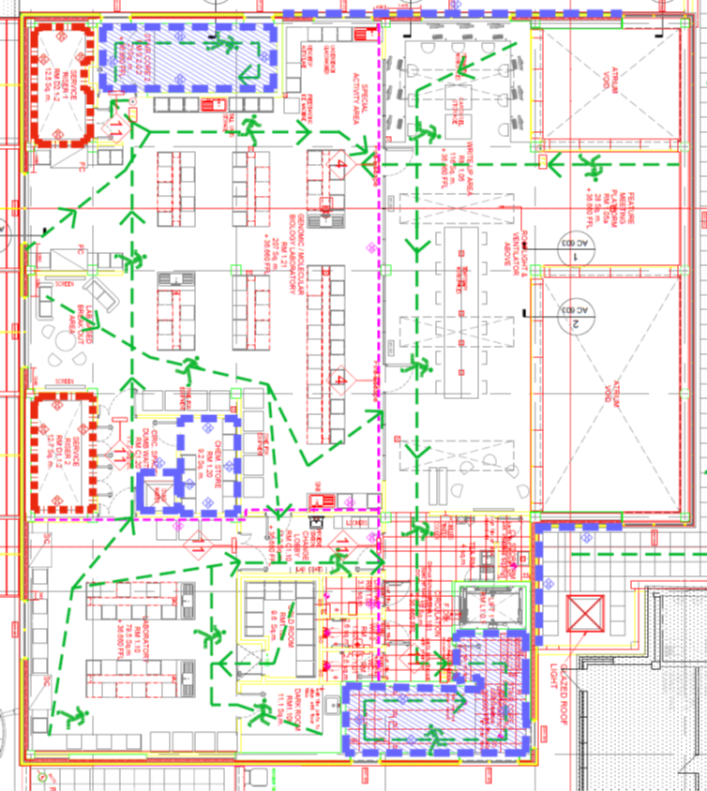

William Davies
Ground Floor
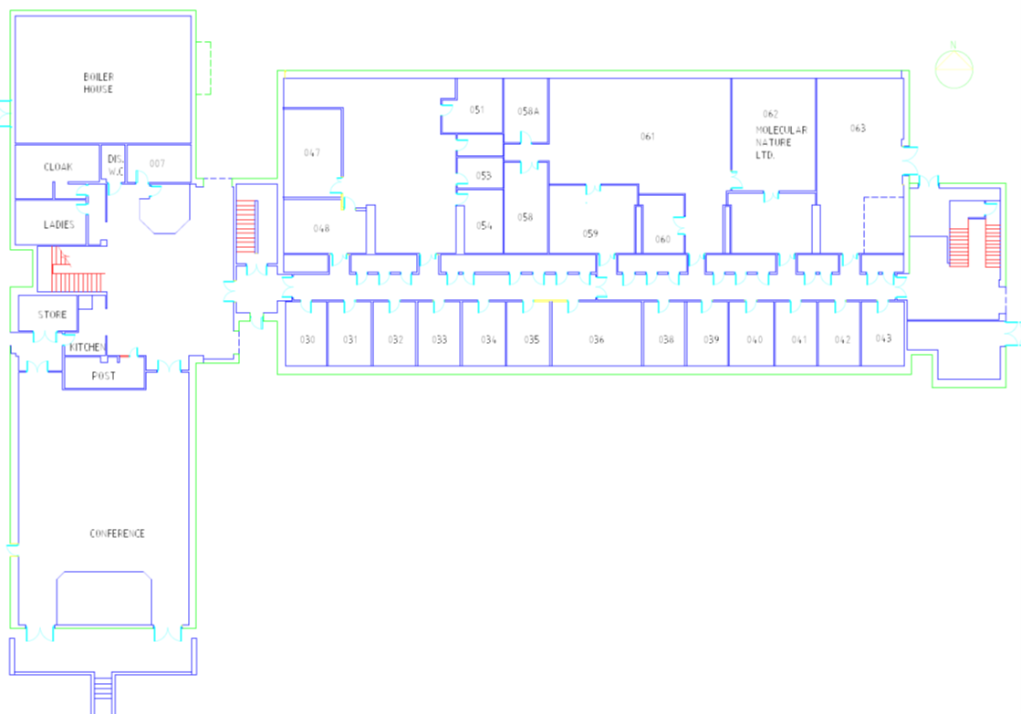

First Floor
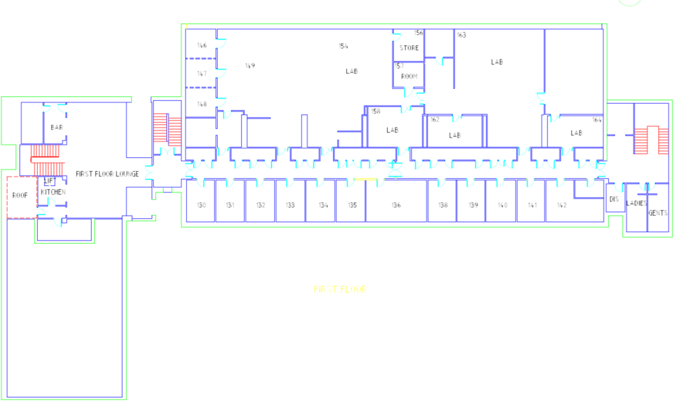
Second Floor
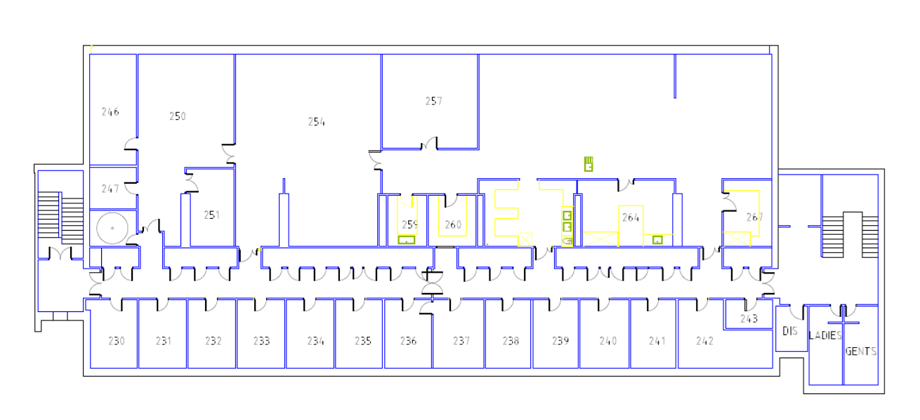

PT Thomas
Ground Floor
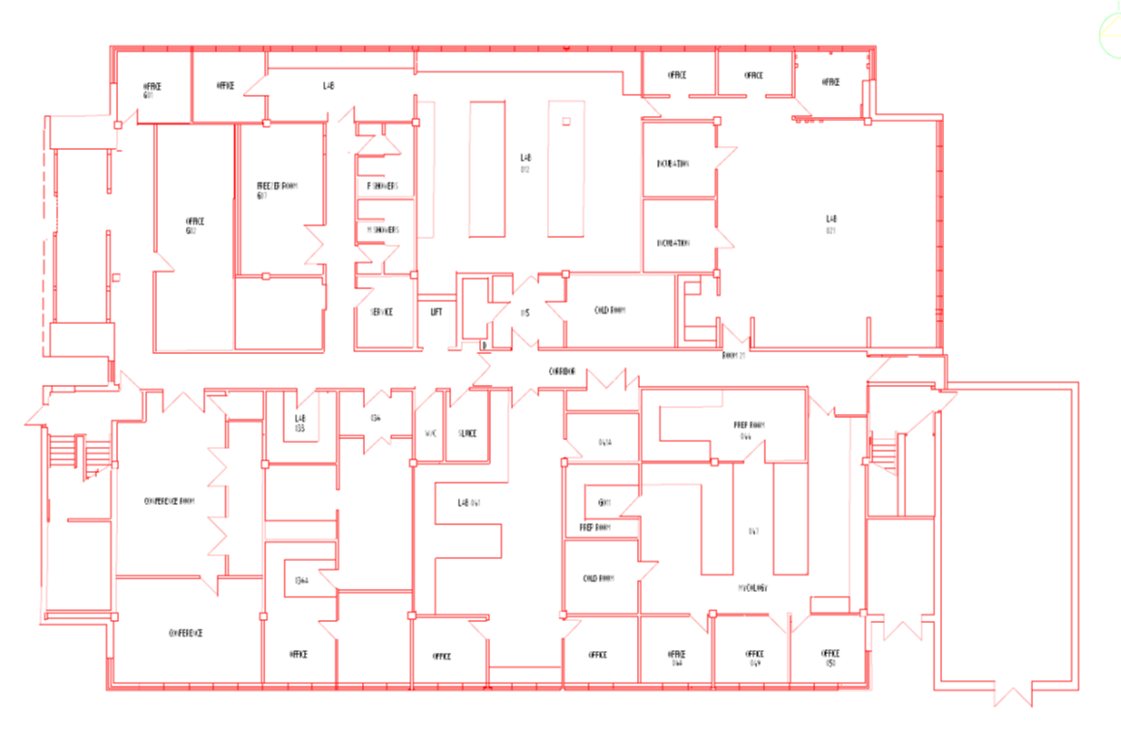
First Floor
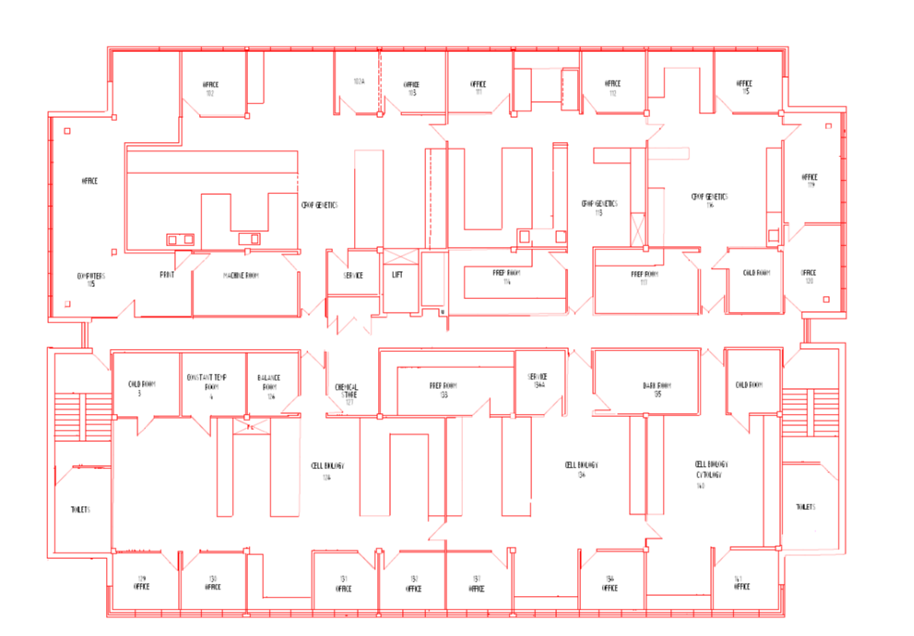
Second Floor
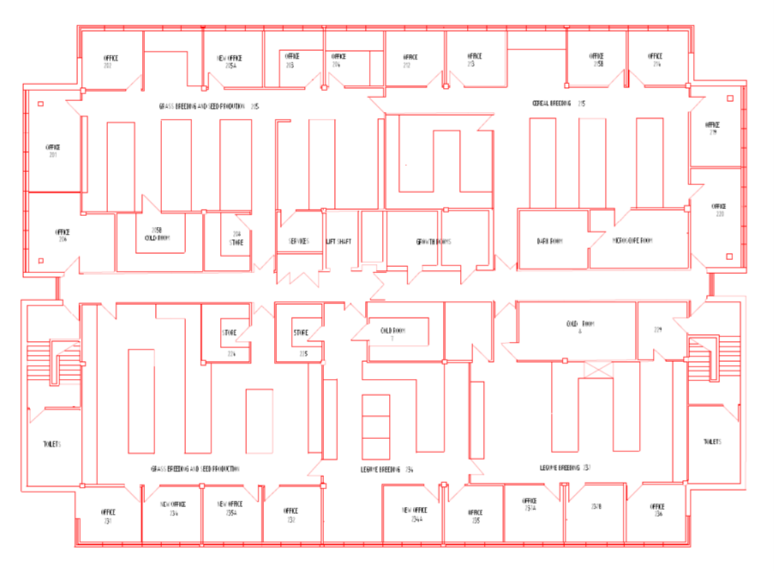

7.3 Proforma to record building clearance during evacuation
Stapledon

Fire Warden Coordinator Checklist

- Put on Orange Jacket

- Take clip board to assembly point.

- Collect cards from wardens.

- Redeploy Fire Wardens to stop people re-entering building.

- Receive instructions from Site Security/FRS to re-enter building.

Date of Alarm Activation ……………………………..

Time ………………………………

 |  | Area Cleared/Comments
Floor 0 | F0 A  F0 B
Floor 1 | F1 A  F1 B
Floor 2 | F2 A  F2 B
Comments on evacuation

Name of Warden Coordinator…………………………………………

7.3 Proforma to record building clearance during evacuation
IBERS

Fire Warden Coordinator Checklist

- Put on Orange Jacket

- Take clip board to assembly point.

- Collect cards from wardens.

- Redeploy Fire Wardens to stop people re-entering building.

- Receive instructions from Site Security/FRS to re-enter building.

Date of Alarm Activation ……………………………..

Time ………………………………

 |  | Area Cleared/Comments
Floor 0 | F0 A  F0 B
Floor 1 | F1 A  F1 B
Comments on evacuation

Name of Warden Coordinator…………………………………………

7.3 Proforma to record building clearance during evacuation
William Davies

Fire Warden Coordinator Checklist

- Put on Orange Jacket

- Take clip board to assembly point.

- Collect cards from wardens.

- Redeploy Fire Wardens to stop people re-entering building.

- Receive instructions from Site Security/FRS to re-enter building.

Date of Alarm Activation ……………………………..
Time ………………………………

 |  | Area Cleared/Comments
Floor 0 | F0 A  F0 B  F0 C
Floor 1 | F1 A  F1 B
Floor 2 | F2 A  F2 B
Comments on evacuation

Name of Warden Coordinator…………………………………………

7.3 Proforma to record building clearance during evacuation
PT Thomas

Fire Warden Coordinator Checklist

- Put on Orange Jacket

- Take clip board to assembly point.

- Collect cards from wardens.

- Redeploy Fire Wardens to stop people re-entering building.

- Receive instructions from Site Security/FRS to re-enter building.

Date of Alarm Activation ……………………………..

Time ………………………………

 |  | Area Cleared/Comments
Floor 0 | F0 A  F0 B
Floor 1 | F1 A  F1 B
Floor 2 | F2 A  F2 B
Comments on evacuation

Name of Warden Coordinator…………………………………………

7.3 FIRE DRILL REPORT BY HS&E Office

Location of Fire Drill (Building/Premises/Zone):
Date: | Time:
Total Number of Participants:
Time Taken to Evacuate Building/Premises/Zone:
Miscellaneous Information:
(Give details of any important factors affecting the fire drill e.g. deliberate blocking of exits to simulate inaccessibility; weather conditions, etc.)
Problems Identified |  | Action Required:
Signature………………………….  (Print Name)……………………… |  | Date:………………………………………..

7.4 Summary details of the Deaf Alerter system

Deaf Alerter at AU 
Deaf Alerter
A radio based fire alarm warning and messaging system
Introduction
Aberystwyth University have installed a new radio-based fire alarm system for deaf and hearing impaired visitors, students and staff. The system is available in most University buildings. The logo, above, is also a Registered Trade Mark and logo stickers have been located on entrance doors to buildings.
Vibrating Alerter – What is it and How does it Work
The Alerter is a small and compact radio-receiver device which vibrates and displays an appropriate message when it receives a signal from a Deaf Alerter transmitter. When a building fire alarm is activated the Deaf Alerter transmitter in turn sets off the alerter which should be worn close to the body to be most effective.
Message Display
Along the top edge of the alerter there is a display box which will display the location of a building when the alerter receives an emergency evacuation alert such as an active fire alarm in a building.
Continuous Audible Alert
Another feature of the Alerter is to emit an audible tone which would assist emergency rescue personnel to identify the presence of an individual with an alerter within a building. The system enables personnel in the location of individuals in the event of a fire, when they have been unable to vacate the building during the emergency.
Allocation of Alerters
An Alerter will be made available to each visitor, student and member of staff that requires one on the basis of a hearing impairment. Personal identification will need to be established prior to the allocation of a deaf alerter.
Visitors
A supply of alerters is available at central service points for visitors, for example the Penglais Reception Lodge, Sports Centre, Arts Centre, and all Library Issue Desks. Visitors should make an enquiry at the reception area where they see the Deaf Alerter display.
Students
Students will be allocated an alerter through the HS&E office and flagged in the student record. A Night Cradle may also be supplied for students in halls of residence. Where a different arrangement exists in any Hall, students will be notified of the local procedure.
Students living in private residences should consult with the HS&E office.
Alerters should be returned by students at the end of each academic year to the issuing point.
Staff
Staff in need of an alerter should contact the HS&E office.

User Guide
A Deaf Alerter user guide is available from the issuing point. In summary:
Leave the Alerter turned On
For day-to-day use it is recommended that the alerter is carried with you at all times, kept close to the body and left turned ON. This means that the battery will need replacing more frequently, so please note the next section on battery care.
Batteries
Approximately two days before the battery runs out the alerter will signal that the battery is low and needs replacement. Replacement batteries will be organised by the original allocating office; please see below for contact details.
Loss and Replacement
Individuals are responsible for the cost of an alerter replacement in the event of loss. Any faulty alerters should be returned to the issuing point. Replacement alerters will be made available in the event of loss or fault reporting. See contact details below.
Ownership
The alerters will remain the property of AU and are loan items only. Alerters should be returned by students at the end of each academic year to the issuing point. Staff should return them when they leave employment with the university. Visitors should hand them back when their business with the university is completed on the final day of their visit.

AU Contact Details
For more details or queries please contact:
HS&E office hse.office@aber.ac.uk ext 2169
7.5 Summary of fire actions

FIRE EVACUATION PLAN - IBERS Gogerddan

Alarm activations

If you discover a fire staff will:

Operate the fire alarm manual call point immediately.

Call the fire brigade by dialling 999.

Attack the fire if possible, with the equipment provided, but do not take any personal risks.

Leave immediately if the fire cannot be brought quickly under control. Shut doors and windows to slow down the spread of smoke, but only if it will not significantly delay your escape.

On hearing the fire alarm staff will:

Shut down or make safe any dangerous process or machinery eg. Experiments taking place.

Close all windows

Check all storerooms for persons

Instruct all personnel to leave personal belongings if this would delay evacuation.

Direct personnel to the nearest exit at walking speed

Instruct personnel Not to use lifts

Follow personnel out of the building ensuring no one is left behind.

Fire Wardens to sweep building to ensure all areas are clear (including toilets, stores and ancillary areas) if safe to do so and ensure all doors are closed on the way out.

Do not lock any door.

Fire doors within circulation corridors which are normally held open should have defaulted to closed once the fire alarm is initiated. If you pass through a corridor dividing door which is not completely shut, then physically shut them behind you.

The priority is to evacuate the building. Do not delay the evacuation by attempting to fight a fire with fire extinguishers. Only persons trained in the use of firefighting equipment should use it and they consider it safe to do so.

On leaving the building all personnel, staff and visitors must immediately report to the designated assembly point. (Locations are indicated on Fire Action Notices near to all alarm call points)

‘Continuous’ alarm sound indicates that the alarm has been triggered within the building and evacuation should take place immediately.
‘Intermittent’ pulsing alarm sound indicates that the alarm has been triggered in an adjacent segment / Zone of the building. Occupants should prepare themselves for evacuation in case the alarm sounder changes to ‘continuous’.

During the ‘Intermittent’ phase of the alarm, the situation in the ‘continuous’ section will be investigated and if the cause of the alarm is an actual fire, then the whole of IBERS Gogerddan buildings will be set to ‘continuous’ and the buildings totally evacuated.

ASSEMBLY AREA

Zone A | Stapledon & Blas Gogerddan | Front Carpark
Zone B | IBERS Building  PT Thomas Building  William Davies Building | Rear Car park behind William Davies Building

REOCCUPYING THE BUILDING

People must remain at the Assembly Point until they are informed that they may return to the building by the Caretaker or Duty Porter, Site Security or the Warden Coordinator.

Sometimes the fire alarm sounders are silenced before the situation is declared safe, and so this should not be taken as an indication to return.

