FIRE SAFETY & EVACUATION MANUAL

This manual provides an overview of fire evacuation arrangements for the Hugh Owen building. The information given is supplemented by specific training for key personnel.

Information is given to aid in the development of Personal Emergency Evacuation Plans (PEEPS) for staff and students in the Hugh Owen Building should they be required. Specific procedures for the production of PEEPs are given elsewhere.

The evacuation arrangements described (in terms of Wardening) apply during normal working hours (09:00 - 22:00hrs). Outside these times the arrangements will be coordinated by Site Security and the Fire and Rescue Service.

Table of Contents

1. Rationale and synopsis of alarm system

2. Responsibilities and actions

3. Assembly Points

4. Evacuation of mobility and/or sensory impaired people

5. Fire Drill procedure

6. References

7. Appendices

7.1 Building Plans of Hugh Owen

7.2 Proforma to record building clearance during evacuation

7.3 Fire Drill Report by HS&E Office

7.4 Summary details of the Deaf Alerter system

7.5 Fire Evacuation Plan

1.0 Rationale and synopsis of alarm system

In the event of a fire alarm the over-riding aim is to evacuate the building promptly, efficiently and completely.

Evac Cards indicating the areas to be swept are located in holders in corridors, along with yellow Hi Viz jackets.

A Warden Coordinator clipboard, orange jacket and checklist will be located near an exit of the building.

There will be a warden coordinator for the Library and a Fire wardens for the remainder of the Hugh Owen Building.

Communication between the Warden Coordinator and assembly point Fire wardens will be via Handheld radio

On activation of the fire alarm, Fire Wardens will look to see if the Evac Card and jacket are in the holder. If the items are in the holder, they will put on the jacket, sweep the area shown on the Evac Card areas, asking people to leave as they go, then proceed to the Assembly point and hand the card to the Warden Coordinator. The Warden Coordinator will be any member of staff who collects the clipboard and holder as they evacuate the building. If anyone refuses or is unable to evacuate, the information is given to the Warden Coordinator, who informs the Fire and Rescue Service (FRS). If the card and jacket are already deployed they will evacuate as normal.

If staff or students of AU, contractors or other visitors do not evacuate, or refuse requests to do so following activation of the fire alarms they will subsequently be subject to disciplinary or other suitable sanctions. Information on such non-compliance to be passed by the Warden Coordinator to the AU HS&E Advisor for follow-up.

The actions of the Warden Coordinators varies depending on the reason for the alarm activation:

Drill / false alarm

Warden Coordinator Library makes way to Arts Centre concourse to control liaise with site security.

Warden Coordinator Library to obtain all clear for reoccupation of building, once this information has been received by site security. Communication will then be relayed via Hand held radio

Communication between the Warden Coordinator is by Handheld Radio stored on Level D and Level E

Real fire

Warden Coordinator Library makes way to Arts Centre concourse to control liaise with site security.

After ascertaining alarm activation is due to a real fire (Handheld Radio contact with Fire Wardens of other assembly points to coordinate their information and relay details to Fire and Rescue Service.

1.1 Alarm Activation

‘Continuous’ alarm sound indicates that the alarm has been triggered within the building and evacuation should take place immediately.

2.0 Responsibilities and Actions (during normal working hours)

2.1 Site Security

On arrival at the fire alarm control panel one member of the Security Team will liaise directly with the FRS, if present.

One member of the team will be deployed to level B to operate the evacuation lift master control station.

Once it is decided that the building may be reoccupied, Site Security staff will communicate the information to the Warden Coordinator.

Once the building may be reoccupied, Site Security will notify the evacuated people either via the Warden Coordinator or directly (using a megaphone where appropriate).

Following a fire alarm activation (be it real, false or a planned fire drill) the Security staff will complete the relevant sections of the Fire Log Book.
2.3 Warden Coordinator

On hearing the fire alarm the Warden coordinator will collect the fire alarm clipboard and orange Hi Viz vest (storage locations for these to be determined locally) and proceed to the appropriate Assembly Point and receive reports and Evac Cards from the Fire Wardens.

For the library warden coordinator this will be on the Arts centre concourse

On receipt of their reports the Fire Wardens may then be deployed by the Warden Coordinator to a variety of tasks, such as assisting site security by positioning themselves at building entrances to discourage re-entry if the all-clear has not been given.

Information to be relayed back to the staff at the assembly point includes:

- the location of people who refuse or cannot evacuate
- any other relevant information, for example unexpected fire hazards such as gas cylinders in transit

On receipt of the ‘all-clear’ from the FRS (or other Responsible Person such as Site Security) the evacuated people can be given permission to re-enter the building.

Note: sometimes the fire alarms may be silenced before permission to re-enter has been given; on such occasions requests by people to re-enter should be rejected.

2.4 Fire Wardens

All staff are acting as Fire Wardens for their building and have an important proactive role in fire prevention. They should take ‘ownership’ of the areas around their offices and monitor their evacuation routes day-to-day and immediately report to Campus Services (or remove as appropriate) objects that present a fire safety risk (such as combustible rubbish dumped in stairwells, fire doors wedged open; fire evacuation routes compromised e.g. by furniture being ‘temporarily’ stored in corridors, anything that might impede the opening of fire escape doors).

To become familiar with fire-fighting equipment in their areas and to report to the Campus Services Helpdesk if equipment vanishes or if extinguisher tags are broken.

To check that the Evac Cards and Hi Viz jackets are present in their holders – if not then report the situation to the HS&E office immediately.

On hearing the fire alarm the Fire Wardens should look for the Evac Card and Hi Viz jacket in the holder on the corridor;
If the items are in the holder they will put on the jacket, and sweep the area shown on the card asking people to leave and ensuring doors are closed on the way out.

If the card has already been deployed, then the individual will immediately evacuate the building.

Staff members working on Floor F will sweep that floor and check on the way out that Floor E Evac Card has been collected.

If it is still in its location the staff member will carry out the sweep of that floor and then continue to the assembly point.

If people state they cannot leave (for whatever reason) they should be encouraged firmly to do so, but physical inducements should not be used. A note should be taken (name, or if not known a physical description plus location) and the information immediately passed on to the Warden Coordinator on arrival at the Assembly Point.

A note should be made of any unusual / unexpected fire hazards on their way out (e.g. gas cylinders abandoned en-route to destination).

Following arrival at the Assembly Point and delivery of information, Fire Wardens can be deployed to help manage building door entrances, keeping people within the assembly area away from the building or other tasks as requested by the Warden Coordinator.

Fire Wardens should acquaint themselves with any specific local issues and procedures such as restricted area access (darkrooms etc) and make suitable arrangements with staff responsible for those areas.

All staff in the building will be trained to act as Fire Wardens.

2.5 Building Safety and Evacuation

The responsibility to ensure that departmental staff understand and follow AU safety arrangements rests with the relevant Head of Institute and Institute Manager.

n.b. physical issues to do with buildings (such as maintenance of fire detection and alarm systems) are the responsibility of the Property Services Team in Campus Services.

3.0 Assembly Points

It is important that people evacuated from a building are located in a suitable place away from danger (such as falling debris from the burning structure) or away from where they may get in the way of Emergency Services.

The Assembly Point for the Hugh Owen Building is

A) Car park outside Penbryn.

B) Concourse outside Arts Centre

C) The rear car park towards Parry Williams

4.0 Evacuation of mobility and/or sensory impaired people

A great variety of building types and facilities exist at AU and this presents a wide range of challenges to access and egress arrangements, especially during emergency evacuation situations.

For people who cannot use stairs the principal measure to ensure safe evacuation for them (and others who may be involved) is to provide their needs (e.g. teaching space; office accommodation; computer workstations; laboratory research etc) in locations with one or more horizontal routes of egress. This should be considered the norm, with any other locations being viewed as unusual and should only be contemplated if a suitable case and management arrangements can be made by the Department concerned.

For people with auditory impairments the Hugh Owen buildings have been equipped with the ‘DeafAlerter’ system to help warn individuals of an evacuation situation (see Appendix 7.4).

For people with serious visual impairments reliance is placed on a guiding companion; spatial awareness training; or the AU host (for invited visitors), to aid safe evacuation.

4.1 AU Staff and Students

On first arrival at the university an individual with a special need relevant to safe emergency evacuation will participate in the generation of a Personal Emergency Evacuation Plan (PEEP). The Health, Safety and Environment office are responsible for coordinating the PEEP process.

The methodology for generating a PEEP is documented elsewhere but will make use of the Hugh Owen building specific information given in this manual.

4.2 Visitors to AU

Visitors fall into three main classes: people attending open public events; those who are attending third party arranged meetings / conferences; or those who are invited.

Public Events at AU mainly take place in the Arts Centre and the Sports Centre where arrangements are in place to manage the evacuation of those with special needs who may arrive without prior notification. It is not expected that the Hugh Owen Building will be host to such events.

Third Party Conferences at AU are arranged via the Conference Office who assist the organisers by specifying suitable locations for their meetings, including a consideration of emergency arrangements (in part by making use of information held in this manual).

Invited Visitors (including those coming to Open Days and public lectures). The AU host is responsible for ensuring that suitable emergency evacuation arrangements are in place for their visitor/s. For those with special needs (excluding mobility impaired) the arrangements would usually consist of supervision and guidance by the host or representative (following suitable dialogue with the visitor to ascertain needs).

Visitors with mobility impairments (essentially where stairs cannot be used) must currently be accommodated in areas with horizontal routes of egress (see below for details).

4.3 Evacuation routes for people who cannot use stairs.

The evacuation plan requires a number of responses dependent on the level in the building. Note

PEEP development guidance on areas in Hugh Owen Building that can / should not be occupied by people who cannot use stairs.
Floor | Hugh Owen, Departmental section | Hugh Owen Library
Level A | Horizontal evacuation routes possible. | N/A
Level B | Horizontal evacuation routes possible from all zones. | N/A
Level C | Horizontal / Vertical evacuation routes possible | N/A
Level D | Horizontal / Vertical evacuation routes possible | Horizontal evacuation routes possible
Level E | Horizontal / Vertical evacuation route possible | Horizontal / Vertical evacuation route possible
Level F | N/A | Access not allowed

4.4 Evacuation Lift procedure

On activation of the fire alarm the evacuation lift will return to and park at exit level B with the car doors open. All landing calls will be ignored.
Mobility impaired persons move to the Refuge area on floors C, D and E to the fire protected lift lobby to await the lift.
To activate the lift in During a Fire Evacuation the Identity access control card of the individual is swiped on the Salto card reader,
This activates the lift call button which calls the lift to the required floor.
When the lift arrives enter the lift.
Do Not press any car Buttons, the lift will descend automatically to the final exit level.

Fire Wardens must inform the Warden Coordinator at the fire assembly point of all persons who have reached a place of safety.
Persons are then to proceed to the Fire assembly point outside Tamed da.

If the lift lobby becomes untenable before the lift arrives:
The Mobility impaired person moves to position in the protected stairway in a compartment not yet affected by the fire, to await assistance in moving to a lower floor.
This communication that the person is moving locations will be passed by the Landing call point system.
progressive movement is continued down the stairway towards the final exit level.

Evacuation Controls

Master Station

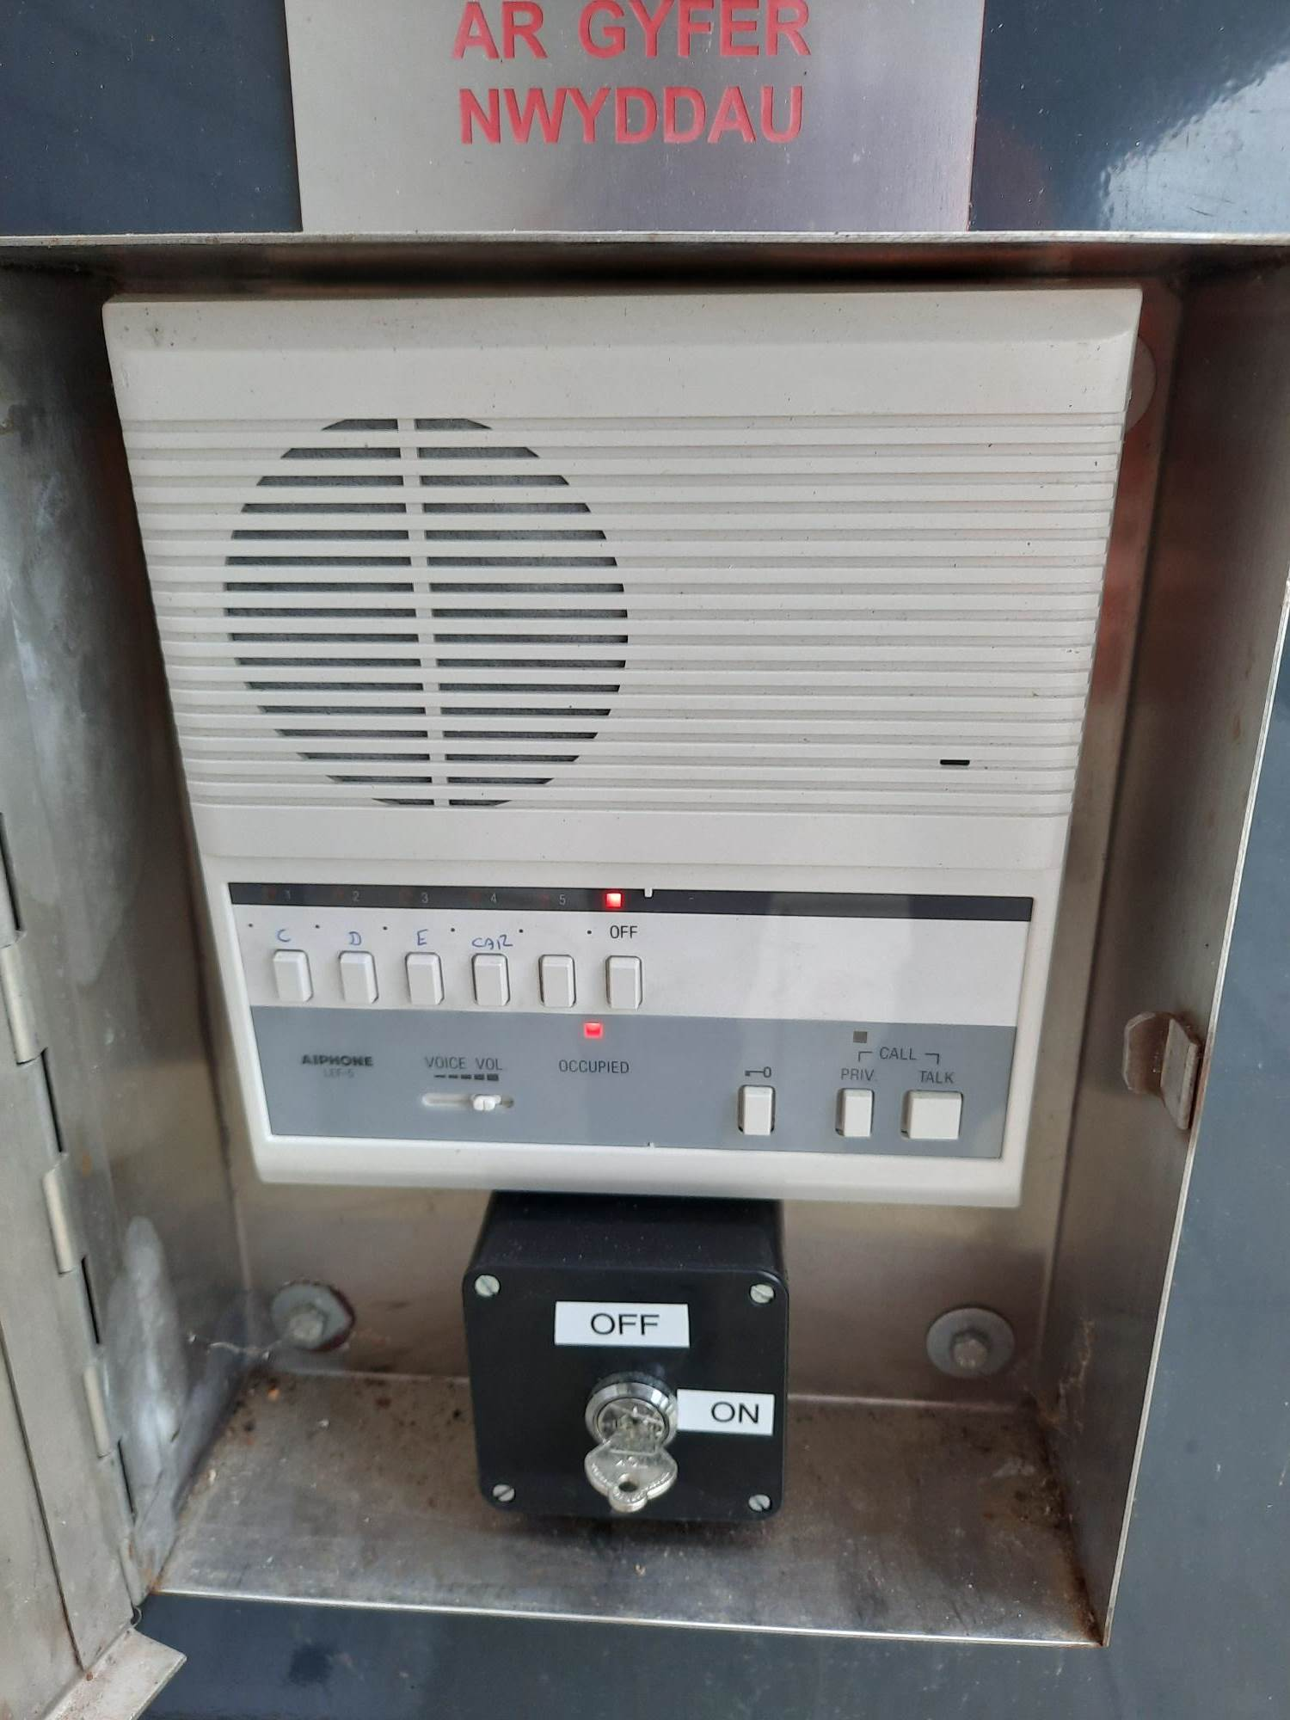

The master call station is used to establish communications with the landing call points which are located on each floor and in the lift car.
When the landing call points has been pressed, this call will go direct to the master station on floor B allowing communications between the two locations.
When receiving a call from a landing call point, the landing call point calls in tone and will light up one of the buttons, this will stay lit for 20 seconds.

To operate;
- Depress the lit landing call selector button
- Press the talk button to speak, and release to listen.
- Depress OFF button when finished (this will turn off the landing call point)

When the master station is not receiving any calls from the landing call points, the master station can be used to call the landing call points to check for presence on that floor.

To operate the master station to call a landing call point;
- Depress the landing call point selection button ( C,D,E, Car)
- Press the talk button to speak, and release button to listen to reply.
- If you wish to ring to attract attention, press the PRIV (privacy button) and talk buttons together, then hold the TALK button down while speaking.
- To conclude, depress off button.

Landing Call point

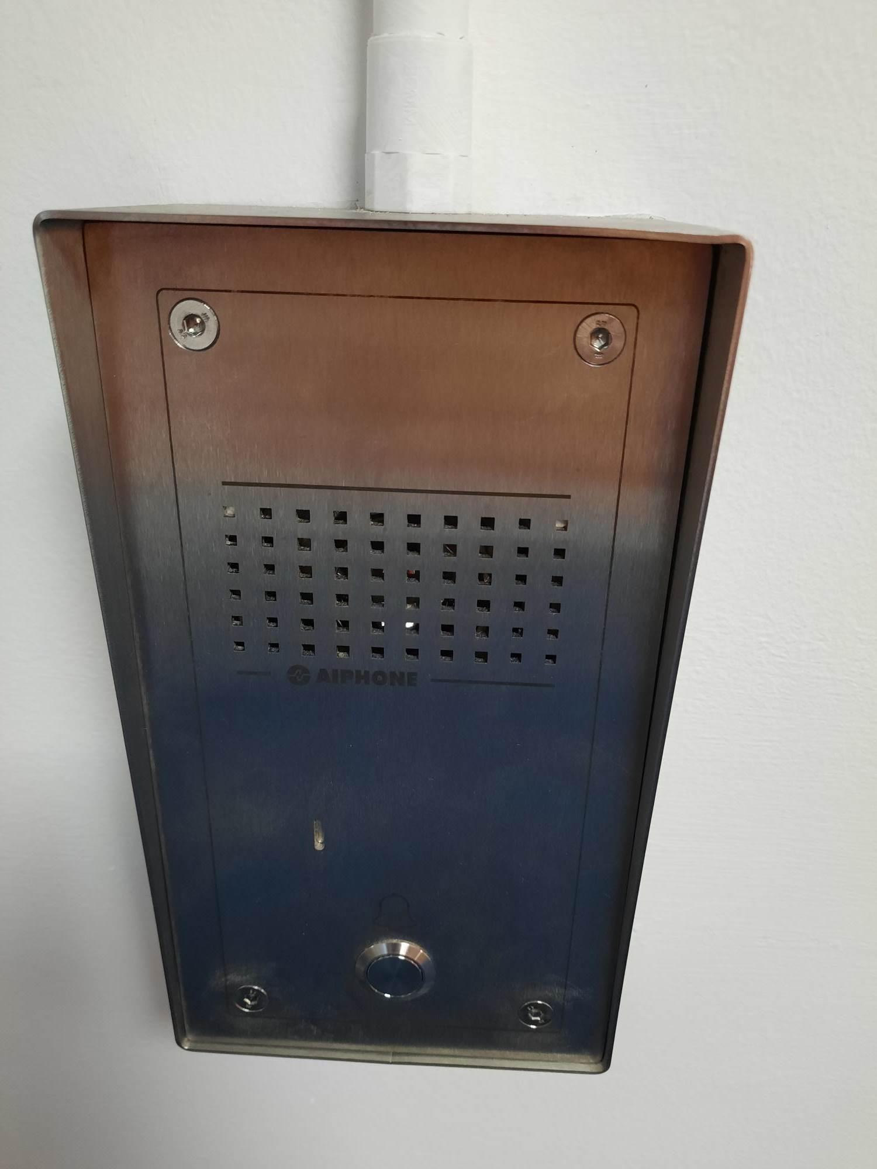

Within the lift car and on each landing, a landing call point will be present. This is to allow persons on the floor to communicate with the master call station if required.

To operate;
- Press the call button on the front of the landing call point and release.
- Hands free operation of the system is now automatically activated.
- Keep speaking through the landing call point, if after 20 seconds nothing is heard.
- Repeat point 1, press the call button and release and continue till communication is established.

5.0 Fire Drill Procedure

Fire drills should be carried out each year during the autumn term.

The HS&E office will liaise with the Department represented in the building concerned, so as to try and avoid sensitive dates and times (e.g. Open Days, Examinations etc).

Site Security will ensure the appropriate communications with the Alarm Receiving Centre and the FRS take place.

Site Security will initiate the drill and the guidelines given in Section 2 will be followed.

Where appropriate, it is good practice during drills for some fire Wardens to act as a ‘fire’ in commonly used routes and ask evacuating staff to seek out the alternative escape routes.

6.0 References

6.1 Fire Safety Risk Assessment - Educational Premises. HM Government (2006)
Available via:
http://www.aber.ac.uk/safety-environment/english/handbook/proc_and_pracs/fire_safety/rro_guides.shtml

6.2 Fire Risk Assessment – Hugh Owen

6.3 BS 9999:2017 Fire safety in the design, management and use of buildings – Code of practice.
Annex G (normative) Recommendations for refuges and evacuation lifts

Appendices
7.1 Building plans

Floor A
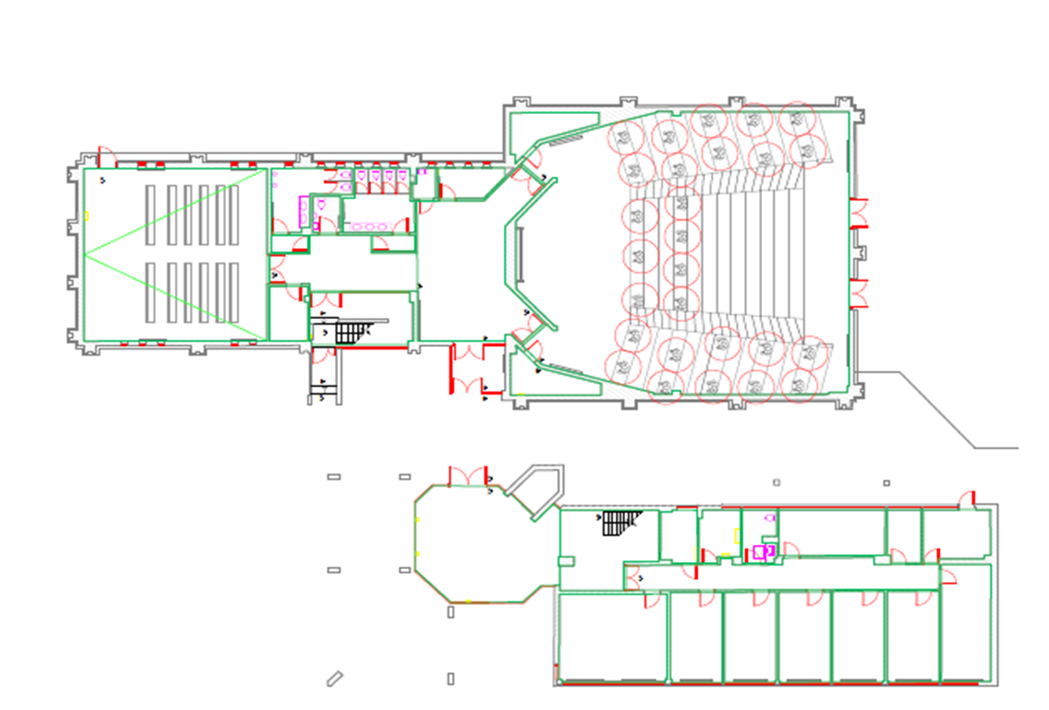

Floor B

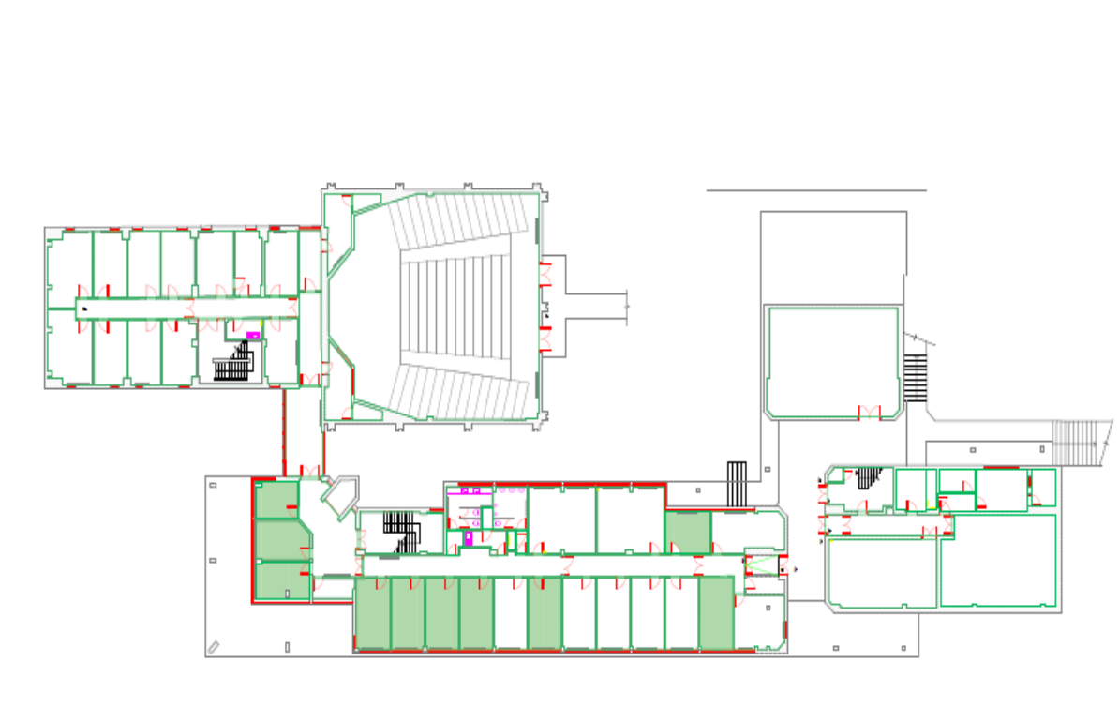

Floor C
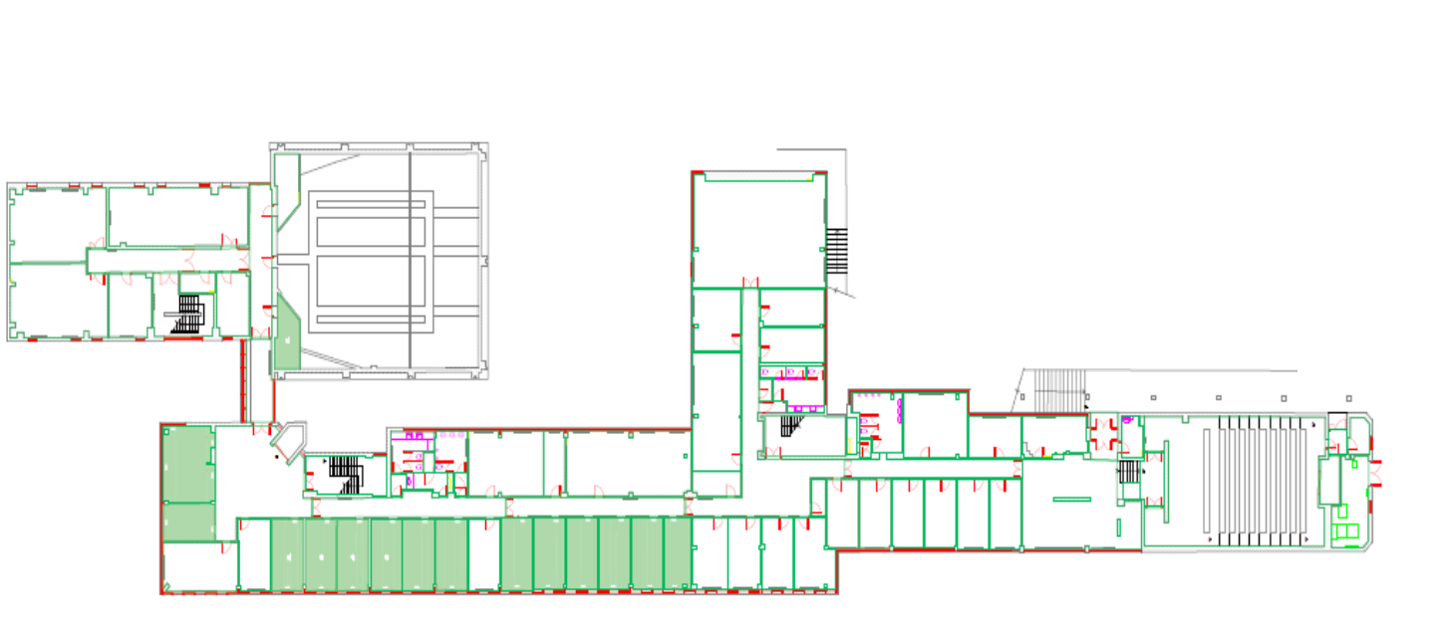

Floor D

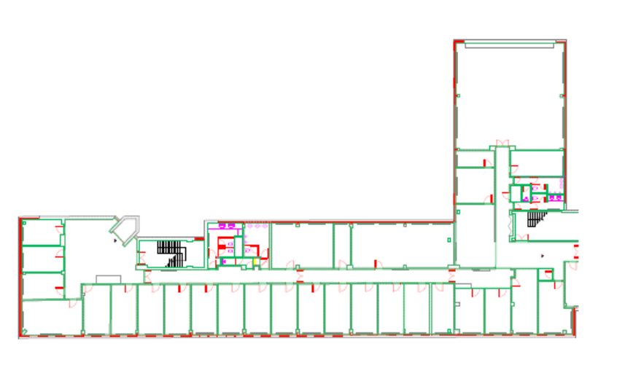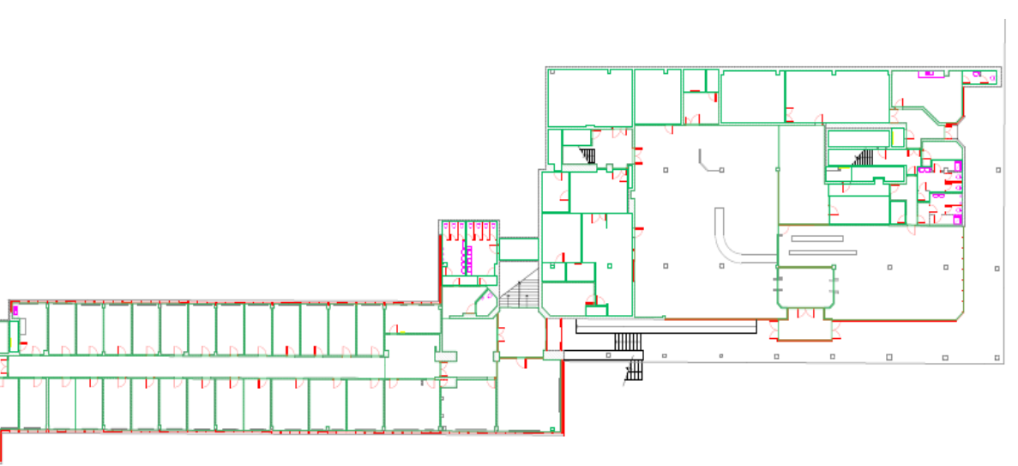

Floor E

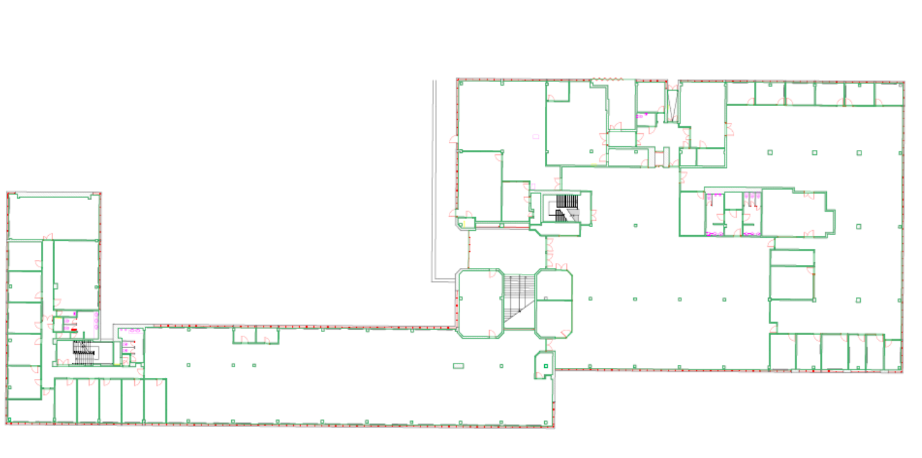

Floor F

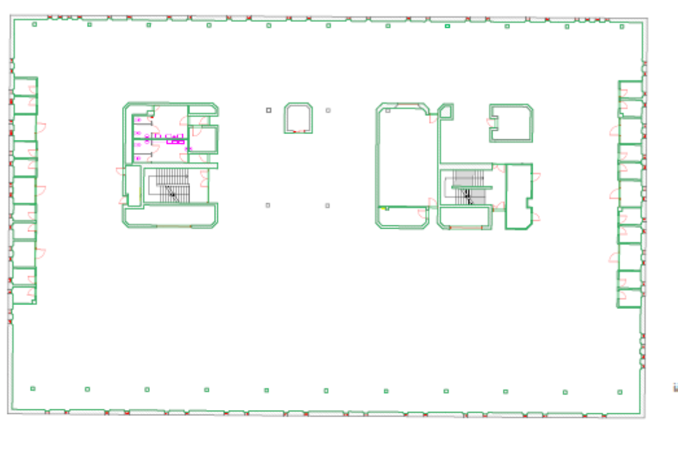

7.2 Proforma to record building clearance during evacuation
Hugh Owen

Fire Warden Coordinator Checklist

- Put on Orange Jacket

- Take clip board to assembly point

- Collect cards from wardens

- Contact Fire Wardens Via Handheld radio

- Redeploy Fire Wardens to stop people re entering building

- Receive instructions from Site Security/FRS to re enter building

Date of Alarm Activation ……………………………..

Time ………………………………

 |  | Area Cleared/Comments
A floor | A1  A2
B Floor | B1  B2
C floor | C1  C2  C3
D floor | D1  D2  D3
E floor | E1  E2  E3
F floor
Comments on evacuation

Name of Warden Coordinator…………………………………………

Hugh Owen

Rhestr Wirio Cydgysylltydd Warden Tân

• Gwisgo’r Siaced Oren.

• Mynd â’r clipfwrdd i’r man ymgynnull.

• Casglu cardiau gan y wardeniaid.

• Trefnu bod wardeniaid tân ar gael i atal pobl rhag mynd yn ôl i mewn i’r adeilad.

• Derbyn cyfarwyddiadau oddi wrth diogelwch safle/FRS i fynd yn ôl i mewn i’r adeilad.

Dyddiad Actifadu’r Larwm ……………………………..
Amser ………………………………

 |  | Mannau a Gliriwyd / Sylwadau
Llawr A | A1  A2
Llawr B | B1  B2
Llawr C | C1  C2  C3
Llawr D | D1  D2  D3
Llawr E | E1  E2  E3
Llawr F
Sylwadau ar y broses gwacáu

Name of Warden Coordinator…………………………………………

7.3 FIRE DRILL REPORT BY HS&E Office

Location of Fire Drill (Building/Premises/Zone):
Date: | Time:
Total Number of Participants:
Time Taken to Evacuate Building/Premises/Zone:
Miscellaneous Information:
(Give details of any important factors affecting the fire drill e.g. deliberate blocking of exits to simulate inaccessibility; weather conditions, etc.)
Problems Identified |  | Action Required:
Signature………………………….  (Print Name)……………………… |  | Date:………………………………………..

7.4 Summary details of the Deaf Alerter system

Deaf Alerter at AU 
Deaf Alerter
A radio based fire alarm warning and messaging system
Introduction
Aberystwyth University have installed a new radio-based fire alarm system for deaf and hearing impaired visitors, students and staff. The system is available in most University buildings. The logo, above, is also a Registered Trade Mark and logo stickers have been located on entrance doors to buildings.
Vibrating Alerter – What is it and How does it Work
The Alerter is a small and compact radio-receiver device which vibrates and displays an appropriate message when it receives a signal from a Deaf Alerter transmitter. When a building fire alarm is activated the Deaf Alerter transmitter in turn sets off the alerter which should be worn close to the body to be most effective.
Message Display
Along the top edge of the alerter there is a display box which will display the location of a building when the alerter receives an emergency evacuation alert such as an active fire alarm in a building.
Continuous Audible Alert
Another feature of the Alerter is to emit an audible tone which would assist emergency rescue personnel to identify the presence of an individual with an alerter within a building. The system enables personnel in the location of individuals in the event of a fire, when they have been unable to vacate the building during the emergency.
Allocation of Alerters
An Alerter will be made available to each visitor, student and member of staff that requires one on the basis of a hearing impairment. Personal identification will need to be established prior to the allocation of a deaf alerter.
Visitors
A supply of alerters is available at central service points for visitors, for example the Penglais Reception Lodge, Sports Centre, Arts Centre, and all Library Issue Desks. Visitors should make an enquiry at the reception area where they see the Deaf Alerter display.
Students
Students will be allocated an alerter through the HS&E office and flagged in the student record. A Night Cradle may also be supplied for students in halls of residence. Where a different arrangement exists in any Hall, students will be notified of the local procedure.
Students living in private residences should consult with the HS&E office.
Alerters should be returned by students at the end of each academic year to the issuing point.
Staff
Staff in need of an alerter should contact the HS&E office.

User Guide
A Deaf Alerter user guide is available from the issuing point. In summary:
Leave the Alerter turned On
For day-to-day use it is recommended that the alerter is carried with you at all times, kept close to the body and left turned ON. This means that the battery will need replacing more frequently, so please note the next section on battery care.
Batteries
Approximately two days before the battery runs out the alerter will signal that the battery is low and needs replacement. Replacement batteries will be organised by the original allocating office; please see below for contact details.
Loss and Replacement
Individuals are responsible for the cost of an alerter replacement in the event of loss. Any faulty alerters should be returned to the issuing point. Replacement alerters will be made available in the event of loss or fault reporting. See contact details below.
Ownership
The alerters will remain the property of AU and are loan items only. Alerters should be returned by students at the end of each academic year to the issuing point. Staff should return them when they leave employment with the university. Visitors should hand them back when their business with the university is completed on the final day of their visit.

AU Contact Details
For more details or queries please contact:
HS&E office hse.office@aber.ac.uk ext 2169
7.5 Fire Evacuation Plan

FIRE EVACUATION PLAN - Hugh Owen

Raising the alarm
IF YOU DISCOVER A FIRE
- Operate the fire alarm immediately by operating a manual call point (MCP) 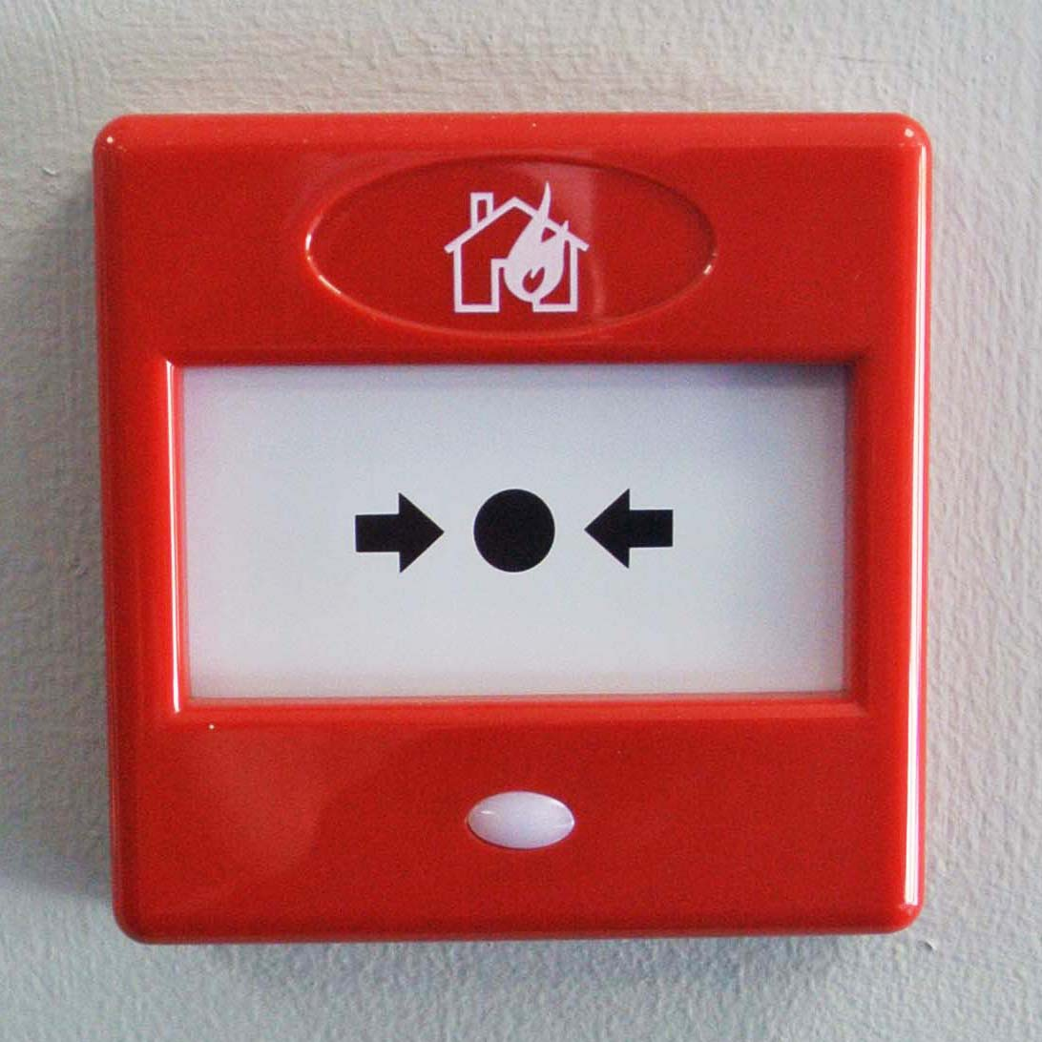
- Evacuate the building by the nearest safe exit, fire exit routes are indicated by fire exit signage.
- Do not use the lifts unless defined within PEEP for the building.
- Leave the building and proceed to the assembly point.
- Only collect small valuables and a coat if they are close.
- Do not stop to collect other personal belongings.
- Take your friends, colleagues and fellow students with you.
- Where possible, shut doors and windows to slow down the spread of smoke, but only if it will not significantly delay your escape.
- Do not re-enter the building until instructed that it is safe to do so.
- Any attempt to extinguish the fire should only be considered if safe to do so by trained personnel.
- Call the Fire & Rescue Service from a safe location.

ON HEARING THE ALARM —
- Evacuate the building by the nearest safe exit.
- Leave the building and proceed to the assembly point.
- Do not use the lifts unless defined within PEEP for the building.
- Only collect small valuables and a coat if they are close.
- Do not stop to collect other personal belongings.
- Take your friends, colleagues and fellow students with you.
- Do not re-enter the building until instructed that it is safe to do so.

ASSEMBLY AREA

The Assembly Point for the Hugh Owen Building is

A) Car park outside Penbryn

B) Concourse outside Arts Centre

C) The rear car park towards Parry Williams
.

REOCCUPYING THE BUILDING

People must remain at the Assembly Point, until they are informed it is safe to re-enter the building. Aberystwyth University Security team or Fire and Rescue Service personnel (if in attendance) will inform persons at the assembly point when it is safe to re-enter.

The fire alarm sounders may be silenced before the situation is declared safe; this should not be taken as an indication to return to the building.

