Outlet |  |  |  |  | Pantycelyn Week 2
Day |  |  |  |  |  |  |  | Ensure that ALL dishes produced are noted on the list EVERY DAY
Date
 | Please initial each dish that YOU add to the sheet, that you have made
Dish |  | Celery/ Celeriac | Gluten/ Cereals see list | Shellfish | Eggs | Fish | Lupin | Milk and milk product | Molluscs | Mustard | Tree Nuts | Peanuts | Sesame | Soya | Sulphur dioxide/  Sulphates | Comments | Initial
If unsure of what the allergens are, refer to sheet at front of this file |  | 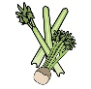 | 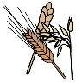 | 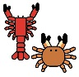 |  |  | 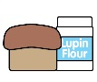 |  |  | 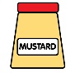 | 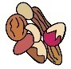 | 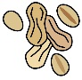 | 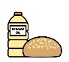 |  | 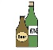
Chicken parmigiana |  |  | X |  |  |  |  | X |  |  |  |  |  |  | X
Gluten free Pork and leek sausages |  | X |  |  |  |  |  |  |  |  |  |  |  |  | X
Thai style vegan meatballs and rice
Tex mex burger |  | X | X |  |  |  |  | X |  |  |  |  |  | X | X
Beef lasagne and garlic bread |  | X | X |  |  |  |  | X |  | X |  |  |  |  | X
Mojo chicken with charred peppers and onions
Vegetable and chick pea curry with rice |  |  |  |  |  |  |  |  |  | X
Greek style lamb pitta |  |  | X |  |  |  |  | X
Chicken mushroom and spinach pasta |  | X | X |  |  |  |  | X |  |  |  |  |  |  | X
Beef massaman and rice  Naan bread |  |  | X |  |  |  |  | X |  | X
Smokey butternut squash bake |  | X |  |  |  |  |  |  |  |  |  |  |  | X | X
Deep south wrap |  |  | X |  |  |  |  | X |  |  |  |  |  |  | X
Spaghetti Bolognese |  | X | X |  |  |  |  |  |  |  |  |  |  |  | X
Roast Pork  Stuffing |  | X | X |  | X |  |  | X |  |  |  |  |  | X
Onion bhaji bake |  |  | X |  |  |  |  |  |  | X
Bangkok bad boy burger |  |  | X
Fried fish |  |  | X |  |  | X
Coconut and chilli chicken with rice
Vegan roasted vegetable moussaka |  |  |  |  |  |  |  |  |  |  |  |  |  | X | X
The Jamaican burrito |  |  | X |  |  |  |  | X

