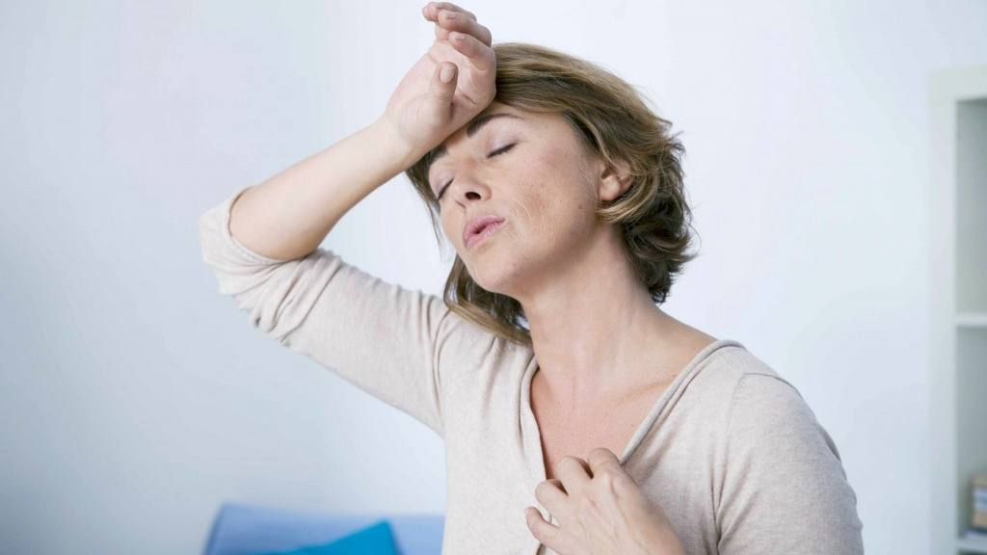

**1.** The menopause is a natural part of ageing that usually occurs between 45 and 55 years of age, as a woman's oestrogen levels decline. In the UK, the average age for a woman to reach the menopause is 51.

**2.** The menopause is caused by a change in the balance of the body's sex hormones, which occurs as you get older. It happens when your ovaries stop producing as much of the hormone oestrogen and no longer release an egg each month.

**3.** Premature or early menopause can occur at any age, and in many cases, there's no clear cause.

**4.** Around 1 in 100 women experience the menopause before 40 years of age. This is known as premature menopause or premature ovarian insufficiency.

**5.** Common symptoms include: hot flushes, night sweats, vaginal dryness and discomfort during sex, difficulty sleeping, low mood or anxiety, reduced sex drive (libido), problems with memory and concentration.

**6.** Consider talking to your GP if you have menopausal symptoms that are troubling you or if you're experiencing symptoms of the menopause before 45 years of age. Your GP can usually confirm whether you are menopausal based on your symptoms, but a blood test to measure your hormone levels may be carried out if you're under 45.

**7.** If you’re finding it hard to manage your symptoms, your GP may suggest you try hormone replacement therapy (HRT). An alternative to HRT is bioidentical hormone therapy.

**8.** If you don’t want, or are unable to take HRT, your GP may suggest other treatment options. These will vary depending on your symptoms, and may include talking therapies, vaginal lubricants and/or non-hormonal medicines for hot flushes and sweats.

**9.** Complementary therapies such as aromatherapy, acupuncture and reflexology can improve the symptoms of the menopause. The same is generally true for plant or herbal remedies.

**10.** Menopause can affect your mental health as well as physical health and often brings increased stress, anxiety, and fear.

### Menopause Information

Care first is a leading provider of confidential, professional counselling, information and advice services.

All employees are eligible to use Care first.

**Menopause information from Care first**

The menopause is when a woman stops having periods and is no longer able to get pregnant naturally. Periods usually start to become less frequent over a few months or years before they stop altogether. Sometimes they can stop suddenly.