Blackboard and Turnitin External Examiners Guide 2026-27
Digital Education Team (elearning@aber.ac.uk)
Updated July 2026
Contents
General Information 2
External Examiner Access 2
Computing Account 2
Logging in 3
Your Courses 4
Accessing Assignments 5
Turnitin 5
Turnitin Document Viewer 7
Blackboard Assignment 9
Blackboard Gradebook 11
Further help 12

General Information
Students submit a large proportion of their text-based assignments via Turnitin, which is integrated into our Virtual Learning Environment, Blackboard. Academic staff use Turnitin's tools to deliver electronic screen-based feedback to students. Some text-based assignments are not suitable for submission to Turnitin, and they are submitted using the Blackboard Assignment tool. Instructions on using this can be found towards the end of this document.
This guide is intended to provide assistance to External Examiners who have been asked to review module materials and student submissions to Turnitin, and the feedback left within Turnitin.

External Examiner Access

Computing Account
To gain access to Blackboard you will need an active Aberystwyth University computing account.
Computing accounts for all staff, including External Examiners, are generated and updated from the Human Resources/Payroll system via an overnight process. Please ensure that you have completed and submitted all forms requested by Human Resources.
When your Aberystwyth University IT account has been created, you will be emailed with instructions for activating it. If you have not received an activation email please contact the IT Service Desks.
Aberystwyth University uses Microsoft 365 authentication with 2 step verification for access to Blackboard. Once you have activated your account, you will need to set up 2-step verification:
- Go to https://blackboard.aber.ac.uk
- You will see the Microsoft 365 login prompt.
- Choose your Aberystwyth University account. If this is not listed choose Use another account and then type in your Aberystwyth University username with @aber.ac.uk.
- Click on the More Information button and follow the instructions to set up 2-step verification.
If you have not received your login credentials, or if you experience any problems logging in, please contact the IT Service Desk on 01970 622 400 or e-mail is@aber.ac.uk.

Logging in
To log in to Blackboard go to https://blackboard.aber.ac.uk and enter your username and password.
Please check you have been assigned the correct courses and contact the academic department if there are any errors or queries.
External Examiners are encouraged to login and check that they can access Turnitin as soon as possible. To do this follow the steps below and view a single individual paper.
If there are any problems with the system, please report them to the Digital Education Team (elearning@aber.ac.uk) immediately so that they can take steps to resolve them. Resolutions can take a few days and it is preferable to deal with these quickly.
It is not possible to switch off the ability for external examiners to make comments or amend grades therefore, External Examiners are requested NOT to add or amend anything on the system. Any additions you make could erase the work of the original markers or make it difficult to determine who wrote what. Feedback and comments should be given in the usual way to Module Coordinators and/or be included in the External Examiners Report once moderation has been completed.
As with both students and academic staff, if the use of electronic tools and screen reading creates a health and safety issue, alternative arrangements can be made and you should contact the department in this respect.
Turnitin can also be accessed via an App from the Apple Store that can be downloaded to any Apple device. At present there is no Android equivalent.

Your Courses
The Blackboard course space is used to deliver module information and learning materials, and for the submission of assignment work.
Once you have logged in you will see your Blackboard homepage.
Courses that you have been enrolled on are listed in the Courses section - the landing page from when you login. Click on the course name to enter the course:
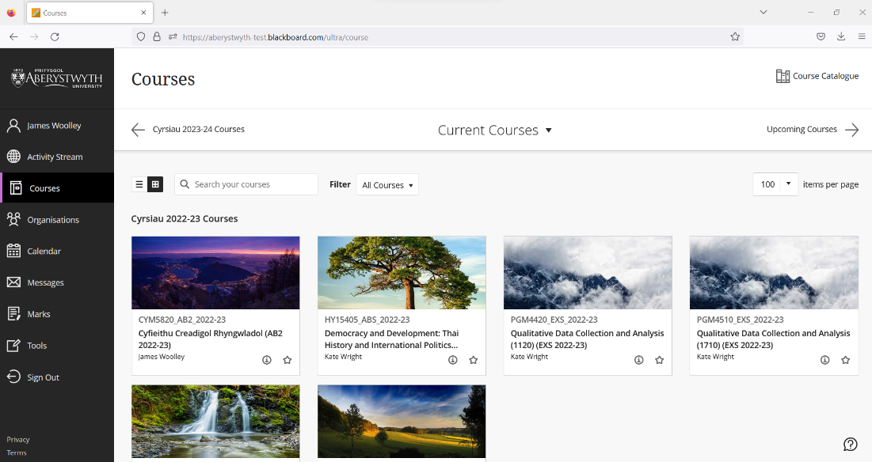
The Institution page includes further support materials for Blackboard Ultra:
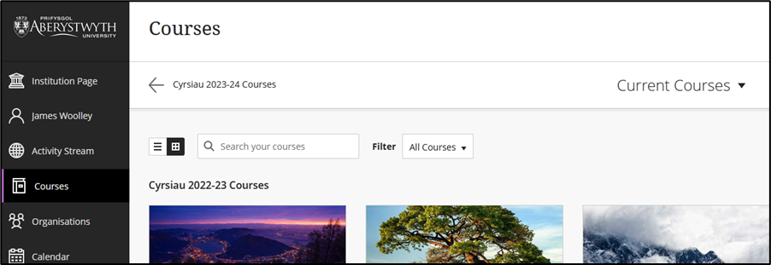

Accessing Assignments

Turnitin
Turnitin is the tool commonly used for e-submission, marking and feedback.
To view students’ work and the marks and/or feedback left by lecturers, enter the module, and go to the area where the submission point has been created (normally this is Assessment and Feedback). Click on the Turnitin submission point and the assignment inbox will open in a new window:

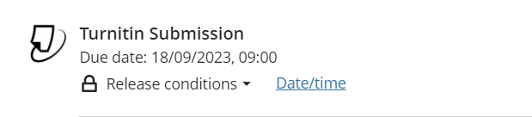
The Assignment Inbox displays a summary of all work submitted to the assignment:
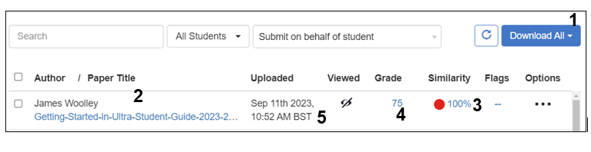
The Grade Report option under the Download all button (1) opens an Excel spreadsheet with a list of enrolled students and their submission titles. This option is particularly useful for larger modules, where information may need to be sorted and filtered.
Title (2): Click on the title of the student’s work and the Turnitin Document Viewer will open (see below). This will display the individual piece of work, the mark, originality report and marker’s feedback.
Similarity (3):
0% = No matching text detected
100% = Match found for all submitted text
Grade (4): This shows the mark awarded. If marks have not yet been awarded, then a blue pencil will appear in this column instead. Some coordinators may not upload a full set of marks to Turnitin, instead using the Blackboard Grade Centre.
Date (5): This shows the date work was submitted. If an assignment was submitted after the deadline then a red text saying ‘Late’ will appear in this column instead.

Turnitin Document Viewer
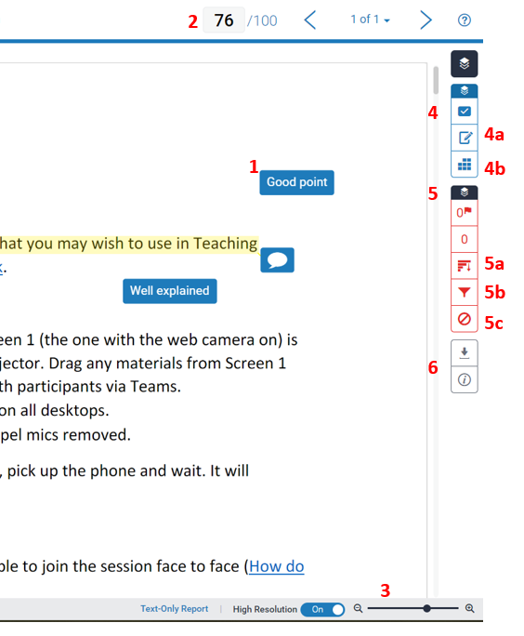

Comments (1) are embedded in the assignment. Click on the speech bubble or comment to read.
The provisional mark awarded is at the top of the screen (2).
To increase/decrease the size of text, click, hold the slider and drag left or right (3).
The blue section contains Grading Tools (4) . General Feedback (4a) provides a Textual feedback from the lecturer. Turnitin supports also audio feedback (Voice Comment). Some lecturers may use Rubrics (4b) for marking.
The red section contains the Similarity Tools (5).
Originality Score
0% = No matching text detected
100% = Match found for all submitted text
Turnitin checks student submission for text that matches other sources. The system allows considerable flexibility in terms of the originality settings, and in how marks and feedback are to be allocated, practices may vary from module to module.
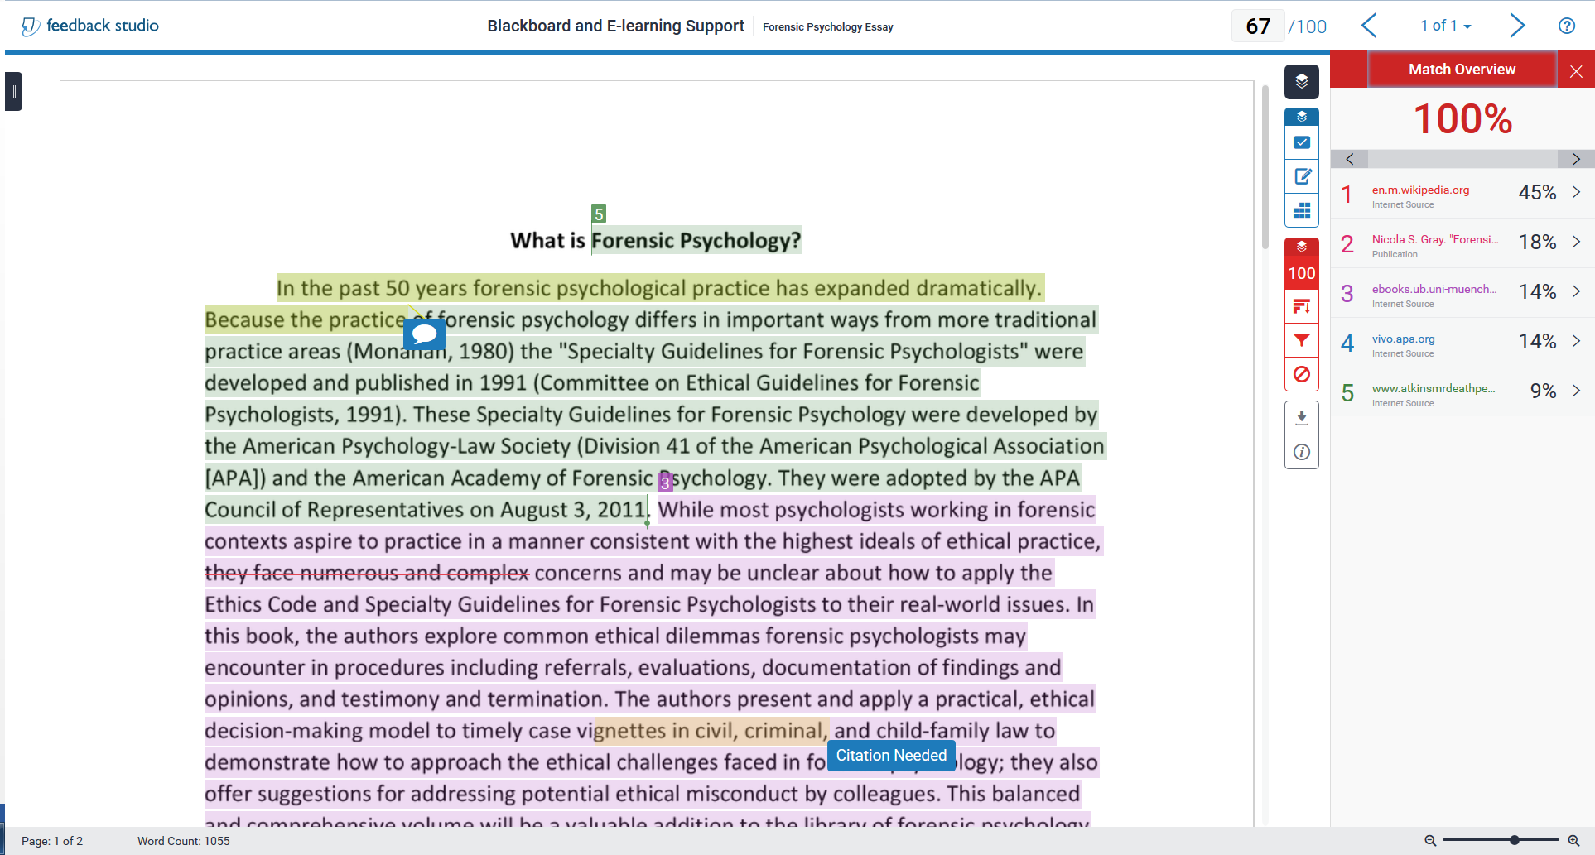
The red section contains Similarity Tools. You will see a Match Overview (percentage of the written work matching individual sources). The Match overview will also be highlighted by different colours in the text.
Similarity Tools also include:
- Checking a detailed list of all sources used (5a)
- Changing filters or settings for the Similarity Report (5b)
- Viewing excluded resources (if available) (5c)
Note: You can switch between Grading and Similarity Layers - viewing each of them individually or together.
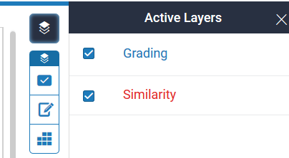
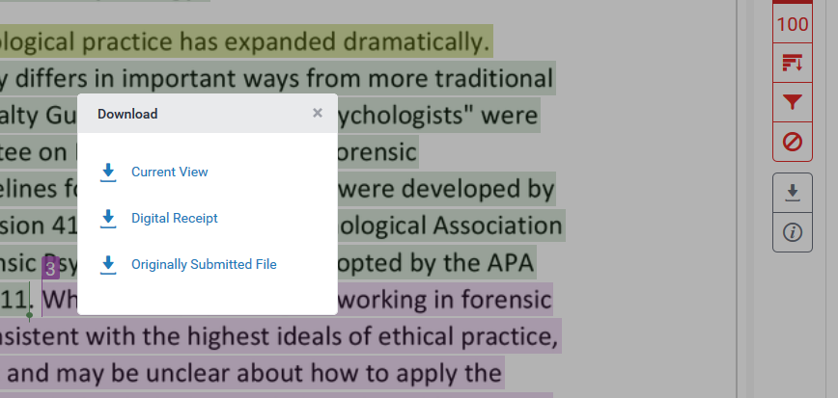
Assignments can be downloaded (6) and printed for ease of reviewing by using this button. It provides you with three options:
- Download PDF of current view for printing – complete with marker feedback.
- Download PDF of digital receipt for printing – as seen by the student.
- Download submitted file – assignment as submitted by student before marking.

Blackboard Assignment
Some courses make use of Blackboard Assignment for submission. Your department can advise you on whether Turnitin or Blackboard Assignment is used.
To view students’ work and the marks and/or feedback left by lecturers, enter the module, and go to the area where the submission point has been created (normally this is Assessment and Feedback. Click on the Assignment submission point.
To view all the submissions to the Assignment, click on the Submission link at the top of the page
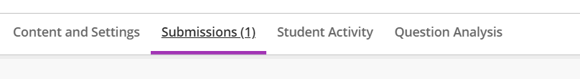
The submission page shows a summary of all work submitted to the assignment
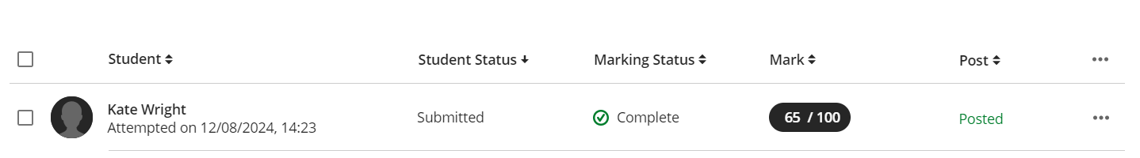

From here you can see the date and time of submission, the mark, and whether the work has been marked and marks posted to the students.
Click on the student’s work and the document will open (see below). This will display the individual piece of work, the mark, originality report and marker’s feedback.
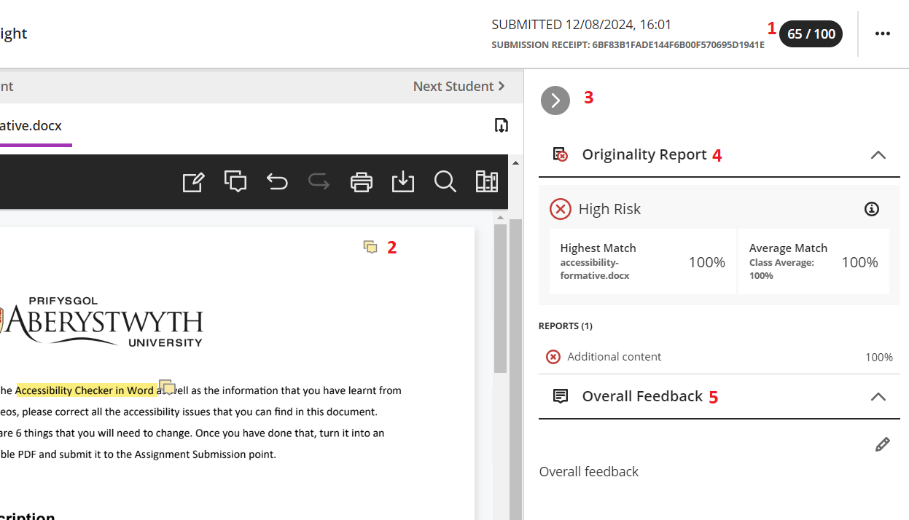
The grade is in the top right-hand corner [1]. You will see comments in yellow boxes on the assignment [2]. Click on these to see the details of the comment. The overall feedback [5] can be seen by opening the feedback pane with the small grey arrow [3].
Some staff will make use of the Originality Report [4], which can be seen in the same pane as the overall feedback. More information about the Originality is available on the Blackboard help site.

Blackboard Gradebook
Turnitin is suitable for text-based assignments – i.e. essays, reports. Therefore, in some courses, the Blackboard assessment tools are used which allow submission of other file types such as images, multimedia, or presentations. In this case student grades and feedback will be visible from the Blackboard Gradebook.
Access the Blackboard Gradebook via the Gradebook link at the top of the screen
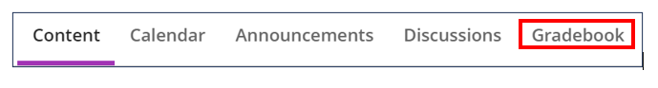
From here click on Marks. This will open up an overview of the marks for each student broken down by assignment.
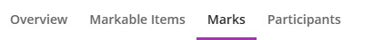
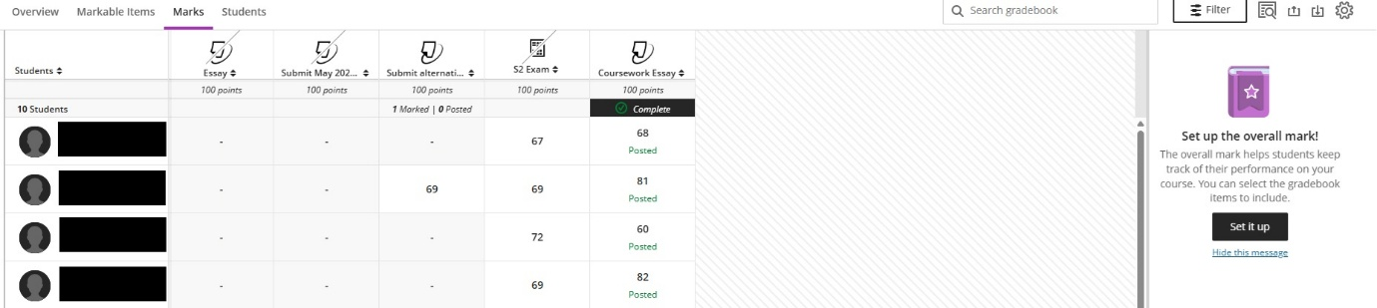

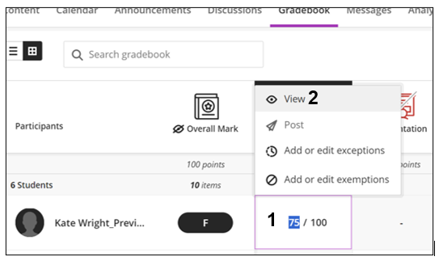
Mark awarded (1).To view further details regarding mark awarded, click on the cell and select View (2). You will then see any feedback provided.

Further help
If you require any further assistance, please use the contact details below:
Section | Telephone Number | Email Address
Digital Education Team | 01970 622472 | elearning@aber.ac.uk
IT Service Desk | 01970 622400 | is@aber.ac.uk

Please report any issues immediately to avoid delays in resolving the problems.

