Using Blackboard Assignment 2025-26

Digital Education Group ([elearning@aber.ac.uk](mailto:elearning@aber.ac.uk))

Updated July 2025

Contents

How do I create an assignment submission point using Blackboard Assignment and SafeAssign? 2

How do I mark assignments in Blackboard Assignment? 3

How do I release marks and feedback to students 4

Using the SafeAssign Originality Report 4

How do students see their marks and feedback? 4

This guidance should be read in conjunction with the [University’s E-submission Policy.](https://www.aber.ac.uk/en/academic/e-submission/)

# How do I create an assignment submission point using Blackboard Assignment and SafeAssign?

See the [Create Blackboard Assignment](https://help.blackboard.com/Learn/Instructor/Ultra/Assignments/Create_and_Edit_Assignments) page for the details of setting up your assignment.

The following settings should be used at AU:

* Under **Details and Information**,
  + Enter the Due Date and Time(see [AU E-submission policy](https://www.aber.ac.uk/en/academic/e-submission/) points 4.2 and 4.3 for guidance on setting due dates)
  + Leave the other boxes unticked
  + Note that if you are applying Release Conditions, the available until date should be at least 1 minute after the due date
* Under **Marking & Submissions**
  + Attempts allowed – Unlimited
  + Attempts to mark – Last attempt
  + Mark using – Percentage
  + Maximum points – 100
  + Anonymous marking – tick the box next to Hide student names
* Under **Additional Tools**
  + Originality Report – click on Enable SafeAssign
  + Click on the cross next to Enable SafeAssign to switch on SafeAssign
  + Leave the other boxes unticked.
  + Note that because of the way that SafeAssign describes the Similarity Report in terms of ‘risk’ we recommend **not** making this available to students at the moment. We have raised an enhancement request with Blackboard to remove reference to this.
  + More information about SafeAssign is available on the [SafeAssign in Your Course](https://help.blackboard.com/SafeAssign/Instructor/In_Your_Course) page.

# How do I mark assignments in Blackboard Assignment?

See the [Assign Grades](https://help.blackboard.com/Learn/Instructor/Ultra/Grade/Grading_Tasks/Assign_Grades) page for details of how to:

* + Access assignments that need be marked
  + Add the final grade and feedback
  + Add in-text comments and annotations

By default, marking comments in Blackboard Assignment contain the name of the staff member marking. If this is not appropriate for your marking, you can make them anonymous.

When you create a comment, click on the anonymous marking icon

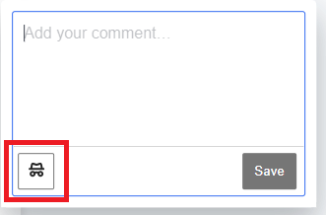

You can edit existing comments to make them anonymous by clicking on the comment. Click on the three dots in the top right-hand corner of the comment and then click on **Anonymous**.

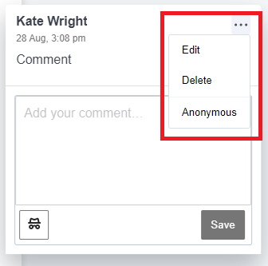

# How do I release marks and feedback to students

To release marks and feedback to the students, you must Post the marks. There is no automatic release of marks from Blackboard Assignment.

You can do this from either the Gradebook or the grading page for the assignment. For information see the information on posting grades on the [Blackboard grading page](https://help.blackboard.com/Learn/Instructor/Ultra/Grade/Grading_Tasks/Assign_Grades).

# Using the SafeAssign Originality Report

Information about viewing and interpretating the Originality Report is available on the [SafeAssign Originality Report](https://help.blackboard.com/SafeAssign/Instructor/Grade/Originality_Report) page.

# How do students see their marks and feedback?

Information for students on viewing marks and feedback is available on the [Assignment Grades](https://help.blackboard.com/Learn/Student/Ultra/Assignments/Assignment_Grades) page.