Using Blackboard Assignment 2026-27

Digital Education Group (elearning@aber.ac.uk)
Updated June 2026
Contents
How do I create an assignment submission point using Blackboard Assignment and Turnitin? 2
How do I mark assignments in Blackboard Assignment? 3
Viewing the Turnitin Originality Report 4
How do I release marks and feedback to students 4
How do students see their marks and feedback? 5

This guidance should be read in conjunction with the University’s E-submission Policy.

How do I create an assignment submission point using Blackboard Assignment and Turnitin?
See the Create Blackboard Assignment page for the details of setting up your assignment.
The following settings should be used at AU:
- Under Details and Information,
  - Enter the Due Date and Time (see AU E-submission policy points 4.2 and 4.3 for guidance on setting due dates)
  - Leave the other boxes unticked
  - Note that if you are applying Release Conditions, the available until date should be at least 1 minute after the due date
- Under Marking & Submissions
  - Attempts allowed – Unlimited
  - Attempts to mark – Last attempt
  - Mark using – Percentage
  - Maximum points – 100
  - Anonymous marking – tick the box next to Hide student names

- Under Additional Tools
  - Originality Report – click on Enable Turnitin
  - Click on the cross next to Enable Turnitin to switch on Turnitin:
    - Similarity report: Allow students to view report after submitting
    - Information about other settings can be found in the AU Turnitin Guide
Guidance is also available at https://guides.turnitin.com/hc/en-us/articles/24007741812493-Creating-an-assignment-with-the-Blackboard-Ultra-Assignment-integration

How do I mark assignments in Blackboard Assignment?
See the Assign Grades page for details of how to:

  - Access assignments that need be marked
  - Add the final grade and feedback
  - Add in-text comments and annotations
By default, marking comments in Blackboard Assignment contain the name of the staff member marking. If this is not appropriate for your marking, you can make them anonymous.
When you create a comment, click on the anonymous marking icon
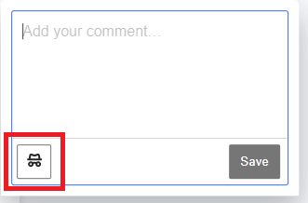
You can edit existing comments to make them anonymous by clicking on the comment. Click on the three dots in the top right-hand corner of the comment and then click on Anonymous.
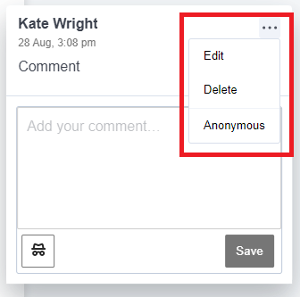

Viewing the Turnitin Originality Report
To view the Turnitin Originality Report, click on the percentage matching score in the top right-hand corner of the screen:
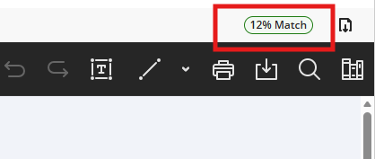
Alt text: Turnitin percentage matching score in an oval shaped icon in the top right-hand corner of the screen. This example is green and says "12% Match"
The report will open in a new browser window. The report uses the new Similarity Report style which looks slightly different to our standard Turnitin view. You can find information about the new view on the Turnitin help sheet.
Information interpretating the Originality Report is available in our Turnitin Guide.

How do I release marks and feedback to students
To release marks and feedback to the students, you must Post the marks. There is no automatic release of marks from Blackboard Assignment.
You can do this from either the Gradebook or the grading page for the assignment. For information see the information on posting grades on the Blackboard grading page.

How do students see their marks and feedback?
Information for students on viewing marks and feedback is available on the Assignment Grades page.

