Component Marks Transfer Guide 2026-27
Digital Education Team (elearning@aber.ac.uk)
Updated July 2026
Overview 1
Getting the foundations right 2
Assessment weightings in AStRA 2
Blackboard Gradebook 2
Preparing the Blackboard Gradebook for Marks Transfer (Module Co-ordinator) 3
Posting Marks 3
Automatically Created Columns 4
Manually Created Columns 4
Add Item 5
Add Calculation 5
Add Total Calculation 6
Dropping Scores 7
Creating a module mark 8
Mapping the Gradebook 8
Mapping Columns to the Astra Component 9
Merged Modules 12
Checking the marks have transferred to AStRA 12
FAQs: 13

Overview
This process takes marks for assessment components from Blackboard and transfers them to AStRA.
In AStRA, a module mark is automatically calculated based on the component weightings.
Module co-ordinators are responsible for:
- Clearly labelling columns so that FSEA colleagues know which column to associate with which component
- Ensuring that all marks are entered and posted in the Gradebook
- Checking marks in AStRA following the transfer ahead of exam boards
Faculty Student Education Administration are responsible for:
- Associating the columns in Grades Transfer
- Transferring marks to AStRA
All marks for all components should be in the Blackboard Gradebook even if the student has not submitted electronically. See the E-submission policy for further information.

Getting the foundations right

Assessment weightings in AStRA
Because the module mark is calculated automatically based on the component weightings, the percentage needs to be correct in the module record in AStRA.
If you notice any errors with the assessment weightings, contact the Quality Assurance Team in Registry: qaestaff@aber.ac.uk.

Blackboard Gradebook
The Gradebook is made up of a series of columns – a column is created for each assignment. Some of these are created automatically, for example, if you have a Turnitin submission point. Others need to be manually created, for example, if you have students sitting an in-person exam.
So that the correct marks are transferred, all marks need to be posted in the gradebook.
Note that only one column can be mapped to a component in AStRA.

Preparing the Blackboard Gradebook for Marks Transfer (Module Co-ordinator)
Module Co-ordinators should ensure that all work is marked, marks are posted, and columns are created to allow the transfer of marks.
The Gradebook is in every Blackboard Course and contains information about student assessment marks.
To access the Gradebook, go to the course and click Gradebook:
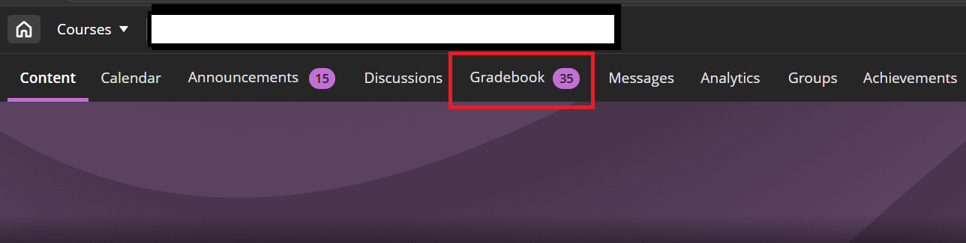
[alt-text: Blackboard course interface with Gradebook highlighted.]
There are 2 views to the Gradebook:
- Grid view – this lists all students, associated marks, and columns like a spreadsheet
- List view – this lists all the columns for gradeable items

Posting Marks
For Component Marks transfer to work correctly, all marks need to be posted. For Turnitin, marks are posted automatically on the Feedback Release Date.
For all other marks in Blackboard, these need to be posted manually once marking has been completed.
To do this, go to the To do menu:

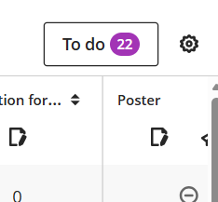
[alt-text: To do menu]
If you do not want the marks to be visible to students in Blackboard make sure the column is hidden. Hidden columns have a line through them and you can amend this from the list view:

[Alt-text: example of a column that is hidden]

Automatically Created Columns
When you create a Turnitin submission assignment, Blackboard Assignment (including Panopto submission), Blackboard Test, or Graded Blackboard tool, a column is automatically created in Blackboard Gradebook. You do not need to create a column.

Manually Created Columns
There are 3 types of columns that can be created in Gradebook.
Note that columns can only be created in the Markable Items and the Marks view of the Gradebook.
The three columns to use are:
- Add Item - use this to add marks for something submitted non-electronically, for example, a written exam
- Add Calculation – use this to bring two items in the Gradebook together so that they can be associated with the component in Grades Transfer and mapped. For example, a Turnitin submission point and an extension submission point.
- Add Total Calculation – use this to bring together a series of assessment activities that need to be combined to form one component for marks transfer. For example, you’ve got a portfolio assessment that is made up of 40% journal entry, 30% listening test, 30% comprehension.
- Dropping scores – use this to not include certain scores in the component calculation. For example, you have run 8 in class tests but want to carry forward the 6 best results for each student.

Add Item
- Go to Markable Items or Marks View of Gradebook, click on the purple plus and choose Add Item.
- Give your item a name, for example, Exam.
- Give it a due date.
- Mark using points, maximum points 100. Save.
- To enter exam marks, click on number to mark:
[alt-text: Image showing the number of assignments to mark]
- Enter the corresponding mark against the corresponding students.
- Once you have entered the marks, click Post All Marks.

Add Calculation
- Go to Markable Items or Marks View of Gradebook, click on the purple plus and choose Add Calculation.
- Give the calculation a name – choose something clear so that the correct column can be chosen in the mapping process. For example, Assignment 1 (including extension).
- Most calculations bring multiple submission points together. For example, extensions.
For this we recommend choosing Maximum from the Functions and Variables menu and then clicking on the dropdown and selecting the columns that you want:
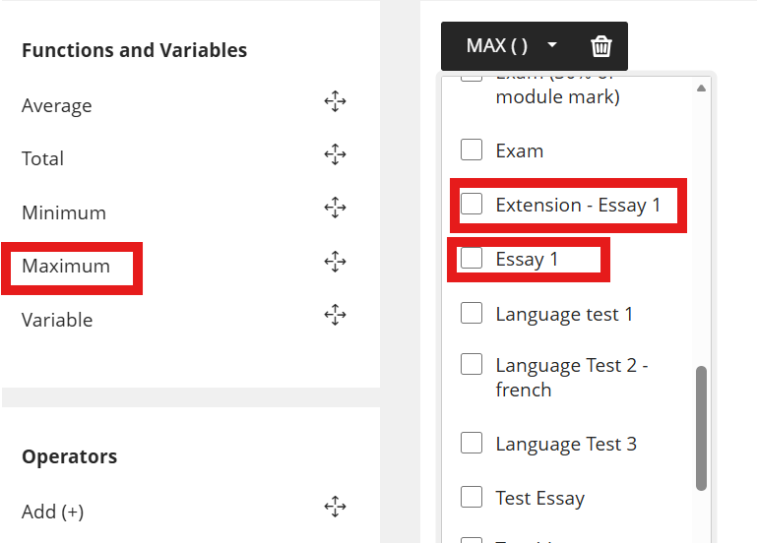
[alt-text: screenshot of Maximum with items from the dropdown highlighted]
We recommend Maximum for this scenario because if a student has accidentally submitted to the original submission point and the extension, the highest mark will carry.
- Click Save and view marks to check they are displaying correctly.

Add Total Calculation
- Go to Markable Items or Marks View of Gradebook, click on the purple plus and choose Add Total Calculation.
- Give the calculation a name – choose something clear so that the correct column can be chosen in the mapping process. For example, Assignment 2: Portfolio (Listening Test, in Class Test combined).
- Change your view to Weighted.
- Exclude the items and categories that you don’t want to include in the calculation:
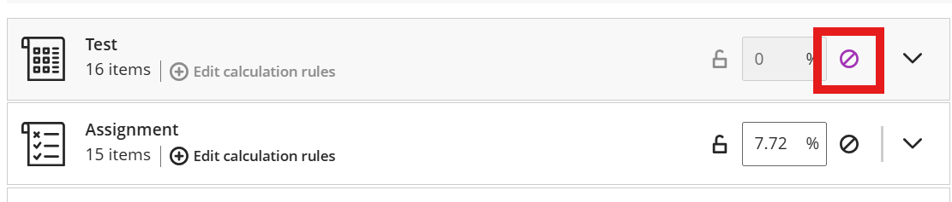
[Alt-text: screenshot showing excluded icon]
The weightings will automatically be adjusted for marks distribution across the different components.
You can amend the different percentage distribution by changing the weighting. This will automatically redistribute the percentages.
- If you want to calculate a non-entry as a 0, make sure that you deselect Calculate marks based on points earned out of total points:
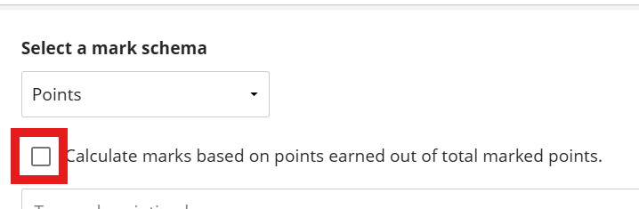
[Alt-text: screenshot showing Calculate marks based on points earned out of total marked points with the option deselected]

Dropping Scores
There might be scenarios where you want to drop scores as part of the calculation. For example, you run 8 weekly tests but want to drop the 2 lowest scores.
To do this, follow the Add Total Calculation process. Select:
- Edit calculation rules:
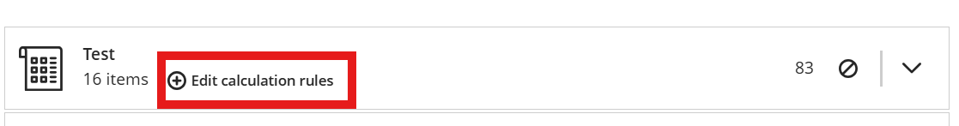
[Alt-text: Edit calculation rules highlighted]
- Choose to Enable the Category Calculation Rule
- Choose Drop Scores:
  - Drop [x] lowest scores
  - Drop [x] highest scores
- If you want to calculate a non-entry as a 0, make sure that you deselect Calculate marks based on points earned out of total points:
[Alt-text: screenshot showing Calculate marks based on points earned out of total marked points with the option deselected]

Creating a module mark
Whilst AStRA calculates the true module mark, you may wish to calculate a module mark in Blackboard before transfer to facilitate appropriate selection of work for the moderation sample.
To do this:
- Follow the guidance for creating a Total Calculation
- Use the columns that you have created for the transfer and apply the correct weighting for each component.
- This will then give you the module mark for use for moderation .

Mapping the Gradebook
This process is usually managed by Faculty Student Education Administration.
Mapping the columns can be done at any time after your Gradebook columns have been created.
If you are working off campus, you will need to have VPN enabled to access MyAdmin.
- To map a module’s marks, go to myadmin.aber.ac.uk
- Click on Grade Transfer
- You will then be taken directly into the Grade Transfer screen in myadmin.aber.ac.uk for that module:
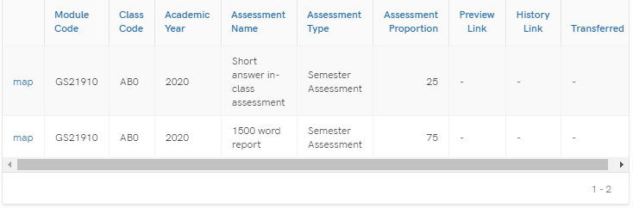

Mapping Columns to the Astra Component
The information displays from AStRA, so if there are any issues or discrepancies, the module record in AStRA needs to be amended. The Assessment Proportion (weighting) for each component will display.
Each component from the Astra module record will be arranged on separate lines.
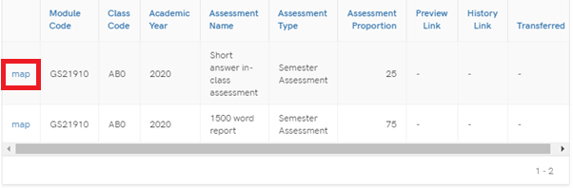

To begin the transfer process, select:
- Map on the component that you wish to transfer
- A window will open for you to select the Blackboard Grade Centre Column and further details of the Assessment information will be displayed.
- Select the Grade Centre Column that you would like to map by clicking on the dropdown menu. Gradebook Columns will display in the same order that they appear in the Grade Centre. Any hidden columns will display at the bottom of the list and will have (hidden) after their names.
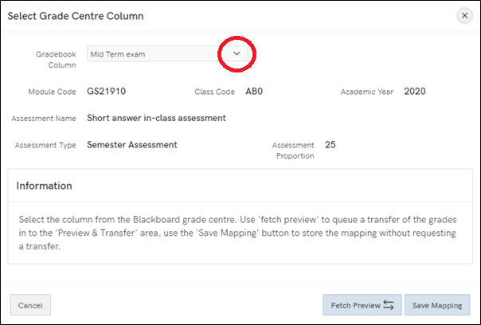
- Note that you can map the same Blackboard Grade Centre column to multiple modules in Astra. However, you can only map 1 Grade Centre Column against each component. Please see guidance on creating Grade Centre Columns further in this document to pull together multiple Grade Centre columns into one column to transfer.
- Fetch Preview to be selected if you want to queue the transfer of grades into the Preview & Transfer area
- Save mapping if you just want to set up the mapping process but transfer at a later date
After clicking Fetch Preview, the option will disappear:
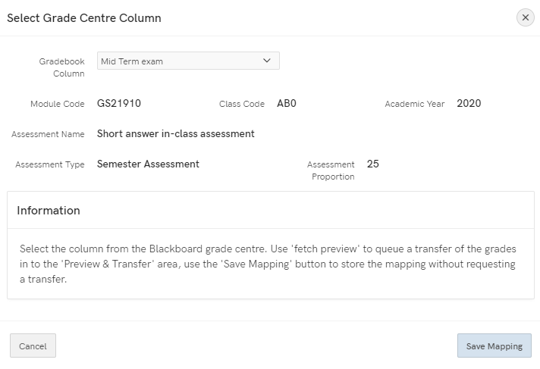
- After 5 minutes, the option to Preview & Transfer will appear
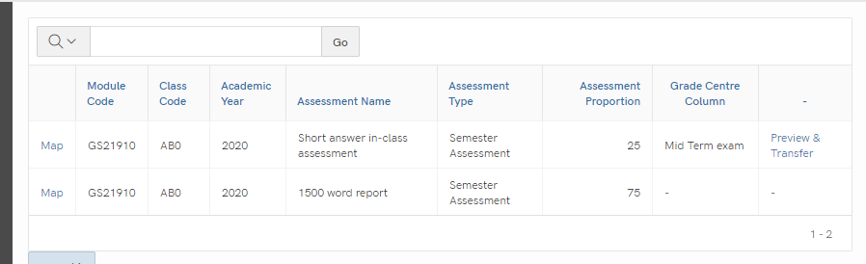

- You can amend the columns against which marks are mapped for any point if you save.
- When you are ready to transfer the marks, click Preview & Transfer. Once you select Preview & Transfer, you’ll be unable to amend the mappings
- In the window that opens, you’ll see a list of the students and their marks.
- The scores for the component will be in the far right hand column – double-check that these scores are correct.
- Anyone with a score of 0 are highlighted as per the below for you to double-check:
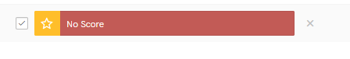
- Note that the marks will be transferred as they are – for example, if a component is out of 120 and the student gets 110, a score of 110 will be transferred. To get a score out of 100, the column needs to be converted to a percentage.
- If you are satisfied with the preview, scroll down to the bottom of the page and select Mark for Transfer
- You’ll get a pop up acknowledging that Marks staged for next Transfer
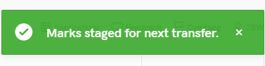

Merged Modules
If you have merged modules:
- Go to myadmin.aber.ac.uk and log in
- Select Grades Transfer tool
- Search for the secondary module in My Admin
- Select the Column that you would like to map the marks to and follow the process as above

Checking the marks have transferred to AStRA
Once marks have been transferred, module co-ordinators need to check that marks are correct.
FSEA can provide a report which is uploaded to SharePoint to check.
You can then check they have appeared correctly by logging into AStRA and viewing STF080.
To access the STF080 report:
Students > Student Modules > Exams > Assessment Marks per Module
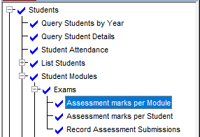

The marks should appear in AStRA quarter past and quarter to every hour.
If you need to transfer additional marks, you can press the Preview & Transfer button again.

FAQs:
- What if I’ve transferred the wrong marks?
The preview and transfer process should prevent this from happening.
If you notice at the preview and transfer stage that the marks are wrong, remap the correct column and go through the process again.
If you have transferred the marks, contact the Digital Education Team (elearning@aber.ac.uk) and they will unlock the column.
If marks have been applied, contact Digital Education Team (elearning@aber.ac.uk) who will liaise with BIS and Registry to get the release the column. This can take a bit of time.
- What if my score is not out of 100 but I need a score of 100 to transfer?
Change the display in the column to show as percentage.
- All the marks are 0 or there are some that are more than 100
Chances are that the wrong column has been selected. Double-check and remap if necessary.
- Is it possible to map multiple columns to the same component?
No, create a total column to pull together the columns to map.
- What if the marks are correct in Blackboard but there are different marks in AStRA?
Make sure that all marks have been posted. Refetch the marks.

