Creating Recorded Presentations

Digital Education Group ([elearning@aber.ac.uk](mailto:elearning@aber.ac.uk))

Updated July 2025

You may be asked to create recorded presentations for one of your assignments. This guide is intended to talk you through the technicalities of creating your recorded assignment. If you have any questions about the assignment brief, please contact your module coordinator.

You will submit your recorded assignment using the Panopto option embedded in Blackboard assignment.

As recorded presentations require you to plan, design, and record, we recommend that you start work on them well ahead of the deadline. Additionally, recorded presentations often produce large files so give yourself plenty of time to submit before the deadline. Not leaving enough time may result in your submission not being processed as the deadline passes and does not give you the opportunity to check your content.

# Preparing for your recorded presentation

You will need to plan and practice your presentation before recording. The first stage of this will be to create a plan of what you would like to say. Most recorded assignments have time limits applied so incorporate into your plan how long you intend to spend on each section.

Give time at the start to introduce your presentation by giving an outline of what you intend to cover. Factor in time at the end of the presentation to conclude and give an overview of your presentation’s main points and arguments.

Make sure that you consult the assignment brief and the marking criteria and seek clarification from your module coordinator if you have any questions.

Make sure that you have the equipment that you need to do the recording. We recommend that you avoid using mobile devices to record on (where possible). Loan stock equipment is available to hire from [Information Technology Services.](https://www.aber.ac.uk/en/is/it-services/loans/) Most laptops have inbuilt microphones but you can also hire these if they are not available. If you do not have access to the correct equipment, then it is possible to [book a teaching room.](https://www.aber.ac.uk/en/timetable/room-bookings/) Please see our [teaching room guidance](https://www.aber.ac.uk/en/media/departmental/informationservices/e-learning/Teaching-Room-Guide-2025-26.docx) on how to use the equipment.

## PowerPoint slides

It is likely that your recorded presentation will need a PowerPoint slideshow to go alongside it.

As a student of the University, you have access to Microsoft PowerPoint via your Office 365 licence. We recommend that you use Microsoft PowerPoint to create your slideshow.

See Microsoft’s [guidance on using PowerPoint](https://support.microsoft.com/en-us/office/create-a-presentation-in-powerpoint-422250f8-5721-4cea-92cc-202fa7b89617).

## Recording your presentation

Once you have created and planned your presentation, it is time to record. We recommend doing a practice short recording first to check that your microphone and equipment is being recorded. Playback the recording to check that you are happy with the sound levels.

Choose an appropriate location for the recording – quiet and free from distractions. Before starting your recording, close all other programmes on your computer.

When it comes to recording your presentation you have two options:

1. Recording in PowerPoint
2. Recording in Panopto (via Blackboard Assignment)

### Recording in PowerPoint

Follow the [guidance from Microsoft on how to record a presentation.](https://support.microsoft.com/en-gb/office/record-a-presentation-2570dff5-f81c-40bc-b404-e04e95ffab33)

In order to submit your recorded presentation, you will need to save and export your recording as a .mp4 file to submit (see steps below).

### Using Panopto to record

If you do not want to use PowerPoint to record your presentation or you do not have a PowerPoint slideshow, you can use Panopto to record directly into Blackboard Assignment.

To do this:

1. Follow the instructions on this [FAQ on submitting your assignment](https://faqs.aber.ac.uk/index.php?id=1581)
2. Select Record:

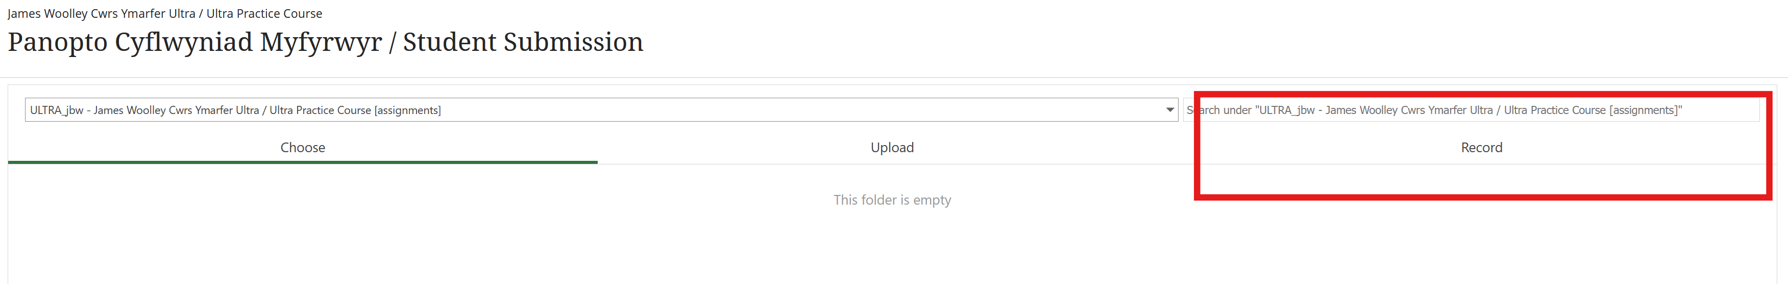

1. Follow the instructions on recording via Panopto (either using Browser or downloading the application)
2. As with PowerPoint, make sure you do a practice to check that your settings are correct.

# Submitting your recorded assignment

Follow our [FAQ on submitting your recorded presentation.](https://faqs.aber.ac.uk/index.php?id=1581)

Departments should be notified in the first instance if you are having difficulties submitting. You are also welcome to contact [elearning@aber.ac.uk](mailto:elearning@aber.ac.uk) / 01970 622472 ahead of the deadline to assist with your submission.