Creating Recorded Presentations
Digital Education Group (elearning@aber.ac.uk)
Updated July 2026
This guide takes you through the technical steps for making a recorded presentation. If you have any questions about the content of your presentation or the details of the assignment, please contact your module coordinator.

Making a recorded presentation will take time and we recommend you start working well ahead of your deadline.
This checklist gives you details of what you will need to do:
- Prepare your presentation
- Prepare your equipment
- Choose your recording tool
- Make a test recording
- Record your presentation
- Submit before the deadline and check that the upload was successful
Note: Recorded presentations will often be large files so give yourself plenty of time to submit before the deadline. Submitting too close to the deadline can mean that your presentation doesn’t process properly before the deadline. You will also need time to check your presentation has been uploaded successfully.

Step 1: Prepare your presentation

- Read the assignment brief and marking criteria carefully. This will help you plan what you would like to say and long to spend on each section.
- Have a look at our guidance on writing a presentation (AberSkills / Assignment Writing Articulate Guide).
- To create slides, you can use PowerPoint on the university computers or Microsoft PowerPoint in Microsoft 365. See Microsoft’s guidance on using PowerPoint.

Step 2: Prepare your equipment
- We don’t recommend using mobile devices to record a presentation. Most laptops will have an inbuilt microphone and camera.
- You can also borrow laptops, microphones, and webcams from the IT helpdesk.
- You can also book a university teaching room and use teaching room equipment.

Step 3: Choose your recording tool
You can either record your presentation in Panopto or PowerPoint.
Panopto is good if you want to record your screen as well as any slides. With Panopto you can record and save your presentation in Panopto. This means that access it and submit from any computer. You can also submit the presentation directly from Panopto.
With PowerPoint you can record and re-record individual slides easily. Before you submit you will need to save and export your recording as a .mp4 file.

Step 4: Make a test recording

- Make a short practice recording to check that your equipment is working properly
- Choose a quiet location free from distractions
- Close all other applications on your computer.
- Playback the recording to check that you are happy with the sound levels.

Using Panopto to record
- Login to https://panopto.aber.ac.uk
- Click on Create > Panopto Capture
Guidance on using Panopto Capture is available at https://support.panopto.com/s/article/How-to-Create-a-Video-Using-Panopto-Capture (guidance available from Panopto site in English only)
When you have finished recording, make sure that the video is saved in My Folder:
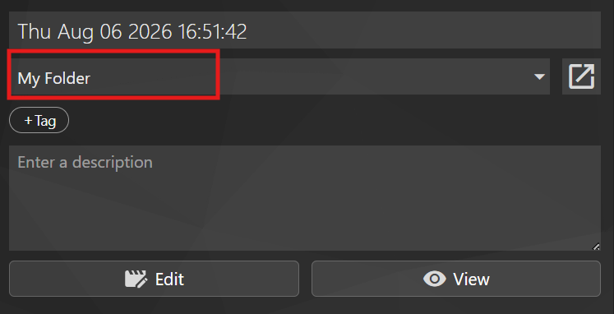
[Alt text: Panopto Capture saving options with My Folder highlighted]

Recording in PowerPoint
Follow the guidance from Microsoft on how to record a presentation.
Export your record as an .mp4 file – follow the instructions from Microsoft.

Step 5: Record your presentation and check it
- Don’t worry if you make mistakes when you start. It might take a couple of recordings before you record your final version.
- Remember that you can pause your recording if you need to take a break. If you use PowerPoint, you can re-record individual slides.
- When you have a recording that you are happy with, make sure you watch it to check it is ready to submit:
  - Does the recording play correctly?
  - Can you hear the audio correctly?
  - Can you read the slides?
  - Is the presentation the correct length?
Step 6:

Step 6: Submitting your recorded presentation
Follow the instructions in our FAQ on submitting your assignment
You will get an email receipt when your file has been submitted - make sure you keep your receipt.
You can also check that the file has been uploaded correctly by going back to the submission link to view your submission.

Getting help
Contact your department if you have problems with your submission.
For technical help before the deadline contact elearning@aber.ac.uk / 01970 622472.

How do I submit a video assignment
You will need record a video using either Panopto or PowerPoint – have a look at our guide for more information.
- Click on the Blackboard Assignment link
- Click on Start Attempt
- Click on the Insert Content icon – it’s the + image
- Click on Additional Tools
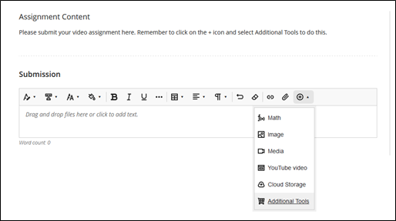
- Click on Panopto Video LTI (Student Submission Tool)
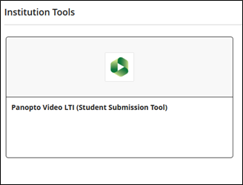
If you have used PowerPoint
- Select the Upload tab.
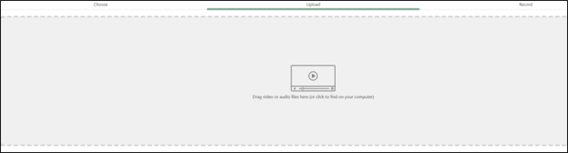
- Click on the grey box and locate your video file
- Select your file and click Open
- Wait for the file to upload
- Click the Insert button at the bottom of the screen
- You can change the display name for the file, or use the one that is added automatically, and then click Insert
- Your file will now appear in the submission window.
- Click on Submit at the bottom of the screen. You must press Submit otherwise the file won’t be submitted for marking.
- Press Submit on the pop-up confirming submission.
- You can download your receipt if you wish – you’ll also get a copy in your email. Make sure you keep your receipt.

If you have already recorded in Panopto
- Select the Choose tab
- Change the dropdown box at to My Folder
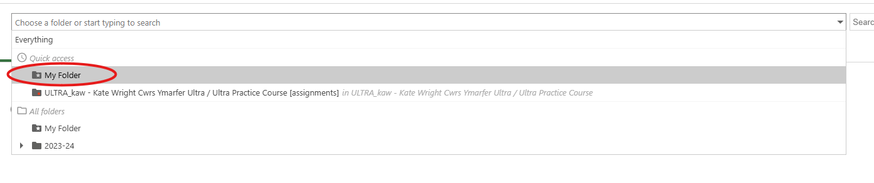
[Alt text: Panopto folder dropdown menu with My Folder option highlighted]
- Select the recording you want to submit
- Click the Insert button at the bottom of the screen
- You can change the display name for the file, or use the one that is added automatically, and then click Insert
- Your file will now appear in the submission window.
- Click on Submit at the bottom of the screen. You must press Submit otherwise the file won’t be submitted for marking.
- Press Submit on the pop-up confirming submission.
- You can download your receipt if you wish – you’ll also get a copy in your email. Make sure you keep your receipt.

