Panopto Video Assignments
Digital Education Team (elearning@aber.ac.uk)
August 2026

Create a Video Assignment Submission link
- Follow the instructions for creating a standard Blackboard assignment.
- Use the Add Text option to add instructions for students.
We strongly recommend that you include the following information for students as part of your instructions:
“To submit your video, please see FAQ: 'How do I submit a Blackboard Assignment? (Student)’, along with the instructions below to add your Panopto video:
- When you have opened the assignment, click on the Insert Content icon – it’s the + image
- Click on Additional Tools
- Find and upload your video
- You must press the Submit button to complete your submission.
- You will receive an email receipt once you have correctly submitted – please save a copy of this receipt.
We also recommend that you set up a test submission so that students can practice before the final submission.

Student Submission
- Click on the Blackboard Assignment link
- Click on Start Attempt
- Click on the Insert Content icon – it’s the + image
- Click on Additional Tools
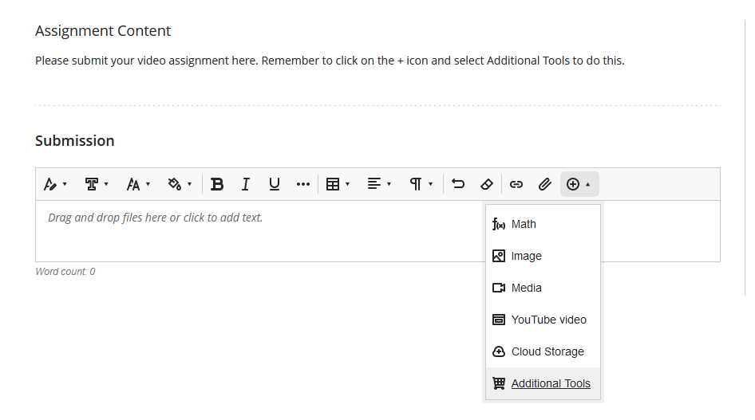
- Click on Panopto Video LTI (Student Submission Tool)

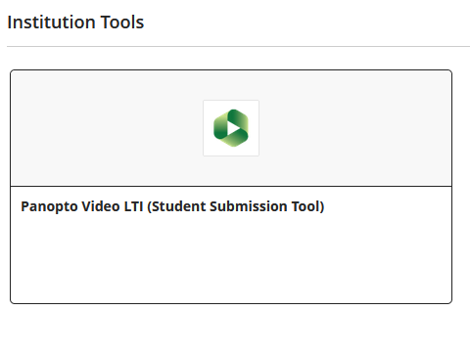
- Select the Upload tab if your file is ready to upload. If you want to record in the session select Record.
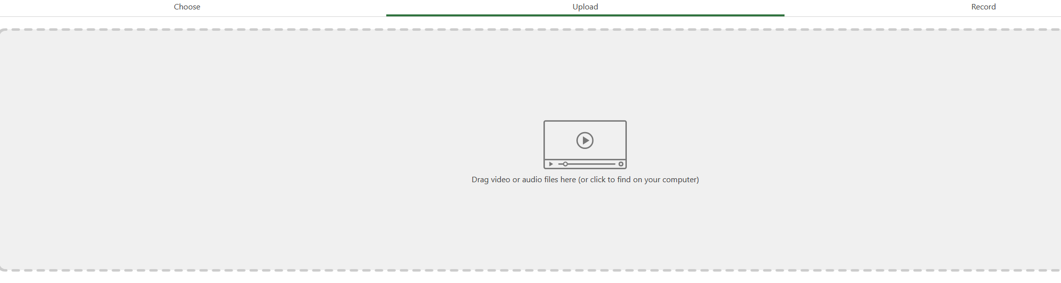
- Click on the grey box and locate your video file
- Select your file and click Open
- Wait for the file to upload
- Click the Insert button at the bottom of the screen
- You can change the display name for the file, or use the one that is added automatically, and then click Insert
- Your file will now appear in the submission window.
- Click on Submit at the bottom of the screen. You must press Submit otherwise the file won’t be submitted for marking.
- Press Submit on the pop-up confirming submission.
- You can download your receipt if you wish – you’ll also get a copy in your email. Make sure you keep your receipt.

Marking Student Submissions
- Click on the submission link you created
- Click on the Submissions tab
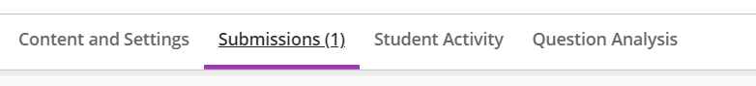
- Click on one of the submissions
- You can play the video in the marking window
- Add your final mark and feedback on the right-hand side of the screen. Click on the arrow, or Plus button to open the Overall Feedback Panel.
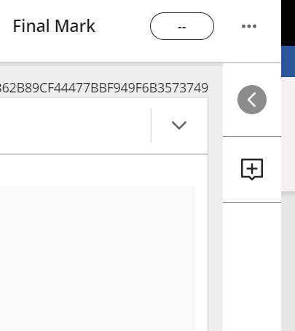
- Once you have marked all submissions, select Post all marks to release marks and feedback.
