Quick Start Guide to Turnitin
Learning and Teaching Enhancement Unit (lteu@aber.ac.uk)
July 2023

How do I create an assignment submission point in Turnitin?
- Go to the Course in Blackboard and click on the create icon + where you want to create your Turnitin Submission Point. This will normally be in the Assessment and Feedback folder.
- Select Additional Tools
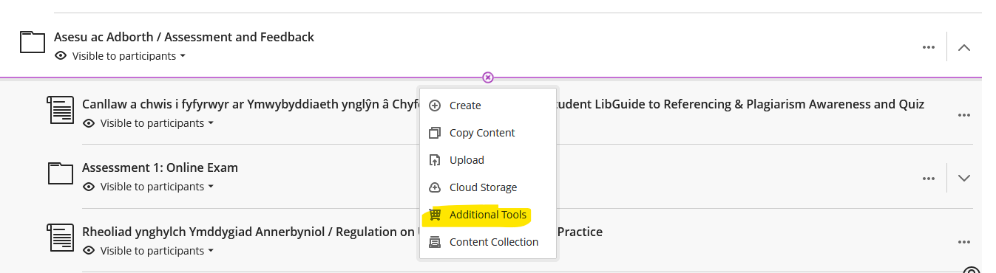
[Alt-text: Screenshot of the content editor with Additional Tools highlighted]
- A screen will load called Institutional Tools.
- Click on Turnitin Assignment 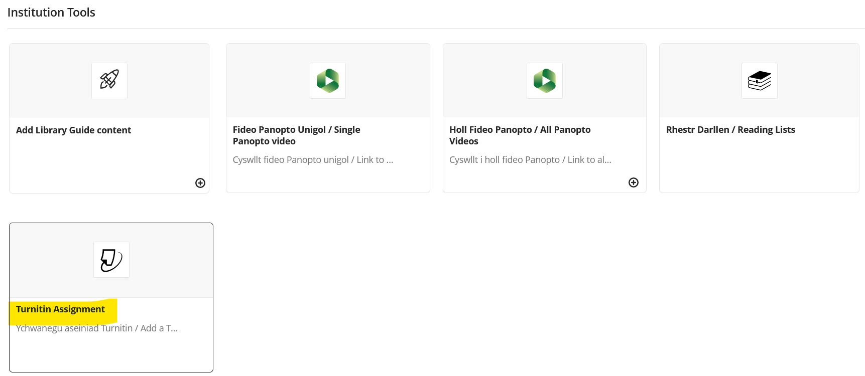
[Alt-text: Screenshot of Institutional Tools with the Turnitin Assignment tool highlighted.
- The Assignment creation page below will appear.
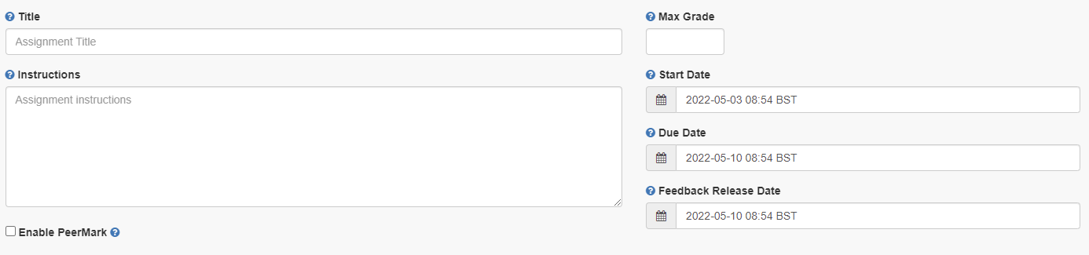
- Enter the assignment’s name in Title
- Enter Max Grade – normally this is 100
- Enter any instructions in Instructions
- Enter a Start Date and Time. This is when the assignment submission point becomes available for students to submit their assignments to.
- Enter a Due Date and Time. This is when students must submit their submission by.
- Enter a Feedback Release Date. This is the time and date that feedback and marks are released to students. With anonymous marking, this is also the point at which you can ascertain the authors of the assignments.
- Click on Optional Settings to choose the correct settings for your Turnitin submission point.
- Submit papers to – standard paper repository.
- Allow submission of any file type – do not select to ensure all assignments can be checked for originality.
- Allow late submissions:
  - If deselected students will not be able to submit after the due date and how assignment extensions are processed should be considered.
  - If selected, students can submit assignments after the due date. Late submissions will be flagged as being submitted late.
- Enable anonymous marking – Yes should be used.
- Enable grammar checking – when enabled marks for grammar will be shown in GradeMark.
- Attach a rubric – select a rubric here if using.
- Compare against – select all.
- Generate Similarity Reports – controls the Similarity Reports as well as whether students can resubmit assessments up to the due date and time. If you select:
  - Immediately (first report is final) – students cannot resubmit assignments. Similarity reports are generated immediately for all submissions. Erroneous submissions must be deleted by instructors before resubmission may be made.
  - Immediately (can overwrite reports until due date) – students can resubmit assignments as many times as they want to until the assignments due date and time.
  - On due date – students can submit an assignment as many times as they want until the assignments due date and time. The Similarity report is generated on the due date and time.
- Exclude assignment template – a template of text can be uploaded or created to be automatically excluded from the Similarity Report (e.g. assignment question, brief, instructions).
- Save these settings for future use – select to save as default for future assignments.
- Click Submit and you will see the submission point in the area on Blackboard:
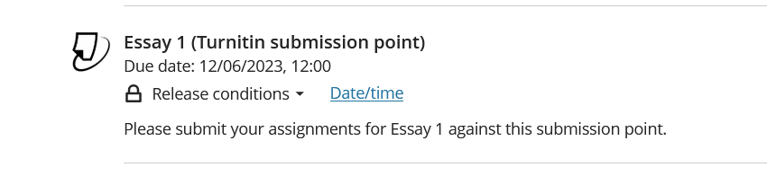
[Alt-text: Screenshot of the successfully created Turnitin submission point]

How do I use Rubrics?

What are rubrics?
Rubrics are marking or assessment criteria. Students will be able to view a rubric / form attached to an assignment submission point before they submit their assignment. Turnitin has four different types of rubrics that can be set up and enable you to define criteria to mark against
- Standard Rubric – each criterion is weighted using percentages and each scale has a mark allocated to it. The overall mark is calculated based on the percentage weightings
- Custom Rubric – criteria are not weighted
- Qualitative Rubric – no weighting or marks can be applied. The scales and criteria are used to provide guideline feedback
- Grading forms – can be used to provide free form feedback based on each criterion. You set the criteria and add comments for each student
For further information, see FAQ 705.

How do I create a rubric?
Rubrics can be created when an assignment submission point is set up, or after students have started to submit and you are ready to mark.
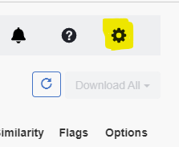
To create a rubric:
- Login to Blackboard and go to the module that contains the assignment
- If the assignment submission point has already been created:
  - Click on the submission point
  - From the Turnitin inbox, select the settings cog:

- Expand optional settings and select Attach a rubric
- The rubric manager dropdown will appear. Here you can choose from the dropdown list to select a rubric that you already have access to.
- If you are creating a rubric, select Launch Rubric Manager
- Select Create new Rubric
- At the bottom of the page select a rubric scoring option (see FAQ 705 for the different types of rubrics that are available to you.)
- Add a rubric name at the top of the page
- Complete the Criteria / Scales depending on the rubric requirements
- Add additional criteria and scales using this symbol:
- Click Save to apply the changes to the rubric

For further information, see FAQ 701.

How do I mark an assignment in Turnitin?
We recommend starting to mark after the due date to prevent student’s assignments from being overwritten.
- Go to the module that you are marking
- Go to the area where the submission point has been created (normally this is Assessment and Feedback)
- Click on the Turnitin submission point and the assignment inbox will open in a new window:
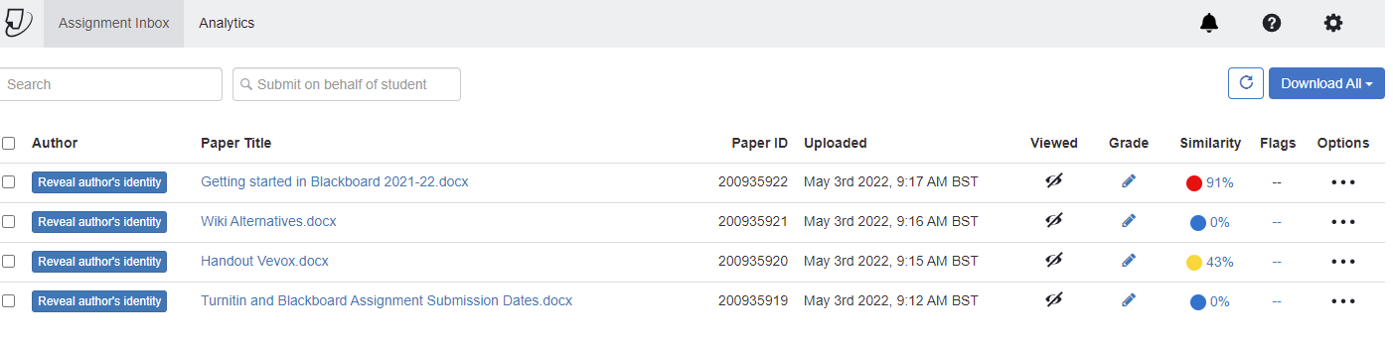
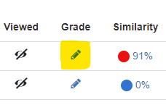
- To grade an assignment, select the pencil icon:
- The assignment will open in the feedback studio for you to mark and leave feedback.

Checking the similarity score
Turnitin has an inbuilt similarity report checker. It is a text matching function and not a plagiarism detection tool:
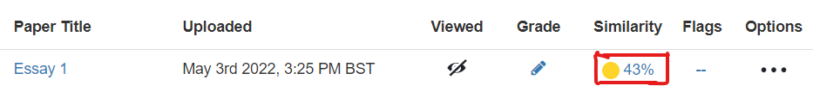
[Alt text: Image from the Turnitin inbox showing the Similarity Score highlighted.]
A Similarity Report shows textual matches or similarities between your assignment submitted to Turnitin and a range of online sources including Turnitin’s own bank of previously submitted work. Turnitin's online sources include: web pages, essay mills, online journals, articles, and publications. The scan is generated once you have submitted your assignment to Turnitin.

The matching text displays as a percentage. To view the similarity report:
- Click on the Percentage, this opens the Document Viewer
- To view the sources, click on the number in the red box:

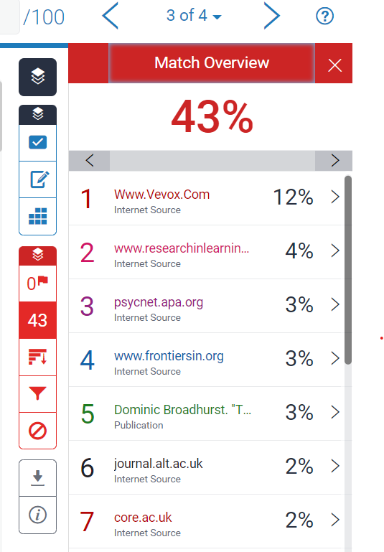
How do I interpret the Similarity Score?

Once you are in the feedback studio interface, you can expand the similarity score to show the Match Overview. This identifies the percentage of other sources that the assignment has used:
Clicking on a source will navigate to the part of the assignment where it is used.
The matching text will be highlighted and a pop up will appear to show the original source that the assignment has matched against.

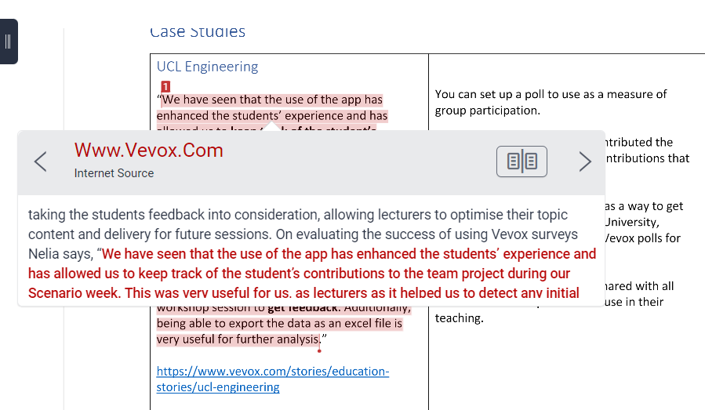

What are flags?
Flags pick up potential integrity issues such as:
- Replaced text characters which could be inserted to circumvent a similarity match.
- Hidden text such as quotation marks, that could impact the percentage of quoted material and enable the passing off of such content as original.
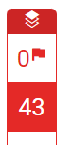
Turnitin’s algorithms look at a document for any inconsistencies that would set it apart from a normal submission. A flag is not necessarily an indicator of a problem. However, we’d recommend you focus your attention there for further review.
If an assignment has a flag, then this will be marked in the feedback studio.
Click on the flag for further information:
[Alt text: Screenshot showing the flag panel]

How do I give in-text feedback and comments on an assignment?
Feedback and comments can be given once an assignment has been opened.
If you click on the assignment this icon appears:
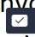
- The symbol is QuickMarks – a tool that contains a bank of comments that can be inserted onto the text.
- The symbol allows you to enter feedback and comments of your choosing.
- The symbol allows you to enter feedback in line with the text on the assignment.
If you are using Rubrics then you can choose to associate your comment with a criterion. When you are creating your comment select Assign Criterion.

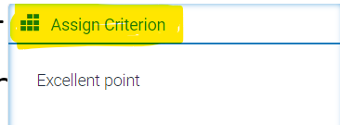

In the dropdown that appears select the Criterion you want to apply to your comment.

How do I mark using groups?
Turnitin groups can be used to divide assignments for marking purposes, for example between seminar groups. Please notes that groups should be formed before the submission point is created.
To put students into groups:
- Set up groups in Blackboard
- Populate the groups with students
- Go to the Turnitin submission point and click on the link to open the assignment inbox.
- Select the groups you want to mark by clicking the dropdown arrow for All Students and selecting Other Groups.

- The assignment inbox will then show the students’ assignments that belong to that group:
- For further information, please see FAQ534.

How do I use QuickMarks?
QuickMarks are a bank of comments that might be applicable on multiple occasions to students across different modules.
They can also provide explanations to help students further develop from your feedback.

How do I enter QuickMarks’ manager window?
There are two ways of entering QuickMark manager:
- Click in any place in a paper submitted to Turnitin and click on the QuickMark icon:
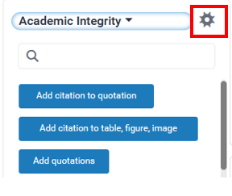
Click on the cog icon in the top right corner of the pop-up window:
- Click on the QuickMark icon on the
Turnitin tools’ menu on the left-hand side:
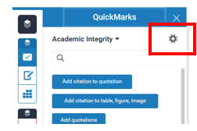
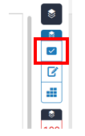

Then click on the cog icon in the top right corner:

How do I add a Quick Mark?
You can either add your QuickMark to existing QuickMark set or create a new set.
- To choose the set from the list:
  - Click on the three horizontal lines icon on the left top corner:
  - Choose one of the Sets:
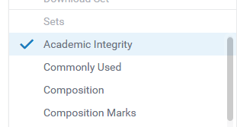
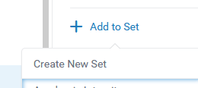
- To create a new QuickMark set:
Select Add to Set and Create New Set
Type in the title and press Save.

How do I use a QuickMark?

- Click in any place in a paper submitted to Turnitin and click on the QuickMark icon:
Choose the appropriate set by clicking on the black drop-down arrow:
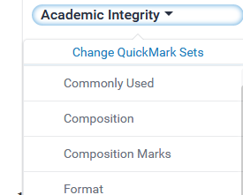
Click on the QuickMark you want to add.
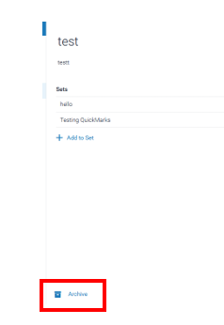

How do I delete QuickMarks and QuickMark sets?
- Deleting QuickMark sets:
In the QuickMark manager window, click on the minus symbol next to the QuickMark set you want to delete:
- Deleting QuickMarks:
You cannot completely delete a QuickMark but archiving it will remove it from any sets and make it invisible. To archive a QuickMark:
- Click on the three horizontal lines icon on the left top corner
- Click on the QuickMark you want to archive and click Archive

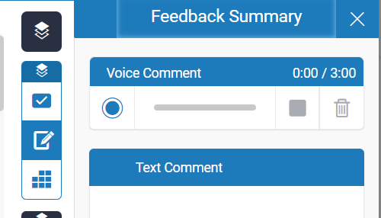
Where should I leave my feedback summary?
General comments and an overview of feedback for students should be left in the feedback summary:
Enter your written feedback in the Text Comment box.
For audio feedback, click on the record button. You will be asked to give browser permission for the device to pick up your microphone. Select Allow.

Where should I enter the final mark?
When you have decided a mark to give an assignment:
- Double click on this symbol:
- Enter the number that you want to give the assignment
- Press Enter on your keyboard and click outside of the mark box (anywhere on the assignment)
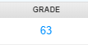
- Close the assignment and the mark should populate in the entry on the Turnitin Assignment page:

Tip: Do not toggle between assessments – instead, after you have marked the assignment, close it down and re-open the next assessment.

How do students submit to Turnitin?
- Log into Blackboard and go to the module for your assignment
- Go to the Turnitin submission point:

- Click on the submission point and a new window will open
- Select Upload Submission
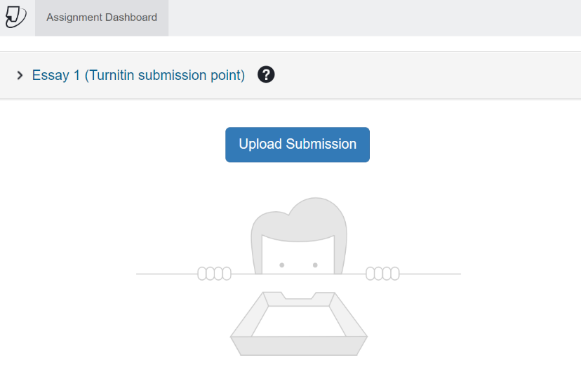

- The file upload window will open.
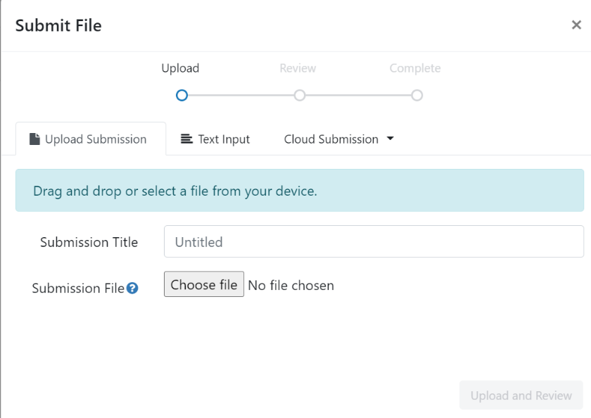

- You can drag and drop your submission file onto the submission point, or select Choose file to search your file store.
- The Submission Title will automatically populate with your file name. You can amend this by deleting the text and renaming the file if you wish.
- Select Upload and Review
- Your file will upload, and you will be able to preview the submission:
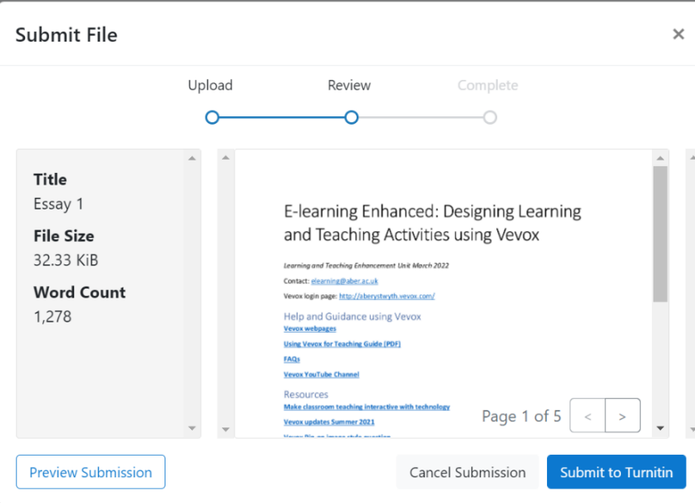

- If you are happy that it’s the correct file, select Submit to Turnitin.
- You will see a message to say your submission is complete.
- You can also download your Digital Receipt:

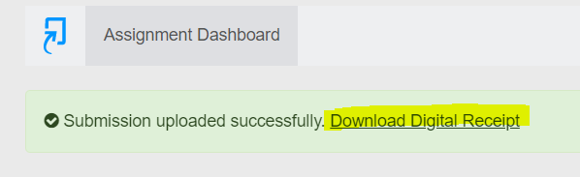

- For confirmation of your submission see our guidance on How do I check that my assignment submission has been successful?

