Using Vevox for Teaching

Digital Education Group (elearning@aber.ac.uk)

Updated June 2025

Using polling software for in-class activities can be a way of improving students’ engagement. This guide provides instructions for using the interactive software Vevox, which includes polling, Q&A and surveys. More information is available on the [Vevox helpsite](https://help.vevox.com/hc/en-us) (English-language materials only).

Vevox is the recommended and supported polling software for Aberystwyth University.

Contents

Getting started with Vevox 2

What elements are available in Vevox Sessions? 3

What types of questions are available in Vevox? 3

How do I create activities in Vevox? 5

How do I set up a poll in Vevox? 5

How do I set up a survey in Vevox? 6

How do I set up a Q&A board in Vevox? 7

How do I start and stop my Session in Vevox? 9

How do I run polls in Vevox? 9

How do I run surveys in Vevox? 10

To end a Session 11

How do I integrate Vevox with PowerPoint? 11

How do I use Vevox in a Teams meeting? 14

# Getting started with Vevox

1. Go to https://[aberystwyth.dashboard.vevox.com](https://aberystwyth.dashboard.vevox.com/#/).
2. Click **Login with SSO**

Because Vevox contains a number of interactive elements in one place, you must create a Session before setting up any polls, Q&As, or surveys. This makes sure that all materials relevant to a given Session are in one place.

1. Click on the **Create Session** button.
2. Give your Session a name
3. Click **Create**.

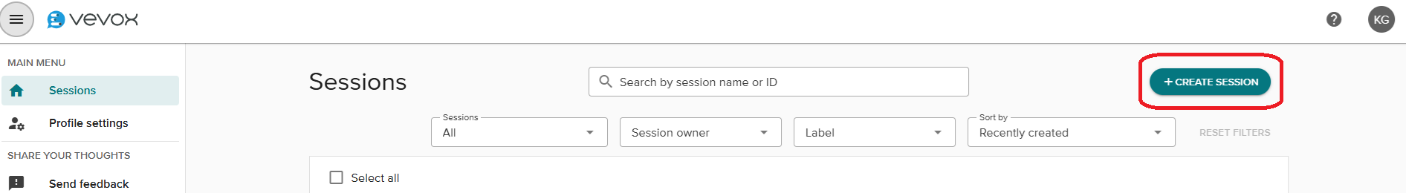

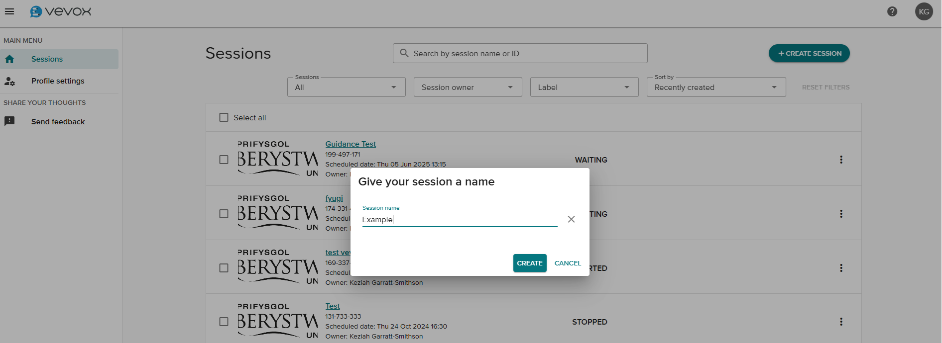

Vevox automatically opens the session and places you in the Polls section of your session. You can then navigate to any other part of your Vevox Session through the menu on the left.

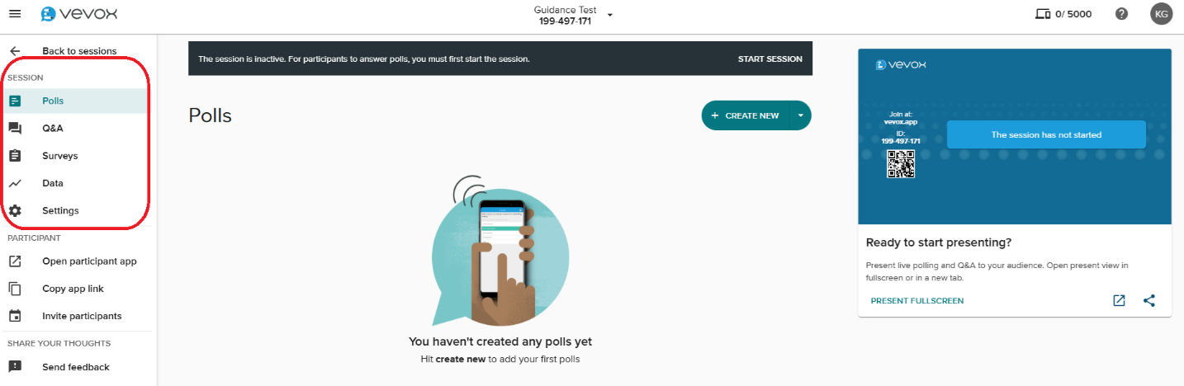

# What elements are available in Vevox Sessions?

|  |  |
| --- | --- |
| **Element** | **Description** |
| Poll | Participants can answer a range of questions (see below). Some question types can either have correct answers, or be used to collect opinions and ideas. |
| Q&A Board | Participants can send anonymous questions to the presenter (a little like the Chat function in Teams) |
| Survey | Provide Survey questions that can be answered during a session or circulated after a session |

# What types of questions are available in Vevox?

|  |  |
| --- | --- |
| **Question Type** | **Description** |
| Multichoice | Gives the participants the option to choose between different answers. A correct answer can be set, or multiple answers permitted. An image can be added to this type of question. |
| Word Cloud | Participants can answer a question by submitting words which appear as a “cloud” on the slide. Words that have been submitted the most appear larger. |
| Text | Allows your participants to write longer comments that appear on the slide in the form of Speech Bubbles, One by One or as a Flowing Grid. |
| Ranking | Rank choices in order of preference or place them in a correct order. |
| Rating scale | Allows your participants to rate certain statements i.e. how much they disagree or agree on an issue/statement, using a 1 to 5 star rating system. |
| Numeric | The numeric poll allows participants to enter any number within a range that you specify.  You also have access to the following additional features with numeric polls:   * Indicate the **correct answer** if there is one * Allow answers with up to **two decimal places** * Allow for a **margin of error** for the correct answer |
| XY Plot | This type of question is for questions where you want to determine the relationship between two data points. Your participants can respond within the parameters that you set up, e.g. a Cost/Benefit comparison. |
| Pin on image | Respond by placing one or more pins on an image. |
| Demographic | Single choice question used for grouping or team leaderboards. |

# How do I create activities in Vevox?

## How do I set up a poll in Vevox?

1. Create a new session and give it a name
2. Click **Add Content**
3. Select your question type
4. Create your question, filling in the fields on the Question Content page. Each question type will require different information
5. Press **Create** when you have finished

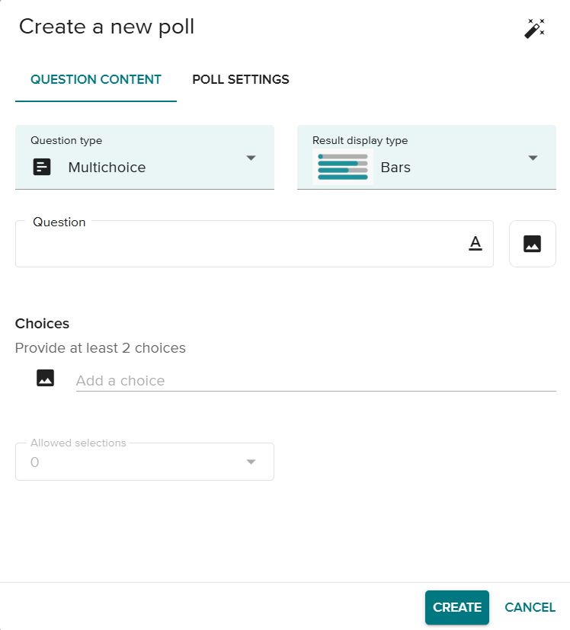

More information on [Polling](https://help.vevox.com/hc/en-us/categories/360001607017-Polling) is available on the Vevox website (guidance is only available in English).

## How do I set up a survey in Vevox?

1. Create and name your session (or edit an existing one)
2. Click on Survey on the left-hand side of the screen

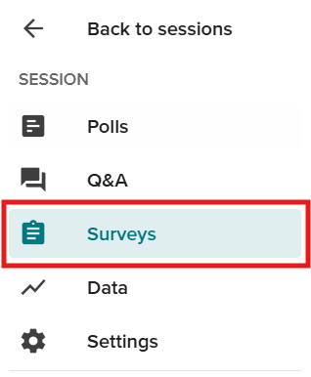

1. Click **Create New**

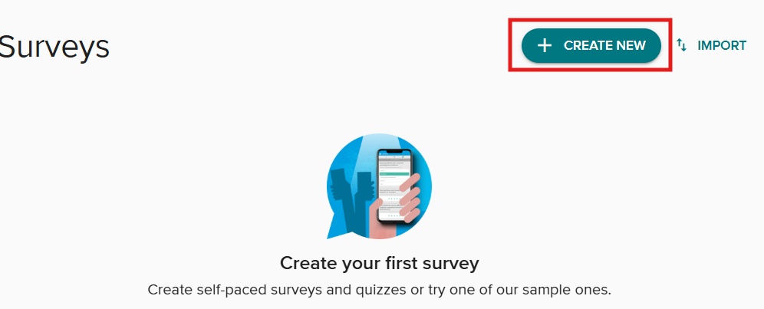

More information on [Surveys](https://help.vevox.com/hc/en-us/categories/360001599098-Survey) is available on the Vevox website (guidance is only available in English).

## How do I set up a Q&A board in Vevox?

1. Create and name your session (or edit an existing one)
2. Click on **Q&A** on the left-hand side of the screen

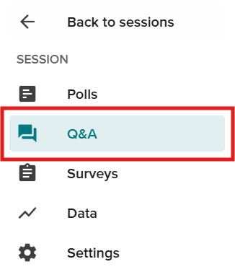

1. Use the drop-down menu to turn the Q&A Board on and off

Screenshot of the Q&A board with the Turn on option highlighted


You can post an announcement for participants using the **Manage and Publish Announcements** button. Note that you can make announcements before starting the Session, but your participants will only see them once the Session has started.

More information on [Q&A](https://help.vevox.com/hc/en-us/categories/360001599078-Q-A) is available on the Vevox website (guidance is only available in English).

# How do I start and stop my Session in Vevox?

To run your Session with participants you will need to Start it in the Vevox dashboard:

1. Login to Vevox and click on the name of your Session
2. Click **Start Session** at the top of the screen

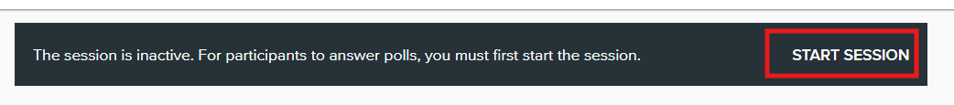

This will automatically open the Q&A board. Polls and Surveys needed to be opened individually (see below)

## How do I run polls in Vevox?

1. Start the session (see above)
2. Click **Present Fullscreen** so that your participants can see the access code and questions. If you are in a teaching room, make sure that you drag this window to Screen 2.
3. The Fullscreen option provides a QR code, URL and access code that your participants can use to join the session on their devices
4. Use the navigation options at the bottom of the screen to open and close individual polls

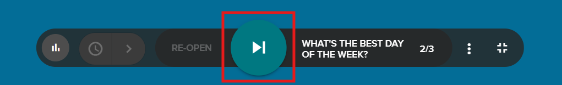



You can use the three dots More options icon to view questions and re-open Polls



# How do I run surveys in Vevox?

You will need to start the Survey in the Vevox dashboard. You won’t be able to display it in the full screen view, but participants will see it as an extra tab on their device, as long as the Session is open.

The speech bubbles (1) are the Q&A Board and the clipboard (2) is the Survey

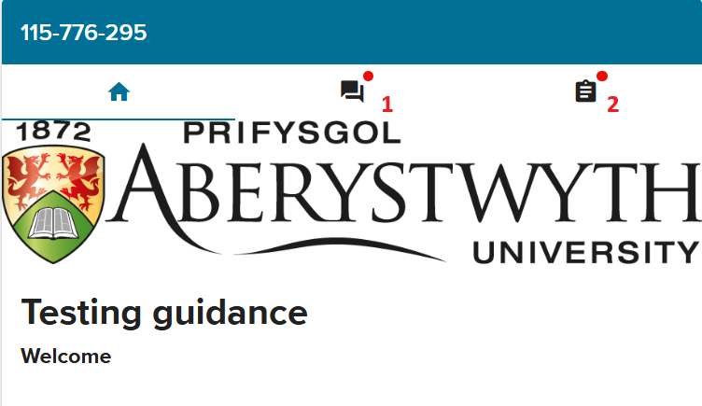

## To end a Session

1. Click on the name of the Session at the top of the screen
2. Click **End session**

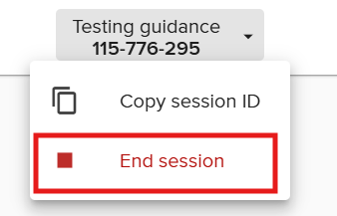

1. Click **Yes** to close the session

# How do I integrate Vevox with PowerPoint?

You can add polls or transform existing slides in polls with the Vevox PowerPoint Add-In.

1. Install the add-in from the [Company Portal](https://faqs.aber.ac.uk/index.php?id=2967).
2. You will see a Vevox icon in PowerPoint

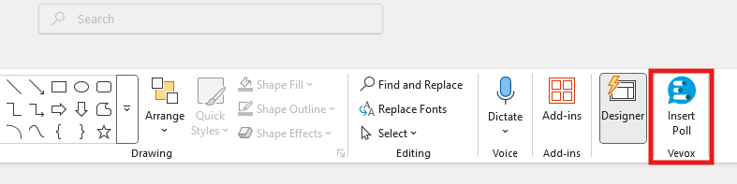

1. The Vevox tools will appear in a panel on the right-hand side of the screen:

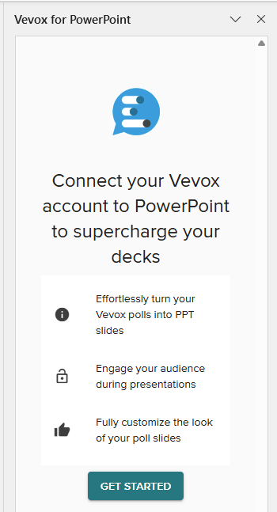

1. Click on **Get Started**
2. Click on **Login with Microsoft**
3. You will then see a list of all your Sessions
4. You can either select the Session you want to use or click the Plus icon to add a new Session.
5. Select the session you want to use
6. You’ll then see options to select the Polls you want to use.
7. You can also add a slide with joining instructions for your participants

More information on using [Vevox in PowerPoint](https://help.vevox.com/hc/en-us/categories/360001607057-PowerPoint-Add-in) is available on the Vevox website (guidance is only available in English).

# How do I use Vevox in a Teams meeting?

1. Login to Vevox and start the Session you want to run
2. Start the meeting in Teams
3. Click on the **Apps** button

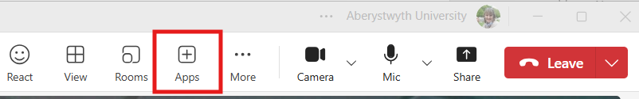

1. Search for Vevox and click on the Vevox icon

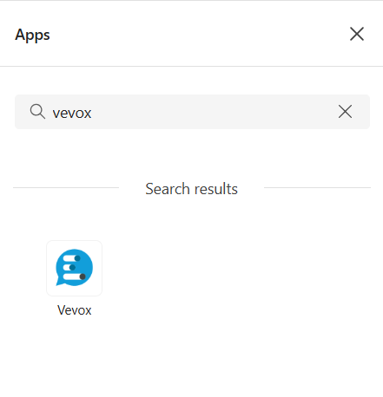

1. Click **Login** and **Login with Microsoft**
2. Select your Session and click **Save**
3. Use the Vevox dashboard to open and close polls

Participants in your Teams meeting should click on the vevox icon on their Teams dashboard

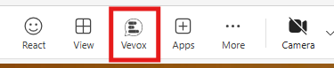

This opens the Vevox poll on the left-hand side of their screen and they can take part via this pane.

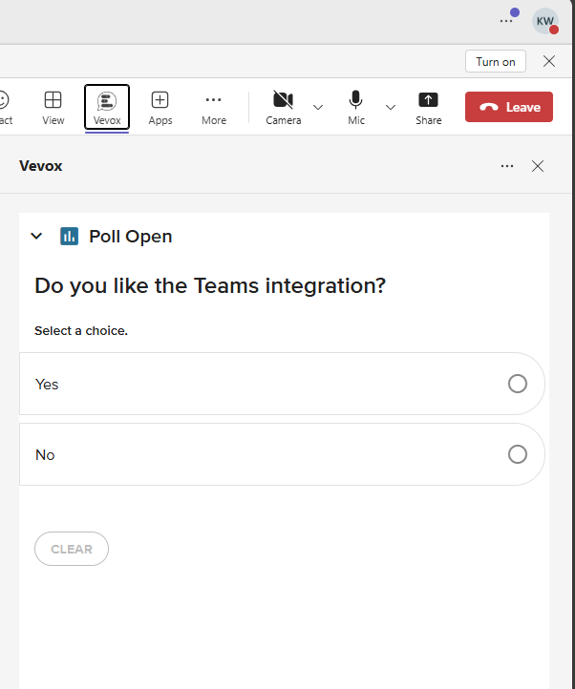

More information on using [Teams in Vevox](https://help.vevox.com/hc/en-us/articles/360009153397-Using-Vevox-with-Microsoft-Teams) is available on the Vevox website (guidance is only available in English).