Using Vevox for Teaching

Digital Education Team (elearning@aber.ac.uk)
Updated July 2026

Using polling software for in-class activities can be a way of improving students’ engagement. This guide provides instructions for using the interactive software Vevox, which includes polling, Q&A and surveys. More information is available on the Vevox helpsite (English-language materials only).
Vevox is the recommended and supported polling software for Aberystwyth University.
Contents
Getting Started with Vevox 1
Create a Session 1
Adding Content to Your Session 4
What elements are available in Vevox Sessions? 4
What types of polls are available in Vevox? 5
How to set up a Poll in Vevox 8
How to set up a Q&A in Vevox 9
How to set up a Survey in Vevox 10
Non-polling Presentation Content 10
Create a Spin the Wheel 10
Presenting a Session in Vevox 11
How do I start my Session in Vevox? 11
How do I present polls in Vevox? 11
How do I present Q&As in Vevox? 12
How do I run surveys in Vevox? 13
How to end a Session 14
How do I integrate Vevox with PowerPoint? 14
How do I use Vevox in a Teams meeting? 16

Getting Started with Vevox

Logging In

- Go to https://aberystwyth.dashboard.vevox.com.
- Click Login with SSO.

Create a Session

Vevox contains a number of interactive elements in one place, so before setting up any polls, Q&As, or surveys, select ‘CREATE SESSION’ in the top-right corner of the screen. This makes sure that all materials relevant to a given Session are in one place.

- Click on the ‘Create Session’ button.
- Give your Session a name.
- Click ‘Create’.
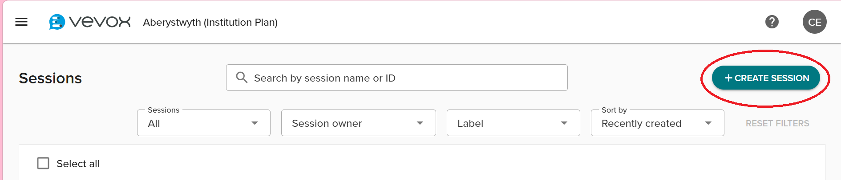

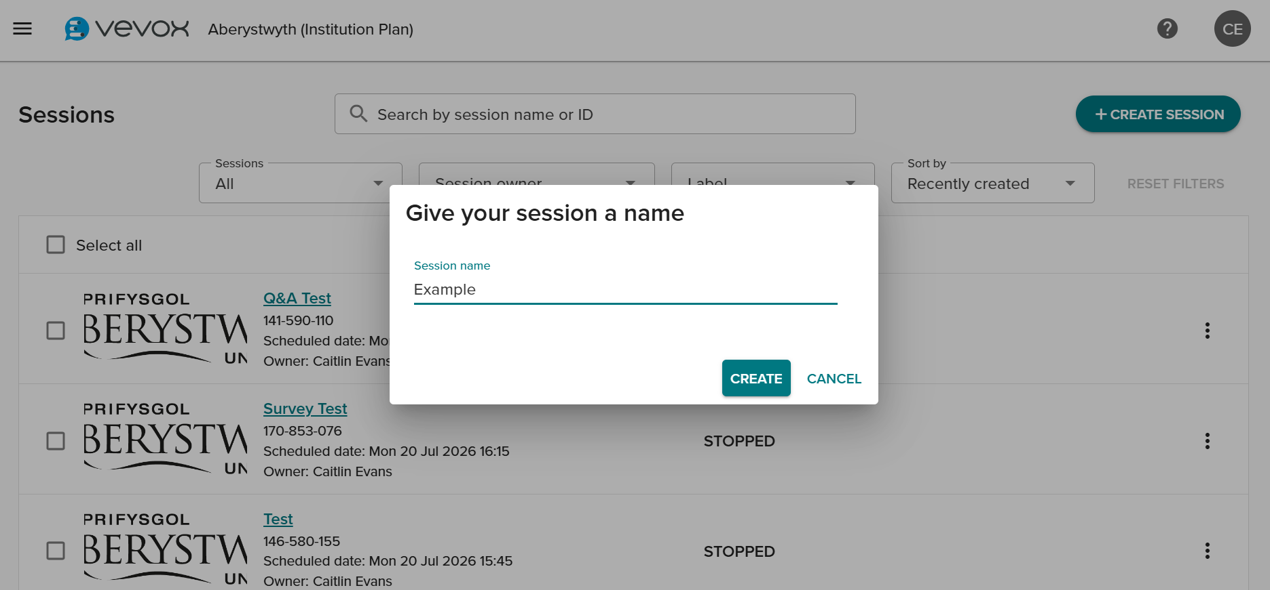
Vevox automatically opens the session and places you in the 'Presentation’ section of your session. From here, you can add content including polling questions, non-polling content, and imported content (see more about adding content below).
You can also use the ‘Question Library’ to find your previously used questions or to use questions from Vevox sample content.
You can navigate to any other element of your Vevox Session through the navigation menu on the left.
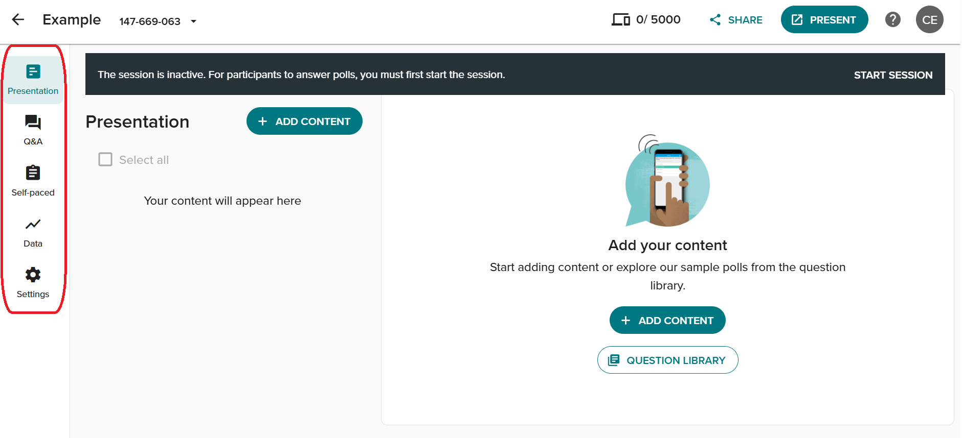
Customise your session settings by selecting the ‘Settings’ tab in the navigation tab. 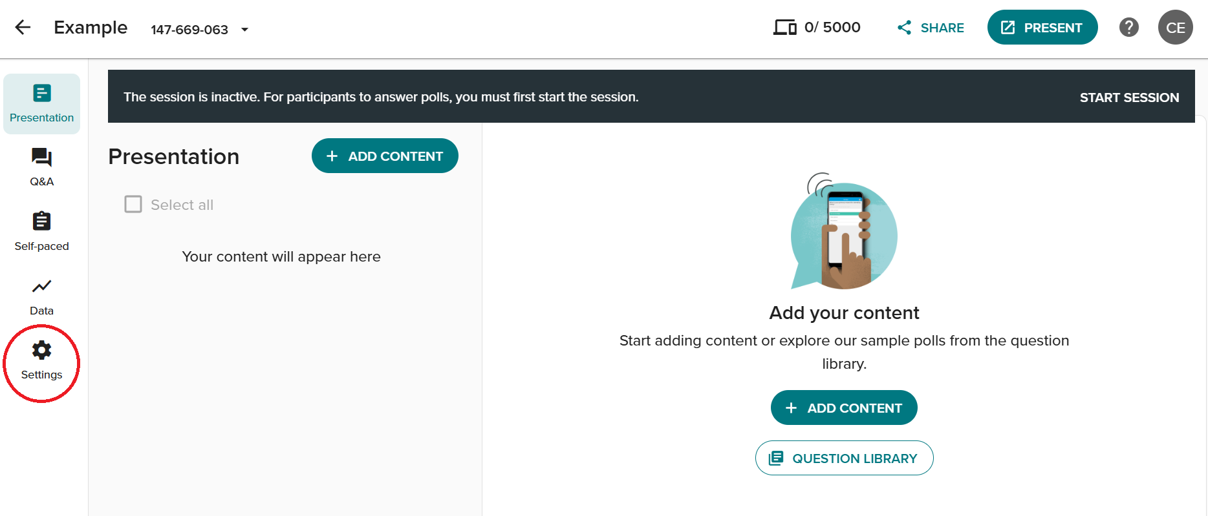
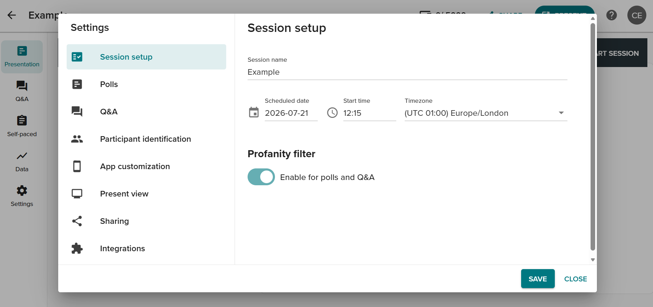
See more information on customising your session settings here.

Adding Content to Your Session

What elements are available in Vevox Sessions?

Element | Description
Polls | Questions that you ask your audience in real-time. Polls are usually used in live events, both in person and online. Participants can answer a range of questions (see below). Some question types can either have correct answers, or be used to collect opinions and ideas.
Questions and Comments (Q&A Board) | This allows participants to send anonymous questions or comments to the presenter (a little like the Chat function in Teams). This is also live, allowing for real-time engagement.
Surveys | Surveys allow participants to answer questions at their own pace. Surveys don’t require live participation, so they can be answered during a session or circulated after a session.

See more information about each element below.

What types of polls are available in Vevox?

Poll Type | Description
Multichoice | Gives the participants the option to choose between different answers. A correct answer can be set, or multiple answers permitted. An image can be added to this type of question.
Word cloud | Participants can answer a question by submitting words which appear as a “cloud” on the slide. Words that have been submitted the most appear larger.
Text | Allows your participants to write longer comments that appear on the slide in the form of Speech Bubbles, One by One or as a Flowing Grid.
Ranking | Rank choices in order of preference or place them in a correct order.
Matching | Asks participants to match items from two columns, connecting items on the left with their correct match on the right.
Numeric | The numeric poll allows participants to enter any number within a range that you specify.  You also have access to the following additional features with numeric polls:  - Indicate the correct answer if there is one  - Allow answers with up to two decimal places  - Display in a number cloud or a column chart  - Allow for a margin of error for the correct answer  - Show the median and mode averages.
Number cloud | A visual way to display numeric responses. They look like word clouds, but with numbers; the more a number is submitted, the bigger it appears.  Number clouds can:  - Represent positive and negative numbers  - Have up to 10 decimal places  - Have a correct answer  - Show mean, median and mode averages.
Rating | Allows your participants to rate certain statements i.e. how much they disagree or agree on an issue/statement, using a 1 to 5 star rating system or a sliding scale (Likert scale).
XY Plot | This is typically used for:  - Risk assessment  - Impact analysis  - Or anywhere you want to determine the relationship between two data points  Your participants can respond within the parameters that you set up, e.g. a Cost/Benefit comparison.
Quick polls (adhoc polls) | Fast, lightweight polls designed to capture real0time participant responses without pre-setup in the dashboard. Unlike traditional polls that you build and organise ahead of time, quick polls are created on the spot during a presentation directly from Present view.
Using images or photos in polling | There are three ways of using images in polls:  - Image polling. Images can be added to all question titles with Vevox polling types  - Pin on image. Ask participants to place a pin (area) on an image  - Multichoice on image. Plot the multichoice answer options directly onto an image.
Pin on image | Participants have to point to specific parts of an image, identify sections on an image or indicate their preferences on an image. You can decide if:  - Participants can place one pin on an image or multiple pins on the same image  - You can set correct answers to your image poll.
Pin on choice image polls | Based on a basic multichoice poll but has an image with the choice/answer options displaying as numbers on the image.
Before and after comparisons | Ask the same poll at different times during a session. Valuable for monitoring changes in knowledge, attitudes, and perceptions over time.
Demographic Segmentation | Dividing your audience based on various characteristics. Start by running a demographic poll, followed by an opinion poll.

More information on poll types available here (guidance is only available in English).

How to set up a Poll in Vevox
- Create a new session and give it a name or select an existing session.
- Click ‘Add Content’.
- Select your question type.
- Create your question, filling in the fields on the 'Edit’ page. Each question type will require different information. The question will automatically save but you can continue to edit the content. You can change the question type whilst in ‘Edit’, and edit the poll settings using the icon in the top right corner. Continue adding questions by selecting ‘Add Content’ on the left of the screen.
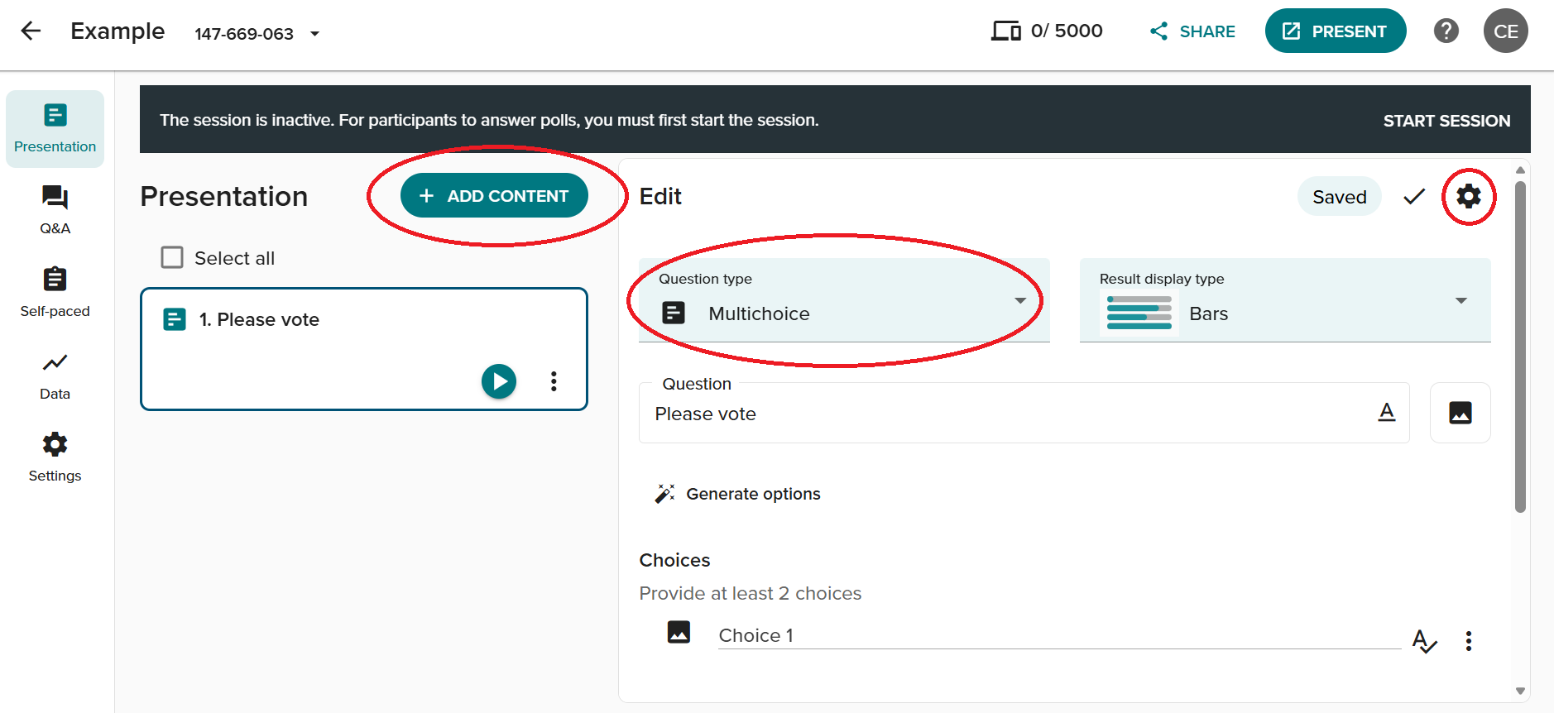
- Select the tick icon when you have finished to view the question preview. You can go back and edit the question in preview mode by selecting the edit icon in the top-right corner.
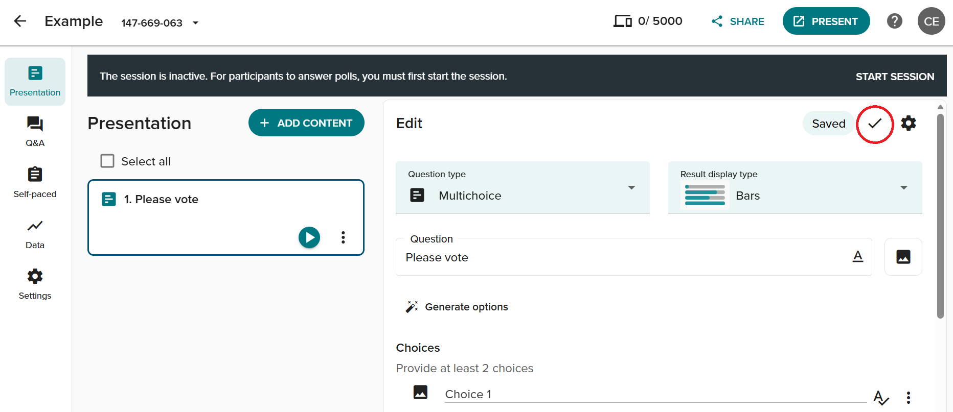
More information on Polling is available on the Vevox website (guidance is only available in English).

How to set up a Q&A in Vevox

- Create a new session and give it a name, or select an existing session.
- Click on Q&A on the left-hand side of the screen.
- Use the drop-down menu to turn the Q&A Board on and off.
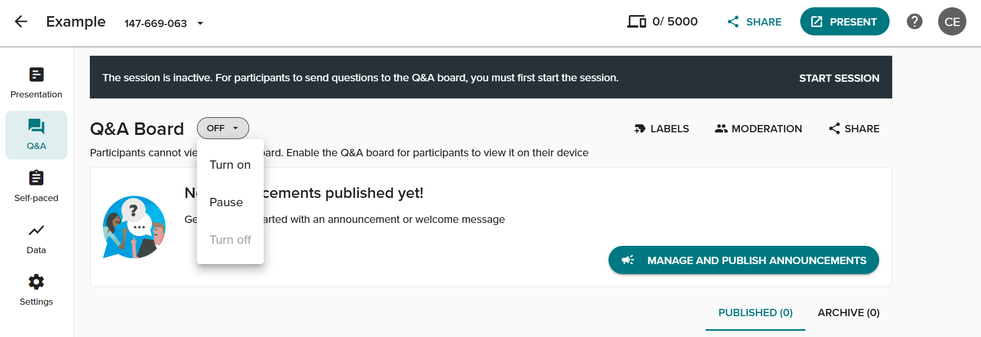
You can post an announcement for participants using the Manage and Publish Announcements button. Note that you can make announcements before starting the Session, but your participants will only see them once the Session has started.

More information on Q&A is available on the Vevox website (guidance is only available in English).

How to set up a Survey in Vevox
- Create a new session and give it a name, or select an existing session.
- Click on 'Self-paced' on the left-hand side of the screen.
- Click ‘Create New’.
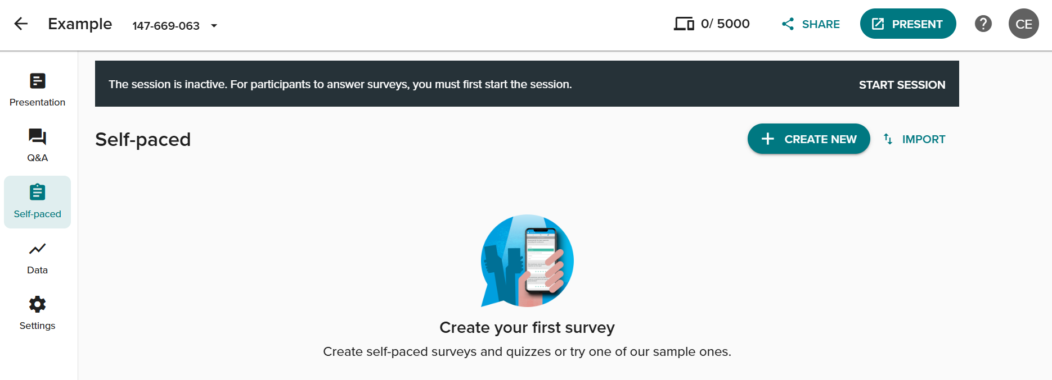
More information on Surveys is available on the Vevox website (guidance is only available in English).

Non-polling Presentation Content

You can also create non-polling content in your presentations to provide context, structure, links or visuals throughout your session. Use non-polling content anywhere in your presentation to set the scene, indicate a break between topics, or share additional insights before or after a poll or Q&A.

Create a Spin the Wheel
Spin the Wheel is a virtual spinning wheel that helps you make decisions, announce winners, or select actions during sessions. To set up Spin the Wheel, go to ‘Add Content’ in Presentation view and under ‘Non-polling Content’, select ‘Spin the wheel’.
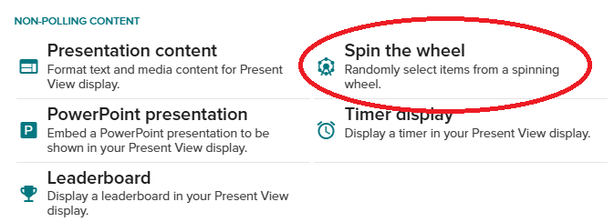
More information on non-polling content is available here (guidance is only available in English).

Presenting a Session in Vevox

How do I start my Session in Vevox?

To run your Session with participants you will need to Start it in the Vevox dashboard:

- Login to Vevox and click on the name of your Session.
- Click ‘Start Session’ at the top of the screen.

How do I present polls in Vevox?

- Start the session (see above).
- Click ‘Present’ in the top-right corner. This opens the presentation so that your participants can see the access code and questions. If you are in a teaching room, make sure that you drag this window to Screen 2.
- The Fullscreen option provides a QR code, URL and access code that your participants can use to join the session on their devices.
- Use the navigation options at the bottom of the screen to open and close individual polls. You can use the clock icon to set a countdown, and the bar graph icon allows you to show the results.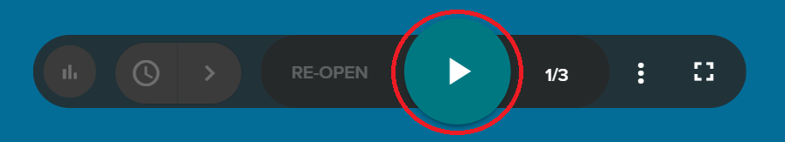

You can use the three dots icon to open the dashboard view and see previews of questions exactly as they will appear in the presentation.


How do I present Q&As in Vevox?

- On your dashboard, select ‘Q&A’ from the navigation menu and create an announcement, and turn the Q&A board on (see section above).
- In the presentation, select the icon at the bottom of the screen to show the Q&A prompt on the screen. You can switch between the Q&A and live poll in present mode.




How do I run surveys in Vevox?
You will need to start the Survey in the Vevox dashboard. You won’t be able to display it in the full screen view, but participants will see it as an extra tab on their device, as long as the Session is open.
- Select ‘Self-paced’ on the navigation tab.
- Select ‘Open Survey’.
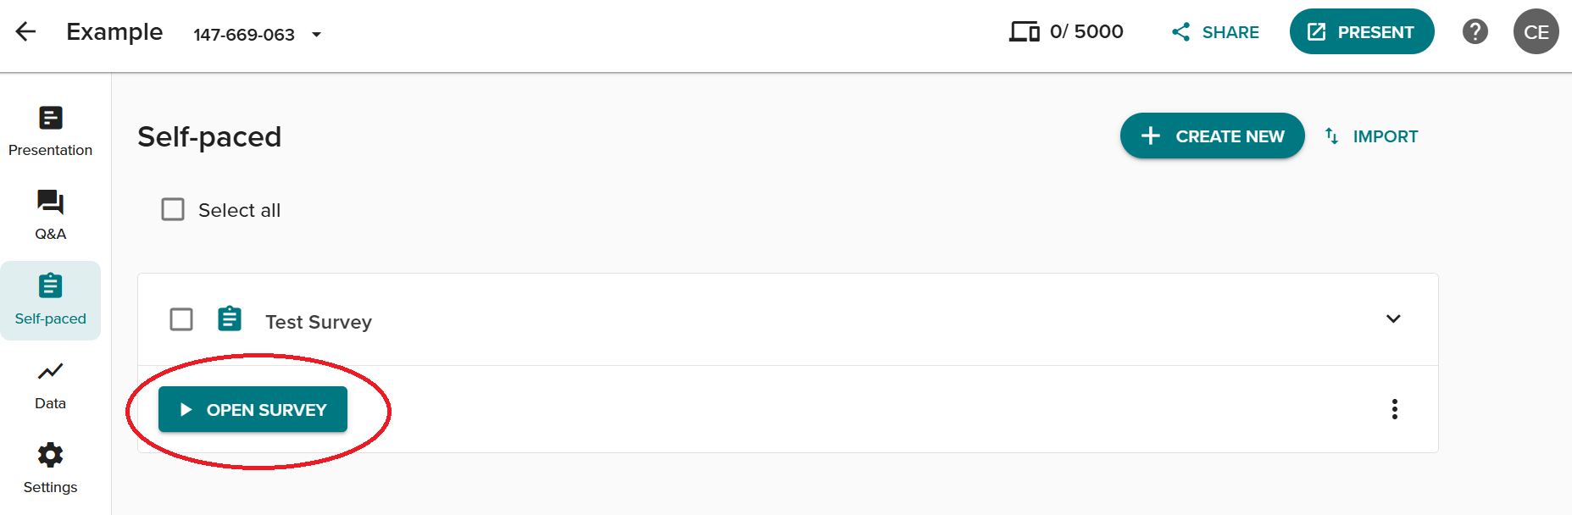
- To close the survey, select ‘Close survey’.
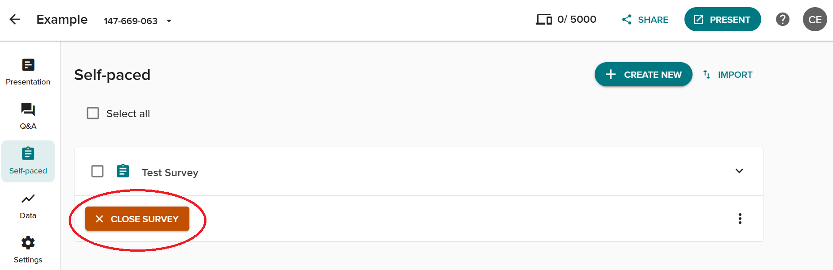

How to end a Session
- Click on the name of the Session at the top of the screen.
- Click ‘End session’.

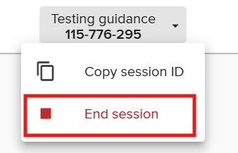

- Click ‘Yes’ to close the session.

You can view the responses to your polls. Q&A, and survey in ‘Data’ on the navigation tab.

How do I integrate Vevox with PowerPoint?

You can add polls or transform existing slides in polls with the Vevox PowerPoint Add-In.
- Install the add-in from the Company Portal.
- You will see a Vevox icon in PowerPoint.
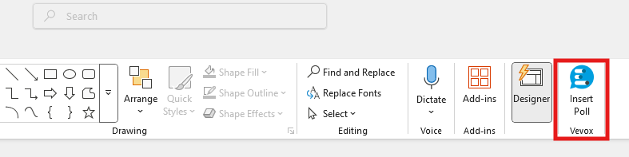
- The Vevox tools will appear in a panel on the right-hand side of the screen: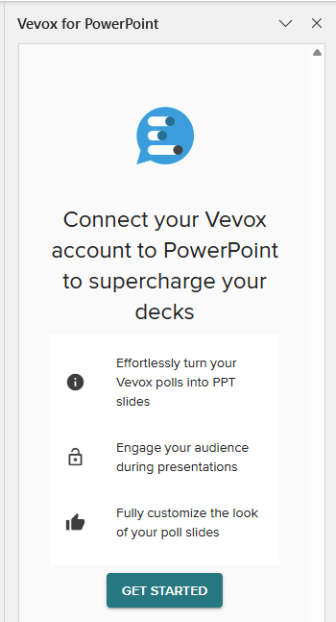
- Click on ‘Get Started’.
- Click on ‘Login with Microsoft’.
You will then see a list of all your Sessions. You can either select the Session you want to use or click the Plus icon to add a new Session. You’ll then see options to select the Polls you want to use.
- Select which questions you want to add to your presentation, or ‘Select all'. You can also add a slide with joining instructions for your participants.
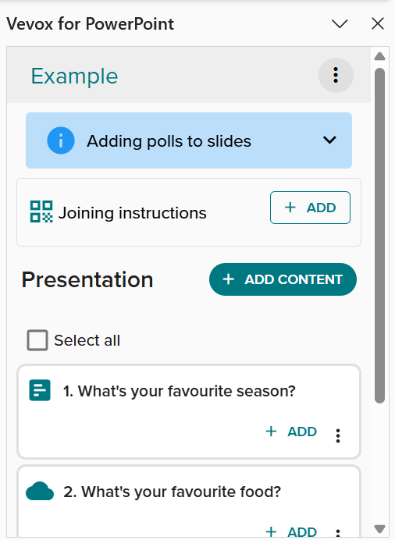
More information on using Vevox in PowerPoint is available on the Vevox website (guidance is only available in English).

How do I use Vevox in a Teams meeting?

- Login to Vevox and start the Session you want to run.
- Start the meeting in Teams.
- Click on the ‘Apps’ button.

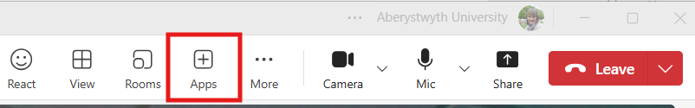

- Search for Vevox and click on the Vevox icon.

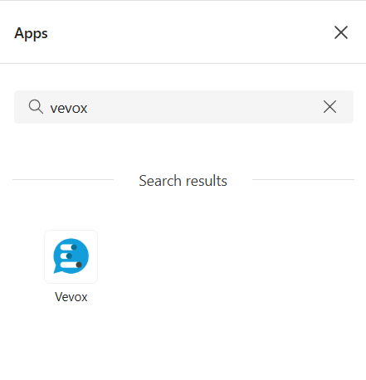

- Click ‘Login’ and ‘Login with Microsoft’.
- Select your Session and click ‘Save’.
- Use the Vevox dashboard to open and close polls.

Participants in your Teams meeting should click on the Vevox icon on their Teams dashboard.

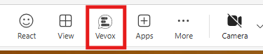

This opens the Vevox poll on the left-hand side of their screen, and they can take part via this pane.

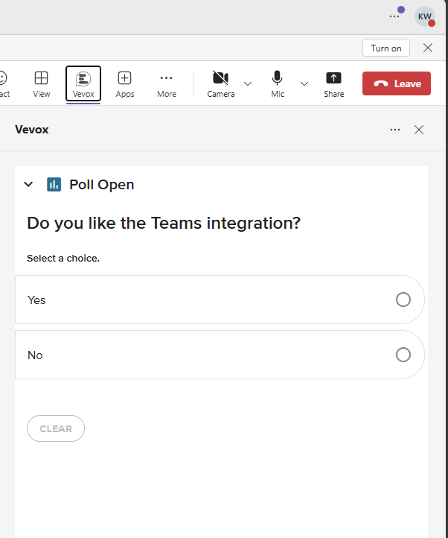

More information on using Teams in Vevox is available on the Vevox website (guidance is only available in English).

