Panopto Lecture Capture Software Guide 2026-27

Digital Education Group (elearning@aber.ac.uk)
Updated July 2026

Contents
Getting started 3
Make a recording 4
Naming and folder location 4
Checking Settings 6
Linking to recordings in Blackboard 8
Add a link to all recordings 8
Add a link to a single recording 9
View and edit recordings 11
View recordings 11
Edit recordings 12
Copy and share recordings 13
Share a recording 15
Captions 16
Restoring from the archive 16

Panopto is the University’s Lecture Capture Software. For further information on its use, please consult the Aberystwyth University’s Lecture Capture Policy.

Getting started
- Log into a PC in a teaching room and wait until Panopto opens automatically or click on the Panopto icon on the desktop.
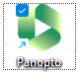

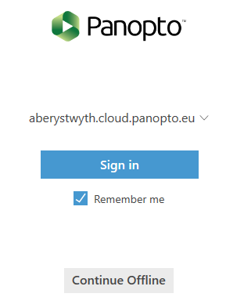

- Untick the Remember me on the log in screen as you are using a shared machine and proceed to sign in using your AU username and password.
- If you see a Google screen prompting you to sign into Google, you can click Stay signed out
- Click Open Panopto recorder in the pop-up window,
- A browser window will open prompting you to enter your Aberystwyth University username and password.
- You will then be taken into Panopto to start recording.

Make a recording

Naming and folder location
- The first step is to choose the correct location to save your recording. Click on the drop-down arrow on the top right and either:
  - choose the module folder and remember to select the correct academic year for the module in question
  - OR type in the module code / name in the search bar.
- NOTE: The default folder location is the folder you last made a recording in.

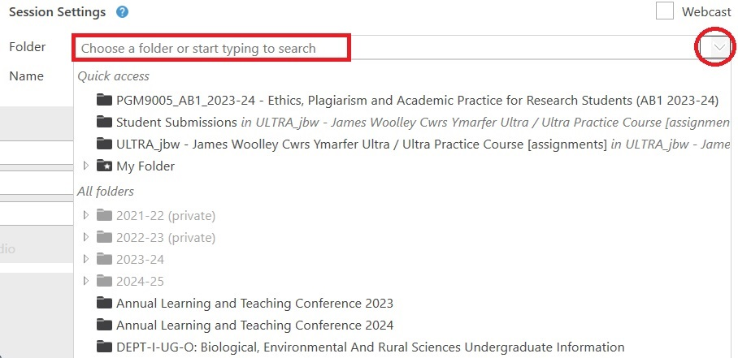

- It is important to give your recording a meaningful name so that you and your students can find the recording easily as the default name is the date and time of the recording.
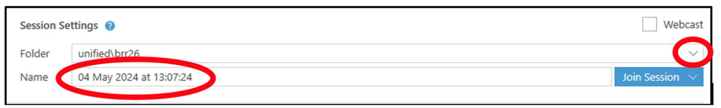

Checking Settings

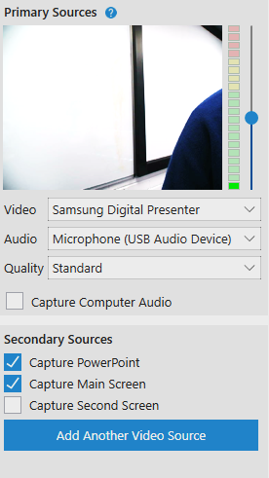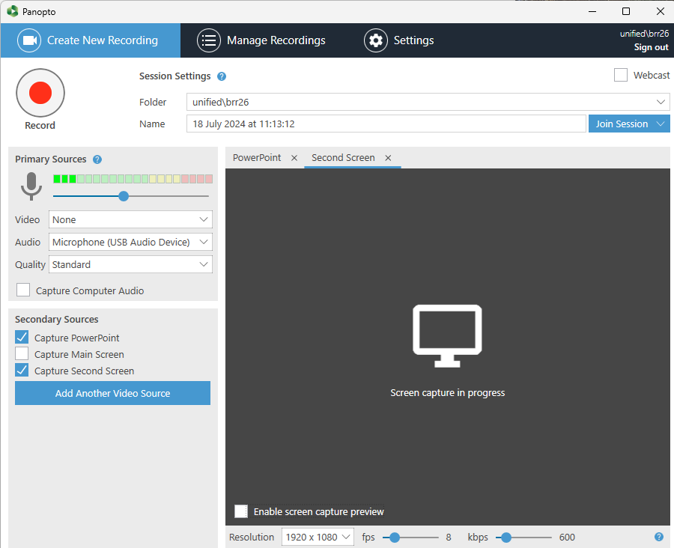

Before starting a lecture and making a recording check that the settings are correct. In the Primary Sources settings on the left-hand side choose:

Video: Select None if you only want to record the presenter's audio and not video. Each room will have different video options:
- The web cam is usually named USB Video Device
- The visualiser (useful for handwritten notes) is usually called Samsung Digital Presenter

Audio: Choose Microphone (USB Audio Device) to record the audio with a Neck Microphone. You must turn on the neck mic, using the rectangular button on the front of the mic. Press and hold the button for a couple of seconds – the light on the top will then turn green

To ensure adequate sound levels check there are 2-3 green audio bars highlighted. Move the slider on the right of the audio bars to increase the volume of the recording.

Quality: Choose Standard

Tick 'Capture Computer Audio' if you want to record any sounds made by your computer whilst recording as well as the audio recorded by the microphone.

Secondary Sources
Select the 'Capture PowerPoint' option if you're only using PowerPoint slides or 'Capture Second Screen' if you want to show something else on the monitor.

When all the settings are correct, click the red record button at the top right (or you can press F8) to start recording. If you have started your PowerPoint presentation through the Panopto recorder there is an option to start recording automatically when you start the presentation.
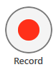

To pause the recording press the 'Pause' button (or F9 on your keyboard). You may need to pause the recording for an informal question and answer session or during a class discussion. Remember to restart the recording at the end of the informal session. Note that Panopto keeps recording whilst Pause is pressed, although this is not made available to students

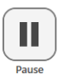

When you've finished your lecture press the 'Stop' button at the top (or F10 on your keyboard) to cease recording.



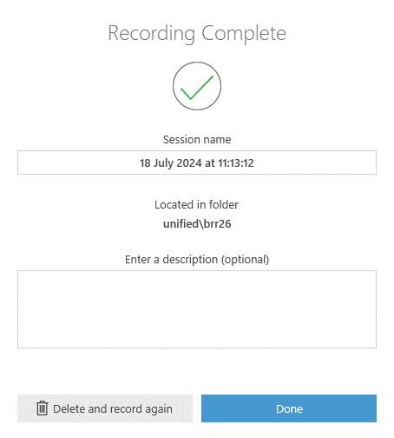

- In the Recording Complete dialogue box you can change the title of your recording and enter a description of the video, then click Done. (If you are unhappy with the recording, you have the option to Delete and record again.) The system will then automatically start uploading the recording to the server. Once this has been completed, you will receive an email notification.
- You can now log out of the computer while the recording uploads.

Linking to recordings in Blackboard
In line with the Blackboard RMP (Required Minimum Presence) you should add a link to all the Panopto videos the 'Module Information' area. You can also create a link to the Panopto module folder (so that students can see all the recordings in one location).

Add a link to all recordings
- Open the Module Information
- Click the plus icon (+)
- Click Additional Tools
- Navigate to All Panopto videos and click on the plus icon (+) in a circle in the bottom right-hand corner.
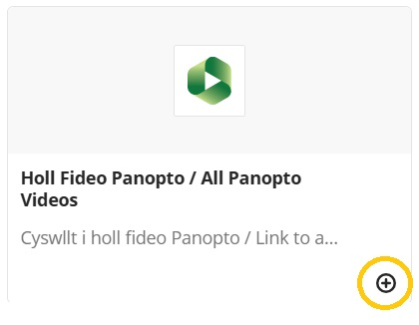
- A link to All Panopto Videos for the module will appear in Blackboard. Remember to set the link to Visible to students.
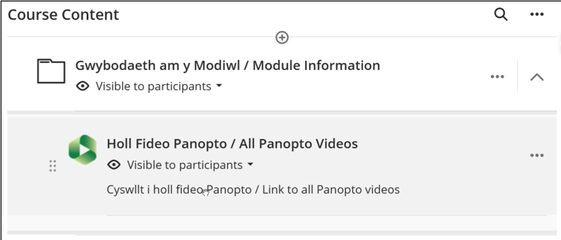

Single Panopto recordings should be included alongside the relevant learning materials / activities for the module.

Add a link to a single recording
- To add a link to a single Panopto recording in Blackboard, open the required module in Blackboard
- Open the appropriate section of the course
- Click the purple plus icon (+)
- Click Additional Tools
- Click Single Panopto video
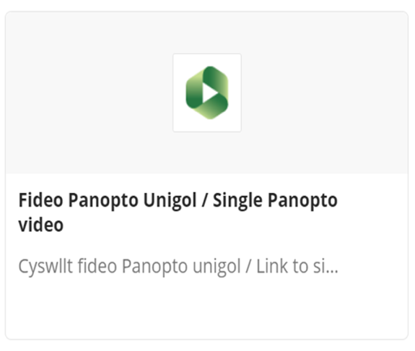
Select the video by checking the checkbox and click Insert. Remember to make the recording visible to students. View and edit recordings

View recordings
To view your recording, log into Panopto at panopto.aber.ac.uk and choose the correct folder destination in your video library. Click on the thumbnail or recording name to open and view the recording.

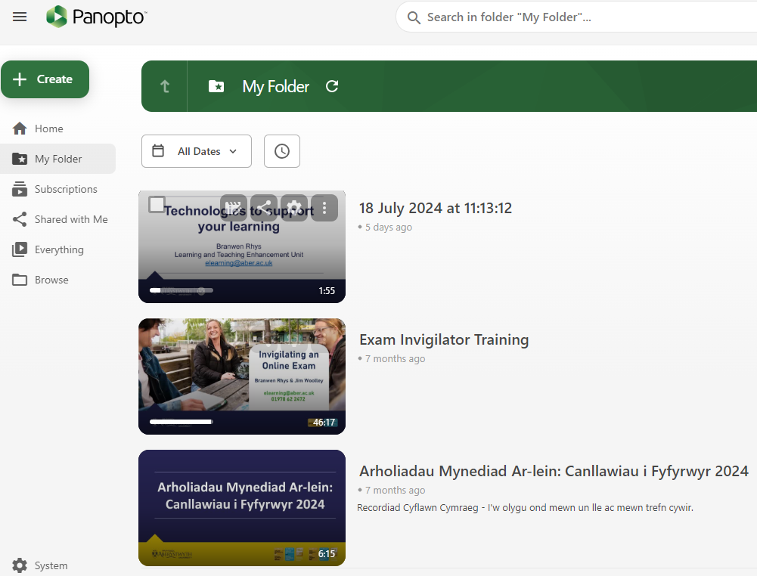

Edit recordings
- There is no requirement to edit recordings, although you may wish to edit the start and end of lectures in some circumstances. See the AU Lecture Capture Policy, for examples of situations where editing would be required.
- To edit a recording, select the recording in the checkbox and click on the Edit icon.
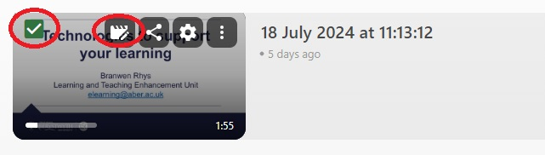
- The video will open in the Panopto editor.
- A timeline will open at the bottom of your recording showing the different streams, Primary and Secondary Streams. Each stream will be on a separate row. When you play the recording in this view, a vertical red bar will move through the timeline. (See below)

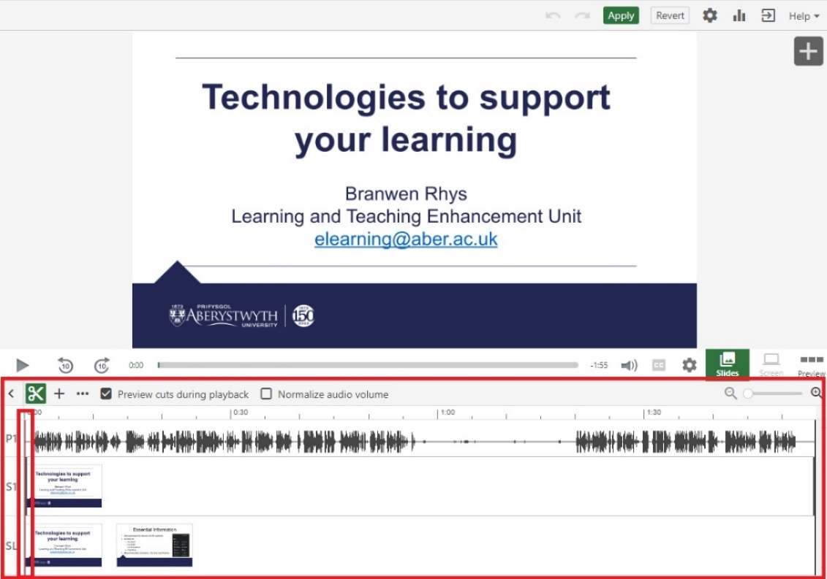
- To edit or trim your recording click on the cut or scissors icon.

Note: Before editing an original source video, the user will receive a warning window indicating that the video is referenced by other video(s). For further information on Reference Copies click Learn About Video Reference Copies (guide available in English only on the Panopto web site)
- Two grey lines will appear, one at the beginning and one at the end of the timeline. To cut a section from the beginning of your recording, play the video and pause it just before you’d like to start. Select the Scissors icon and drag the grey line to trim or cut out this section.
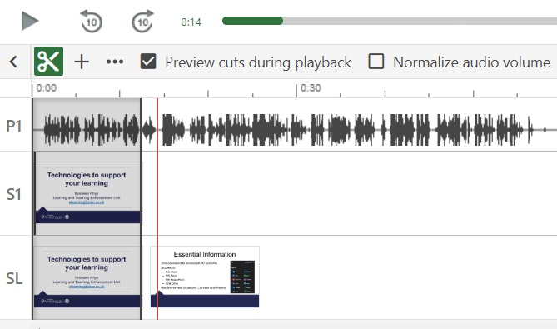
Note: The grey line will snap into the same position as the red line allowing you to be precise with any cuts.

- Trimmed out sections will always appear in your timeline – but they will not appear during playback after publishing your changes. It is possible to re-insert the cut sections if you need to at a later date. When you have finished cutting the recording click Apply on the top right-hand side of the screen.
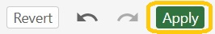

Copy and share recordings
To use Panopto videos from previous years, we recommend copying them into the current years’ folder of the course. This allows access to all students enrolled on the Blackboard course to view the videos:
- Log in to Panopto
- Use Browse in the left-hand menu to locate the folder from which you want to copy. Alternatively use the search bar at the top of the page.
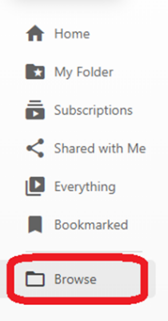
- Select the video or videos you would like to copy.
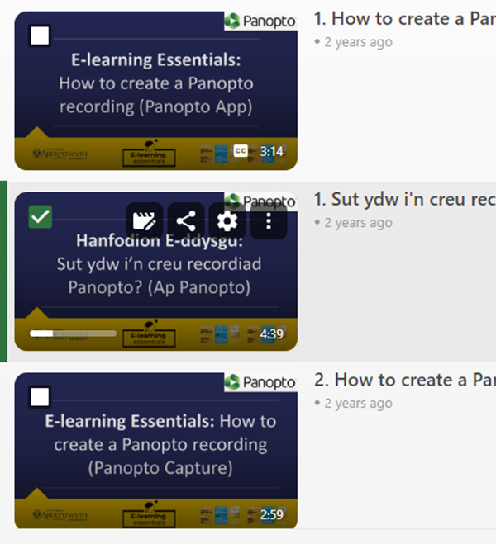
- Press the Copy button.
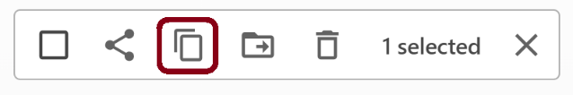
- Locate and select the folder you want to copy the video to in the dropdown menu that appears. Press Copy.
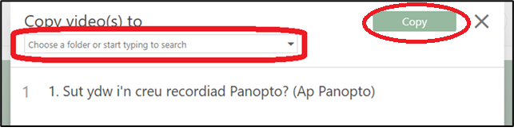
Note: This process creates a reference copy of the video which takes up minimal additional storage. Video reference copies refer back to an original source video but with a completely clean slate of viewer-contributed metadata, such as quiz results, comments, and notes. When its source video is edited, the reference copy will automatically also reflect the same edits.

Share a recording
To manage the sharing permissions on a recording login into Panopto and select:
- Manage Recordings (at the centre top of the screen)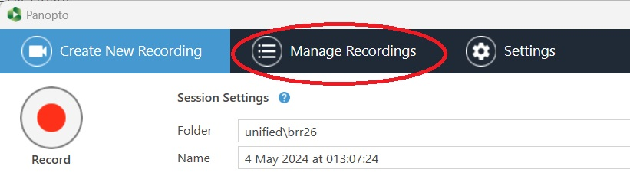
- 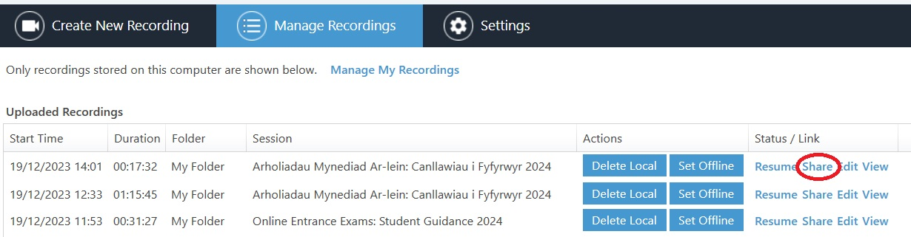Locate the required recording and click Share on the far right-hand side
- Press Change to select the option you wish to use. See this article on the Panopto Support pages for more information (available in English only on the Panopto web site).
- Select Link and click on the Copy Link button to circulate the recording. 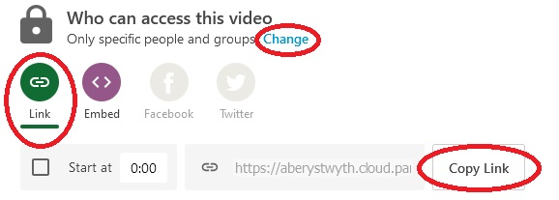

Captions
Automatic speech recognition (ASR) captioning for both Welsh and English recordings is automatically added to all recordings made after 1st September 2025. Please note that the quality and reliability of automatic captioning varies due to the language and subject matter of the recording.

Staff are not required to edit ASR generated captions although they can be edited (guidance is available How to add and edit captions FAQ).

The ASR caption language is set in each Panopto folder. The language of each Panopto folder is taken from AStRA. All modules flagged as being taught 100% in Welsh in AStRA will be set to use Welsh language captions. All other folders will be set to English. Guidance on language settings including how to manage modules with recordings in multiple languages is available on the E-learning blog

Captions in a different language to the folder settings will need to be added manually following the guidance How to add and edit captions FAQ. Note that this is a recommendation and there is no expectation on staff to do this.

Restoring from the archive
Recordings that haven’t been viewed in over 13 months are moved into the archive. Staff and students can restore recordings from the archive

- Go to panopto.aber.ac.uk and find your folder
- At the bottom of the folder page you will see a link to the archive

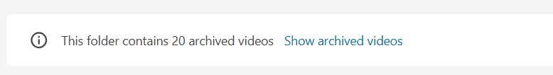
[Alt text: This folder contains 20 archived videos. Show archived videos is a link to the archived list]

- Click the Show archived videos link and find the recording to restore
- Hover your mouse over the thumbnail or recording title.
- The Restore from Archive icon will appear on the thumbnail image

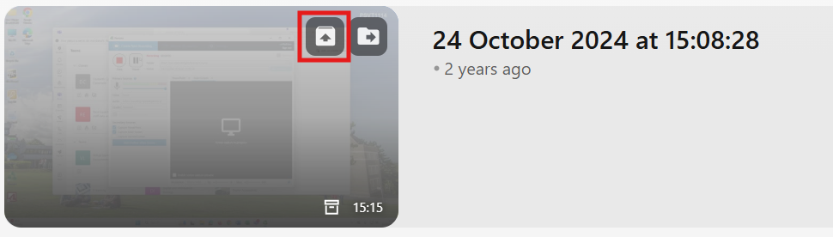
[Alt text: Restore from Archive option highlighted on recording thumbnail – icon is the first from the left and has an arrow in a folder symbol]

- Press OK to confirm and the restore process will begin

The Restore process can take up to 72 hours but normally takes about 48. More information is available the FAQ How do I Restore Archived Panopto Content?

Note that both staff and students can restore recordings.

