Blackboard Tests for In-Person Exams
Learning and Teaching Enhancement Unit (elearning@aber.ac.uk)
November 2023
This guidance is split into five sections:
- Create, Edit and Organise your questions
- Create the Test
- Test Settings
- Take and Check the Test
- In-Person Exam

Questions

Question Banks
A question bank is a collection of questions that can be re-used in multiple tests and in other Courses. They are an effective way of organising your questions, for example, by topics.
To access the question pools in your Course, go Details & Actions > Question Banks > Manage banks
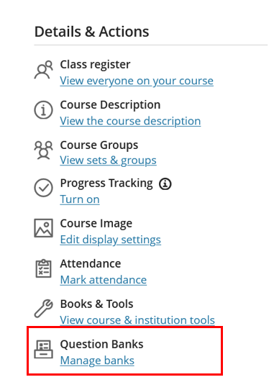
[Alt text: Screenshot of Details & Actions menu with Question Banks highlighted]
See the Blackboard help site for guidance on Question Banks.

To import existing question banks from an original course
- Go to the Content section of your course (note that it doesn’t matter where you do the following steps – the question bank will only appear in the question bank section)
- Click on the plus icon > Copy Content
- Find your original course and click on the title
- You will see Question Banks in the list:
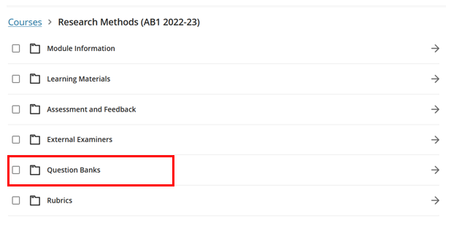
[Alt text: screenshot of the Copy menu with Question Banks highlighted]

- To copy over all question banks, click in the box next to Question Banks
- To copy selected question banks, click on the title Question Banks and select the banks you want to copy
- Click Start Copy
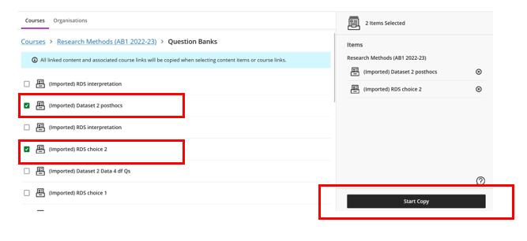
[Alt text: screenshot of the individual question banks and start copy highlighted]
Once the copy has completed all your Question Banks will be available from the Manage banks link.

Creating a Question Bank and Questions
See the Blackboard help site for guidance on creating question banks, and adding questions, and editing questions.

Creating a Test
Once you have created your question banks, you can build your test. See the Blackboard help site for guidance on creating a test using questions from your question bank.
All tests should be created in the Assessment and Feedback folder. We strongly recommend that tests used for exams are added at the top of the folder to make it easy for students to find.

Test Settings
When you create your test, you will notice that the Allow participants to add content at end of assessment option is ticked by default. Please UNTICK this option unless you want students to be able to upload a file. Note that you cannot amend this setting until a question has been added and saved to your test:
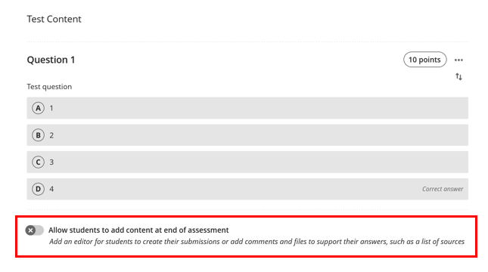
[Alt-text: Screenshot of the Test Content page with allow students to add content at end of assessment de-selected and highlighted]

Once you have added your questions, you need to use the Test Settings for exam conditions (see Blackboard help site for details of how to change test settings).
The list below are the settings required for AU in-person exams.
- Exam location – first item in the Assessment and Feedback folder or in a folder clearly named at the top of the Assessment and Feedback area.

Test Settings
- Set the Due date. The date should be the date of the exam and the time should be 30 minutes after the last candidate could submit remembering to include candidates with extra time in your calculations.
To the right of the question bank, you will see your test settings options:
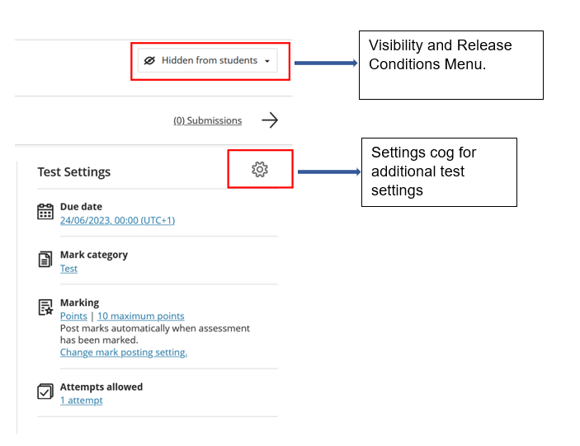
[Alt. text: Test settings menu showing visibility to student and release conditions menu highlighted along with settings cog]

Visibility and Release Conditions Menu
- Make Visible to Students
- Click on Release Conditions:
  - Select All members
  - Under Set additional conditions – select Date / Time:
    - Show on Date (date of exam) and Time (30 minutes before the official start of the exam)
  - When will content appear? – select Hide
- Click Save

Settings cog for additional settings menu
Click on the Settings cog.

Details & Information
- The Due Date should have already been set in the previous menu, but you can also amend here
- Prohibit late submissions – TICK
- Prohibit new attempts after the due date – TICK
- Allow class conversations – UNTICK
- Collect submissions offline – UNTICK

Presentation Options
- Display one question at a time – TICK
- Prohibit backtracking – UNTCK
- Randomise Questions – TICK (due to the spacing of monitors in exam rooms) unless questions follow in a specific order and build on the previous answer.
- Randomise Answers – TICK, unless answers follow in a specific order
- Randomise Pages – TICK (if you have used pages), unless pages follow in a specific order

Marking and Submissions
- Mark Category – Test
- Attempts allowed – 1
- Mark using – Percentage
- Anonymous marking – UNTICK for tests that are marked automatically
- Evaluation options:
  - UNTICK 2 markers per student
  - UNTICK peer review
- Post Assessment marks automatically – UNTICK

Assessment results
- Submission Results – click on Available after Submission to access the options:
  - Allow students to view their submission – UNTICK
  - Click Save

Assessment Security
- Add an Access Code from the Assessment Security section. The code, which is automatically generated, (in the form of a 6-digit numerical code), is shared with students in the examination room. This prevents absent students from gaining access to the test. Use the highlighted icons below to generate / change the access code.
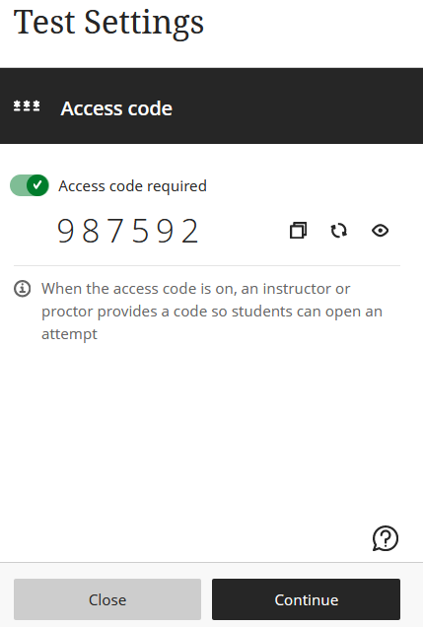
Click this icon to copy the Access Code.

Click this icon to change the Access Code.
Click on the eye icon to hide or make the access code visible. The code does not change if it is marked hidden.
[Alt. text: Showing Access code required selected and highlighted copy code, renew code and hide/show code icons]
- 30 minutes after the test starts the code should be changed so that anyone who leaves the exam room early does not communicate the code to other people.
- If you are doing two sittings of the exam, use the second code from the first sitting to start the second exam. The code should then be changed in the Blackboard test settings 30 minutes after the second sitting begins.
- Access codes created 30 minutes after the start of the exam should be shared with the exam supervisors via a 'chat' message on MS Teams.
- The access code that starts each test should be shared with the Examinations Office on eosstaff@aber.ac.uk

Additional Tools
- Do not add a Time Limit for an in-person online exam – this is managed by invigilators in the room.

Taking and checking the Test
Once you have created your test it is important to try it out yourself and access the results as a student.
It is also recommended that a member of staff (or PG student) who is not as familiar with the content of the exam takes the test, to spot any issues that the lecturer may not (for example, with time allotted to complete the test). You can do this in your Practice Organisation:
- Go to your practice Organisation
- Copy the test from your course (see the Blackboard help site for how to copy a test)
- You will need to make the test available, and change the Show On date so that it is available
- You can take the test using the Participant preview option (see the Blackboard help site for how to use Student Preview). Remember to Save the preview data when you exit Preview, so that you can view the results in the Gradebook
- If you want someone else to take the test, add them to the Organisation as a Participant (see the Blackboard help site for how to add people to your Organisation).
- Information on how to take a test is available from the Blackboard help site.
When taking the test and viewing the results, check the following points:
- The accuracy, clarity and comprehensibility of the question and possible answers.
- The questions cover all relevant topics and sub-topics.
- The difficulty level of the exam.
- The skill levels being tested (higher order thinking or just knowledge recall?)
- The feasibility of the exam timing.
- The wrong answers are plausible.
- The question does not give away the correct answer (e.g. wording or grammatical cues).
- The marks and scores are set correctly (check any questions you answered incorrectly).
- The correct answers are set.
- Spelling and grammar.
- The formatting of the exam is standard, and the questions and images display properly.

In-Person Exam

Prior to the Exam
Test settings have changed in Blackboard Ultra and the exam arrangements have also been updated, so give yourself plenty of time to prepare the test and read the new guidelines. Ensure that the following are in place before the exam:
- Check the Test Settings
The Learning and Teaching Enhancement Unit will check your test settings before the exam. You will receive the email invitation a few months before the exam from the Unit with further details. They are unable to check your test settings without a final date or time.
- Create and Share Access Code
You will need to create an access code for your test. Before the exam, this access code should be shared, with the Examinations Office on eosstaff@aber.ac.uk and the Learning and Teaching Enhancement Unit on elearning@aber.ac.uk
- Create a new MS Teams Chat
Create a new Teams Chat before the exam for each exam. This will provide a confidential method of communicating the second access code with the relevant staff. It is not possible to create two access codes before the exam. The module coordinator is responsible for ensuring that each members of staff supervising the exam is included in the Teams Chat. The following staff should be included: the Examinations Officer, Catherine Bean, 2 Examination Superintendents, examination supervisors and any relevant administrative staff.

During the Exam
Support is available remotely during your online exam via elearning@aber.ac.uk / 01970 62 2472 if you have asked us to double-check your exam. For non-technical advice about your exam, please contact the Examinations Office on eosstaff@aber.ac.uk.
- Attending the In-Person Exam
- All module coordinators are expected to be present at the in-person examination for their module. This is important for generating and communicating the second access code 30 minutes after the start of the exam.
- If you are unable to attend, you must arrange a substitute to take your place.
- Necessary Equipment
- The module co-ordinator should bring a laptop/mobile device, that is set up to log into Blackboard and MS Teams, into the examination room.
- Generating and Circulating Access Code
- 30 minutes after starting the exam, you will need to change the Access code. (See the Assessment Security section in this document for guidance.)
- Copy the new Access code.
- Open the Teams chat (ensuring that the notification settings are disabled/silent).
- Paste the new Code into the chat and send.
- Ask for confirmation of receipt from all attendees
- Leave the Teams Chat
- Repeat this process a second time (i.e. to generate a third acccess code) if two exam sittings are held.

