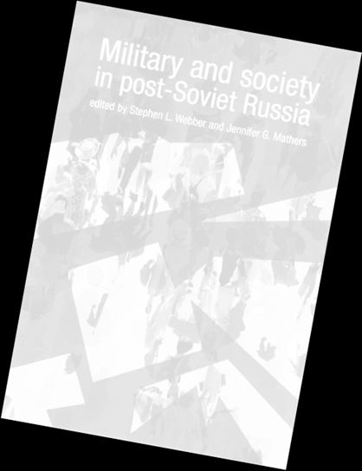
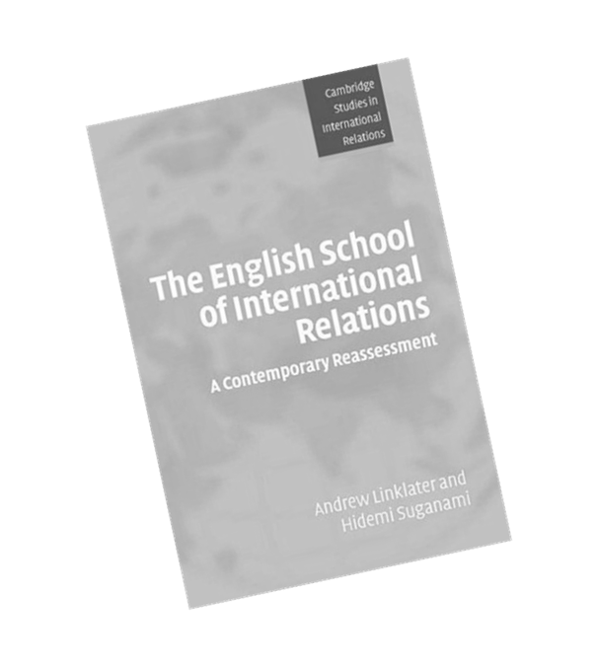

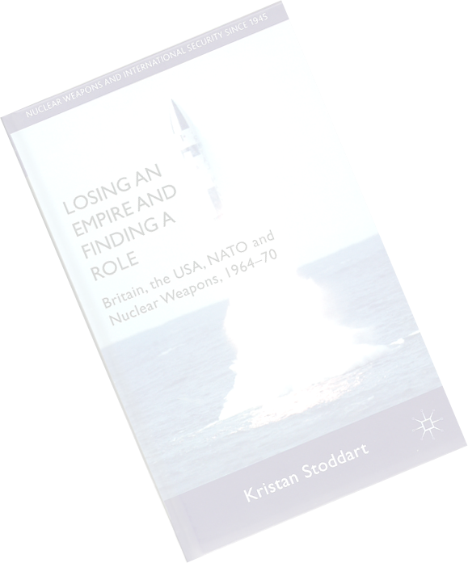

WRITING AND REFERENCING
IN INTERPOL
2023-2024
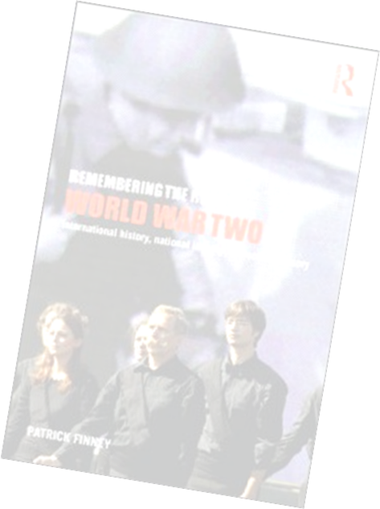

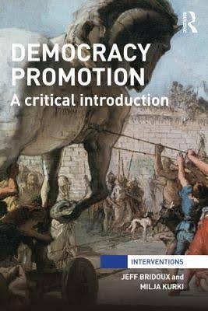

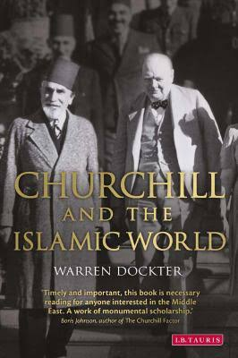

Table of Contents
Unacceptable Academic Practice 3
a. Plagiarism 3
b. Collusion 3
c. Fabrication of evidence or data 3
d. Unacceptable academic practice in formal examinations 3
e. Recycling of data or text 4
f. A Note on Plagiarism 4
Fair Usage of Generative AI for International Politics Students 7
a. Guiding Principles: 7
b. Examples of Fair AI Usage: 8
c. AI use statement for assignments: 8
How to Write an Essay 9
Step 1: Identify the Question 9
Step 2: Planning your Essay Structure 10
Step 3: Reading and Research 11
Step 4: The Writing Stage 12
a. Introduction 12
b. Thesis Statement 13
d. Topic Sentences, Body Paragraphs and Signposts 14
e. Counter-Arguments 15
g. Bibliography and Citations 16
Step 5: How to Reference an Essay 16
d. 16
e. Why do I need to reference my essays? 16
f. When should I insert a reference? 16
g. Which referencing systems can I use? 17
h. 17
i. Using the In-Text (Harvard) System 17
j. 23
k. Using the Footnote/ Endnote System 24
Step 6: Editing 29
A Note on Essay Length 30
a. Under length essays 30
b. Over length essays 30
Making Use of Feedback 31

Unacceptable Academic Practice
The University is committed to detecting unacceptable academic practice and imposing appropriate penalties on those students who engage in it. Unacceptable academic practice comes in several forms, including:

Plagiarism
Plagiarism is defined as using another person's work and presenting it as your own, whether intentionally or unintentionally. Examples of plagiarism include:
  - Use of quotation without the use of quotation marks.
  - Copying another person's work (for example, submitting a friend’s work from a previous year).
  - Unacknowledged translation of another person's work.
  - Paraphrasing or adapting another person's work without due acknowledgment.
  - Unacknowledged use of material downloaded from the internet.
  - Use of material obtained from essay banks or similar agencies.

Collusion
Collusion occurs when work that has been undertaken by or with others is submitted and passed off as solely the work of one person.

Fabrication of evidence or data
Fabrication of evidence or data and/or use of such evidence or data in assessed work includes making false claims to have carried out experiments, observations, interviews or other forms of data collection and analysis. Fabrication of evidence or data and/or use of such evidence or data also includes presenting false or falsified evidence of special circumstances to Examination Boards or Appeal Panels.

Unacceptable academic practice in formal examinations
Examples of unacceptable academic practice in formal examinations include the following:

- Introducing into an examination room and/or associated facilities any unauthorised form of material such as a book, a manuscript, data or loose papers, information obtained via any electronic device, or any source of unauthorised information, regardless of whether these materials are of relevance to the subject in question.
- Copying from, or communicating with, any other person in the examination room and/or associated facilities except as authorised by an invigilator.
- Communicating electronically with any other person, except as authorised by an invigilator.
- Impersonating an examination candidate or allowing oneself to be impersonated.
- Presenting an examination script as one's own work when the script includes material produced by unauthorised means.

Recycling of data or text
Recycling of data or text in more than one assessment. In International Politics it is forbidden to submit the same – or a substantially similar – essay on two different modules.

Full details of University procedures here are available in the Regulation on Unacceptable Academic Practice, which can be found here.

Please note that every essay submitted via Turnitin is automatically checked for plagiarised material, so it is very unlikely that unacceptable academic practice will escape detection.

Penalties for unacceptable academic practice can be severe, including the cancellation of marks or even permanent exclusion from the University.

A Note on Plagiarism
To plagiarise is to take and use another person’s thoughts, writings or ideas as one’s own, without proper attribution. Plagiarism in a piece of academic work submitted during study for a degree is a very serious offence. On the one hand, the use of proper citation and bibliographic format is the cornerstone of good scholarly practice: it is what makes academic writing distinctive as a genre. On the other hand, plagiarising to gain credit towards an academic qualification that may bring financial and other benefits is not only intellectually dishonest, it is tantamount to fraud.

For these reasons, the Department and the University regard plagiarism as absolutely unacceptable and heavy penalties may be imposed including, ultimately, exclusion from the University.

We recognise that it can sometimes be difficult for students to understand how to apply proper citation and bibliographic practices, and when and how material taken from another source should be referenced. As a general rule, while commonly known facts need not be referenced, all borrowed ideas or figures must be followed by proper academic citations. Example 1 below illustrates that close paraphrasing without references to the source can be considered to be plagiarism.

Example 1—Paraphrasing without References to the Source

Political realism believes that politics, like society in general, is governed by objective laws that have their roots in human nature. Plagiarism

Morgenthau (1978: 4) states that ‘political realism believes that politics, like society in general, is governed by objective laws that have their roots in human nature.’
OK—Not Plagiarism

As previously mentioned, commonly known facts need not be referenced. In Example 1, a general statement about the attributes of political realism would not need to be referenced; but a quotation or close paraphrase of a particular formulation of such a statement does require a reference. Facts such that the French Revolution began in 1789 and that there are twenty eight member-states of the European Union (EU) need not be accompanied by citations. Statistical facts, however, should almost always be accompanied by a citation. When in doubt as to whether or not a fact or statistic requires a reference, it is always better to include a reference.

Example 2—Facts or Figures without References to the Source

Between 580 000 to 660 000 children below the age of 15 in Sub-Saharan Africa alone are believed to have been infected with HIV in 2003. Plagiarism

Between 580 000 to 660 000 children below the age of 15 in Sub-Saharan Africa alone are believed to have been infected with HIV in 2003 (WHO, 2004).
OK—Not Plagiarism

All direct quotations in your essay should be indicated using quotation marks. You should, however, use quotations sparingly and make sure that the bulk of your essay is in your own words.

At times students may plagiarise inadvertently. Poor note-taking or time management problems may be the fundamental cause of such unintentional plagiarism, but these cannot serve as legitimate excuses. Plagiarism is plagiarism, and will be dealt with accordingly. If you are ever in any doubt about what constitutes plagiarism, please ask for advice from your seminar tutor, module convenor or personal tutor.

Please also note that the Department regards ‘auto-plagiarism’, or the submission of the same piece of work twice, either in whole or in part, as constituting unacceptable academic practice. Each essay that you submit must be an original piece of work. While there may be some overlap in the material studied on the various modules that you will take during your studies, avoid re-using any written work that you have submitted previously. This also applies to students resitting modules: you must produce new work for the resit.

Fair Usage of Generative AI for International Politics Students
Generative AI can be a valuable tool for students in the field of International Politics. We believe it is crucial for our students to learn how to use such technologies in a fair and ethical manner, maintaining academic integrity and fostering originality of thought. The following guidance provides students with recommendations on using generative AI responsibly in their academic pursuits.

Guiding Principles:
- Acknowledge the AI’s contribution: Indicate at the end of your assignment the ways in which you have used generative AI in your work, demonstrating transparency and honesty in your academic practices. Assignments prepared with input from generative AI but submitted without clear acknowledgment will be treated as cases of unacceptable academic practice.
- Understand the limitations: Recognise that AI-generated content may not always be accurate or applicable. It is essential to verify the information generated by AI against reliable sources and course materials.
- Use AI as a supplement, not a replacement: Generative AI tools should be used to enhance your understanding and critical thinking, rather than to replace your own efforts. Do not rely solely on AI-generated content for your assignments and research.
- Maintain originality: Ensure that your work remains unique and reflective of your own voice and ideas, using AI-generated content to develop and refine arguments further. The starting point for your assignments should be the content covered during the module, including the module reading list.
- Respect intellectual property rights: Avoid using generative AI to produce derivative works (works that heavily use elements of another work).

Examples of Fair AI Usage:
- Language improvement: Employ AI to help with clarity, style, and syntax, as well as to suggest alternative phrasings and more precise vocabulary. This is about conscious engagement, though. Do not uncritically accept all that AI recommends.
- Proofreading and editing: Use AI tools to assist in identifying grammar, punctuation, and spelling errors in your work. As above, this is about conscious engagement. Do not uncritically accept all that AI recommends.
- To enhance your search for resources: following your use of Primo and your module reading list, employ AI tools for a supplementary search to find pertinent resources. Yet these additional sources must be checked and verified as generative AI will often ‘invent’ sources that do not exist.
- Feedback and critique: Seek constructive feedback on your drafts by using AI-based tools that provide suggestions for improvement, while keeping in mind that the final decision on revisions is yours.

By adhering to these guidelines and examples, students can use generative AI as an effective and ethical tool to support their studies in the Department of International Politics.

AI use statement for assignments:
If you use generative AI while preparing an assignment you should include these two statements at the end to indicate how it was used:

- While preparing this assignment the following generative AI tools were used: [list the names of all generative AI tools used].
- Generative AI was used for the following purposes: [list the different ways in which generative AI was used while working on the assignment].

Note that including such a statement at the end of your assignment will not be treated as adding to the overall word count.

How to Write an Essay
This guide is aimed at helping you through the essay-writing process from beginning to end. It is a basic guide and you may receive additional guidance from tutors or other sources. Members of staff, and in particular your seminar tutors, will be happy to help you at any stage. Please note, however, that staff are not allowed to read essay plans or draft essays. For the Department’s assessment criteria regarding essays, please see the Departmental website and Blackboard.

Step 1: Identify the Question
First and foremost, it is important to identify an essay question. Most modules provide a choice of set essay questions. Naturally, your individual interests will play a part in determining which question you select.

If you are having difficulty selecting an essay question, you may find it helpful to write possible essay structures or outlines for those questions that interest you. This exercise may help you to decide by identifying strengths and gaps in your knowledge about the subject matter and firing your enthusiasm for particular topics or issues.

When selecting a question, ensure that you take the time to identify its analytical demands:

- What is the essay question really asking?
- What are the key concepts and theories associated with this question?
- Based on your knowledge of the relevant literature, what are the main arguments? What are the main debates about?
- What are possible arguments or hypotheses? In what ways can they be supported or refuted?
- In what ways can you add your own original analysis?

Analysing the question carefully before proceeding is highly recommended as this will influence how you structure your essay and perform your research.

Key Point
Select an essay question based on your individual interests but take the time to scrutinise its analytical demands.

Step 2: Planning your Essay Structure
Essay structure is crucial. Many of you will find that feedback comments often centre on essay structure because of its importance in determining the strength of the overall argument.

Drafting a preliminary essay structure along with a word budget is highly recommended before proceeding to further stages. Remember that this is a preliminary draft and that you can modify the structure throughout the process. An example of a basic essay structure is shown in Figure 1. The Writing Stage section below examines the essay structure in detail by explaining the purpose behind each of the essay components.

Figure 1: A Basic Essay Structure

Introduction  and  Thesis Statement  ‘Road Map’  Topic Sentence #1  Body Paragraph #1  Signpost  Topic Sentence #2  Body Paragraph #2  Signpost  Topic Sentence #3  Body Paragraph #3  Signpost  Topic Sentence #4  Body Paragraph #4  Signpost  Topic Sentence #5  Body Paragraph #5  Signpost  Topic Sentence #6  Body Paragraph #6  Signpost  Counter-Arguments  Conclusion  Bibliography | Word Budget  (example 3000 word essay)  300  200  300  300  300  300  300  300  400  300

Remember that essays are not papers that contain everything that you know about a given subject area. The point of an essay is to present a clear and cogent argument as a specific response to a specific question. During the writing process, ask yourself how each section of your essay is helping you to answer the question. Ideally, your essay will combine original analysis with knowledge of the subject area.

Step 3: Reading and Research
Your lectures and readings from both the essential and recommended online reading lists are excellent resources to begin your research. They will not only provide you with basic knowledge of the subject area but will also help you to identify further readings. Please note, however, that you should not generally cite from your lectures in essays. University-level research entails accessing and reading critically a wide variety of published sources. These include books as well as academic journals and newspapers. It can also entail making use of credible internet sources, but you should take great care when using them. While the internet is an incredibly valuable tool, many web-based sources do not conform to academic standards because they are not peer-reviewed. They can be misleading or even wrong. You should not rely wholly on the internet for your research. The University of California, Berkeley, has thoughtfully posted an online guide to the critical evaluation of online sources. It is well worth a read!

While conducting your research, it is essential to keep notes and to ensure that you record the essential publication information that you will need for your bibliography. It cannot be stressed enough that proper citation and the use of a bibliographic format following an officially recognized academic style is a cornerstone of all academic writing. Detailed advice on this is given in the section on How to Reference an Essay below.

Key Points
- Utilise all available sources including books, academic journals, newspapers and credible sources accessed on the internet.
- Make sure you note down the publication details of any sources that you consult.
- Ensure that you use one of the two official academic citation and bibliographic styles that complies with Departmental regulations.

Step 4: The Writing Stage
Experienced writers will know that while the final product should look smooth and polished, it takes a lot of work to get it into this shape. The writing process is usually anything but smooth! Most students will find it useful to write an essay by sections, re-working and editing as they go along. The writing process is, however, a very personal matter that is dependent not only on the subject area but the preferences and character of the individual. What follows is a detailed breakdown of what each section of your final essay should contain, with reference to Figure 1 above. Please remember, however, that Figure 1 is only a rough guide: it is not a template that must be mechanically applied to every piece of written work. The structure of any given essay will vary depending upon the particular demands of the question and the response of an individual author to them.

Introduction

The introduction of the essay should begin generally and narrow towards the thesis statement. However, avoid beginning with a cliché. The opening sentence should give the reader a sense of your subject area without resorting to catch-all stock phrases. The essay question should appear in some modified form early on in the introduction. As a whole, the introduction should grab the reader’s attention and provide a contextualised overview of the research question by identifying key concepts, issues or the main debate.

Key Points
- Begin generally, avoiding clichés, and build towards the thesis statement.
- Grab the reader’s attention.
- Contextualise the research question or debate.

Thesis Statement
Often forgotten, this sentence is perhaps the single most important sentence of the essay. This statement is essentially the central argument of your essay. More than just an answer to the essay question, the thesis statement provides the reader with the backbone of the entire essay. The remainder of the essay should therefore be related directly to and provide evidence to support the thesis statement. Ideally, the thesis statement should stand solidly on its own and it can also be signposted more explicitly phrases such as “This essay will argue that…. ”. Although your thesis argument may alter slightly throughout the writing phase, it is nonetheless important to have a clear thesis statement from the outset in order to develop a strong essay structure.

Key Points
- The thesis statement is the most important sentence of your essay so take the time to craft it precisely.
- It should stand solidly on its own.
- You can also potentially use signposting phrases such as “This essay will argue . . .”

- ‘Road Map’ Paragraph
This paragraph is especially useful for longer essays. As its name implies, the ‘road map’ paragraph provides the reader with insight into how the rest of the essay is structured. Most commonly, this paragraph lists in order the sections that follow. It demonstrates to the reader your methodology for substantiating your central argument.

Key Point
- For longer essays, a ‘roadmap’ paragraph is a useful device that tells the reader how your argument will unfold

Topic Sentences, Body Paragraphs and Signposts
While the content of every body paragraph will vary according to the essay topic, they should all contain evidence in support of the central argument. Topic sentences help with transition in packaging all of the evidence that supports the argument. They provide structure to the essay by ordering the evidence into discrete areas or issues, which is obviously preferable to presenting that evidence in a random or haphazard manner.

You may wish to divide your essay, for instance, into sections that deal with political, economic and cultural issues. Similarly, a theory paper might be divided into realist, liberal and constructivist sections while a paper on humanitarian intervention might be divided into case studies dealing with Somalia, Rwanda and East Timor. Whatever the section types, the topic sentences introduce the section and state how its issue area relates directly to the central argument. With longer essays, is often useful to separate sections with subheadings. With shorter pieces, however, subheadings can often detract from the overall flow of the essay. The body paragraph should relate only to the topic sentence which, given the evidence, will then lend credence to the thesis. Exclude superfluous information by sticking to the subject area and the central argument.

Each section should conclude with sufficient signposts that link back to the thesis. Signposts remind the reader of the discussion in previous sections and summarise how a particular section contributes evidence for the thesis/argument. It can also help with the transition to the succeeding section. It therefore plays an important function in highlighting where the argument / thesis has got to and where it is going, thus creating coherence across the essay.

Key Points
- Topic sentences and body paragraphs help with transition and provide structure to the essay by packaging evidence for the thesis thematically.
- Use subheadings to separate topic paragraphs whenever useful but avoid detracting from the overall flow of the essay.
- The evidence contained within each body paragraph should pertain only to its respective topic sentence.
- Conclude the section with the use of signposts that link back to the argument.

Counter-Arguments
With longer essays and where appropriate, it is often useful to include a counter-arguments paragraph that precedes the conclusion. This paragraph considers any final counter-arguments to which your argument may be susceptible and states why these critiques are not relevant, are beyond the scope of the given limitations, or do not hold for any other grounds. Thus, while the preceding body paragraphs allow you to provide consistent evidence in support of your thesis, this section can lend sophistication to your analysis by demonstrating that you acknowledge contending hypotheses but maintain your position for reasonable grounds.

Key Point
- Often useful for longer or upper-year work, this section allows you to acknowledge contending hypotheses and to reinforce your thesis by arguing against them.

- Conclusion
Unfortunately, the conclusion is often the most poorly written section of an essay. As its name implies, the conclusion draws the essay to a close. While it is common to begin with a summary of the preceding arguments, avoid being redundant or overly repetitious. Moreover, as with the introduction, avoid ending with a cliché. It is often useful to return to situate the findings of the essay within the broader disciplinary context. Link the findings of your essay back to the original question and to the ‘big picture’. An essay on a specific topic such as human rights or Cold War deterrence, for example, might conclude by drawing attention to the broader implications for International Politics as a whole. These implications may be theoretical, in terms of International Relations theory, or practical, in terms of diplomacy, public policy or public opinion or world order. Furthermore, it is often useful to conclude by acknowledging the limitations of your research and suggesting avenues for further study.

Key Points
- Avoid redundancy or excess repetition
- Avoid clichés by turning attention to broader context of the discipline of study
- It is often useful to suggest avenues for further study

Bibliography and Citations
You must adhere to the rules for proper citation and bibliographic format. You may use embedded citations or footnotes or endnotes according to your preference—as long as you use only one style consistently. Your essay must include a full bibliography of all sources consulted in the researching and writing process.

Step 5: How to Reference an Essay

Why do I need to reference my essays?
- To avoid plagiarism by identifying the words, ideas, arguments and conclusions of other writers and distinguishing them from your own.
- To support and strengthen your argument through the use of evidence, examples and quotations.
- To enable the marker to consult the original source upon which you have drawn. This allows the marker to check that your use of sources is accurate and reliable.
- To demonstrate to the marker the breadth and depth of your reading and research.

When should I insert a reference?
- After directly quoting someone else’s written or spoken words.
- After paraphrasing or summarising another writer’s words.
- After using or summarising another writer’s idea or theory.
- After using statistics or data generated by another person.
- After reproducing images or other media forms created or owned by another person.

Which referencing systems can I use?
The Department of International Politics has formally adopted two systems – the in-text (Harvard) system and the footnote/endnote system – for students to use in assessed work. You are free to use either of these referencing systems. Please contact the Director of Undergraduate Studies if there are suggestions to the contrary

You must choose one of these systems for a piece of assessed work and follow it consistently. DO NOT attempt to combine the two; use EITHER the Harvard system OR the footnote/endnote system.

Each system has two components: a way of citing the references in the body of the essay and a way of listing references in the bibliography. MAKE SURE you use both components from the same system

Using the In-Text (Harvard) System
This section provides a number of examples of how to reference different kinds of source using the In-Text (Harvard) referencing system. Different types of source sometimes require different treatment but, as a general rule, certain bits of information are crucial. You will almost always need to reference the author (or editor’s) name and the year of publication. You will normally be required to provide the page number(s) as well. The only exception to this is if you are referring to the argument of a book or article in its entirety and not to a specific part of it. There are also issues arising in relation to e-books and Kindle style e-readers where page numbers are not given. Information on referencing electronic and online sources is also given below.

Referencing different types of sources using the In-Text (Harvard) system

Referencing a book or journal article with a single author
Howard (1981: 133) argues that, since the end of World War II, liberals in Western Europe and the United States were slow to ‘come to terms with the nationalism of the Third World.’

OR

Since the end of the World War II, ‘liberals of Western Europe and the United States have only slowly and painfully come to terms with the nationalism of the Third World’ (Howard, 1981: 133).

‘Howard’ refers to the surname of the author, ‘1981’ is the year of publication and ‘133’ is the page number of the book where the direct quote can be found.

Listing a book with a single author in the bibliography
Books should be listed by author, year, title, place of publication, and publisher:

Howard, M. (1981) War and the Liberal Conscience. Oxford: Oxford University Press.

Listing a journal article with a single author in the bibliography
Journal articles should be listed by author, year, title of article, journal name, volume and inclusive pages:

Wendt, A. (1987) 'The Agent-Structure Problem in International Relations Theory'. International Organization, 41, pp. 35-70.

Referencing books or journal articles with more than one author
Where a book or article has been co-written by two authors:

(Snyder and Diesing, 1977: 392)

Where a book or article has been written by three or more authors, use only the first author’s name followed by the phrase “et al.”:

(Best et al., 2003: 217-221)

Referencing chapters or essays in edited volumes
The in-text reference is the same as for a book or journal article:

(Ferris, 2005: 59)

However, the reference in the bibliography will be different. Chapters in edited volumes should be listed by author(s), year, title of chapter, volume title, volume editor(s), inclusive pages, place of publication, and publisher:

Ferris, J. (2005) ‘Power, Strategy, Armed Forces and War’. In International History, edited by Patrick Finney, pp. 58-79. Houndmills: Palgrave.

Referencing a document or publication produced by a Government, International Organisation, Corporation or NGO
For the in-text reference

The House of Commons Foreign Affairs Committee (1987) reported that…

OR (for a direct quote)

In the 1980s, the Government decided that British ‘cultural values should be represented overseas’ (House of Commons Foreign Affairs Committee, 1987: 7)

In this instance, the reference in the bibliography would look like:

House of Commons Foreign Affairs Committee (1987) ‘Cultural Diplomacy’. London: Her Majesty’s Stationery Office.

Referencing an article in a newspaper or magazine
For the in-text reference if the name of the journalist is given:

(Freedland, 2011)

In this instance, the reference in the bibliography would look like:

Freedland, J. (2011), ‘For dictators, Britain does red carpet or carpet-bombing’. The Guardian (London), 1 March 2011.

If the name or the journalist is not given, use the title of the newspaper. The in-text reference would be:

(The Guardian, 2011)

The reference in the bibliography would be:

Guardian, ‘For dictators, Britain does red carpet or carpet-bombing’. The Guardian (London), 1 March 2011.

If you have accessed the article online, make this clear in the reference in the bibliography:

Freedland, J. (2011), ‘For dictators, Britain does red carpet or carpet-bombing’. The Guardian 1 March 2011. Available at: http://www.guardian.co.uk/commentisfree/2011/mar/01/dictators-britain-arms-trade-hypocrisy [Accessed 24 October 2011].

Referencing a television or radio broadcast
For the in-text reference, cite the programme name and the year it was broadcast, for example (Panorama, 2011)

The reference in the bibliography would look like:

Panorama, 2011. [TV programme] BBC, BBC2, 30 January 2011, 20.00

Referencing material from a website
For the in-text reference, provide the name of the author or the website from which the material has been accessed, for example: Recent estimates of North Korean missile capabilities (BBC, 2011) suggest that…

The reference in the bibliography would look like:

BBC News (2011) North Korea Country Profile. Available at: http://news.bbc.co.uk/1/hi/world/asia-pacific/country_profiles/1131421.stm [Accessed 23 July 2011]

Referencing material accessed by an e-book reader (e.g. Kindle, etc.)
For the in-text reference, provide the author and year of publication, such as
(Smith, 2008). Note that E-books often lack page numbers (though PDF versions may have them). If page numbers are not available on ebook readers, use the chapters instead for indicating the location of a quoted section.

For the reference in the bibliography, include the following information:

- author name and initial
- year (date of Kindle Edition)
- title (in italics)
- the type of e-book version you accessed (two examples are the Kindle Edition version and the Adobe Digital Editions version).
- accessed day month year (the date you first accessed the ebook)
- the book’s DOI (digital object idenitifer) or where you downloaded the e-book from (if there is no DOI).

For example:

Smith, A. 2008, The Wealth of Nations, Kindle version. Accessed 20 August 2010 from Amazon.com.

Smith, A. 2008, The Wealth of Nations, Adobe Digital Editions version. Accessed 20 August 2010, doi:10.1036/007142363X.

Referencing material from an e-book online
For the in-text reference, provide the author’s surname, year of publication, and page number(s) as in previous examples, such as (Wendt 1999: 107).

The reference in the bibliography would look like:

Wendt, A. 1999. Social Theory of International Politics. [e-book] Cambridge: Cambridge University Press. Available at: Google Books (http://books.google.co.uk/books?id=s2xjEd0ww2sC&lpg=PP1&dq=international%20politics&pg=PP1#v=onepage&q&f=false) [Accessed 5 December 2011].

Secondary Referencing
Secondary referencing means referencing a book or article that you haven’t read yourself but which you have seen quoted in another person’s work. When using the Harvard (in-text) referencing system, follow the system below:

Research recently carried out in Sierra Leone by Brown (2009 cited in Smith, 2010: 142) found that …

In this example, Brown is the work, which you wish to refer to, but have not read directly for yourself. Smith is the secondary source, in which you found the summary of Brown’s work. You would then include a reference to Smith’s book in the bibliography.

Referencing social media (Twitter, Blogs)
Twitter
To cite a tweet use the following format:

Surname, initial. (year of publication) full tweet, date of tweet [Twitter]. Available at: URL [Accessed date].

For the in-text reference:

The President called for action on climate change (Obama: 2014) …

The reference in the bibliography would look like:

Obama, B. (2014) “We have to work together as a global community to tackle this global threat before it is too late.” – President Obama, 23 September [Twitter]. Available at: https://twitter.com/BarackObama/status/514462253605609472 [Accessed 30 September 2014].

Blogs
To cite a blog use the following format:

Surname, initial. (year of publication/last updated) ‘Title of message’, Title of Website, day/month of posted message [Blog]. Available at: URL [Accessed date].

For the in-text reference:

Robert Cox’s famous distinction continues to be cited (Davies: 2014) …

The reference in the bibliography would look like:

Davies, M. (2014) ‘IR Theory: Problem-Solving Theory Versus Critical Theory’, E-IR, 19 September [Blog], Available at: http://www.e-ir.info/2014/09/19/ir-theory-problem-solving-theory-versus-critical-theory/ [Accessed 30 September 2014].

Using the Footnote/ Endnote System
There is much greater similarity between the two components of the footnote-endnote system than is the case with the Harvard/ in-text system. The reference in the bibliography will normally be the same as the reference in the footnote/ endnote but without the need to refer to a specific page reference.

First component
In the footnote/endnote system, the references are marked by a superscript number in the text and placed either at the bottom of the page (footnotes) or at the end of the essay (endnotes).

For example, in the text of your essay a reference number, normally superscripted, should be added:

...in such a system war is said to be inevitable.

Please note that this reference number is placed after the full-stop not before. At the bottom of the page or the end of the essay should appear a list corresponding to the reference numbers in the text. References should be in full the first time they are mentioned.

Thereafter the author's name and an abbreviated title should be used (do not use op. cit. or ibid. as this can cause confusion if the text is revised later). For example:

Hence it is the system structure which is claimed to be the crucial variable.

Second component
The second component of the footnote/endnote system is a complete list of references given at the end of the essay, arranged in alphabetical order of the author’s last name. You should provide a reference for all sources consulted during the researching and writing of the essay even if you have not cited them directly in the essay. The references should conform to the format given in the examples on the following pages.

Referencing different types of sources using the Footnote/Endnote system
As with the Harvard in-text system, different types of sources require different treatment. The examples that follow indicate the way that different types of sources (books, articles, websites, etc) should appear in your endnotes/ footnotes and in the bibliography.

Referencing books
Footnote/ endnote:
Waltz, K. Theory of International Politics (London, McGraw Hill, 1979), p. 117.

Bibliography:
Waltz, K. Theory of International Politics (London, McGraw Hill, 1979).

Referencing chapters in edited volumes
Footnote/ endnote:
Grieco, J. 'Anarchy and the Limits of Cooperation', in Neorealism and Neoliberalism: the Contemporary Debate, edited by David Baldwin (New York, Columbia University Press, 1993), p. 126.

Bibliography:
Grieco, J. 'Anarchy and the Limits of Cooperation', in Neorealism and Neoliberalism: the Contemporary Debate, edited by David Baldwin (New York, Columbia University Press, 1993), pp. 116-42.

Referencing journal articles
Footnote/ endnote:
Wendt, A. 'The Agent-Structure Problem in International Relations Theory', International Organization, 41 (1987) p. 49.

Bibliography:
Wendt, A. 'The Agent-Structure Problem in International Relations Theory', International Organization, 41 (1987) pp. 35-70.

Referencing a document or publication produced by a Government, International Organisation, Corporation or NGO
Footnote/ endnote
House of Commons Foreign Affairs Committee, ‘Cultural Diplomacy’ (London, Her Majesty’s Stationery Office, 1987), p. 7.

Bibliography:
House of Commons Foreign Affairs Committee, ‘Cultural Diplomacy’ (London, Her Majesty’s Stationery Office, 1987)

Referencing an article in a newspaper or magazine
Footnote/ endnote:
Freedland, J. ‘For dictators, Britain does red carpet or carpet-bombing’. The Guardian (London), 1 March 2011, p. 17.

Bibliography:
Freedland, J. ‘For dictators, Britain does red carpet or carpet-bombing’. The Guardian (London), 1 March 2011.

If you have accessed the article online, make this clear in the footnote/ endnote and in the bibliography:

Freedland, J. ‘For dictators, Britain does red carpet or carpet-bombing’. The Guardian, 1 March 2011. Available at: http://www.guardian.co.uk/commentisfree/2011/mar/01/dictators-britain-arms-trade-hypocrisy [Accessed 24 October 2011].

Referencing a television or radio broadcast
Same for footnote/ endnote and bibliography:

Panorama, BBC2, 30 January 2011, 20.00

Referencing Websites/Blogs/Twitter
Same for footnote/ endnote and bibliography:

BBC News, North Korea Country Profile. Available at: http://news.bbc.co.uk/1/hi/world/asia-pacific/country_profiles/1131421.stm [Accessed 23 July 2011].

Davies, M. ‘IR Theory: Problem-Solving Theory Versus Critical Theory’, E-IR, 19 September 2014 [Blog], Available at: http://www.e-ir.info/2014/09/19/ir-theory-problem-solving-theory-versus-critical-theory/ [Accessed 30 September 2014].

Obama, B. “We have to work together as a global community to tackle this global threat before it is too late.” – President Obama, 23 September 2014 [Twitter]. Available at: https://twitter.com/BarackObama/status/514462253605609472 [Accessed 30 September 2014].

Referencing online e-books
Footnote/ endnote:
Wendt, A. Social Theory of International Politics (Cambridge, Cambridge University Press, 1999), p. 107.

Bibliography:
Wendt, A. Social Theory of International Politics (Cambridge, Cambridge University Press, 1999). Available at: Google Books (http://books.google.co.uk/books?id=s2xjEd0ww2sC&lpg=PP1&dq=international%20politics&pg=PP1#v=onepage&q&f=false) [Accessed 5 December 2011].

Referencing material accessed by an e-book reader (e.g. Kindle, etc.)
If page numbers are not available on ebook readers, use the chapters instead for indicating the location of a quoted section)

For the footnote/ endnote and the bibliography, include the following information:

- author name and initial
- title (in italics)
- the type of e-book version you accessed (two examples are the Kindle Edition version and the Adobe Digital Editions version).
- year (date of Kindle Edition)
- accessed day month year (the date you first accessed the ebook)
- the book’s DOI (digital object idenitifer) or where you downloaded the e-book from (if there is no DOI).

For example:

Smith, A, The Wealth of Nations (Kindle version, 2008). Accessed 20 August 2010 from Amazon.com.

Smith, A, The Wealth of Nations (Adobe Digital Editions version, 2008). Accessed 20 August 2010, doi:10.1036/007142363X.

Secondary Referencing
Secondary referencing means referencing a book or article that you haven’t read yourself but which you have seen quoted in another person’s work. When using the footnote/ endnote system, follow the following guidelines:

Enter a footnote or endnote citing the author you are quoting but make it clear that you have found the reference in another book.

For example:

Ninkovich, F. The Diplomacy of Ideas (Cambridge, Cambridge University Press, 1981), p. 1, cited in Vaughan, J. Unconquerable Minds. The Failure of American and British Propaganda in the Middle East, 1945-1957 (Houndmills, Palgrave, 2005), p. 2.

In the bibliography, you would only enter the book in which you found the reference, in the case of the above example:

Vaughan, J. Unconquerable Minds. The Failure of American and British Propaganda in the Middle East, 1945-1957 (Houndmills, Palgrave, 2005).

Step 6: Editing
Editing is often a frustrating stage of the essay-writing process. After spending hours, days or weeks on your essay, it may be difficult to see errors or flaws with your writing or in the development of the overall argument.

To begin with, always use a spell-checker.

Secondly, attempt to read your draft from the anonymous reader’s point of view. This might be a difficult task. However, the writer needs to ensure that the language of the essay is as clear and concise as possible. Avoid overly complex sentences or long quotations that may detract from the readability of your essay. Long quotations can often be summarised and referenced. Moreover, ensure that each paragraph contains only a single thread of thought or a single conjoining point or idea. If paragraphs become too long, simply divide them into discrete ideas while ensuring that the paragraphs flow smoothly from one to the next.

If time permits, it is often very useful to have friends or colleagues edit your work for either grammatical or stylistic errors as well as larger conceptual problems or problems with the development of the argument.

Key Points
- Spell-check your work.
- Read or edit your work from an anonymous reader’s point of view, ensuring that your prose is as clear and concise as possible.
- Get a friend or colleague to proof read.

A Note on Essay Length
It is vital that you adhere to the designated word length for written coursework. This discipline helps to foster the ability to decide whether material is crucial or peripheral to the topic under discussion. Developing such judgement is an important part of the learning process. Equally, succinctness – the ability to convey ideas clearly and concisely – is an important transferable skill.

For every essay, we stipulate a word limit (stated in the module handbook). The word limit refers to the body of the essay, and does not include bibliographical footnotes/ endnotes nor the bibliography.

Be aware that the exemption of footnotes/ endnotes from the word count applies to bibliographic references only. Any blocks of text (argument, analysis, examples, evidence etc.) inserted into the footnotes/endnotes must be included in the formal word count.

The Department allows you to deviate from the formal word count limit by +/- 10%.

Under length essays
Essays which are more than 10% under length are by definition likely to constitute weak or partial answers to the question and will probably receive low marks as a result. In the case of substantially under length essays, the Departmental expectation is that:

- For essays under 50% of the designated word limit, a maximum grade of 40% will be achievable
- For essays under 30% of the designated word limit: a maximum grade of 25% will be achievable.

Over length essays
When an essay is submitted which is more than 10% above the word limit we reserve the right to deduct marks. Individual members of staff will use their discretion to impose a suitable penalty; as a general guideline, staff will normally deduct one mark for every 100 words over the word limit (taking the +/- 10% into consideration).

Making Use of Feedback
Your tutors, markers and examiners spend a lot of time going over your work. Reflecting carefully on their comments is an integral part of the learning process. Look at their comments as a form of constructive criticism for how you can improve in the future. Every piece of work can be improved in some way or another. Please download/print off your feedback for future reference. We encourage you to contact module convenors to discuss the feedback on your work.

Waltz, K. Theory of International Politics. (London, McGraw-Hill, 1979), p. 37.
Waltz, Theory, p. 121.

