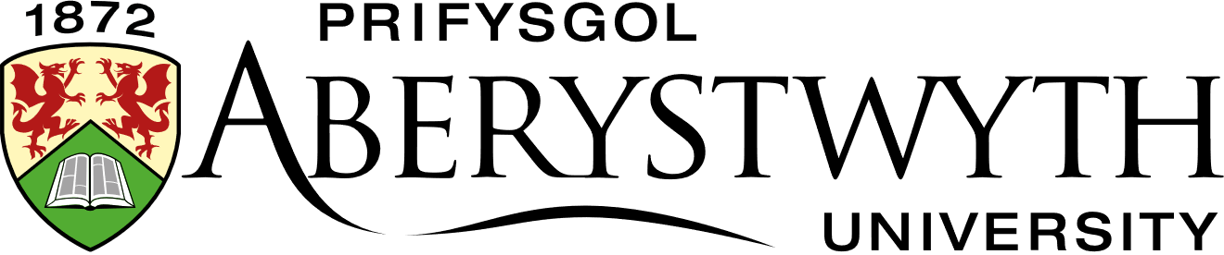

TITLE | Animal Diversity
TUTOR | Emzi Mills-Frater

Dear Student,
Thank you for enrolling on this Lifelong Learning course. This letter gives you some further information. If you have any questions, please contact either:
The LLL Office: learning@aber.ac.uk
The Tutor: Emzi Mills-Frater emf20@aber.ac.uk
The Co-ordinator: Elin Mabbutt emm32@aber.ac.uk
We hope you enjoy the course.
Best Wishes,
The Lifelong Learning Team
----------------------------------------------------------------------------------------------------------------
GETTING STARTED
Aberystwyth University Student Account
Before you can begin your course, you need to activate your Aberystwyth University Student Account. After you pay and enrol, you will be sent your unique student number by the Lifelong Learning Administrator. This will enable you to obtain your student username and set a password for your student account.
Having an account gives you many additional benefits such as access to the university library and online journals, an email address, and discounts for university services.
Click here to find all the instructions you will need to set up your student account.
Once you have completed this process login to your Aberystwyth University email account here

Online Learning Environment: Blackboard
Once you have an active username and password you can login to our online learning environment called Blackboard by going to https://blackboard.aber.ac.uk. This is where you can access the learning materials for your course, interact online with your tutor and other students and submit your assignments. Guide to Blackboard Ultra - Students : Information Services , Aberystwyth University

Microsoft Teams
Your course may include one or more live online learning webinars or seminars. If so, these will be held using the online platform Microsoft Teams. Like Blackboard, you can access Teams online by going to https://teams.microsoft.com/ and logging in with your Aberystwyth University student username and password. Although not essential, we would recommend you download the Microsoft Teams software onto your desktop. Once you have logged in, you can do this from the Microsoft Teams homepage. Click on the circle in the top right-hand corner of the screen and select Download the Desktop App.
If an online meeting has been scheduled by your tutor you will receive an email to your University Email Account that will contain a link, which you can click on to join the meeting. Alternatively, if you go to your Calendar in Microsoft Teams, which is on the left-hand side of the screen, you will see a Join button appear by the meeting just before it begins, which you can click on.
If you haven’t used Microsoft Teams before I would recommend watching this one minute video (link) so you know what to expect.
COURSE OUTLINE
What is the difference between an earthworm, a round worm or a slowworm? Are goldfish more closely related to starfish or to jellyfish? This course will uncover the science behind sorting out members of the Animal Kingdom and reveal their evolutionary relationships.
Together we will examine the structure and life cycles of key animal groups and discover what makes them unique and successful. By exploring animal structure and the evolutionary processes that resulted in their diversity, you will be able to place animals into related groups.
Animal Diversity can be studied as a stand-alone course, but it is also a core module for the Certificate of Higher Education in Field Ecology at Aberystwyth University. This distance learning course enables you to study from home and participate in an online learning community. The course is delivered through Blackboard, our online learning environment and will include one or more live webinars.
LEARNING OUTCOMES
On completion of this module, students should be able to:
- Demonstrate knowledge of the major taxonomic groupings of the animal kingdom and their evolutionary status.
- Demonstrate knowledge of the morphology and diagnostic features of major animal taxa.
- Describe the life cycle and reproductive strategies in selected major animal taxa.
- Compare the adaptations and survival strategies of a range of animals.

COURSE PROGRAMME
Activities and tasks will be embedded into each unit so students can practise the techniques they have learned and develop their skills. Students will be encouraged to share their own work and participate in discussions on Blackboard. Alongside the learning materials on Blackboard the tutor will be on hand via email to answer any queries and provide guidance throughout the course. They will also participate in the online discussions.
- Taxonomy and Classification of animals
- Characteristics and Evolutionary status of major invertebrate taxa, including
- Annelida
- Mollusca
- Echinodermata
- Arthropoda.
- Characteristics and evolutionary status of the major vertebrate taxa.

ASSESSMENTS
- Presentation Slides (max 12 slides) summarising of the taxonomy, morphology and diagnostic features of an animal species (25%)
- Written assignment comparing the life cycle and survival strategies of different animal taxa 1500 words (75%)

Find our full programme listings here: https://www.aber.ac.uk/en/lifelong-learning/courses/
Are you interested in completing a Certificate in Higher Education? If you are, speak to your tutor or contact the co-ordinator: emm32@aber.ac.uk

Don’t forget to follow us on social media to keep updated about Lifelong Learning at Aberystwyth University:
Facebook: Dysgu Gydol Oes Aberystwyth Lifelong Learning

Twitter: @Aber_LLL

Instagram: @aberystwyth.lifelong.learning

