Psychology Science week: Activity Sheet!

This activity sheet will give a step by step guide to make your very own bird in a cage illusion! Use it with our video to have your very own illusion!

What you will need:
Paper/cardboard
ruler
Scissors
String
Glue
Pen
Hole punch
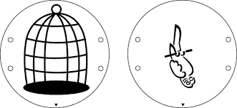
Crayons

Step 1: Print out this sheet and cut out the two circles (above) on this activity sheet OR on a piece of paper draw two circles the same size and draw a cage on one and a bird on the other. Cut your circles out. Feel free to colour your bird and cage!
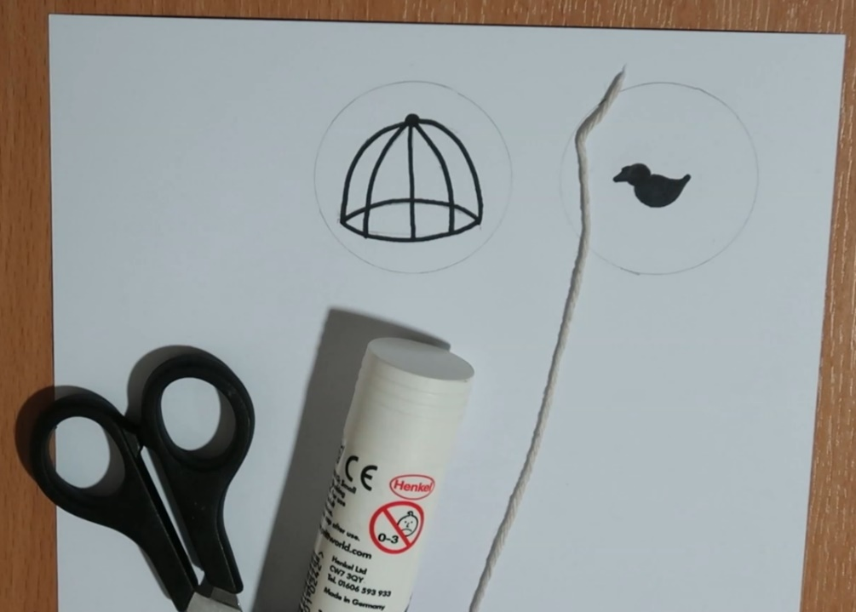
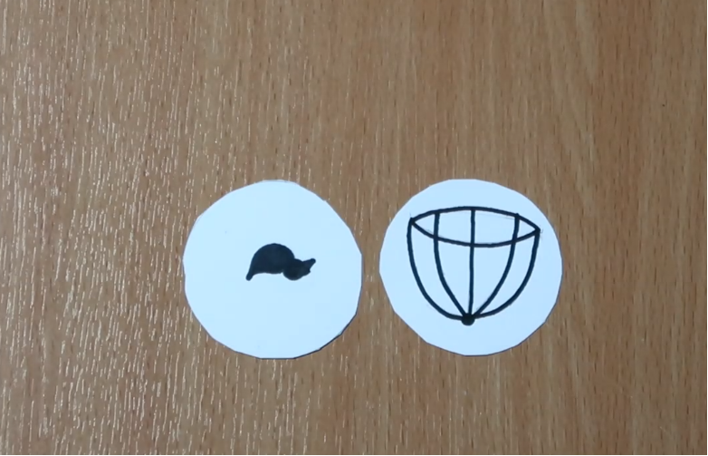
Step 2: put a bit of glue on the back of each of your circles, place your string between them and glue your two circles together with the bird and cage facing outwards. Make sure that your bird and cage are pointing in the same direction!
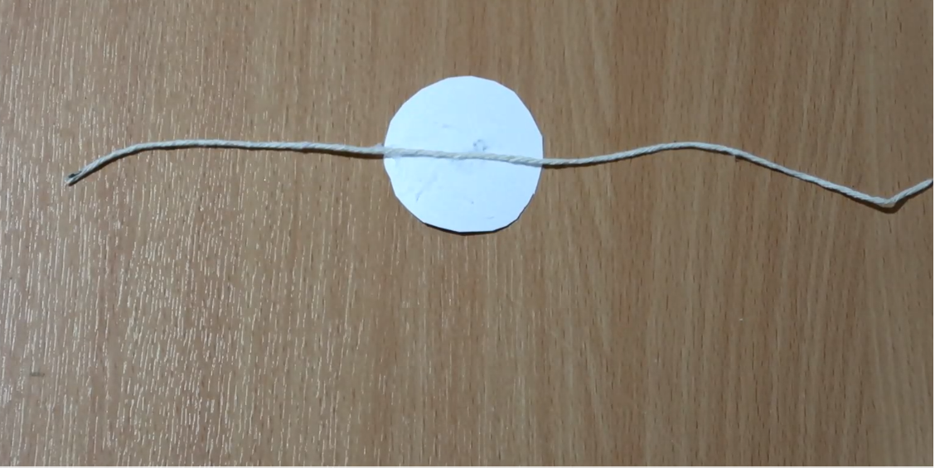
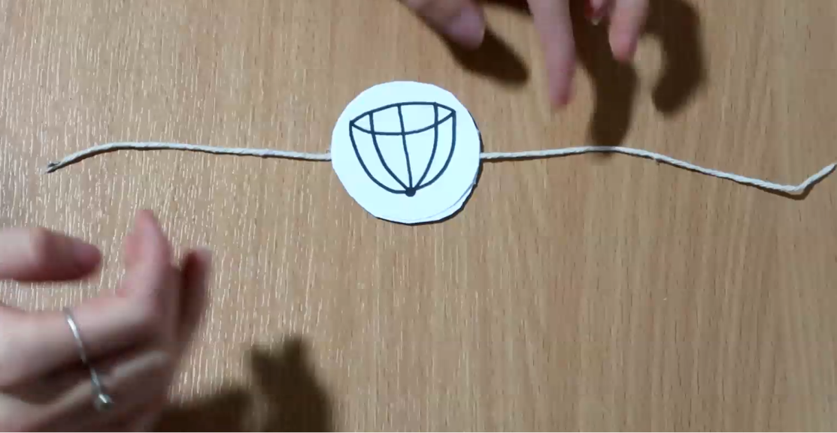
Step 3: once you’ve let the glue dry, you’re ready to try out your illusion! Take either end of your piece of string and twist the string and watch as the circle spins to see your bird in a cage!

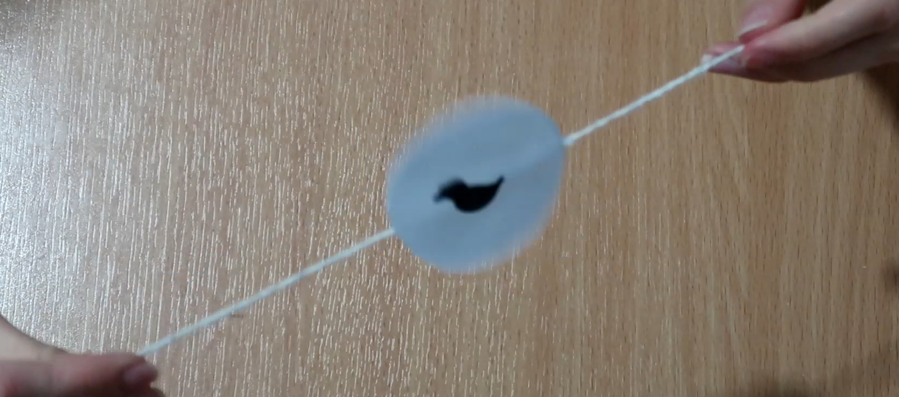

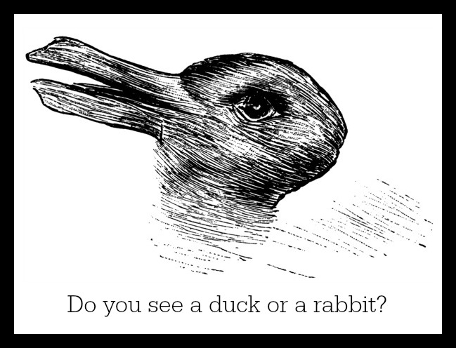

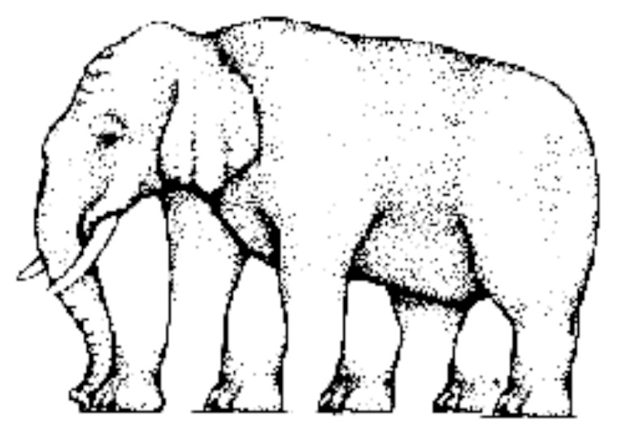
How many legs does the elephant have?

Question: Are these lines the same or different lengths?

Image credit: https://www.all-about-psychology.com/optical-illusions.html
https://sharpbrains.com/blog/2010/10/27/test-your-brain-with-these-top-10-visual-illusions/
https://nautil.us/blog/12-mind_bending-perceptual-illusions
https://www.girlguides.ca/WEB/Documents/MB/Meeting%20Resources/BirdCage.pdf

