BRITISH SCIENCE WEEK QUESTIONS
Could we live on the Moon?

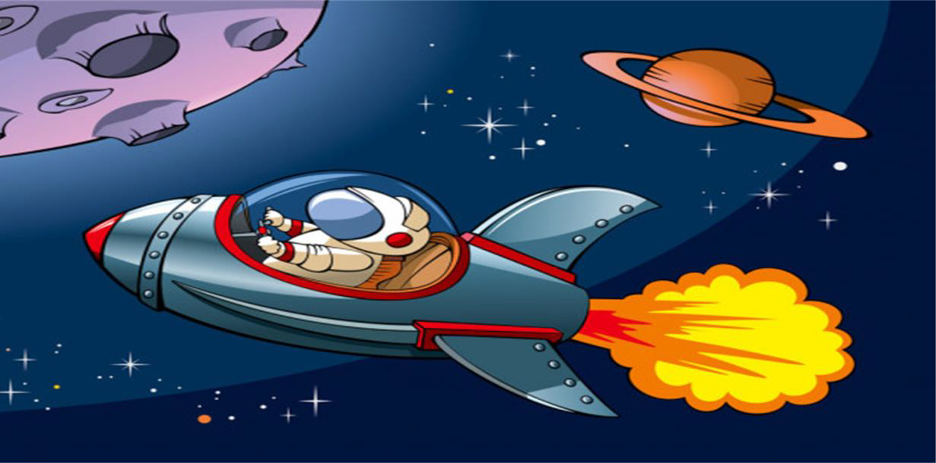

- How old is the Moon?

- How far from Earth is the Moon?

- How long does it take to get to the Moon?

- What year does NASA plan to go back to the Moon?

- Are there other natural satellites within our Solar System?

- What was the name of the NASA missions that took people to the Moon?

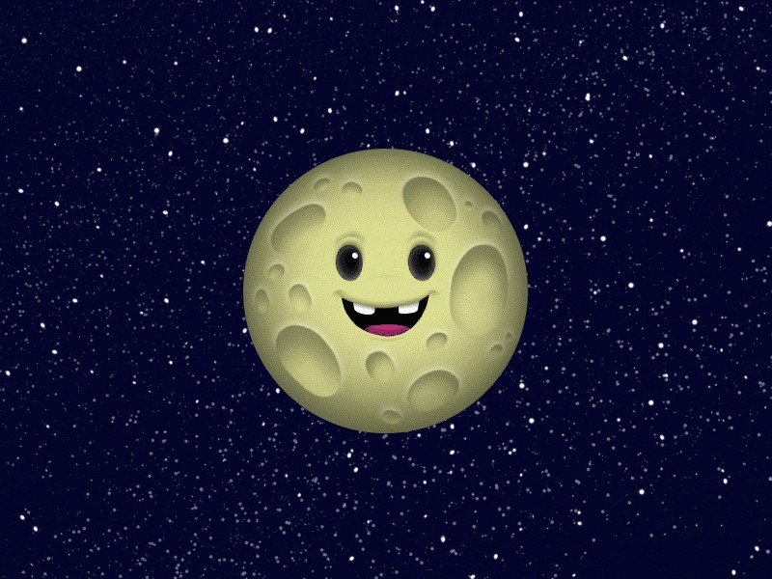
Answers

- 4.6 Billion years old.

- Approximately 250,000 (384.400 Km) miles from Earth.

- 3 days.

4. 2024.

- Yes there are many others.

- Apollo.

Well Done!

