Bacteria live all around us, but they are too small to see. Most are harmless, but occasionally they can cause food poisoning and make us unwell.
We measured how many bacteria could be found on a 1 cm square section of different surfaces in the kitchen. Which surface do you think was cleanest? Which had the most bacteria? Make your choices on the next page and then check your answers.
Why do you think different surfaces have different amounts of bacteria on them?
Perhaps consider how often a surface is touched. How often is it cleaned? Is the surface smooth or rough? Is it plastic, wood or metal? What else might affect how many bacteria can be found?

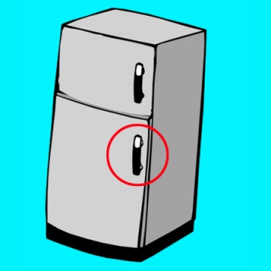
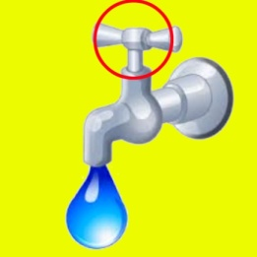
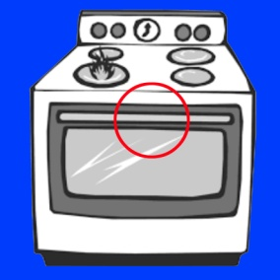
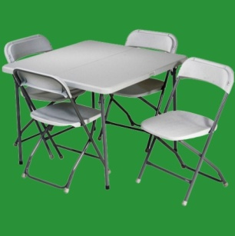
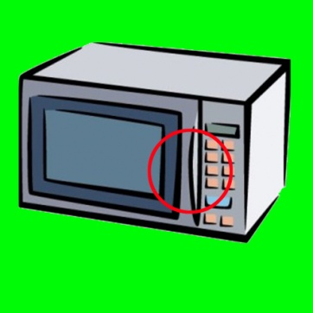
What’s lurking in the kitchen ?
How many bacteria did we find on each object? Connect the numbers to the correct objects
12
74
1
96
8
21
1

