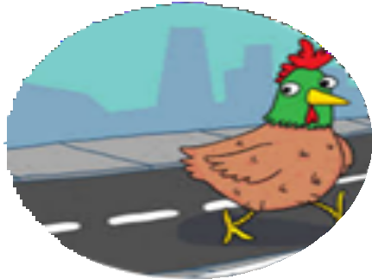
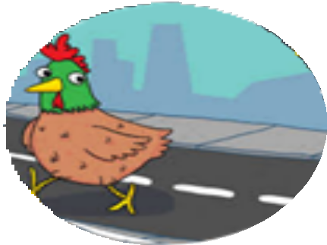
Möbius Strip Activity Sheet

Did you know, in 1858 a German mathematician called
August Ferdinand Möbius
discovered the Möbius strip.

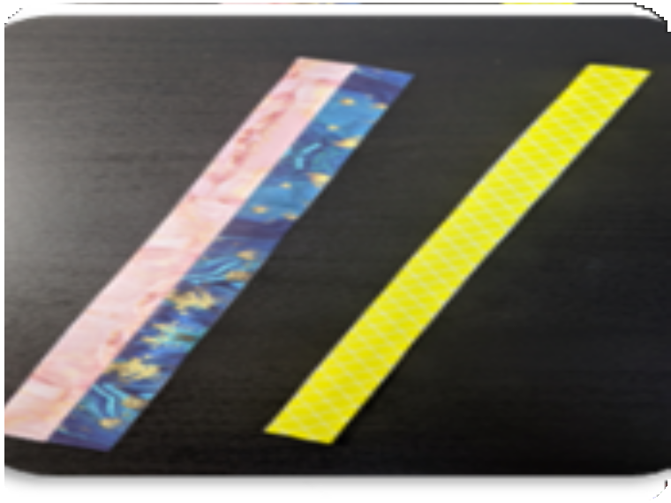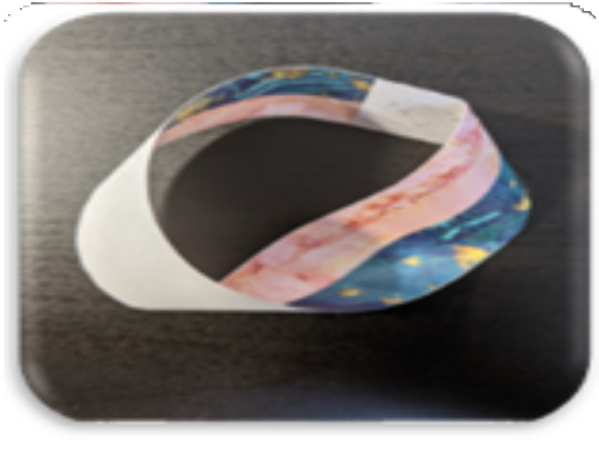Make a
What is a Möbius Strip?
- It is a one-sided shape - a chicken could walk across the whole shape and never reach the other side.
- There are 2 versions of this shape, which are mirror images of each other. This is called chirality.
- It can be left or right-handed, depending on which way the twist goes.
Möbius Strip

WHAT YOU NEED:
EXPLORE:
STEP 3: Tape together
Can you draw a line all the way along the paper without taking your
pen off?
What happens when you cut along this line?
Try making a mobius strip with more than one twist.
What happens if you put an odd or even number of twists in the shape?
- Paper strips
- Colouring pencils
- Scissors
- Tape
STEP 1: Colour in one side of
the paper strip.
STEP 2: Halt-twist the paper strip so that the coloured sides touch.

