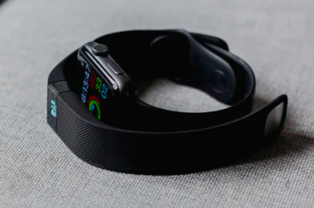
Wearable devices for sport and health

Fitbits are probably the most well-known example of a wearable device; in this case something to wear on your wrist. Learn more about the device on their website, and answer the questions below.

- Circle what you think a Fitbit tracks?

- Write 3 ways a Fitbit can be useful for an athlete.

- Write below what your favourite feature of a Fitbit is.

- In the box below design a future feature that could be useful for athletes.

- Using the words in the table, fill in the blanks in the text below.

Read the paragraphs bellow and fill in the blanks using the given words.

vigorous | nervous | intensity
injuries | fever | wrist
increase | 60 | more

Fitbits track the level of physical activity and are worn on your ________. They often also have a sensor built in, that can estimate the heart rate of the person. At rest, the heart rate is around ______ beats per minute. Once you become active, your heart rate increases. The harder the exercise the _____ energy needed, and the heart rate would _________ further, indicating that the patient would have done light or _____________ activity. This would provide an overview of the _____________of the activity performed.
Athletes, such as runners, also look at their heart rate to stay within particular heart rate zones during their exercises, to improve their abilities rather than getting exhausted too early and sustaining possible _________ (muscle pain, cramps which could lead to trips and strains).
Nevertheless, there is a catch! The heart rate is a vital sign of the body and it responds to many different stimuli besides physical activity. For example, if a person is __________ in a situation their heart rate will increase although they might be just sitting down, or when you’ve got a ________.

