Annual Research Integrity Statement

  - 1st August 2019 – 31st July 2020

Aberystwyth University is firmly committed to the principles found within the Concordat to Support Research Integrity. To improve accountability and provide assurances that measures are being taken to support high standards of research integrity, the Concordat advises that employers of researchers should produce an annual statement to be presented to their own governing body which provides:

- A summary of actions and activities that have been undertaken to support and strengthen understanding and the application of research integrity issues
- A statement to provide assurance that the processes the institution has in place for dealing with allegations of misconduct are transparent, timely, robust and fair, and that they continue to be appropriate to the needs of the organisation
- A high-level statement on any formal investigations of research misconduct that have been undertaken
- A statement on what the institution has learned from any formal investigations of research misconduct that have been undertaken,
- A statement on how the institution creates and embeds a research environment in which all staff, researchers and students feel comfortable to report instances of misconduct

This annual statement sets out the University’s position in relation to research integrity, including what actions are undertaken to achieve compliance, as well as assurances of the process for and full disclosure of any allegations of research misconduct. This statement will be made publicly available through the Aberystwyth University website.

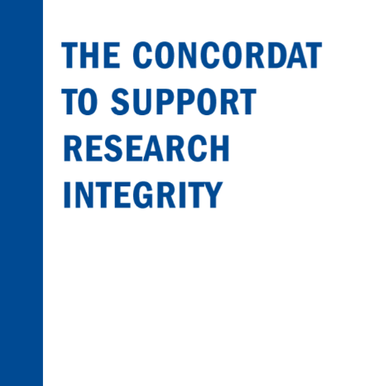
  - This public statement concerns research undertaken by academic staff and postgraduate research students. Research undertaken by undergraduate and taught postgraduate students is administered by the Academic Registry under the Unacceptable Academic Practice regulations.

Research is an integral part of Aberystwyth University's mission and work. As a recipient of public funding, the University recognises the need to be innovative and ambitious yet responsible and professional. This is encapsulated in the University Strategic Plan 2018-23.

95% of the research activity submitted to REF2014 by Aberystwyth University is of an internationally recognised standard. In order to maintain and build upon the university’s successful research portfolio, it is important that we are committed to maintaining the highest standards in our research, from design through to dissemination, by demonstrating openness, rigour and integrity in all of our research activity.

We achieve this through underpinning our research with a number of quality processes and by providing relevant support, policies and guidance in a widely-accessible format.

Signatories

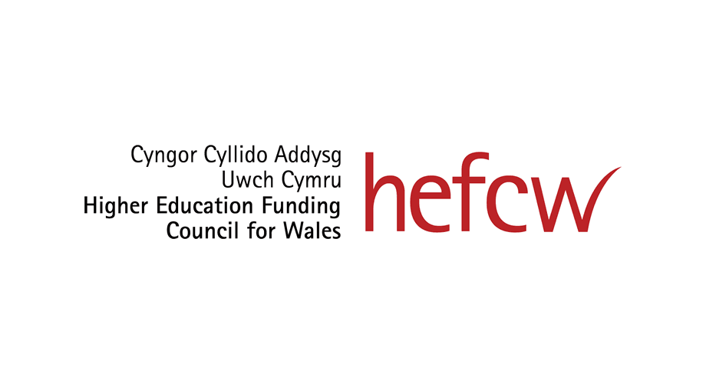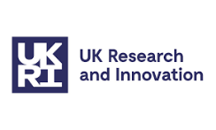

Governance

Embedded within its terms of reference, the University Research Ethics Committee (UREC) holds overall responsibility for overseeing and implementing the Concordat, as well as overall ethics, integrity and governance related policies, and procedures.

UREC reports to Senate. The Committee is chaired by Pro-Vice Chancellor for Research, Knowledge Exchange and Innovation. UREC also has oversight of and / or receives reports from the following committees:

- Research Ethics Panel
- Sponsorship Panel (to consider and approve sponsorship for NHS ethics applications)
- Animal Welfare and Ethical Review Board (AWERB)

Operationally, the Department of Research, Business & Innovation (RBI) provides day-to-day support for all matters relating to ethics, integrity and governance. This includes providing advice and delivery number of training and awareness raising events across all levels of the research community. In addition, RBI also supports UREC and the Research Ethics Panels.

Equally, academic Faculties and Departments play an important role in ensuring that the research conducted by its staff and PGR students is conducted appropriately and to the highest standard. Each Faculty has an Associate Dean for Research, who is an academic member of staff, whose role includes overseeing and championing a range of research-related issues.

Tailored for PGR students, the Graduate School oversees and supports the further development of postgraduates through the provision of training, such as the Researcher Development Programme and a series of induction events throughout the academic year.

The University has a designated ‘Research Ethics and Integrity Officer’ who is responsible for all matters regarding research ethics and integrity within the institution. They are available for advice and guidance and their contact details are made publicly available and can be available to assist with any concerns a researcher may have.

Policies and Procedures

The University hosts a number of policies and procedures to not only ensure that research is conducted appropriately, but to also ensure that effective mechanisms exist for the reporting of any concerns or queries. These policies are regularly reviewed and monitored by the appropriate University Governance committee:

- Research Ethics Framework  - Sensitive Research Policy  - Procedure for the Investigation of Misconduct in Research | -Public Interest Disclosure (Whistleblowing) Policy  - Professional Integrity Protocol  - Data Protection, Processing & Retention Policies  - Research Data Management Policy

Actions and Activities in 2019-2020 undertaken to support and strengthen understanding and the application of research integrity issues

Development and implementation of an Audit Process

UREC held a discussion around the University’s current ethics procedures and this resulted in the development and phased implementation of an ethics audit process. A number of documents were developed by the Research Ethics Team which were approved by UREC in February 2020. The documents approved were:

- Protocol for the Audit of Research Ethics Applications
- Audit Process Flowchart

- Audit Report Template

- Audit Checklist

A pilot audit was launched in March 2020 and full implementation of this process was scheduled for September 2020 but this has now been delayed because of the circumstances around the Covid19 pandemic. Resuming this process is now a priority for the 2020-21 academic year.

Review of the Security Sensitive Research Policy

Aberystwyth University’s Security Sensitive Research Policy was reviewed and approved by UREC in December 2019. This policy is reviewed annually.

Review of the Research Ethics Panel Appeals Policy

Aberystwyth University’s Research Ethics Panel Appeals Policy was reviewed and approved by UREC in December 2019. This policy is reviewed biannually.

Coronavirus Policy

UREC approved a ‘Research Ethics Guidance Policy for Covid19’ which was developed to advise researchers on how to manage their projects during the Covid19 pandemic. The policy was written and approved in April 2020 and provides guidance on:

- Manging ongoing research projects

- Conducting research remotely

- New research projects

- Face to face research

- Research projects related to Covid19

- International Research

Research relating to Covid19

The University monitors whether research projects are being developed in relation to Covid19. All projects relating to Covid19 require referral to the Research Ethics and Integrity Officer for a further review. The University ensures that they are aware of all such projects. At the start of the pandemic the online ethics assessment form added a question asking researchers if their project relates to Covid19. If this box is ticked the project is automatically highlighted to the Research Ethics and Integrity Officer who will ensure that all live projects have undergone an enhanced review. All Covid19 projects are recorded on a spreadsheet for monitoring purposes.

Training

Training and awareness raising in the areas of ethics and integrity plays an important role in facilitating good research practice. Training and awareness raising events at Aberystwyth are aimed at all levels of researchers and are delivered in a variety of formats.

To date, there has been a drive to ensure that student and early career researchers are aware of their responsibilities towards maintaining the highest ethical standards when undertaking their research.

At an UG and PGT level, module co-ordinators and other departmental staff are encouraged to embed the appropriate University processes and procedures into the delivery of their teaching. Undergraduate training on research ethics is organised on a departmental level. At a PGR level, RBI delivers the ‘Ethics, Plagiarism and Academic Practice’ module, which is facilitated by the Graduate School. This module is compulsory for all new research students (PhD & MPhil). This module must be passed in order for the student to progress on to study year two. This module is run every September and January. We are also pleased to have welcomed and engaged with a number of our Professional Doctorate students at a number of residential schools which have taken place this year. These students are required to complete the ‘Ethics Plagiarism and Academic Practice’ module and are also offered a further two sessions which teaches them about research ethics and undertaking dual research in the workplace. These sessions are offered in September and January each year.

Early career researchers and newly-appointed academic staff are invited and encouraged to attend a number of sessions which are tailored and delivered throughout the academic year. Existing research staff members are also able to attend any of the available sessions. We continue to participate in the rolling programme of AU-wide Research Good Practice sessions facilitated by RB&I, which were delivered to a range of new and existing research staff. These Research Good Practice sessions are delivered throughout the academic year and a different session is delivered every two weeks from September to May of each academic year.

The University remains pleased with the levels of engagement from the research community and will continue to develop and refine its training offering ready for the 2020/21 academic year.

AU’s Sensitive Research Policy (related to Prevent Duty)

Researchers considering or undertaking research on sensitive topics, which may include areas associated with the Prevent Duty https://www.aber.ac.uk/en/hse/proc-prac/prevent/ should ensure that the appropriate ethics requirements have been considered and satisfied, and consult the University's Sensitive Research Policy and Procedure. https://www.aber.ac.uk/en/media/departmental/healthsafetyenvironment/Sensitive-Research-Policy-and-Procedure.pdf

The University acknowledges that academic freedom is key in relation to its research activities. However, the University also has a duty to ensure that research, particularly research that is sensitive in nature, is conducted ethically and appropriately.
The University has produced a Sensitive Research Policy Procedure which all researchers (both staff and students) need to follow if they are using sensitive data. Compliance with this policy allows the University to demonstrate to external authorities that any use of such material forms part of legitimate research. Although, we cannot guarantee that this will provide protection from any investigation by such authorities, should the situation ever arise.

External Memberships

RBI continues to actively participate in the Association of Research Managers and Administrators (ARMA).

The University is a member of the UK Research Integrity Office (UKRIO). This has enabled the University to receive support in matters of research integrity and misconduct, consistent with the principles and expectations found within the Concordat to Support Research Integrity.

Procedure for the Investigation of Misconduct in Research - assurance that the processes the institution has in place for dealing with allegations of misconduct are transparent, timely, robust and fair, and that they continue to be appropriate to the needs of the organisation

The University takes all allegations of misconduct in research seriously and has developed a procedure to facilitate full exploration of potentially complex matters in research that can arise in situations where misconduct may have taken place. The procedure was reviewed and updated in January 2020.

This procedure follows the guidelines for a Procedure for the Investigation of Misconduct in Research issued by the UK Research Integrity Office (UKRIO) in August 2008 and in accordance with guidelines from the Concordat. Its objectives are to ensure that issues of misconduct in research may be addressed appropriately and investigated effectively and to enable an independent panel to produce a report on the basis of which the University may initiate appropriate action.
The use of this Procedure will be informed by the principles of Fairness, Confidentiality, Integrity, Prevention of Detriment, and Balance.
There are three stages to the procedure for the investigation of misconduct in research. Any complaints of misconduct in research must be made in writing to the Director of Finance and Corporate Services.
- A preliminary stage is held where the allegation of misconduct is formally acknowledged and the nature of the allegations are reviewed by the Director of Finance and Corporate Services. If the allegations of misconduct cannot be entirely discounted at this point then the second stage will commence.
- A screening stage is then undertaken and the Director of Finance and Corporate Services will convene a Screening Panel (comprised of the relevant Institute Director and two senior members of academic staff at least one of whom should be from the same Faculty as the Respondent) to determine whether the allegations of misconduct in research require formal investigation. This is completed within thirty working days. The Chair will provide a report of the Screening Panels’ findings to the Director of Finance and Corporate Services on whether a formal investigation is required.

- The Formal Investigation Stage is held where a Formal Investigation Panel is appointed. The Formal Investigation Panel will comprise a Pro Vice-Chancellor (normally the PVC with responsibility for Research) in the Chair and two senior members of academic staff from the same Faculty as the Respondent. The panel should be appointed within thirty working days of the receipt of the Screening Panels’ report recommending a formal investigation. The panel will examine the evidence collected and undertake any further investigations necessary and interview the respondent and the complainant. There is no time limit set for this stage and it will be completed as soon as possible.
The University strives to maintain a culture which promotes good practice and encourages honest and ethical research. Researchers have a responsibility to report any allegations of research misconduct and the University has created a procedure which not only facilitates the investigation of research misconduct but also allows people to feel comfortable in reporting any allegations. The University offers an informal process of managing such allegations to alleviate the worry some may feel if making a complaint. A complainant has three other options other than a formal complaint:
A) Approaching the individual and seeking jointly to find a way to resolve the matter
B) Approaching the Faculty PVC/Head of Service Department and requesting that he/she acts as intermediary between the two parties in resolving the issue;
C) Seeking mediation through an ACAS trained mediator at the University or at a sister university.
However, if a researcher felt they had no option but to report an allegation of research misconduct then the University has developed procedures as previously discussed, which not only provides a mechanism to investigate the allegation but to also support the staff involved.

- Summary of Research Misconduct Investigations

Based on the Procedure for the Investigation of Misconduct in Research, the University can report that for 2019-20 there have been NO high level (formal) investigations in relation to research misconduct.

2019/20 | Number of allegation for which an investigation has been undertaken  Staff PGR |  | Number of allegation upheld (in whole or in part)  Staff PGR
Fabrication
Falsification
Plagiarism |  |  | NIL RETURN
Misrepresentation
Breach of Duty of Care
Improper dealing with allegations of misconduct etc
Other (e.g. ethical breach or unprofessional behaviour)

All queries relating to this statement or any of the University’s activities undertaken in relation to the Concordat should be direct to one of the following contacts:

Lisa Fisher – Research Ethics and Integrity Officer, Research, Business & Innovation
Dr Jennifer Deaville – Research Development Manager, Research, Business & Innovation

If anyone reading this document has concerns relating to the conduct of an Aberystwyth University researcher, they should first consult the appropriate policy and procedure (see page 5). If you are unsure which policy applies or if you are a participant in a research project, please contact the Research Ethics team who will be able to advise:

 ethics@aber.ac.uk
 01970 621694

October 2020

