CMS Training: Upgrade
  - 12 May 2023

Introduction
These exercises are intended for users who have attended CMS Contributor Training but are now required to work as a Moderator rather than a Contributor. Work through the exercises in your own time and contact us if you have any queries.
Contents
CMS Training: Upgrade 1
Introduction 1
Exercise 1 – Adding Media Library Categories 2
Exercise 2 – Creating a new section 4
Exercise 3 – Approving Content 6

Exercise 1 – Adding Media Library Categories
- Open the CMS by opening a browser and typing cms.aber.ac.uk into the address bar. Log in using your usual username and password.
- Click on the Content menu on the left of the screen and select Media Library.
- Expand the 'Categorised' category on the left of the Media library by clicking on the plus sign next to it so that you can see the Training category within it.
- Expand the Training category.
- Scroll down to find the appropriate year and month (from when you had your contributor training), then find the sub-category with your name on it and expand it.
- Click on the cog to the right of your category and choose ‘Create child category’ from the menu that appears.
- Give your new child category a name (e.g. training upgrade) in the screen that appears:
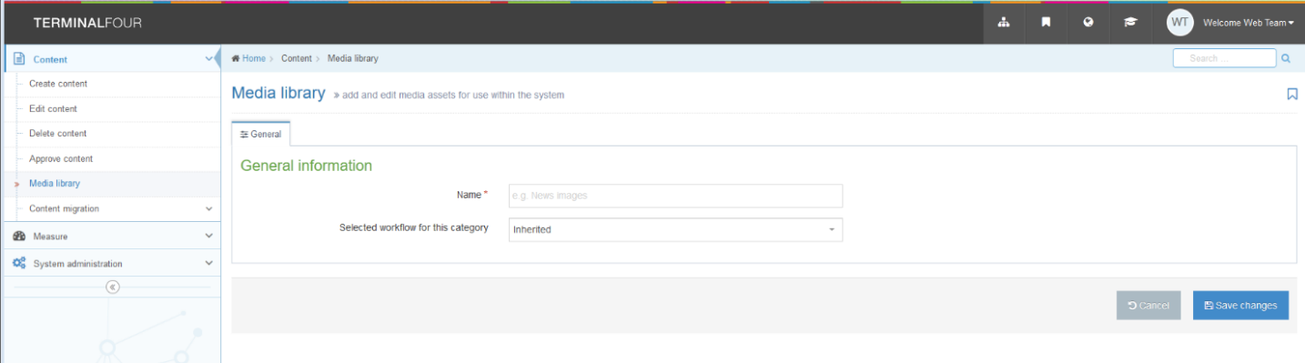
- Click 'Save changes' to finish.
- Expand your category by clicking on the plus sign next to it and find your new child category.

Exercise 2 – Creating a new section
- Return to the Site Structure by clicking on the TERMINALFOUR logo at the top left of the screen, or the Site Structure symbol in the menu at the top right of the screen:
- Click on the 'Actions' button to the right of your main section (the section with your name on it) and choose 'Create section' from the menu that appears:
- The General section details screen appears:
- Type the name of your new Section in the Name box (e.g. About Me).
- Type the output URI in the Output URI box (e.g. about-me)
- Click 'Save changes' to finish.

Useful Tips:
The URI should be lowercase, with spaces replaced by hyphens (-). Don’t use any other symbols.
If you’re not sure what topic to use for your page, why not make it an “About Me” page?

Exercise 3 – Approving Content
- Click on the Content Menu on the left of the screen and select ‘Approve Content’.
- Click on the 'Actions' button to the right of the content you are approving and choose ‘Preview’ from the menu that appears.
- A preview of the page will open in a new tab – check it’s all looking and functioning correctly.
- Return to your CMS tab and click on the ‘Actions’ button again for the content you are approving and select ‘Approve’.

- The ‘Approve content’ pop-up will appear:
- Click the 'Approve' button to finish.
- Repeat for all the content that is awaiting approval.
- Switch language to Cymraeg and repeat the process.

Useful Tip:
Your page would now be ready to be published if you were working a “proper” web page. The Web Team run regular publishes so if your content is approved it will be published along with all other approved content.

Training Evaluation Form:
https://www.aber.ac.uk/en/is/it-services/web/training-evaluation/

